



|  |
| --- |
| VA-Hub User Guide  ACUITY |
|  |

| Related Artifacts | |
| --- | --- |
| Ref. | Name |
|  |  |
|  |  |

|  |  |
| --- | --- |
| Abbreviations and Acronyms | |
| ETL | In computing, extract, transform, load (ETL) is the general procedure of copying data from one or more sources into a destination system which represents the data differently from the source(s) or in a different context than the source(s). |
| ECG | Electrocardiogram |
| AE | Adverse event |
| ctDNA | Circulating tumor DNA |
| ID or id | Identification |
| PK | Pharmacokinetic |
| RECIST | Response evaluation criteria in solid tumors |
| PT | Preferred term |
| SAE | Serious adverse event |
| CI | Cardiac Ischemic |
| CVOT | Cardiovascular Outcome Trial |
| Conmed | Concomitant medication |
| SEM | Standard error of the mean |
| AST | Aspartate aminotransferase |
| ALT | Alanine aminotransferase |
| CKD | Chronic kidney disease |
| TL | Target lesion |
| VAF | Variant allele frequency |

| REVISION HISTORY | | | | | |
| --- | --- | --- | --- | --- | --- |
| Ver. | Description of Change | Author | Date | Approved | |
| Name | Effective Date |
| 1.0 | Guide created | Olga Nekrutkina | 20-Feb-2020 |  | dd-mmm-yyyy |
|  |  |  |  |  |  |
|  |  |  |  |  |  |

Contents

1 Introduction 6

2 Main Application Functionality 6

2.1 About 6

2.2 How to Start 6

3 Main Application Controls 10

3.1 Top Menu 11

3.2 Left Menu 12

3.3 Right Slide Menu 12

3.4 Base Part of the Page 13

4 Working with Plot 14

4.1 Coloring 15

4.2 X and Y Axes Settings 16

4.2.1 Time Binning 17

4.3 Chart Context Menu 19

4.4 Trellised Plots 19

4.4.1 Order of Trellised Plots 19

4.4.2 Demonstration of Trellised Plots 20

4.5 Selection 21

4.5.1 Selection Ways 21

4.5.2 Selection Menu 23

4.6 Details on Demand Table 24

4.7 Filtering 26

4.7.1 Population Filters 27

4.7.2 Event Filters 30

4.7.3 Cohort Filters 32

4.7.4 Settings 33

5 Available Views and Plots 36

5.1 Population Summary View 36

5.1.1 Summary Plot Tab 37

5.1.2 Summary Table Tab 40

5.2 Dosing and Exposure View 41

5.2.1 Analyte Concentration over Time Tab 41

5.2.2 Dose Proportionality Exploration Tab 44

5.2.3 PK-Response Exploration Tab 48

5.3 Adverse Events View 51

5.3.1 AEs Subject Counts Tab 52

5.3.2 AEs Over Time Tab 55

5.3.3 AEs Table Tab 59

5.3.4 AE Summaries Tab 61

5.3.4.1 Any Category Subtab 62

5.3.4.2 Most Common AEs Subtab 63

5.3.4.3 AEs With Outcome Of Death Subtab 64

5.3.4.4 SAEs Leading To Discontinuation Of Study Treatment Subtab 65

5.3.5 AEs Chord Diagram Tab 66

5.3.6 CI Event Counts Tab 70

5.3.6.1 View Linked AEs 73

5.3.7 CI Events Over Time Tab 74

5.3.7.1 View Linked AEs 78

5.3.8 Cerebrovascular Event Counts Tab 79

5.3.8.1 View Linked AEs 82

5.3.9 Cerebrovascular Events Over Time Tab 83

5.3.9.1 View Linked AEs 86

5.3.10 Additional CVOT Suspected Endpoint Counts Tab 87

5.3.10.1 View Linked AEs 91

5.3.11 Additional Suspected CVOT Endpoints Over Time Tab 92

5.3.11.1 View Linked AEs 95

5.4 Conmeds View 96

5.5 Labs View 100

5.5.1 Box Plot Tab 100

5.5.2 Shift Plot Tab 104

5.5.3 Line Plot Tab 105

5.6 Vital Signs View 108

5.7 Cardiac Functions View 111

5.7.1 Jump to Cardiac-related AEs 114

5.8 Liver Function View 115

5.8.1 Jump to Hepatobiliary Disorder AEs 117

5.8.2 Jump to Liver-Related Lab Results 118

5.9 Renal Function View 119

5.9.1 Creatinine Clearance Tab 120

5.9.1.1 Jump to Renal and Urinary Disorder AEs Link 123

5.9.1.2 Jump to Renal-related Lab Results Link 123

5.9.2 CKD Distribution Tab 124

5.10 Respiratory View 127

5.10.1 Exacerbations Counts Tab 128

5.10.2 Lung Function Measurements Over Time Tab 131

5.10.3 Exacerbations Over Time Tab 134

5.10.4 Exacerbations Onset Tab 137

5.11 Tumour Response View 139

5.11.1 Waterfall Plot Tab 139

5.11.2 TL Diameters over Time Tab 142

5.11.3 Prior Therapy vs. Time on Compound Tab 144

5.12 Oncogenic Biomarkers View 147

5.12.1 Genomic Profile Tab 147

5.12.1.1 View on cBio Portal Link 151

5.12.2 ctDNA Tab 152

5.13 Timeline View 155

5.13.1 Status Summary Track 158

5.13.2 Adverse Events Track 159

5.13.2.1 First Level 159

5.13.2.2 Second Level 161

5.13.2.3 Adverse Events Filters 163

5.13.3 Conmeds Track 163

5.13.3.1 First Level 163

5.13.3.2 Second Level 165

5.13.3.3 Third Level 166

5.13.3.4 Conmeds Filters 168

5.13.4 Dose Track 168

5.13.4.1 First Level 169

5.13.4.2 Second Level 170

5.13.4.3 Third Level 171

5.13.4.4 Dose Filters 173

5.13.5 ECG Track 173

5.13.5.1 First Level 173

5.13.5.2 Second Level 176

5.13.5.3 Third Level 177

5.13.5.4 ECG Filters 180

5.13.6 Exacerbation Track 180

5.13.7 Lab Measurements Track 182

5.13.7.1 First Level 182

5.13.7.2 Second Level 184

5.13.7.3 Third Level 185

5.13.7.4 Fourth Level 187

5.13.7.5 Lab Measurements Filters 189

5.13.8 Patient Data Track 190

5.13.8.1 First Level 190

5.13.8.2 Second Level 191

5.13.8.3 Patient Data Filters 193

5.13.9 Spirometry Track 193

5.13.9.1 First Level 193

5.13.9.2 Second Level 194

5.13.9.3 Third Level 196

5.13.9.4 Spirometry Filters 198

5.13.10 Vitals Track 198

5.13.10.1 First Level 198

5.13.10.2 Second Level 199

5.13.10.3 Third Level 200

5.13.10.4 Vitals Filters 203

5.14 Single Subject View 203

5.14.1 Common Table Controls 204

5.14.1.1 Table Tool Panel 205

5.14.1.2 Context Menu 208

5.14.2 Summary Tab 210

5.14.3 Detailed Summary Tab 210

5.14.4 Timeline Tab 211

5.14.5 Dose Tab 212

5.14.6 Dose Discontinuation Tab 213

5.14.7 Respiratory Exacerbations Tab 214

5.14.8 Lung Function Tab 216

5.14.9 Adverse Events Tab 219

5.14.10 Serious Adverse Events Tab 220

5.14.11 Conmeds Tab 221

5.14.12 Labs Tab 222

5.14.13 Vitals Tab 225

5.14.14 Cardiac Tab 228

5.14.15 Liver Tab 231

5.14.16 Liver Risk Factors Tab 232

5.14.17 Liver Diagnostic Investigation Tab 233

5.14.18 Renal Tab 234

5.14.19 Death Tab 237

5.14.20 Medical History Tab 238

5.14.21 Surgical History Tab 239

5.14.22 Death Narrative Tab 240

5.14.23 Substance Use - Alcohol Tab 241

5.14.24 Substance Use - Nicotine Tab 242

5.15 Cohort Editor View 242

5.15.1 Adding a New Cohort 243

5.15.2 Saving and Applying a Cohort 245

5.15.2.1 Applying Several Cohorts. Applying Cohorts on Merged Datasets 247

5.15.3 Renaming and Deleting a Cohort 248

5.15.4 Sharing Cohorts 248

5.15.5 Important Details of Cohorts Usage 249

5.16 Machine Insights View 251

Appendix A. Roles and Permissions 254

Appendix B. VA-Hub Database Tables and Views 255

# Introduction

ACUITY system is intended to perform effective analysis of ongoing clinical trial information, while providing integrated and interactive views of the clinical data. System includes several applications, such as:

* VA-Hub - a web application showing the clinical trials data visualizations;
* AdminUI - a web application supporting clinical studies by editing dataset mappings and conversion rules.
* VA-Security – a web application providing authentication/authorization settings for the system.

Current document describes VA-Hub functionality.

VA-Hub allows a user to view, interpret and analyze clinical trials data.

# Main Application Functionality

## About

Data in the system is organized as follows:

* **Drug programme** is a programme of work to investigate one or more drugs.
* **Study** is a clinical study that is associated with a single drug programme.
* **Dataset** is a set of data that is associated with a clinical study. Essentially such a dataset arrives in tabulated format.

AdminUI application allows to create drug programmes and associate with them appropriate studies and datasets.

VA-Security application allows to provide a user with some role (see Roles and Permissions section for details), and also provide a user with access to some drug programmes/clinical studies/datasets.

Thus, the following preliminary conditions should be met in order to a user to use VA-Hub:

1. A user should be added to the system and appropriate privileges should be assigned to him/her.
2. Required clinical study data should be organized in the system.
3. A user should have access to the required clinical study data.

## How to Start

Open your browser and go to the VA-Hub web portal (<https://decmtreactprod.digitalecmt.com:447/vahub>).

If logging in was successful, a home page will open.

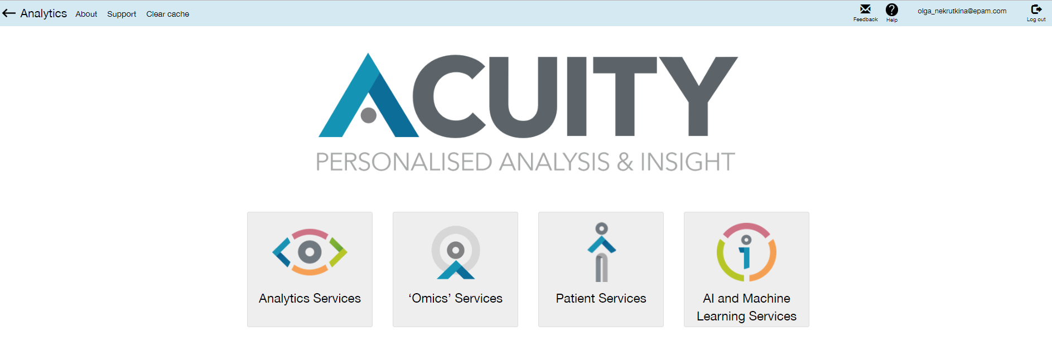

The following links are provided on the top menu of the page:

* **Analytics** – click link to access the application home page.
* **About** – click this link to access the page with information about application.

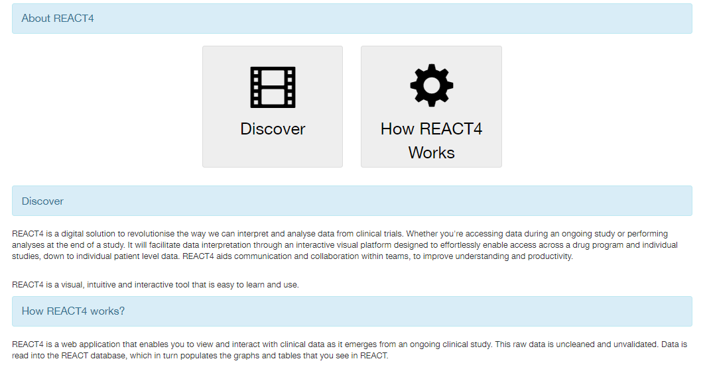

* **Support** – click this link to access **Support** page. It provides a user with useful email addresses.

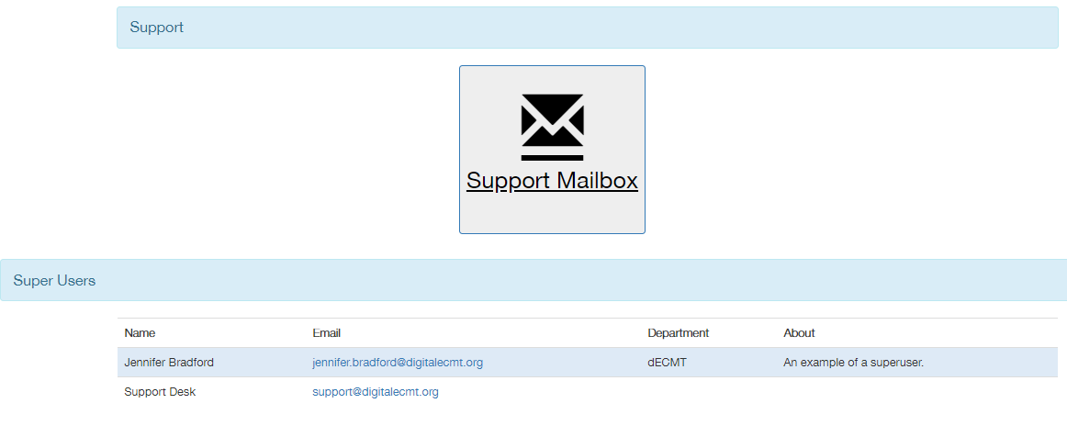

Click **Support Mailbox** to create an email to the support group.

* **Clear cache** – click this link to clean web application cache on server. It can be done before the new version of application is deployed. Caches are always cleared for the particular study after ETL run. Confirmation window appears:

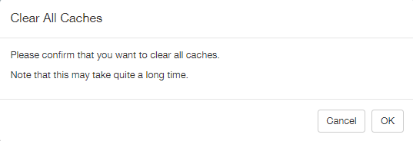

Click **Ok** to start cache clearing process.

* **Feedback** – click this link to provide feedback to the application development team. Email to the support group will be created.
* **Help** – click this link to choose either **Support** or **Help manual** item.

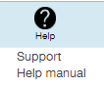

Choosing **Support** opens **Support** page (described above).

Choosing Help manual item opens REACT Training Manual page.

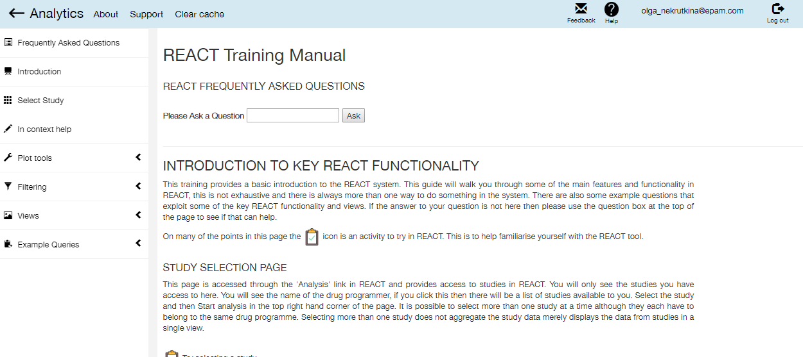

Here main application functionalities are described.

* **Log out** – click this link to log out.

Besides, four clickable icons are provided on the page.



Click **Analytic Services** to start. The page allowing a user to select a dataset for analysis opens.

**Note**: Three other features are planned.

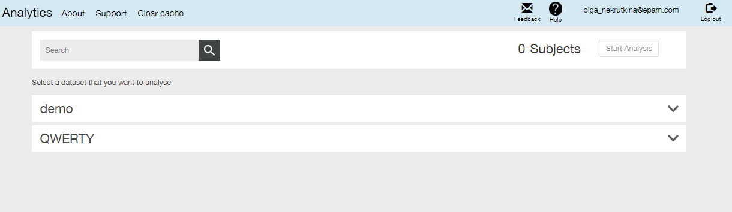

Here list of drug programmes available for a user is provided.

Click the down arrow  to the right of the particular drug programme to expand it and see appropriate studies and datasets.

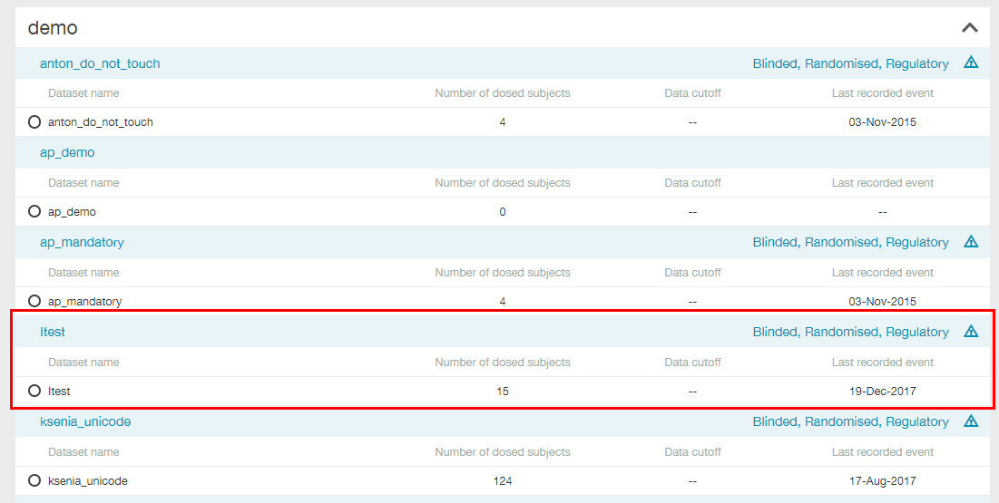

List of studies and accompanying datasets is provided in the table form. Study name is printed in blue, appropriate row is shaded with light-blue. ‘**Blinded, Randomised, Regulatory**’ marks can be placed to the right of the study name.

**Note**: Appropriate checkboxes (**Blinding**, **Randomisation**, **Regulatory**) can be marked (or not) while adding the dataset to the clinical study in the AdminUI application:

* **Blinding** – defines whether a study has blinding aspect, or not;
* **Randomisation** - defines whether study subjects are randomized between arms, or not;
* **Regulatory** - defines whether a study will deliver/support licensing submission, or not.

The following information is provided for each dataset in the study:

* Dataset name;
* Number of dosed subjects;
* **Data cutoff** – this field is currently not used;
* **Last recorded event** - last start event date specified in source files.

Mark one or several datasets to be analyzed and click **Start Analysis** button on the top of the page.

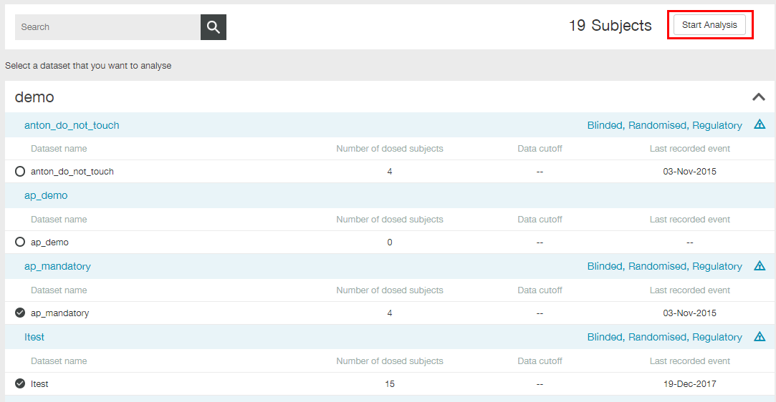

**Note**: It is not possible to select several datasets belonging to different drug programmes.

**Note**: Use **Search** field if you do not see the required dataset within the particular drug programme.

# Main Application Controls

The main application page opens. It consists of the following parts:

* Top menu ();
* Left menu ();
* Right slide menu ();
* Base part of the page ().

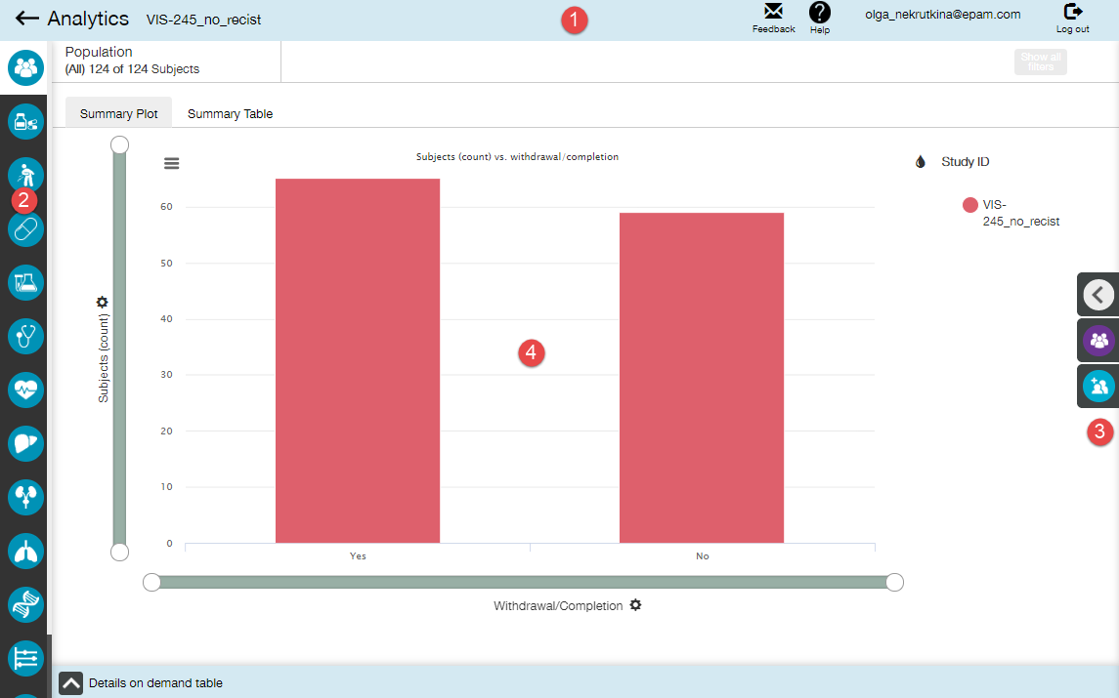

## Top Menu

Top menu contains the following elements:

* ← arrow – click it to return to the page allowing a user to select a dataset;
* **Analytics** – click it to return to the home page;
* Selected dataset name;

**Note**: If several datasets were selected, then only first of them is displayed. Click **show all datasets** to see all of them.

 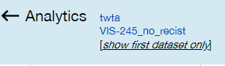

* Feedback link;
* **Help** menu;
* Logged in user details;
* Log out link.

**Note**: The **Help** menu additionally contains the **On Screen Help** item. Clicking this item results in walk through some of the main features of the application by means of the interactive popup window on the screen.

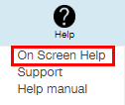

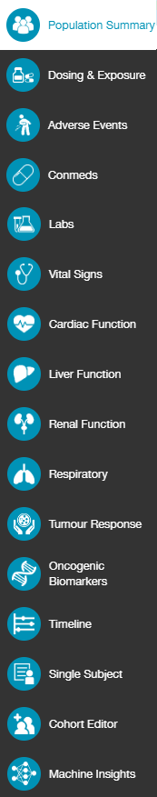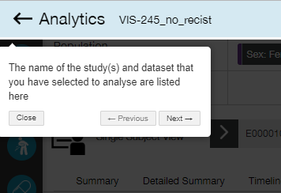

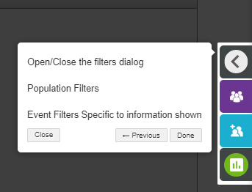

## Left Menu

Left menu expands when a user hovers mouse over it.

Left menu items provide a user with access to various views of selected dataset. Within some views, e.g. **Adverse Events**, there are multiple ways to look at the data and these appear as tabs across the top of the view.

Content of this menu strongly depends on the dataset(s) that was selected for analysis (particular view is available only if appropriate data exist). Current menu item is highlighted in white.

**Note**: Some views (Oncogenic Biomarkers and Machine Insights) require additional settings in the VA-Security application to be available for a particular user.

## Right Slide Menu

Right slide menu contains a set of filters applicable for the current view. Menu items expand when a user hovers mouse over it. For most views this menu contains the following buttons:

* 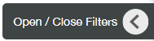- expands/collapses **Filters** panel;
* 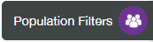 - opens a list of applicable **Population** filters;
* 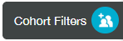 - opens a list of **Cohort** filters;
* 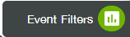 - opens a list of available **Event** filters.

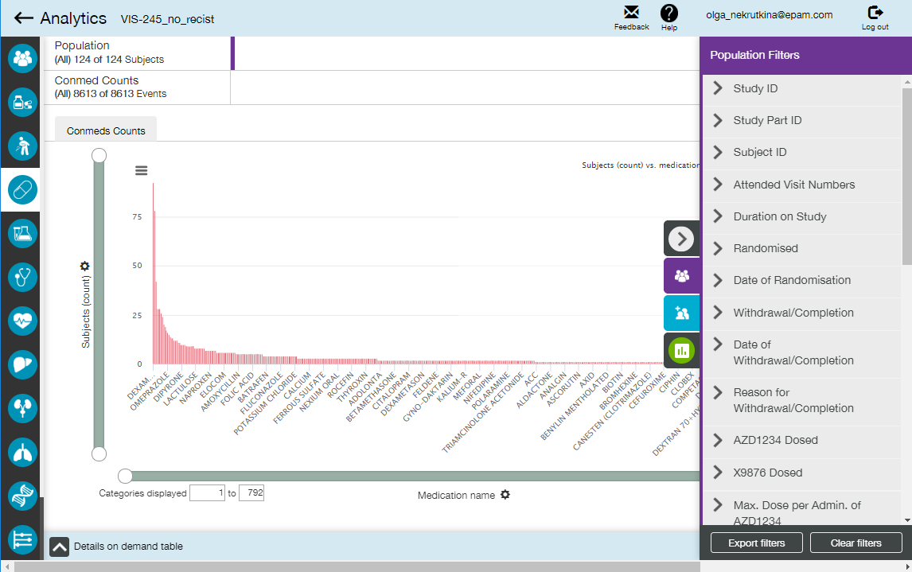

See Filtering section for additional information.

## Base Part of the Page

Particular view, selected from the left menu, is displayed in the base part of the page. Mostly (except for Cohort Editor, Timeline and Single Subject) views are organized as plots with different controls and settings.

Some views contain more than one plot, or even plots and tables. Such views can be organized using:

* Tabs;

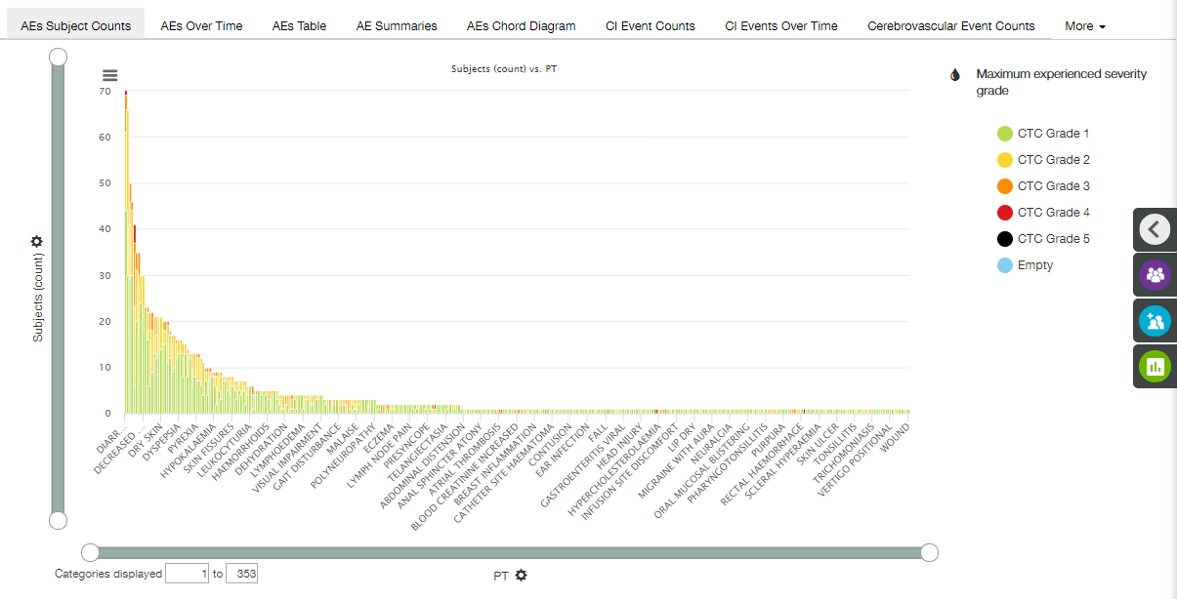

**Note**: If there are too many tabs on one view to be placed on the screen, then some of them are grouped under **More** button.

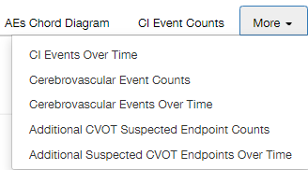

* Trellis visualization (see section Trellised Plots for details).

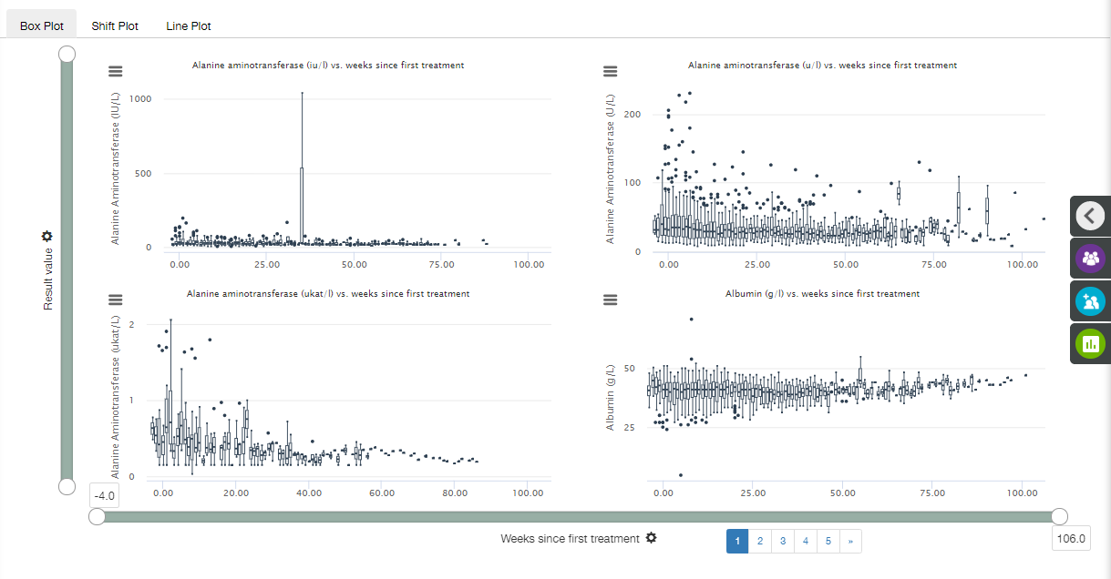

**Note**: The main application page always opens after selecting the dataset(s) displaying **Population Summary** view.

# Working with Plot

Each plot has some controls that operate in nearly the same way for most plots available in the application. These controls are described in this section.

**Note**: Special aspects of controls operating are described in Available Plots section.

## Coloring

If the plot is colored, appropriate legend is displayed besides the right-up corner of the plot area.

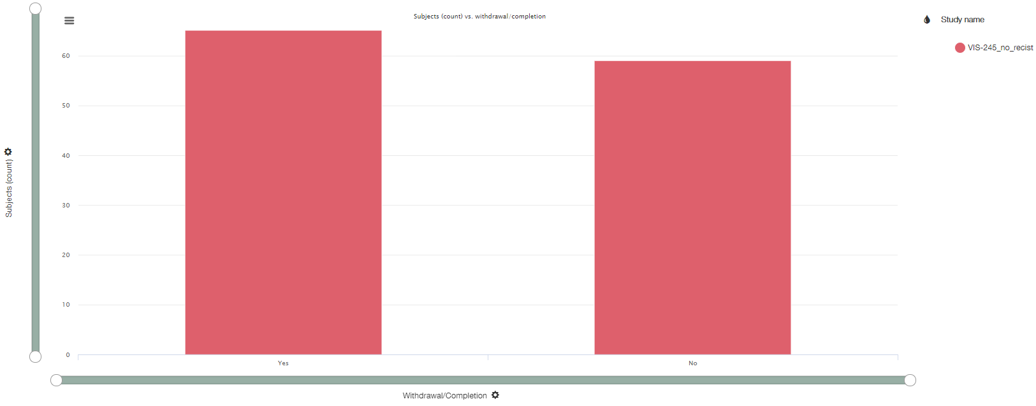

Clicking the  icon on the legend allows to open **Colour by** menu.

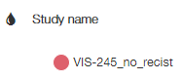 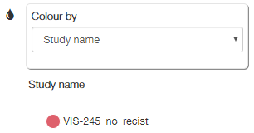

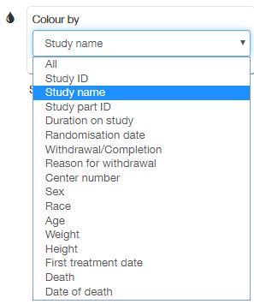

This menu allows to select the criteria of the plot coloring.

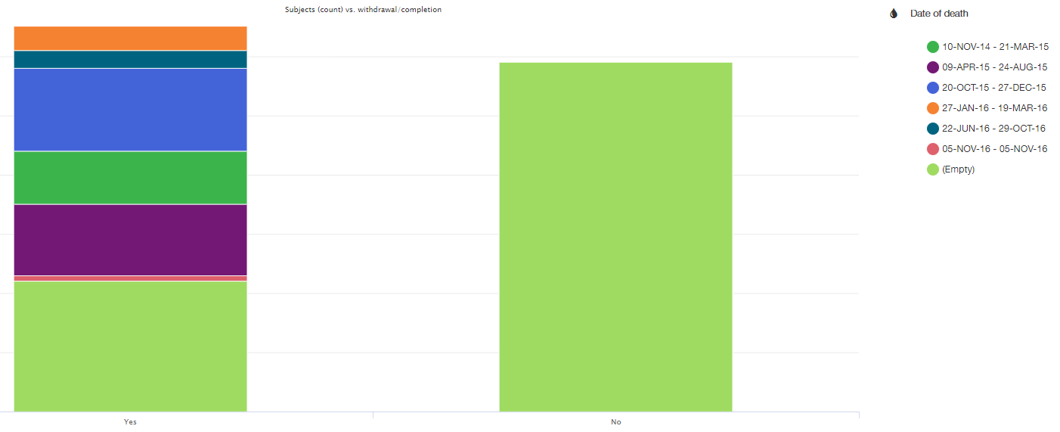

## X and Y Axes Settings

Both X and Y axes have the following attributes:

* Zoom bar;
* Axis label;
* Scale tics;
* Axis Settings menu.



1. Click  button besides the axis label to open **Axis Settings** menu.

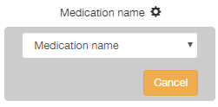

1. Click the down arrow to unfold the drop-down list.

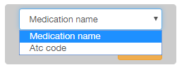

1. Select required axis value from the drop-down list.

**Note**: List of available options strongly depends on the selected view/plot. Besides, the list of options is data-driven, so only options with non-null values are present.

1. Click **Cancel** to collapse **Axis Settings** menu.

**Note**: The default option of the X-axis for all box plots and line plots is "Weeks since first treatment". The default option of the Y-axis for all box plots and line plots is "Result value".

**Note**: Two graphs can be combined together, if they have the same X axis values range. In this case, two different Y scales are displayed.

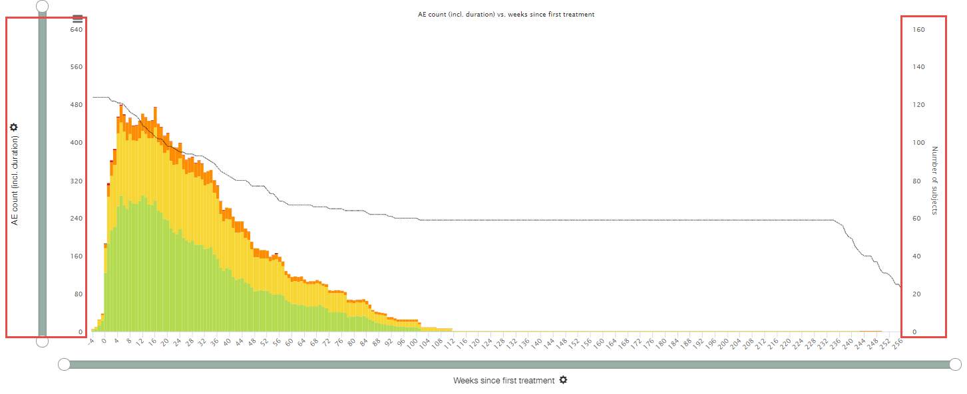

### Time Binning

Time binning function allows a user to set the size (or 'width') of the time bins on the X axis for a time-dependent plot. This function helps to view different drug cycle lengths.

Click the X axis control button (). There are two drop-down lists to select from: axis value and Bin size. Select bin size from the drop-down list and click **Apply**. It effects in redrawing current plot in accordance with selected values.

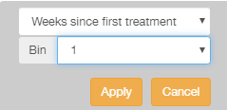

Time binning function has the following properties:

* The bin values are always integers greater or equal to 1 and a maximum of the total number of possible bins. The maximum corresponds to the days/weeks count from the date of first dose and date of last dose. If the date of last dose is null then the earliest date in withdrawal date/death date/last ETL date is taken.
* The default setting is "1". On this setting different week, analysis visit and visit values are displayed in their own bin.
* When the value is greater than 1, the system displays the stated number of values within one bin. For example, when "3" is selected for 'Weeks since first treatment', the first bin groups together the first 3 values, such as weeks 0, 1 and 2, subsequent bins should group the next three and so on.
* There is always a bin whose minimum is the first non-negative value (e.g. week 0), so that negative and positive values are always subdivided into separate bins (because the negative to positive transition is an important transition that should be visible in the plot).

EXAMPLE

Labs view, Line plot

Bin size for the first plot is 1 week, for the second – 4 weeks.

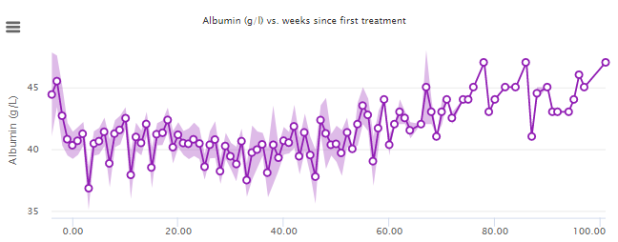

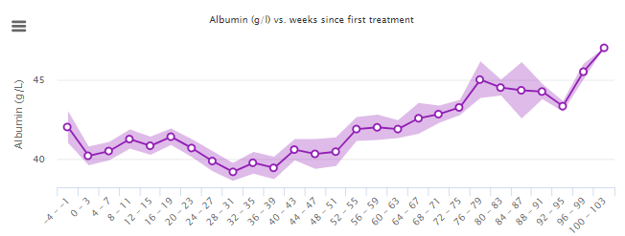

## Chart Context Menu

Each plot has a chart context menu, allowing to print the plot or save it as PNG or JPG.

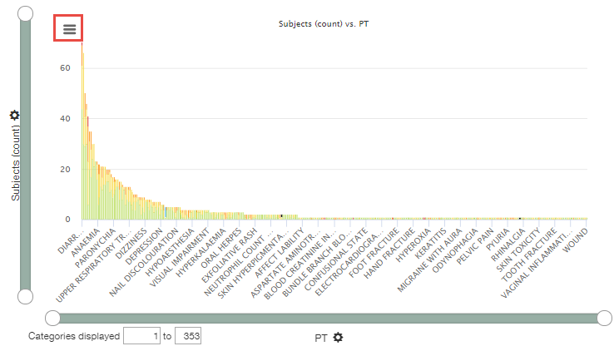

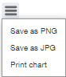

## Trellised Plots

Trellising method is used to visualize complex, multi-variable dependencies in datasets.

Trellis visualization consists of a set of plots. Each plot displays a subset of the original data, where the subsets are defined by the categories.

### Order of Trellised Plots

In a simple case where plots are trellised according to a single variable (like lab name), the plot order is the natural alphanumeric ordering of the items, e.g., so that "Bilirubin" comes before "Urea Nitrogen".

In many cases there are multiple levels of trellising. Trellis hierarchy includes the following items:

1. Measurement category (e.g., the Cardiac measurement type "ECG" or "Ejection Fraction").
2. Measurement type (e.g., the vital measurement name such as "weight").
3. Trellis items that relate to other data aspects.

EXAMPLE

Labs view, Line plot

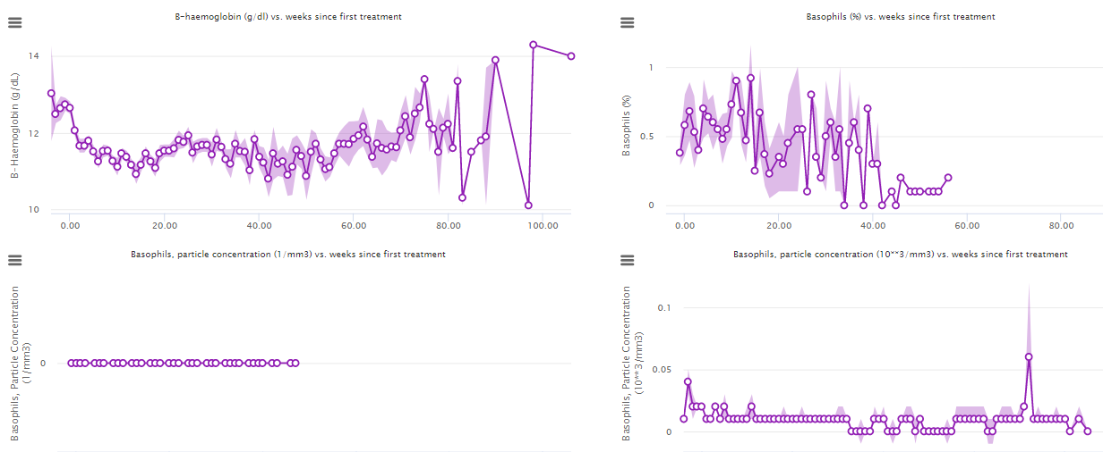

Plots are ordered from top left to right bottom corner, by rows. So the order on this page is the following:

1. B-haemoglobin (g/dl) vs. weeks since first treatment;
2. Basophils (%) vs. weeks since first treatment;
3. Basophils, particle concentration (1/mm3) vs. weeks since first treatment;
4. Basophils, particle concentration (10**3/mm3) vs. weeks since first treatment.

The first level of trellising is measurement name: B-haemoglobin, then Basophils.

The second level of trellising is measurement type for Basophils: %, then particle concentration.

The third level of trellising is measurement units for Basophils particle concentration: 1/mm3, then 10**3/mm3.

### Demonstration of Trellised Plots

Trellised plots are organized as follows:

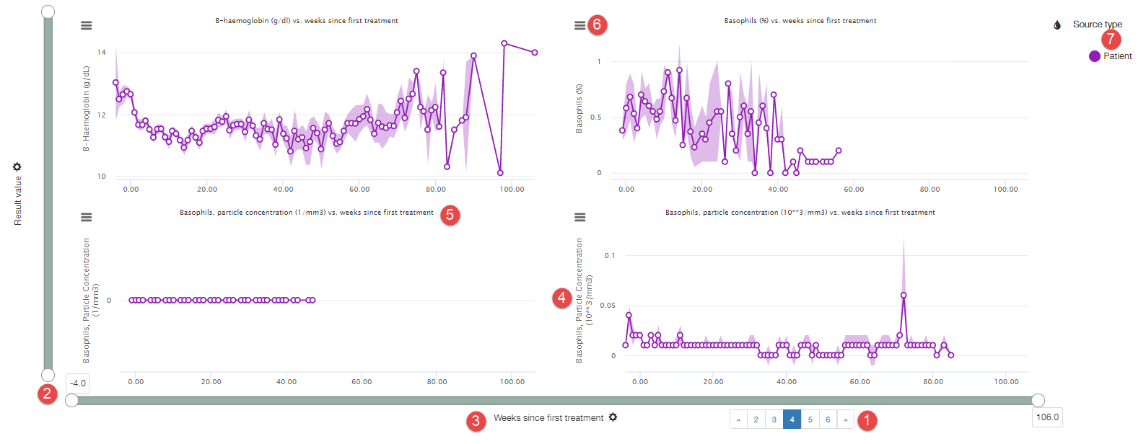

* Trellised plots are provided on the application page using 2*2 layout;
* If number of trellised plots exceeds 4, than plots pagination () is used;
* The X axes scale for all the plots is the same, whereas Y axes scales mostly are different;
* X and Y axes zoom bars () are common for all 4 plots on the page. Y zoom bar works on a relative scale (e.g., moving by 10% changes what is shown on the plot by 10%);
* X axes label () is only one for all 4 plots on the page, being placed below the X zoom bar. Y axes labels () are placed near appropriate Y axes. (Both labels are followed with  icon, providing a user with access to **Axis Settings** menu);
* Each plot has its own name (), describing the displayed dependence, and chart context menu ();
* There is only one legend () for all 4 plots on the page.

**Note**: If trellised plots are zoomed, and available data for some of them do not fit selected intervals, ‘No data to display’ message appears.

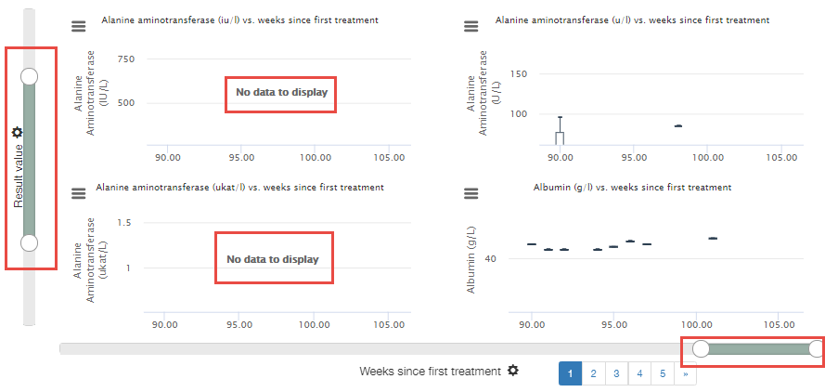

## Selection

### Selection Ways

A user can select some data on the plot by one of the following ways:

* Click and drag across some area in order to select a certain area on the plot.

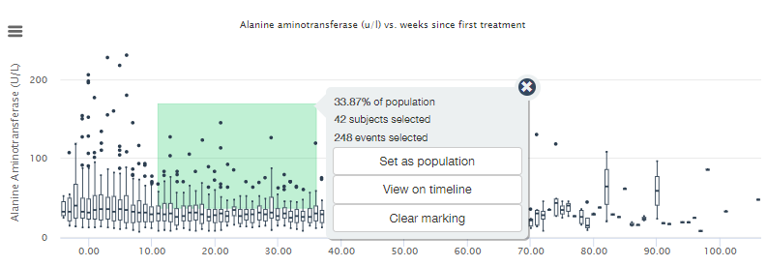

* Click and drag across some area on one plot, and Ctrl + Click and drag across some area on another plot in order to select several areas on different plots.

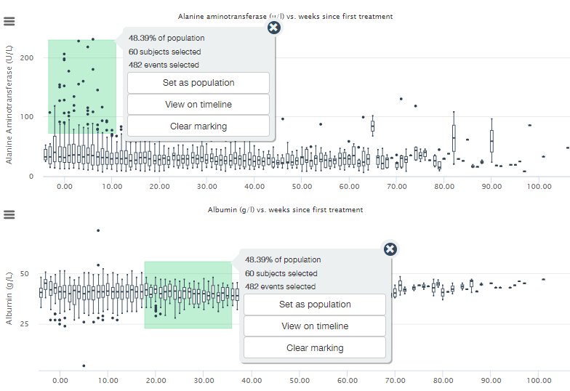

* Double-click on the plot in order to select all data.

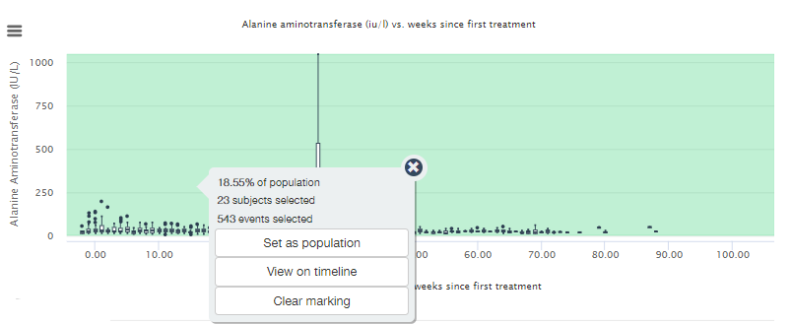

* Double-click **Chart context menu** icon () on one plot and Ctrl + double-click **Chart context menu** icon on another plot in order to select all data on different plots.

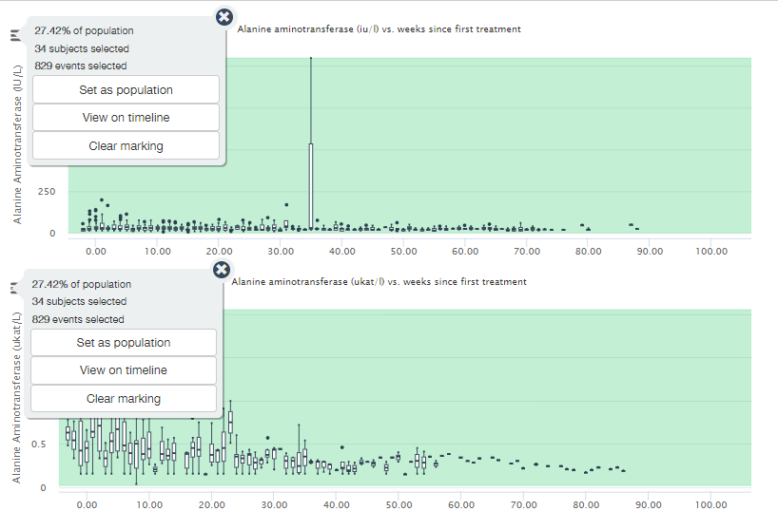

**Note**: Not all abovementioned ways of selection are applicable to all plots in the application.

### Selection Menu

When a user selects an area using one of the suggested ways, the selected area is highlighted and popup menu appears with the following data:

* Percentage of the population;
* Number of selected subjects;
* Number of selected events;
* **Set as population** button – click to apply Subject Id Population filter (see Filtering section for details) to limit population to selected subjects;
* **View on timeline** button – click to view specific timeline tracks for the selected subjects (See Timeline section for details);
* **Clear marking** button – click to clear the selection.

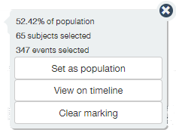

**Note**: Current population is used as denominator to calculate Percentage of the population. It means that applied Population filters (see Filtering section for details) affect Percentage of the population.

## Details on Demand Table

Most part of views (except for Cohort Editor, Timeline and Single Subject view) contain the **Details on Demand** table on the bottom of the page. It is collapsed by default, and a user should click up-arrow icon () to expand it.

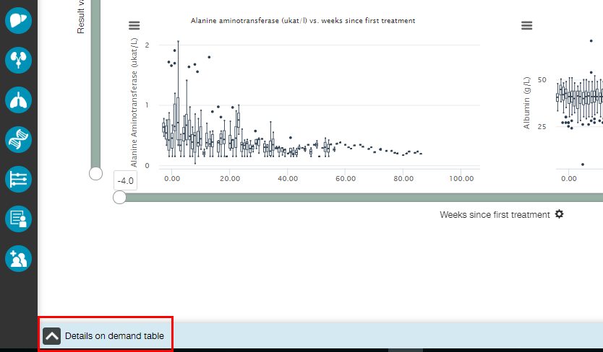

The table is empty. A user should select some data on the plot in order to populate the table with the appropriate data.

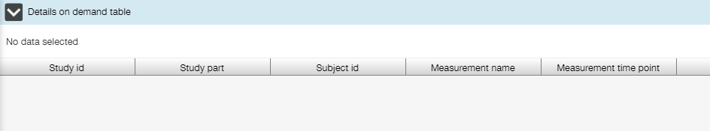

When some data are selected, Details Updates popup temporary appears at the bottom of the screen.



**Note**: Number of records in the **Details on Demand** table is limited with 1000 rows maximum. If number of events exceeds this value, but number of subjects precedes it, then only Subjects table will be available.

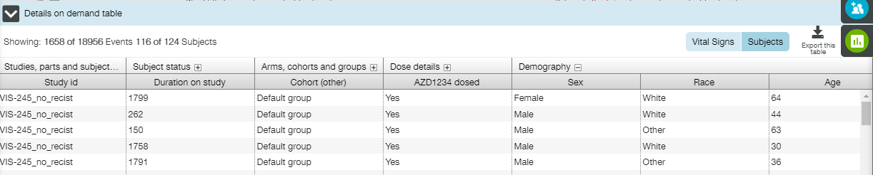

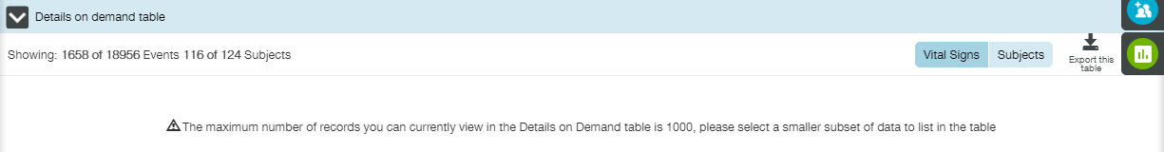

**Details on Demand** table is populated with information relevant for the data selected on the plot. For most plots (except for the **Population Summary** view and some of the oncology related tabs in **Tumour Response** view (like **Waterfall** plot and **Prior therapy vs. Time on compound**)) the table provides a user with the following tabs:

* Event information (depends on the view selected) - details for all of the events that were selected in the chart;
* Subject information – demography, arm, cohort, status information for the subjects selected.

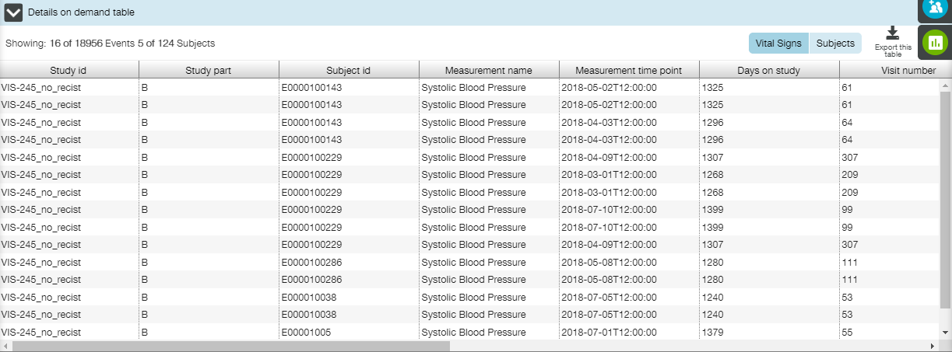

For the **Population Summary** view and some oncology-related tabs in **Tumour Response** view, **Details on Demand** table contains only subject information.

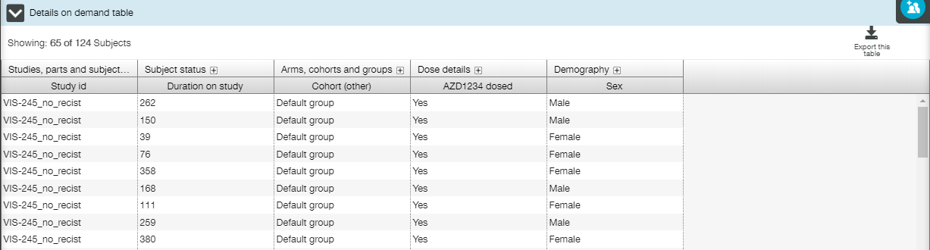

The following settings are available for the Details on Demand table:

* Info line: number of events/subjects selected on the plot is provided in the top left corner of the table;

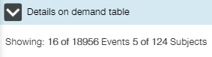

* Tab switcher: a user can switch between event/subject tables clicking on the appropriate icons in the top right corner of the table;

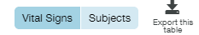

* Export the table: a user can export the table in .csv format by clicking **Export this table** button. Confirmation dialog window will appear. Click **Continue to download** in order to proceed;

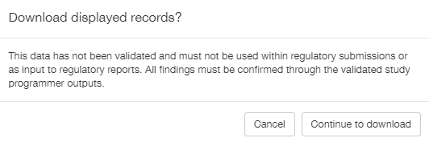

**Note**: Events table and Subjects table should be exported separately.

* Scroll bar at the bottom of the table: enables the user to look at all of the information in the table;
* Expandable columns (for the Subjects table): small plus icon next to the title of the column allows a user to expand columns to display more information;

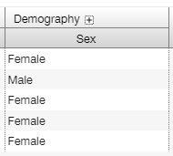

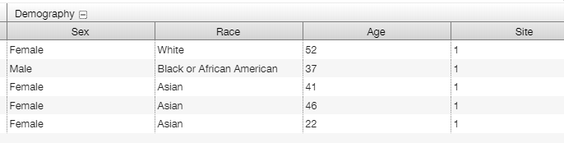

* Sorting: **Details on Demand** table can be sorted (either numerically or alphabetically) by clicking the column header.

**Note**: Click more than once to change the sort order.

**Note**: Use tooltip to see the full column name, if it is cut because is too long.

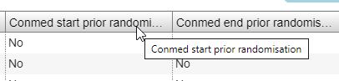

## Filtering

Right slide menu contains a set of filters applicable for the current view. This menu is available at all times for all views but Cohort Editor.

All filters work in combination with another filters.

For most views the following buttons are available:

*  - opens/closes **Filters** panel. Filters selection is saved when Filters panel is closed;
*  - switches **Filters** panel content to **Population** filters;
*  - switches **Filters** panel content to **Cohort** filters;
*  - switches **Filters** panel content to **Event** filters. This button is absent for the following views: **Population Summary**, **Single Subject** (some tabs).

For some views additional button is available:

*  - switches **Filters** panel content to Settings for current plot.

### Population Filters

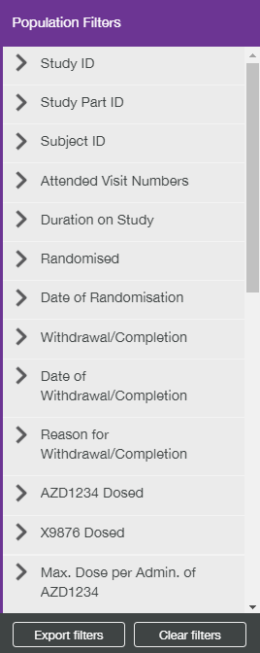

The population filters set allow a user to filter the displayed data by demography characteristics, study details, dosing details.

Filters are displayed as a list. Each filter can be expanded by clicking the right arrow icon besides its name.

The following controls are used to select values for filtering:

* Checkboxes;

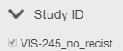

* Search fields;
* List boxes;

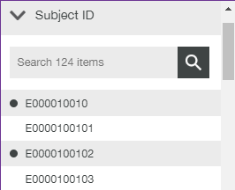

* Sliders;

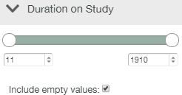

* Date pickers.

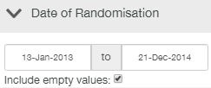

While a particular filter is expanded and possible values are displayed to a user, two buttons are provided on the bottom of the panel:

* **Apply** – click it to apply new filter settings;
* **Reset** – click to reset filter settings.

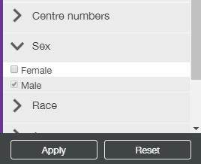

**Note**: If a user selected some values for filtering, but did not click **Apply** or **Reset** buttons, and collapsed the filter, selection is saved and displayed to a user next time when he/she expands the filter.

Applied filters are marked in the filter list – number of selected values is displayed.

Applying a filter effects in redrawing current plot in accordance with selected values, and changing options of the rest population filters.

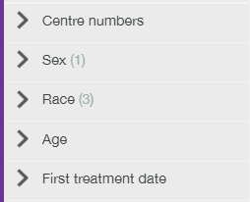

While all filters are collapsed, another two buttons are provided on the bottom of the panel:

* **Export filters** – click it to export the applied filters as a .txt file;
* **Clear filters** – click it to remove the applied filters.

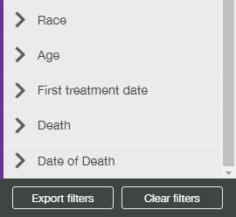

**Note**: A popup window appears when a user clicks **Clear filters** button. Here a user can select which filters to be cleared – all or population filters only.

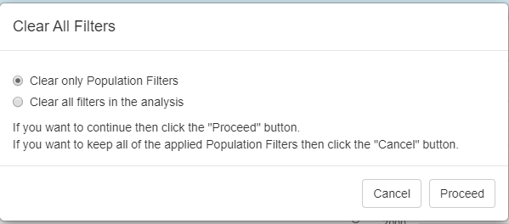

**Note**: Set of population filters is the same for all views. Respectively, each view contains **Population** widget on the top of the page, where all applied population filters are displayed as tags. Each tag has clickable cross-mark that allows a user to remove a filter in one click. Number of totally filtered subjects is also displayed on this widget.

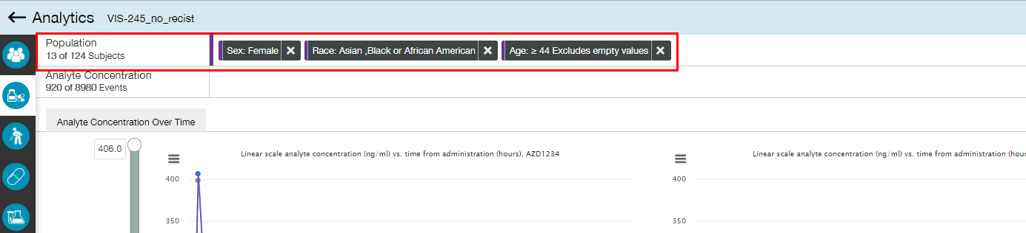

Clicking on these tags displays a popup windows with additional information.

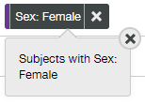

**Note**: If a number of applied filters tags is too much to be placed in the Population widget, then some filter tags hide, and **Show all filters** button becomes active.





When a user clicks **Show all filters** button, Population widget expands, displaying all available tags. **Show all filters** button switches to **Collapse filters** button that should be clicked to collapse the widget back.

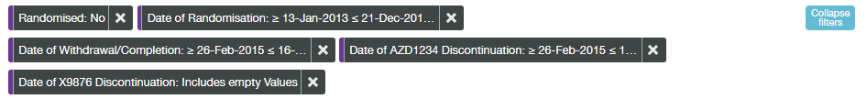

### Event Filters

Event filters list strongly depends on the selected view. If selected view contains several tabs (e.g., **Adverse Events** view), then event filters list is the same for most tabs (e.g. **Adverse Event Filters** for Adverse Events related tabs). So, once selected, events filtering is applied to all tabs where the same Event filters are present (including **Single Subject** and **Timeline** views).

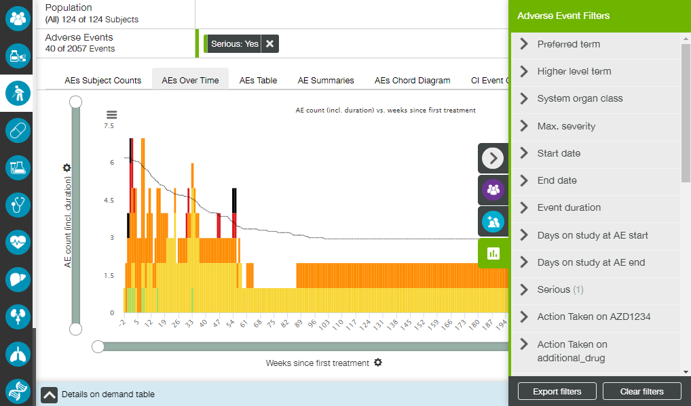

If a tab contains a table with some data, and **Filters** panel is available for this tab, then selected filters also apply to these data.

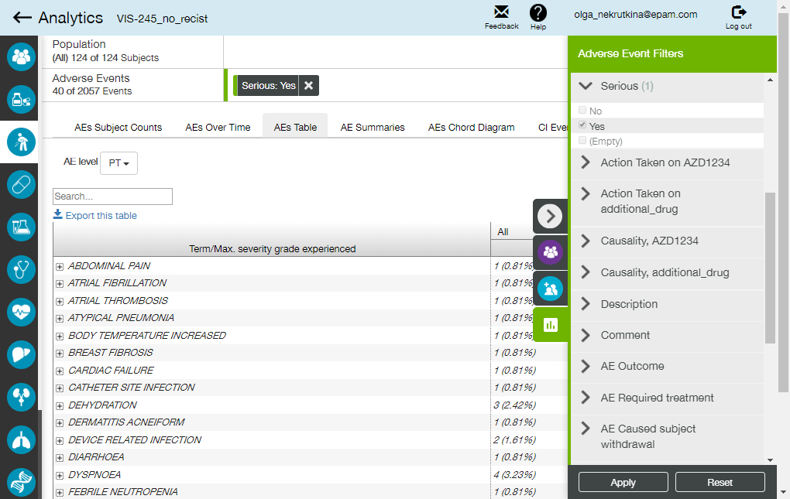

Available controls and buttons are the same as for population filters (see Population Filters section for details).

See information of particular event filters in the Available Views and Plots section.

Each view contains Events widget on the top of the page, where all applied event filters are displayed as tags. Each tag has clickable cross-mark that allows a user to remove a filter in one click. Number of totally filtered events is also displayed on this widget.

Clicking on these tags displays a popup windows with additional information.

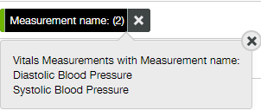

**Note**: If a number of applied filters tags is too much to be placed in the **Event** widget, then some filter tags hide, and **Show all filters** button becomes active.





When a user clicks **Show all filters** button, Events widget expands, displaying all available tags. **Show all filters** button switches to **Collapse filters** button that should be clicked to collapse the widget back.



**Note**: If some event filters were applied, and a user selects another view, the confirmation dialog window appears, providing a user with possibility to limit the subjects visible on other views by current filter settings.

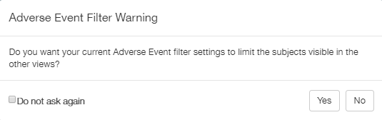

### Cohort Filters



The cohort filters allow a user to filter the displayed data by cohorts – pre-sets of data selected by means of population filters and/or adverse events filters (see Cohort Editor section for details).

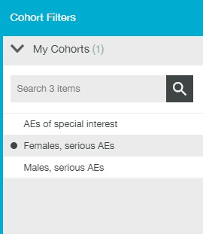

**My Cohorts** group provides a user with set of cohorts, created by this user or shared with him/her.

**Apply** and **Reset** buttons allow a user to apply selected cohort(s) or restore previous selection. Application of selected cohort results in applying appropriate set of population filters and/or adverse events filters to the current plot.

**Note**: All applied cohort filters are displayed as tags at the Population widget on the top of the page.

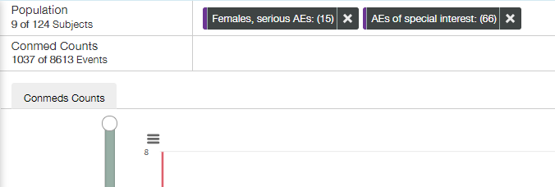

**Note**: If a cohort includes population filters, and a user applied some population filters together with a cohort filter, then only the common part of filtered subjects would be displayed.

**Note**: If a cohort includes adverse event filters, and a user applied some adverse event filters together with a cohort filter, then only the common part of filtered adverse events would be displayed.

**Note**: There is a difference between using Adverse Events filters directly and by means of Cohort filters. See Important Details of Cohorts usage section for additional information.

**Note**: Some cohorts can be organized on the dataset level. A user cannot reach such cohorts by means of **Cohort Filters** panel or **Cohort Editor** view. The only way to find and use them is to open **Population Filters** panel and find **Cohort (Dose)** section.

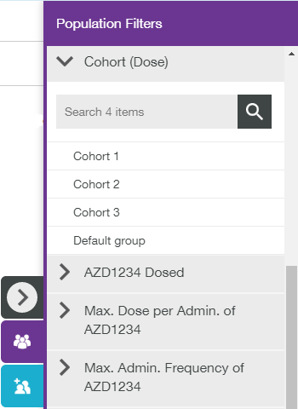

### Settings

Settings list appears only for some views (or even tabs) and strongly depends on the selected view:

* **Dosing & Exposure** view**: Analyte Concentration Settings** define scale, arithmetic mean and error bars;

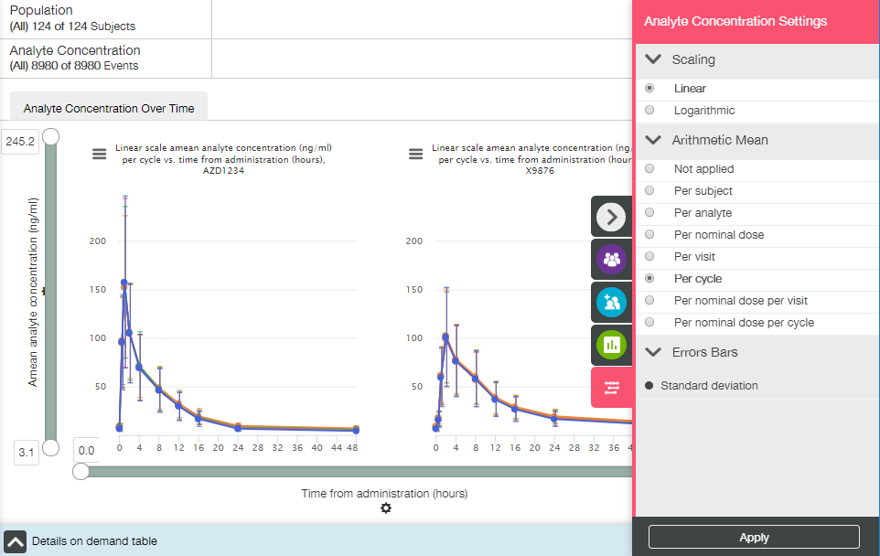

* **Adverse Events** view: **AEs Chord Diagram Settings** define term level, number of days between AEs to constitute a link, and % of the links of the chord that contains the highest number of links;

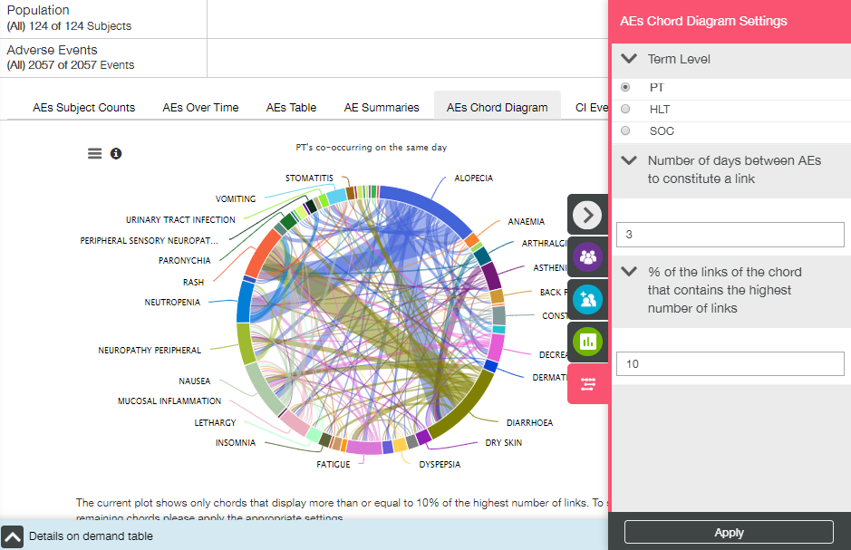

* Tumour Response view: Prior Therapy Settings define therapies;

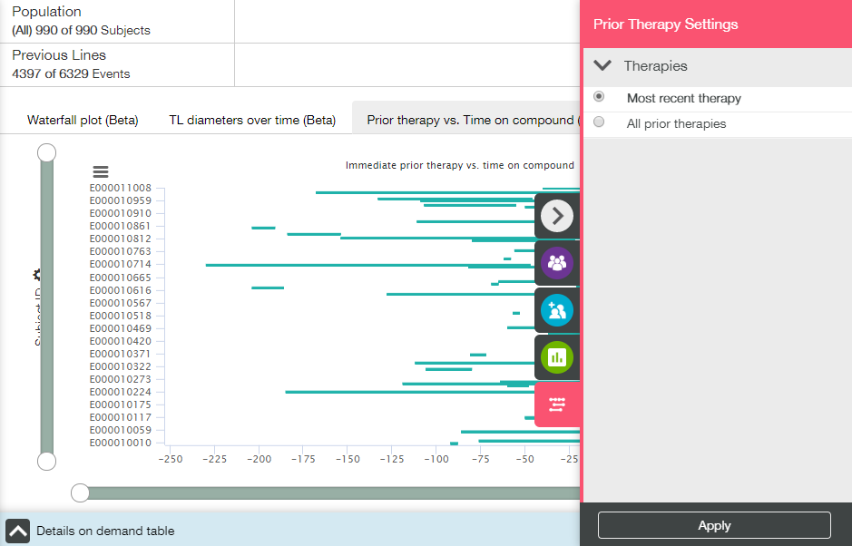

* **Oncogenic Biomarkers** view**: Genomic Profile Settings** define number of subjects/genes shown in zoom;

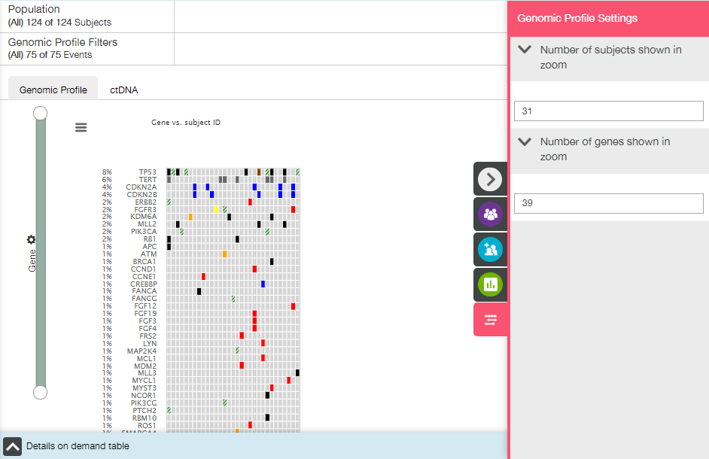

* Oncogenic Biomarkers view: ctDNA Settings define the scale for the plot;

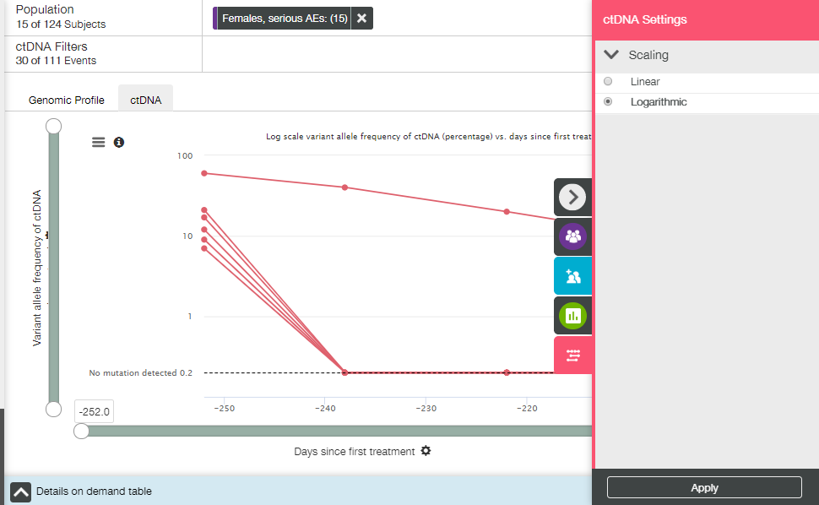

* **Timeline** view: **Timeline Settings** define track selection/settings.

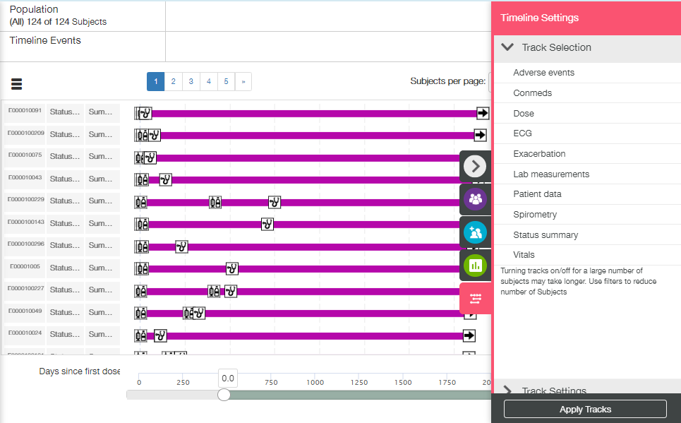

Only **Apply** button is available for **Settings** panel.

# Available Views and Plots

This section describes all possible views and plots.

**Note**: Set of views/plots available for a user strongly depends on the data in the particular dataset.

## Population Summary View

**Population Summary view** opens by default when a user runs a new analysis. This view allows a user to investigate the features of the population of subjects at any given time.

Two tabs are available on the **Population Summary** view: **Summary Plot** and **Summary Table**.

The following elements are available for both tabs:

* Population filters (collapsed by default) in the right slide menu (see Population Filters section);
* Cohort filters (collapsed by default) in the right slide menu (see Cohort Filters section);
* Population filter widget (see Population Filters section).

### Summary Plot Tab

**Summary Plot** is the default tab. It contains dynamic bar plot displaying a subject count or percentage of population for selected categories.

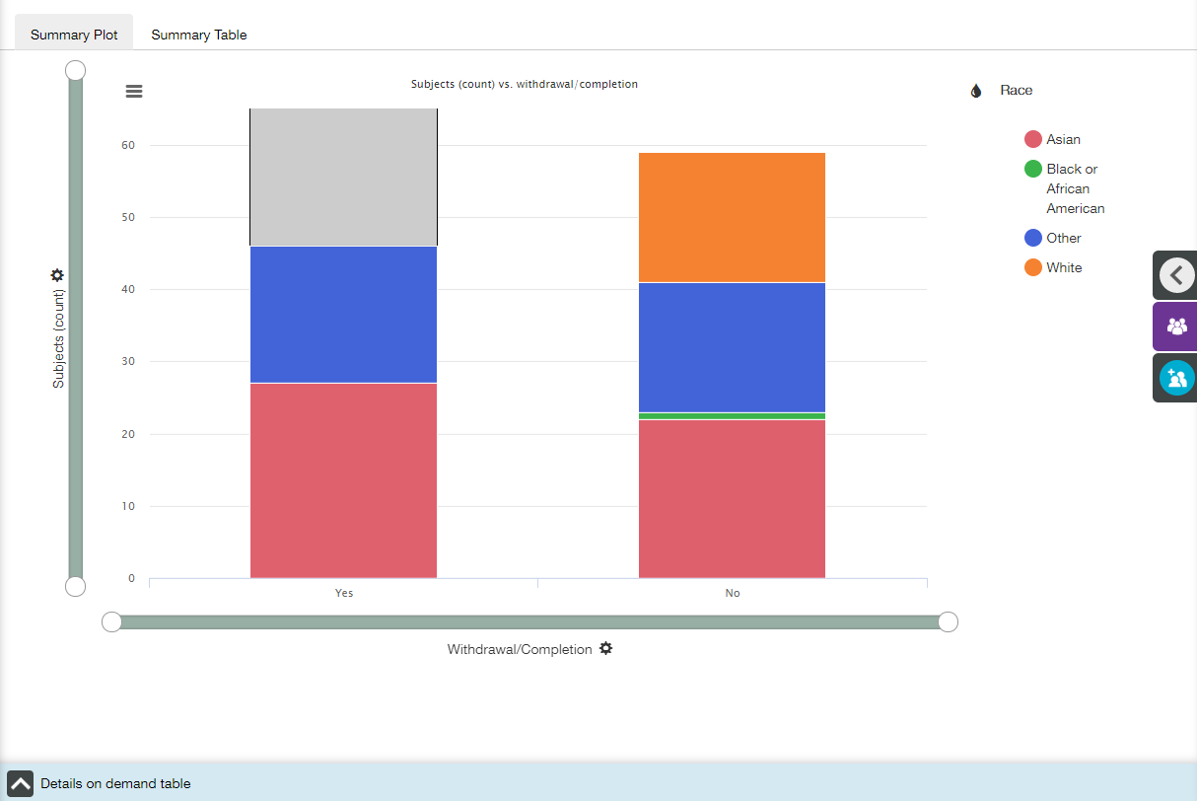

Main elements available on the Summary Plot tab are the following:

* Bar plot;
* X- and Y-axis zoom bars (see X and Y Axes Settings section);
* X- and Y-axis controls and titles (see X and Y Axes Settings section);
* Coloring control (see Coloring section);
* Chart context menu icon at the top left corner of the plot (see Chart Context Menu section);
* Details on Demand table at the bottom of the screen, collapsed by default (see Details on Demand Table section).

X axis

The title of the X-axis is **Withdrawal/Completion** by default.

Value of X-axis could be changed by choosing one of the options from dropdown list under the plot:

* All;
* Study ID;
* Study Name;
* Study Part ID;
* Duration on study;
* Randomisation date;
* Withdrawal/Completion;
* Reason for withdrawal;
* Center;
* Country;
* Sex;
* Race;
* Age;
* Weight;
* Height;
* First Treatment date;
* Death;
* Date of death.

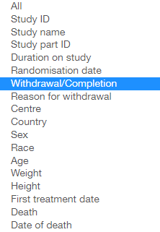

Y axis

The title of the Y-axis is **Subjects (count)** by default.

There are 3 options for Y-axis in dropdown list:

* Subjects (count);
* Subjects (percentage of total);
* Percentage of subjects, 100% stacked.

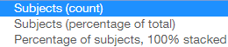

**Note**: “Percentage of total” is a percentage of subjects within the analysis that remain after population filters have been applied. “100% stacked” is a percentage of subjects shown on the X-axis category, such that each bar must add up to 100%.

**Note**: By default, Y-axis shows all subjects count and then scales correctly with zoom bar.

Coloring

**Country** value is default one if countries are mapped. Otherwise the default value is **Study ID**.

The following coloring options are available:

* All;
* Study ID;
* Study Name;
* Study Part ID;
* Duration on study;
* Randomisation date;
* Withdrawal/Completion;
* Reason for withdrawal;
* Center;
* Country;
* Sex;
* Race;
* Age;
* Weight;
* Height;
* First Treatment date;
* Death;
* Date of death;

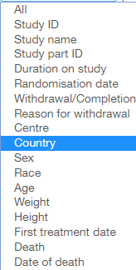

Tooltips

When a user hovers the cursor over a bar, the tooltip with the following fields is displayed:

* X-axis value;
* Y-axis value;
* Coloring option value.

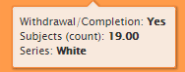

Details on Demand table

Details on Demand table contains only one tab with selected subjects’ data.

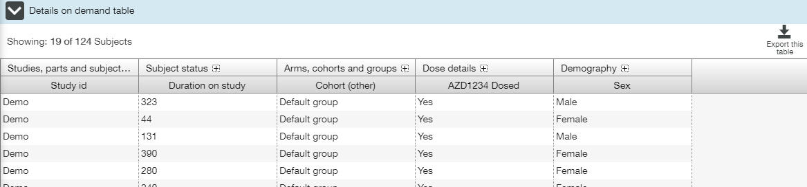

### Summary Table Tab

Summary Table tab contains a dynamic table with options aligned to the Summary Plot. The table displays precisely the same data values as in the Summary Plot.

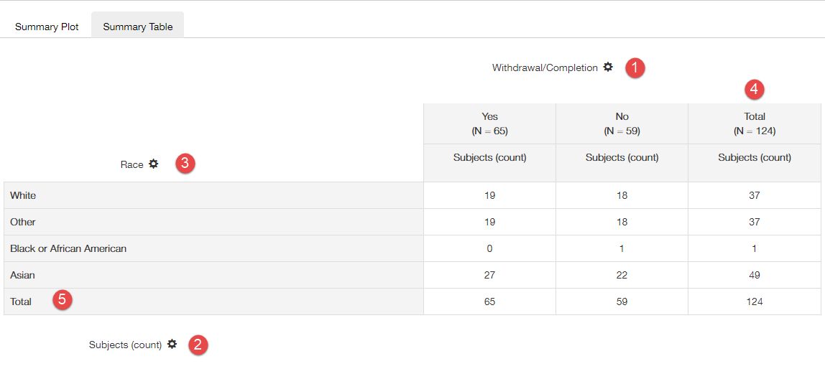

When a user changes options in the Summary Plot tab, this should be maintained in the table view (the state is equivalent). This means that the X-axis categories on the Summary plot are replicated in a column option selector  on the Summary table, Y options for number or percent of subjects are maintained in a value options selector on the table, color categories on the Summary plot are replicated in the row option selector on the Summary table.

**Total** column is present on the far right of the table that provides totals. For Subject (count) values, this is simply a sum of the column on that row values. For percentage option, this is the percent of the absolute total number of subjects (that remain after filtering) that occur in each row.

**Total** row is present at the bottom of the table that provides totals of the column values. For Subject (count) values, this is simply a sum of the rows in that column. For **Percent of subject** values this is the percent that the column total makes up of the absolute total number of subjects (that remain after filtering). For **Percent of subjects by column** values, this is the sum of the percentages in the column, which must add up to 100%.

## Dosing and Exposure View

**Dosing and Exposure view** allows a user to investigate some pharmacokinetic parameters.

Three tabs are available on the **Population Summary** view: **Analyte Concentration over Time**, **Dose Proportionality Exploration** and **PK-Response Exploration**.

The following elements are available for all tabs:

* Population filters (collapsed by default) in the right slide menu (see Population Filters section);
* Cohort filters (collapsed by default) in the right slide menu (see Cohort Filters section);
* Population filter widget (see Population Filters section);
* Event filter widget (see Event Filters section).

Additionally, specific Event filters and Settings panels are available for each tab.

### Analyte Concentration over Time Tab

**Analyte Concentration over Time** is the default tab. It provides a user with analyte concentration time dependence plot trellised by analyte (see **Trellised Plots** section for trellis description).

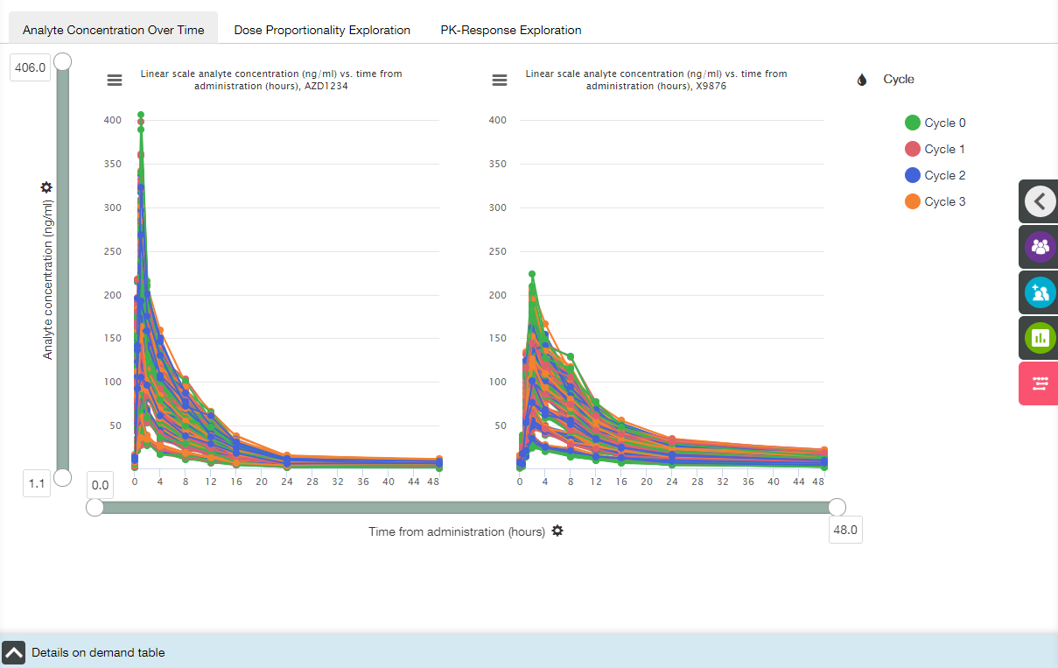

Main elements available on the Analyte Concentration over Time tab are the following:

* Trellised plots;
* X- and Y-axis zoom bars (see X and Y Axes Settings section);
* X- and Y-axis controls and titles (see X and Y Axes Settings section);
* Coloring control (see Coloring section);
* Chart context menu icons (see Chart Context Menu section);
* Details on Demand table at the bottom of the screen, collapsed by default (see Details on Demand Table section).

X axis

The title of the X-axis is **Time from administration**, and no other option is available.

Y axis

The default title of the Y-axis is **Analyte Concentration (ng/ml).** It changes to **Amean analyte Concentration (ng/ml)** automaticallyif any option other than **Not applied** is selected in the **Arithmetic Mean** section of **Analyte concentration settings** panel (see below).

Coloring

**Cycle** value is the default one. The following coloring options are available:

* Subject;
* Cycle;
* Nominal dose;
* Day;
* Visit.

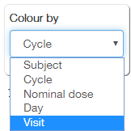

**Note**: Coloring value and appropriate legend changes in accordance with selected Analyte concentration settings and Analyte concentration filters (see below).

Tooltips

When a user hovers the cursor over a bar, the tooltip with some of the following fields is displayed:

* Subject ID: <value>;
* Y-axis value;
* Number of data points: <value>;
* Standard deviation: <value>;
* Cycle: <value>;
* Nominal dose: <value>;
* Visit: <value>;
* Day: <value>.

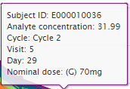

**Note**: Particular set of tooltip fields strongly depends on selected Analyte concentration settings (see below).

Analyte Concentration Filters

A user can apply the following filters to modify the plot:

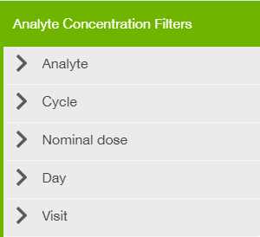

Analyte Concentration Settings

The following settings are available for the Analyte Concentration over Time plot:

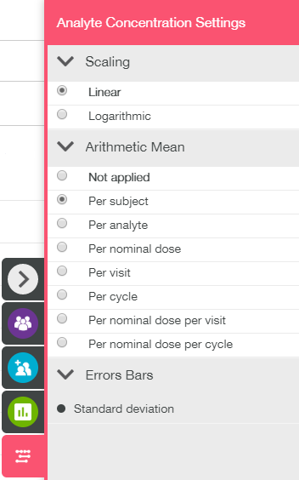

Details on Demand table

Details on Demand table contains two tabs: Analyte Concentration tab and Subjects tab.

Analyte Concentration tab:

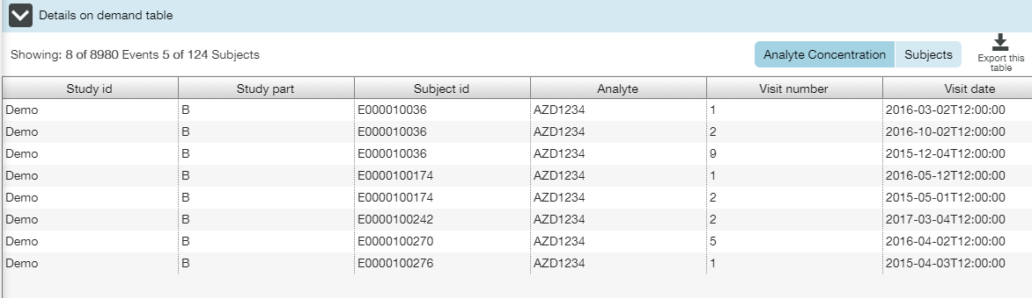

Subjects tab:

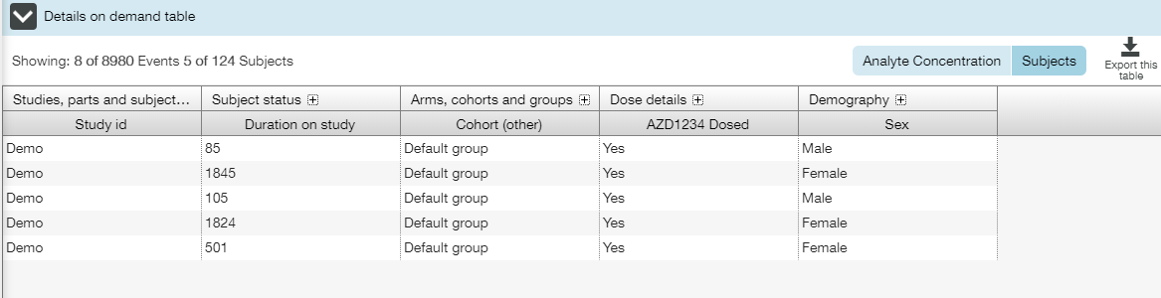

### Dose Proportionality Exploration Tab

**Dose Proportionality Exploration** tab allows a user to investigate concentration and duration of analytes in the patient's blood. The tab contains a set of appropriate box plots trellised by analyte (see **Trellised Plots** section for trellis description).

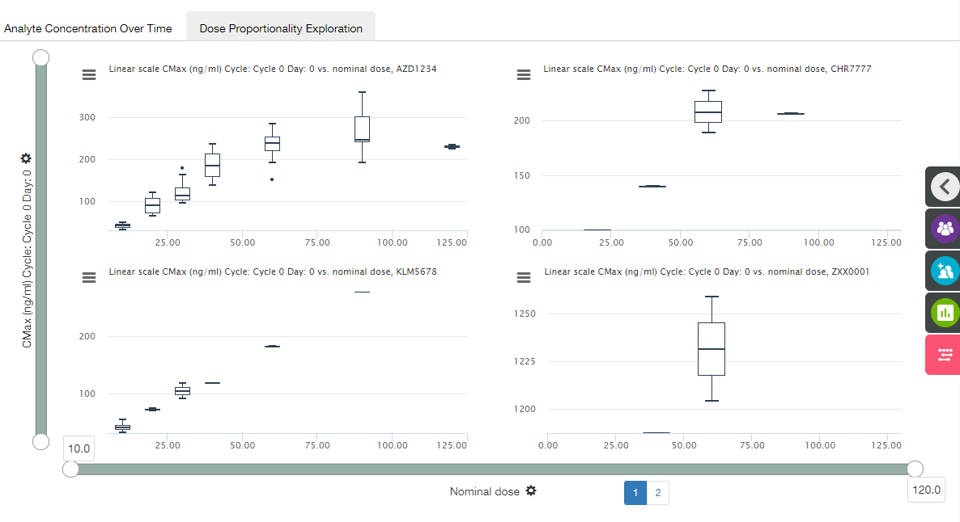

Main elements available on the Dose Proportionality Exploration tab are the following:

* Trellised boxplots;
* X- and Y-axis zoom bars (see X and Y Axes Settings section);
* X- and Y-axis controls and titles (see X and Y Axes Settings section);
* Chart context menu icons (see Chart Context Menu section);
* Details on Demand table at the bottom of the screen, collapsed by default (see Details on Demand Table section).

X axis

The title of the X-axis is **Nominal dose**, and no other option is available.

Y axis

The default title of the Y-axis is **CMax(ng/ml) Cycle: Cycle 0 Day: 0**. **Y** **Axis Settings** menu provides a user with the following settings:

* Parameter (CMax, CMin, TMax etc.);
* Cycle;
* Day.

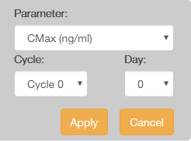

Tooltips

When a user hovers the cursor over a point, the tooltip with the following fields is displayed:

* X-axis value;
* Y-axis value;
* Subject ID: <value>.

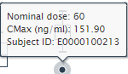

When a user hovers the cursor over a box, the tooltip with the following fields is displayed:

* X-axis value;
* Upper whisker: <value>;
* Upper quartile: <value>;
* Median: <value>;
* Lower quartile: <value>;
* Lower whisker: <value>;
* Sample size: <value>.

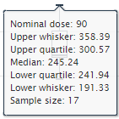

Dose Proportionality Filters

**Dose Proportionality Filters** panel allows a user to select analytes only.

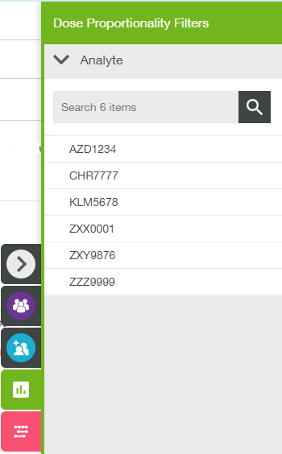

Dose Proportionality Settings

**Dose Proportionality Settings** panel allows a user to change plot scaling only.

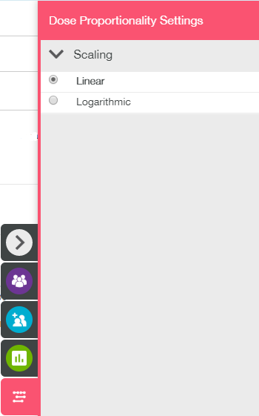

Details on Demand table

Details on Demand table contains two tabs: PK Parameters (Dose) tab and Subjects tab.

PK Parameters (Dose) tab:

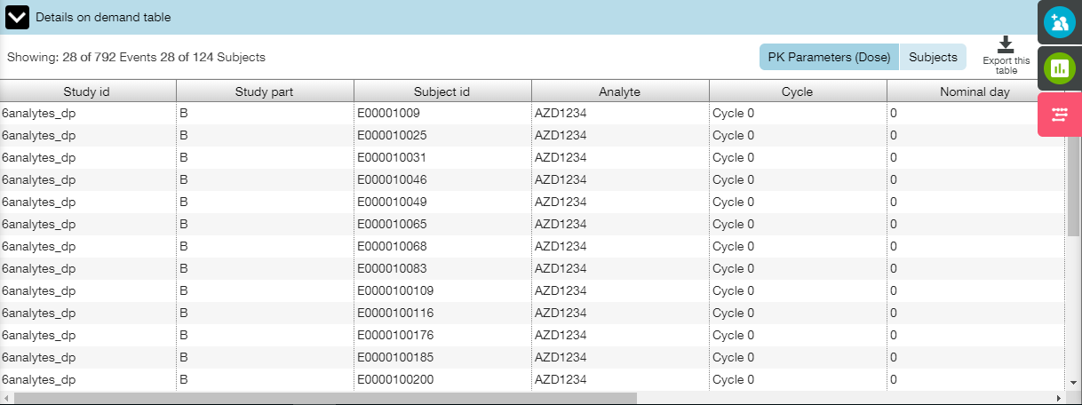

Subjects tab:

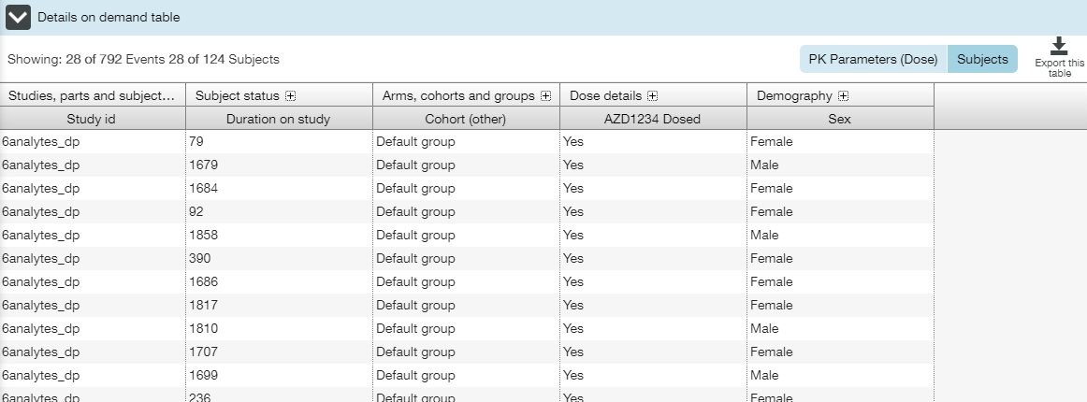

### PK-Response Exploration Tab

**PK Response Exploration** tab allows a user to investigate dependency between Stacked PK Results and RECIST Response (response to anticancer treatment).The tab contains a set of appropriate box plots trellised by analyte (see **Trellised Plots** section for trellis description).

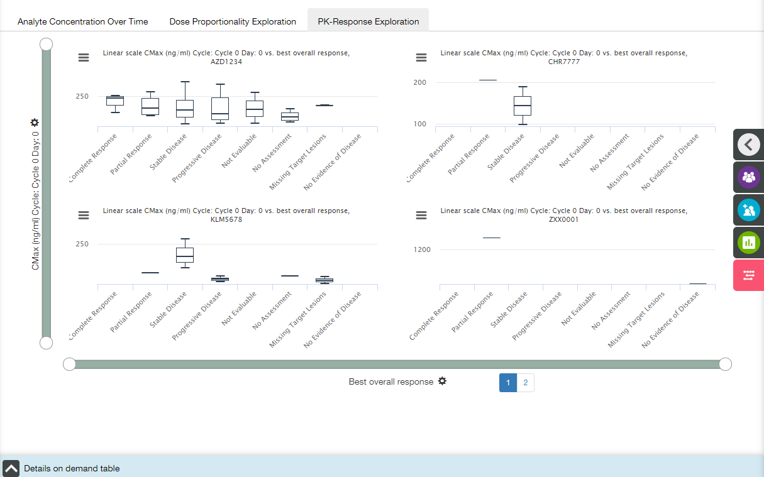

Main elements available on the PK-Response Exploration tab are the following:

* Trellised boxplots;
* X- and Y-axis zoom bars (see X and Y Axes Settings section);
* X- and Y-axis controls and titles (see X and Y Axes Settings section);
* Chart context menu icons (see Chart Context Menu section);
* Details on Demand table at the bottom of the screen, collapsed by default (see Details on Demand Table section).

X axis

The default title of the X-axis is **Best overall response.** **X Axis Settings** menu provides a user with the following settings:

* Best overall response;
* Overall response, week 0;
* Overall response, week 12;
* Overall response, week 18;
* …

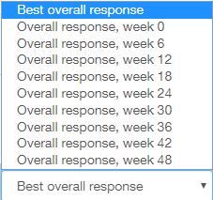

Y axis

The default title of the Y-axis is **CMax(ng/ml) Cycle: Cycle 0 Day: 0**. **Y** **Axis Settings** menu provides a user with the following settings:

* Parameter (CMax, CMin, TMax etc.);
* Cycle;
* Day.



Tooltips

When a user hovers the cursor over a box, the tooltip with the following fields is displayed:

* X-axis value;
* Upper whisker: <value>;
* Upper quartile: <value>;
* Median: <value>;
* Lower quartile: <value>;
* Lower whisker: <value>;
* Sample size: <value>.

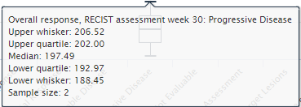

PK-Response Filters

**PK-Response Filters** panel allows a user to select analytes only.

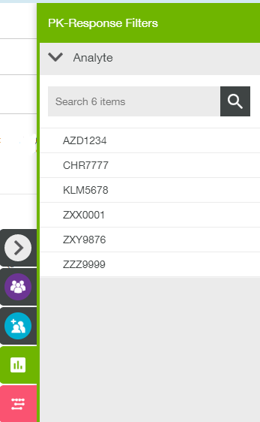

PK-Response Settings

**PK-Response Settings** panel allows a user to change plot scaling only.

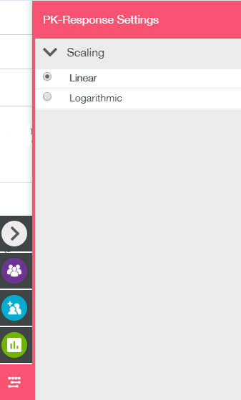

Details on Demand table

Details on Demand table contains three tabs: PK Parameters (Response) tab, RECIST tab and Subjects tab.

PK Parameters (Response) tab:

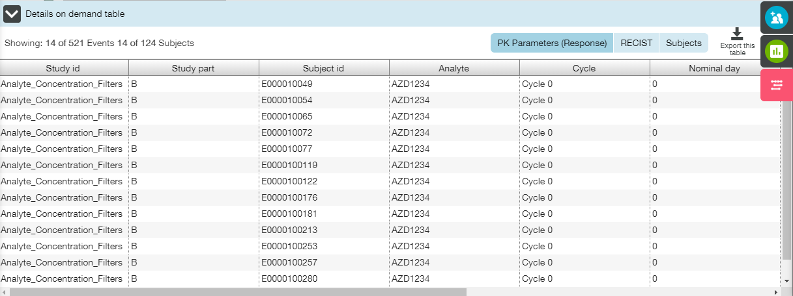

RECIST tab:

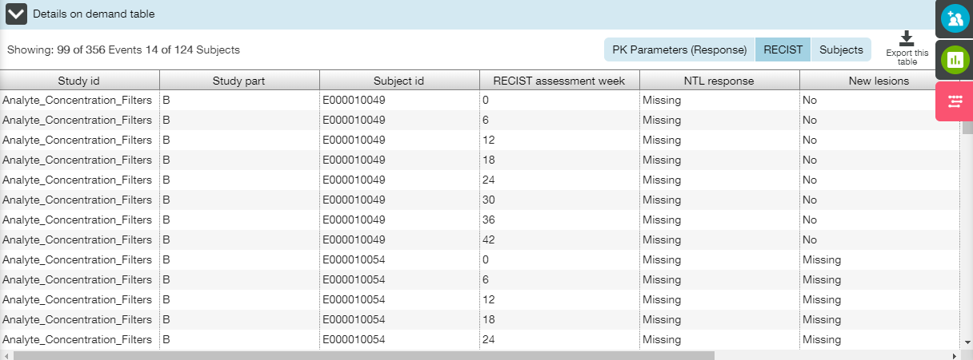

Subjects tab:

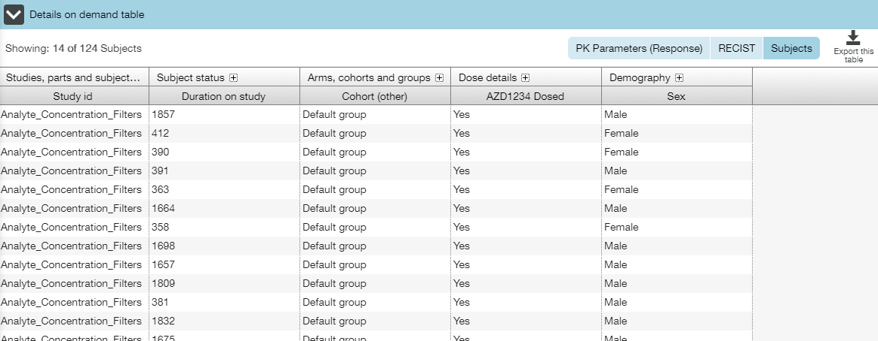

## Adverse Events View

**Adverse Events view** allows a user to investigate the adverse events that have been recorded for all subjects.

The following tabs are available on the **Adverse Events** view:

* AEs Subject Counts;
* AEs over Time;
* AEs Table;
* AE Summaries;
* AEs Chord Diagram;
* CI Event Counts;
* CI Events Over Time;
* Cerebrovascular Event Counts;
* Cerebrovascular Events Over Time;
* Additional CVOT Suspected Endpoint Counts;
* Additional Suspected CVOT Endpoints Over Time;

The following elements are available for all tabs but the AE Summaries tab:

* Population filters (collapsed by default) in the right slide menu (see Population Filters section);
* Cohort filters (collapsed by default) in the right slide menu (see Cohort Filters section);
* Population filter widget (see Population Filters section);
* Event filter widget (see Event Filters section).

Additionally, specific Events Filters and Settings panels are available for some tabs.

### AEs Subject Counts Tab

**AEs Subject Counts** tab provides a user with the bar plot that displays the counts and maximum recorded severity of each AE category for which an AE has been recorded. Adverse Events Subject Counts tab is visualized by the incidence rate and occurrence of each event (the entire set of adverse events for all subjects who received one or more dose of investigational product), grouped by the MedDRA dictionary terms and categorized by their grade of severity. It allows quick assimilation of what AE categories have the highest counts and also highlights relative frequencies of different AE severity (CTC grades).

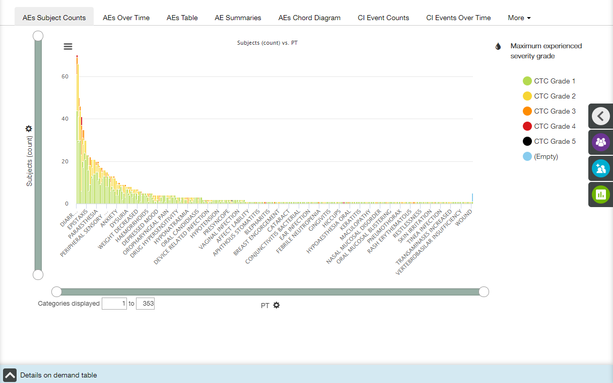

Bars in the plot are subdivided into colored-coded sections that represent different AE severity according to MedDRA CTC grades.

Main elements available on the AEs Subject Counts tab are the following:

* Bar plot;
* X- and Y-axis zoom bars (see X and Y Axes Settings section);
* X- and Y-axis controls and titles (see X and Y Axes Settings section);
* Coloring control (see Coloring section);
* Chart context menu icon (see Chart Context Menu section);
* Details on Demand table at the bottom of the screen, collapsed by default (see Details on Demand Table section).

X axis

The title of the X-axis is **PT** by default.

Value of X-axis could be changed by choosing one of the options from dropdown list under the plot:

* PT;
* HLT;
* SOC;
* Special interest group.

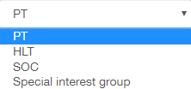

Y axis

The default title of the Y-axis is **Subjects (count)**. **Y** **Axis Settings** menu provides a user with the following settings:

* Y axis measure;
* Unit of measure.

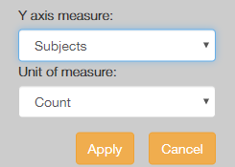 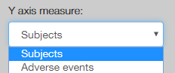 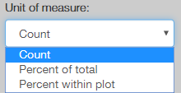

Coloring

Appropriate menu provides a user with two options:

* All;
* Maximum experienced severity grade (selected by default).

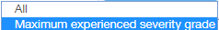

Tooltips

When a user hovers the cursor over a bar, the tooltip with the following fields is displayed:

* X-axis value;
* Y-axis value;
* Coloring option value.

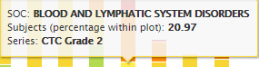

Adverse Event Filters

A user can apply Adverse Event filters to modify the plot.

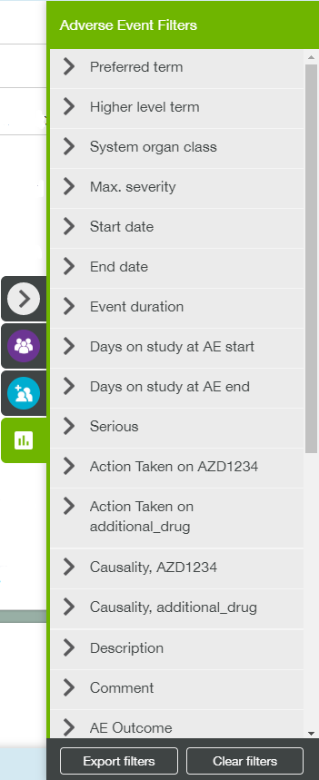

Details on Demand table

Details on Demand table contains two tabs: Adverse Events tab and Subjects tab.

Adverse Events tab:

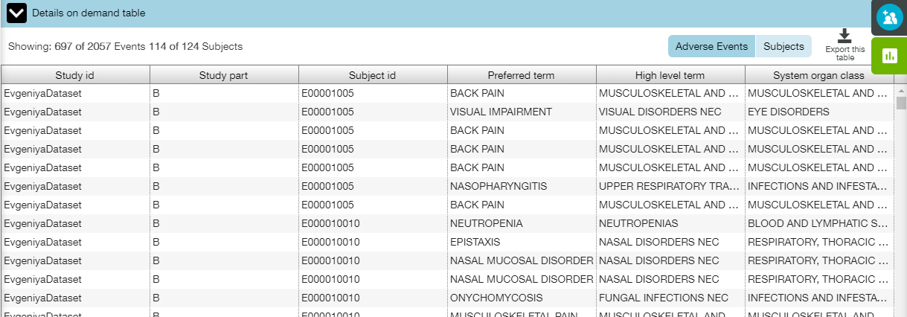

Subjects tab:

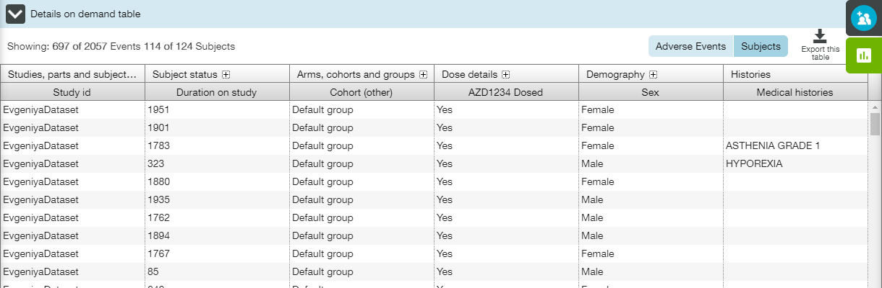

### AEs Over Time Tab

**AEs Over Time** tab provides a user with the bar plot that displays the counts and maximum severity of each recorded AE over the time.

The tab is visualized by the incidence rate and occurrence of each event (the entire set of adverse events for all subjects who received one or more dose of investigational product), categorized by their grade of severity. It allows quick assimilation of what AEs have the highest counts at a particular period of time and also highlights relative frequencies of different AE severity (CTC grades).

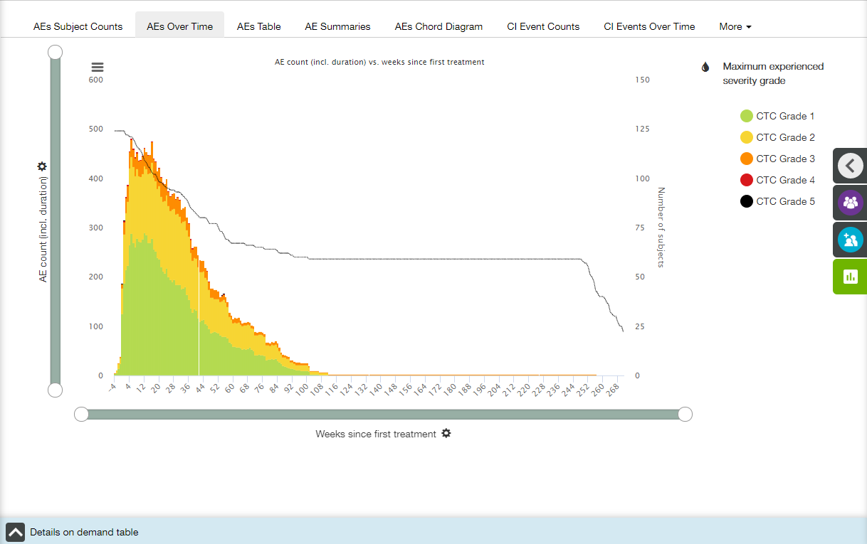

Main elements available on the AEs Over Time tab are the following:

* Bar plot;
* X- and Y-axis zoom bars (see X and Y Axes Settings section);
* X- and Y-axis controls and titles (see X and Y Axes Settings section);
* Z-axis title;
* Coloring control (see Coloring section);
* Chart context menu icon (see Chart Context Menu section);
* Details on Demand table at the bottom of the screen, collapsed by default (see Details on Demand Table section).

X axis

The title of the X-axis is **Weeks since first treatment** by default. X-axis has time binning (see Time Binning section for details).

Value of X-axis could be changed by choosing one of the options from dropdown list under the plot:

* Days since first treatment;
* Weeks since first treatment;
* Days since randomisation;
* Weeks since randomisation.

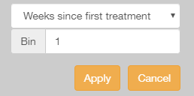 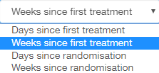

Y axis

The default title of the Y-axis is **AE count (incl. duration)**.

Value of Y-axis could be changed by choosing one of the options from dropdown list:

* AE count (incl. duration);
* AE count (start days only).

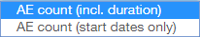

**Note**: “AE count (incl. duration)” option counts any given adverse event across all X axis categories in which the event was present. “AE count (start days only)’ option counts adverse events in the X category in which they started (according to the AE start date).

Z-axis

The plot includes a Z axis that is a single grey line that displays the total number of subjects on the study at the given point in time. The line isn't angled between data points but 'steps' downward each time a subject leaves. For points in time up to and including day zero (including negative values) the number of subjects is assumed to be equal to the number of subjects at day zero. Y zoom bar also affects the Z axis.

Coloring

Appropriate menu provides a user with two options:

* All;
* Maximum experienced severity grade (selected by default).



Tooltips

When a user hovers the cursor over a bar, the tooltip with the following fields is displayed:

* X-axis value;
* Z-axis value;
* Y-axis value for each coloring category.

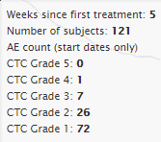

Adverse Event Filters

A user can apply Adverse Event filters to modify the plot.



Details on Demand table

Details on Demand table contains two tabs: Adverse Events tab and Subjects tab.

Adverse Events tab:

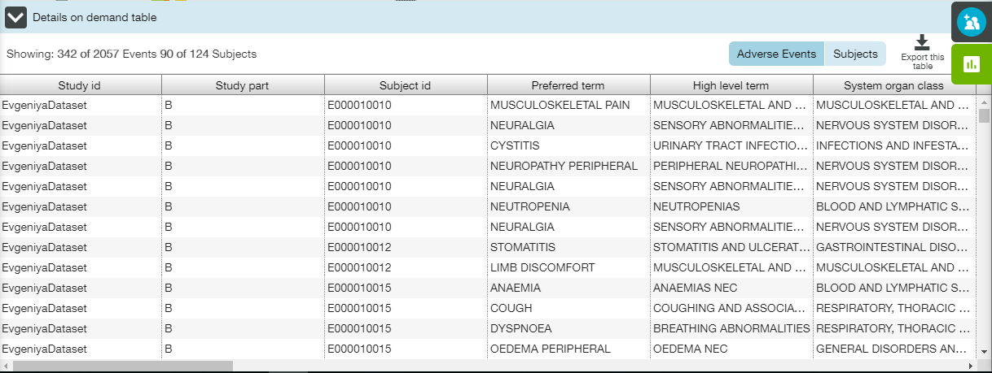

Subjects tab:

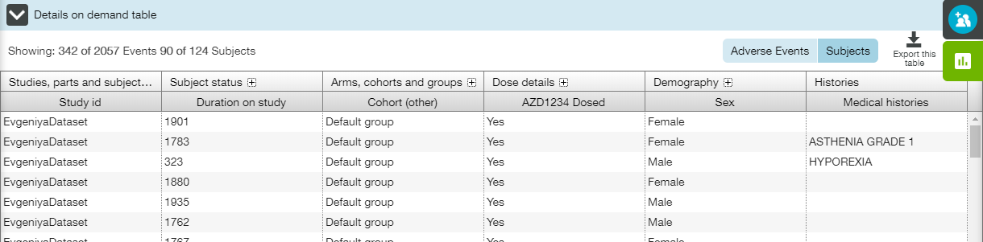

### AEs Table Tab

**AEs Table** tab provides a user with the table that shows counts and percentages of subjects who have experienced an AE at different severity levels. The tab allows quick understanding what % of subjects have experienced a given AE, or set of AEs.

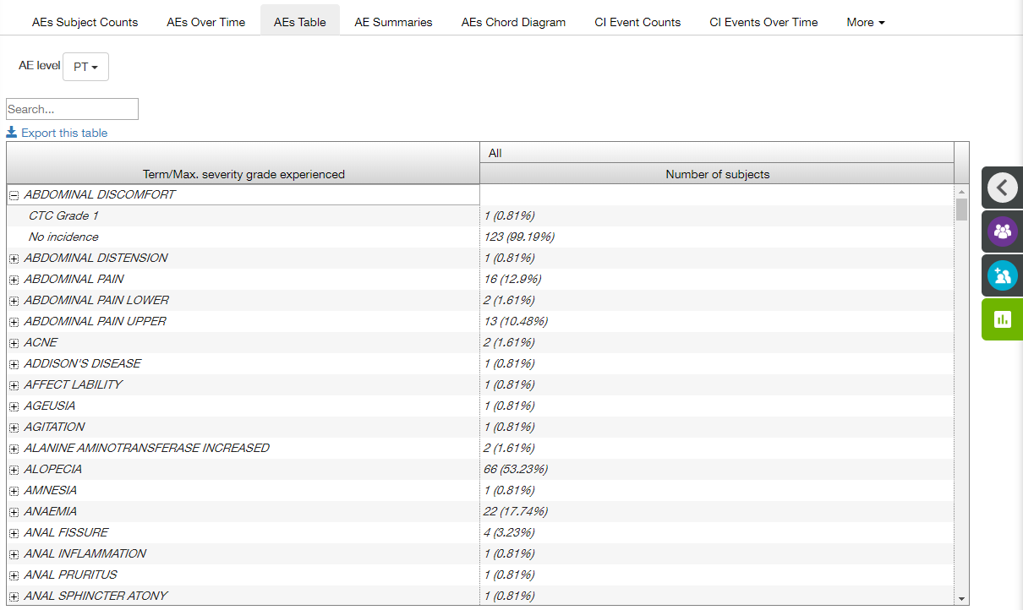

Main elements available on the AEs Table tab are the following:

* Table;
* **AE level** control;
* **Search** field;
* Export this table link.

Table contains the following columns:

* Term/Max. severity grade experienced;
* All (Number of subjects).

Data in the **Term** column is list of adverse events that correspond to the selected category. Once the Term is expanded, there is one result row per severity grade, plus one row for "No incidence" (counting subjects who have not experienced the AE category).

In some cases there are also rows where the severity grade column is empty, which are labelled "No severity grade recorded". In some cases there are empty terms with label "No term recorded".

Data in the **All** column is a count of subjects according to their maximum severity grade experienced (where an empty severity grade is lower than a grade 1).

**Note**: **Search** field could be used to search through AE terms and severity grades.

AE level dropdown list allows a user to select required AE level:

* PT;
* HLT;
* SOC;
* Special interest group.

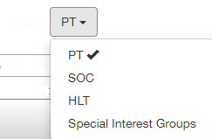

A user can click **Export this table** link in order to save the data locally as a .csv file. The following disclaimer appears:

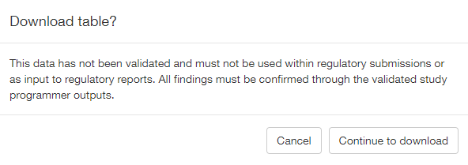

Click **Continue to download** button to proceed.

Adverse Events Filters

A user can apply Adverse Events filters to modify the table.



### AE Summaries Tab

AE Summaries tab allows a user to browse various AEs categories counts.

The tab comprises of four subtabs:

* Any Category;
* Most common AEs;
* AEs with outcome of death;
* SAEs leading to discontinuation of study treatment.

The following elements are available for all subtabs:

* “Total subjects dosed: <value>” row;
* Subtab description row;
* Export this table link;
* Table;
* **Note** section.

**Note**: Only those adverse events with an onset date on or after the date of first dose and up to and including 28 days following the date of last dose of study medication are considered in each of the AE Summaries tab.

#### Any Category Subtab

**Any Category** subtab is the default tab. It provides a user with the counts of each AE category for which an AE has been recorded.

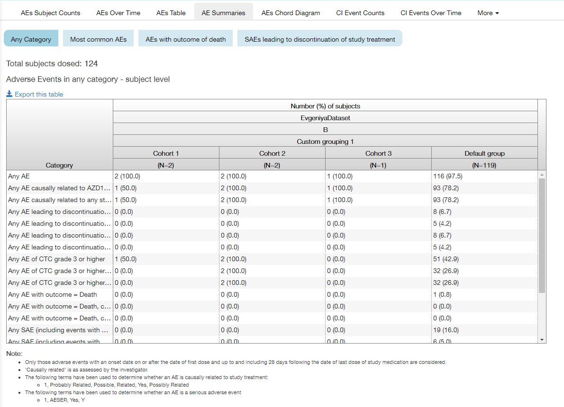

The table contains the following headers:

* Category;
* Number(%) of subjects.

Number(%) of subjects is divided by the following headers:

* Study ID;
* Study part;
* Grouping name;
* Subject group;
* Number of subjects dosed (N=<value>).

**Note**: Table contains values as number of patients and this number as a % of total number of patients dosed.

**Note**: Patients with multiple AE in the same AE category are counted once, e.g., for 'Any AE' category, if a subject has multiple AE, the subject is counted only once NOT one time for each AE.

#### Most Common AEs Subtab

**Most common AEs** subtab provides a user with the count of most common AEs.

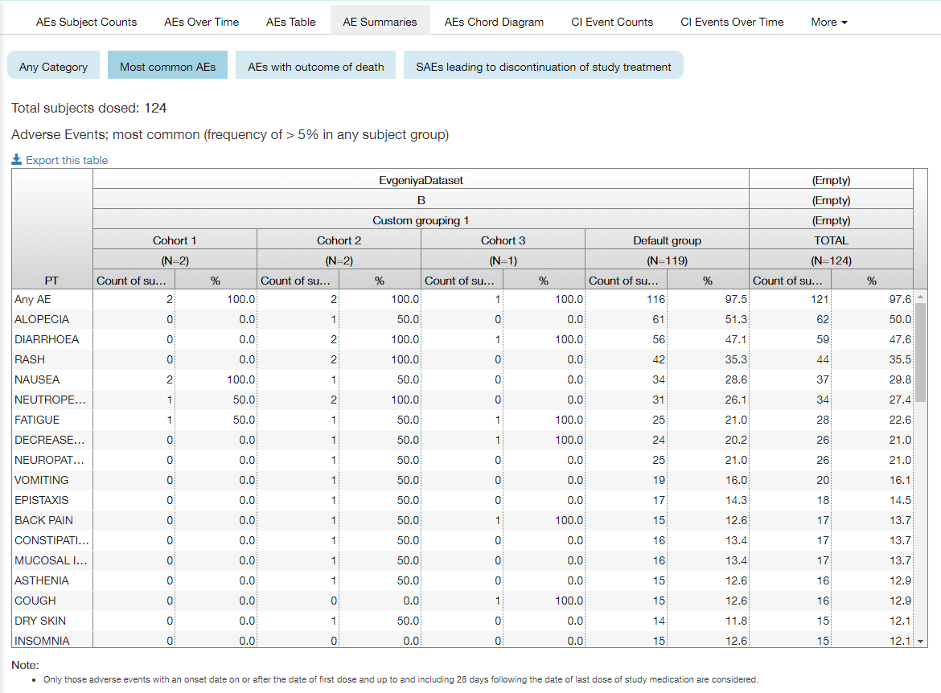

The table contains the following columns:

* PT;
* Subjects data;
* Total.

Subjects data column is divided by the following headers:

* Study ID;
* Study part;
* Grouping name;
* Subject group;
* Number of subjects dosed (N=<value>);
* Count of subjects;
* % of total number of patients dosed.

For each record in the study group, number of patients and % of total number of patients dosed are shown (the percentage is reported to 1 decimal place).

The table lists the most common AE where most common is defined as total frequency of >5% in any subject group - this means that if the AE does not occur for one subject group but has frequency of >5% in another subject group it will appear in the PT column.

The adverse events are sorted in decreasing frequency, by the total across the groups.

The MEDRA preferred term for AE is displayed.

The first row in the table is the number of subjects with any AE; this number matches that in the table of "Adverse Events in Any Category" subtab. If there are no subjects with any AE then only the first row in the table which will contain 0 is displayed.

#### AEs With Outcome Of Death Subtab

**AEs with outcome of death** subtab provides a user with the count of AEs with outcome of death.

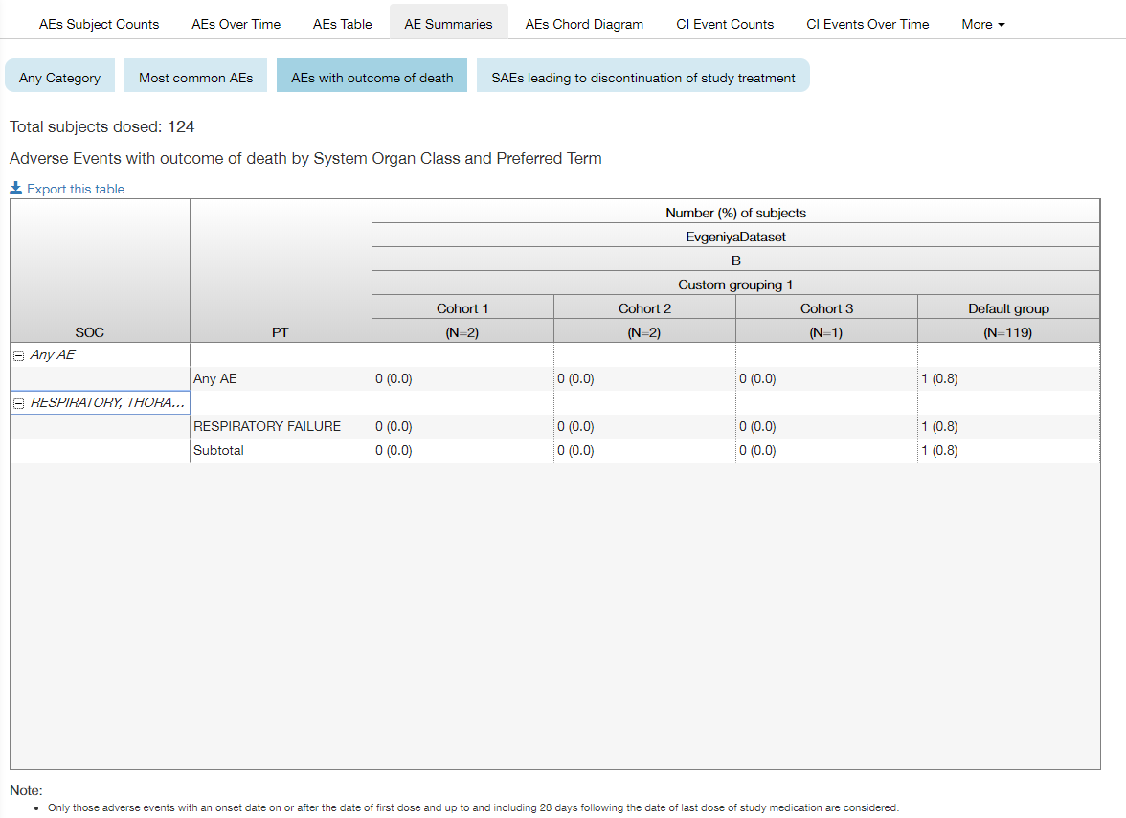

The table contains the following headers:

* SOC;
* PT;
* Number(%) of subjects.

Number(%) of subjects is divided by the following headers:

* Study ID;
* Study part;
* Grouping name;
* Subject group;
* Number of subjects dosed (N=<value>).

Table contains values as number of patients and this number as a % of total number of patients dosed (percentages are displayed to 1 decimal place).

The records are sorted by SOC (in alphabetical order) and within that, alphabetically by preferred term.

The first row in the table is the number of subjects with an AE with outcome of death; this number is consistent with that in the table of "Adverse Events in Any Category" subtab. If there are no subjects with AE leading to outcome of death then only see the first row in the table which will contain 0.

#### SAEs Leading To Discontinuation Of Study Treatment Subtab

SAEs leading to discontinuation of study treatment subtab provides a user with the count of Serious Adverse Events leading to discontinuation.

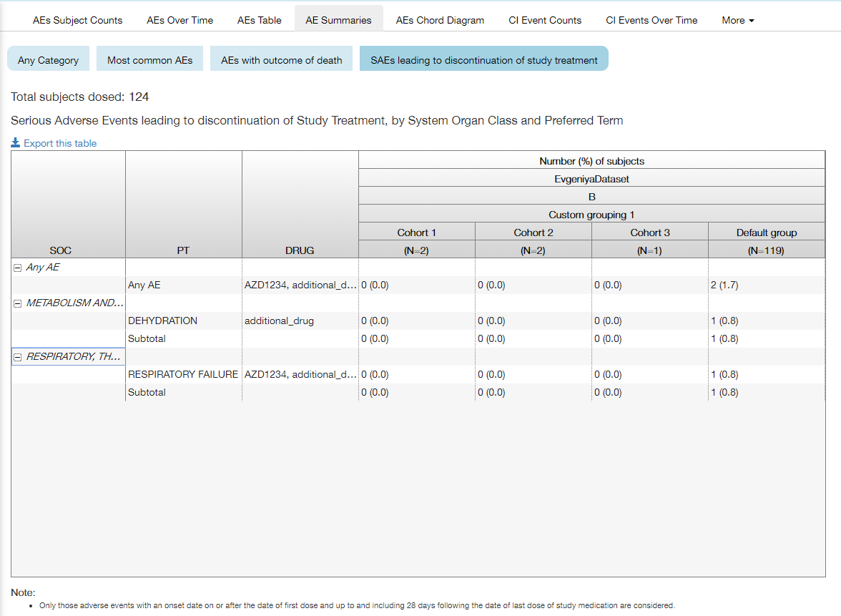

The table contains the following headers:

* SOC;
* PT;
* DRUG;
* Number (%) of subjects.

Number (%) of subjects is divided by the following headers:

* Study ID;
* Study part;
* Grouping name;
* Subject group;
* Number of subjects dosed (N=<value>).

Table contains values as number of patients and this number as a % of total number of patients dosed (percentages are displayed to 1 decimal place).

The records are sorted by SOC (in alphabetical order) and within that, alphabetically by preferred term.

The first row in the table is the number of subjects with a SAE which led to discontinuation; this number is consistent with that in the table of "Adverse Events in Any Category" subtab. If there are no subjects with SAE leading to discontinuation of study treatment then only first row in the table which will contain 0 will be present.

### AEs Chord Diagram Tab

**AEs Chord Diagram** tab provides a user with the chord diagram that displays co-occurring adverse events.

**Note**: A chord diagram is a graphical method of displaying the inter-relationships between data in a matrix. The data are arranged radially around a circle with the relationships between the data points typically drawn as arcs connecting the data. See more detailed description below.

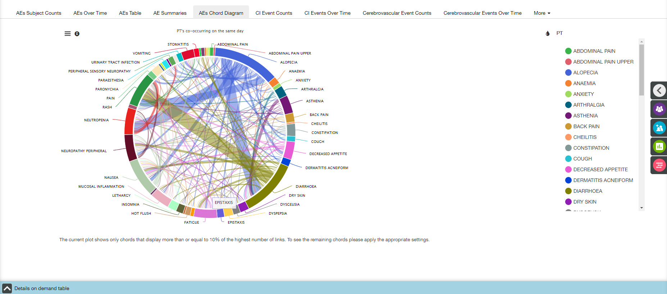

Main elements available on the AEs Chord Diagram tab are the following:

* Chord diagram;
* Diagram title (above the diagram);
* Note (under the diagram);
* Coloring control (see Coloring section);
* Chart context menu icon (see Chart Context Menu section);
* Information icon besides the Chart context menu icon;
* Details on Demand table at the bottom of the screen, collapsed by default (see Details on Demand Table section).

Information icon

When a user clicks the information icon , the following pop-up with chord diagram description appears:

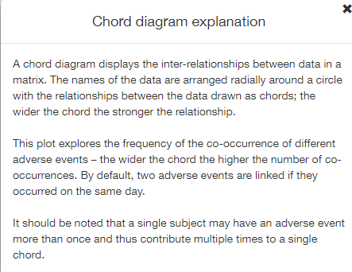

Coloring

Appropriate menu does not allow a user to change the coloring. The diagram is colored in accordance with AE term level items, and the term level can be changed on **AEs Chord Diagrams Settings** panel.

Tooltips

When a user hovers the cursor over a chord, the tooltip with the following fields is displayed:

* <FIRST EVENT> to <SECOND EVENT>;
* Number of incidence: <value>;
* Subjects affected and # times affected:
* <SUBJECT ID> x <# TIMES> list.

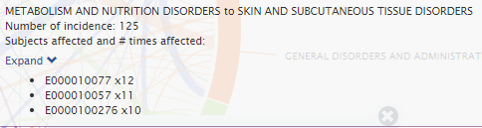

List of affected subjects can be expanded and collapsed.

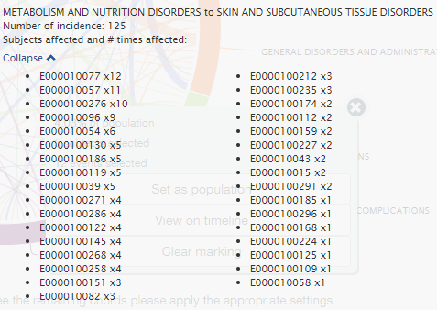

Adverse Events Filters

A user can apply Adverse Events filters to modify the plot.



AEs Chord Diagrams Settings

**AEs Chord Diagrams Settings** panel allows a user to change:

* Term level;
* Number of days between linked AEs;
* % of the links with the highest number of links.

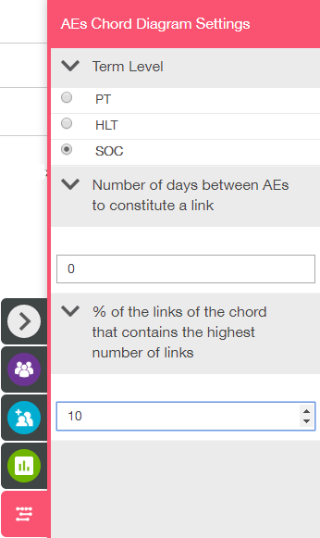

**Note**: Diagram title placed above the diagram describes selected term level and number of days between linked AEs. Note placed under the diagram describes selected % of the links.

Details on Demand table

Details on Demand table contains two tabs: Linked Adverse Events tab and Subjects tab.

Linked Adverse Events tab:

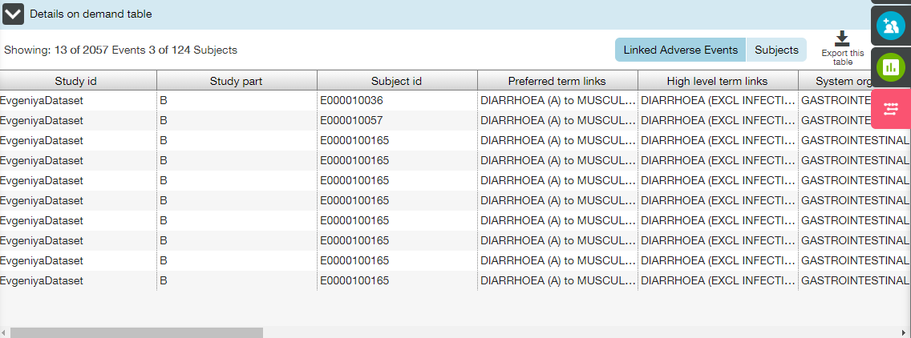

Subjects tab:

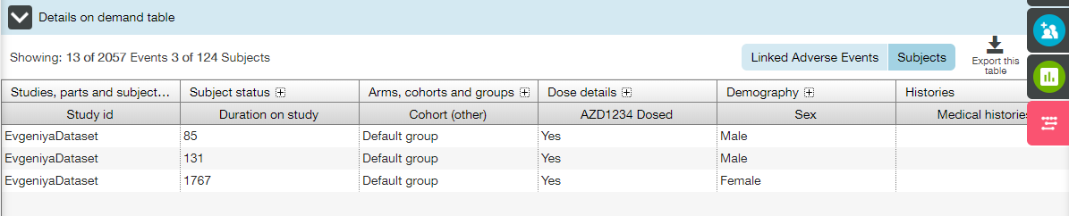

### CI Event Counts Tab

**CI Event Counts** tab displays the count of subject or Cardiac Ischemic (CI) events related to specific CI event category.

CI Events plot is visualized by the incidence rate and occurrence of each event (the entire set of CI adverse events for all subjects who received one or more dose of investigational product). It allows quick assimilation of what CI event categories have the highest counts and also highlights relative frequencies of different CI events.

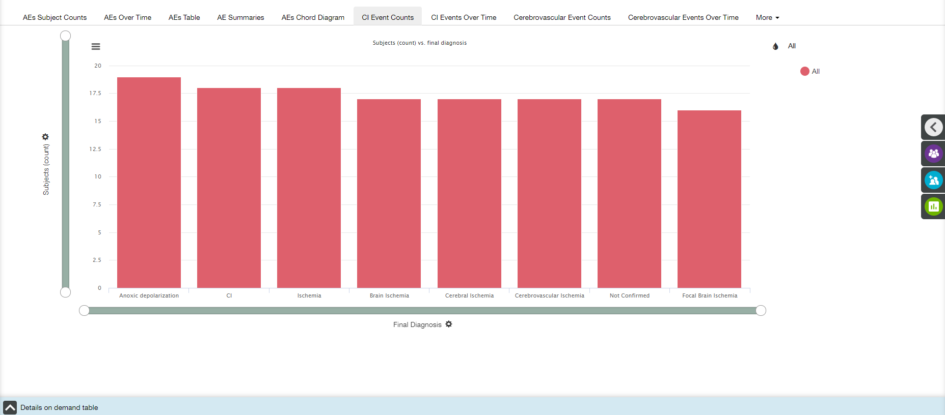

Main elements available on the CI Event Counts tab are the following:

* Bar plot;
* X- and Y-axis zoom bars (see X and Y Axes Settings section);
* X- and Y-axis controls and titles (see X and Y Axes Settings section);
* Coloring control (see Coloring section);
* Chart context menu icon (see Chart Context Menu section);
* Details on Demand table at the bottom of the screen, collapsed by default (see Details on Demand Table section).

X axis

The title of the X-axis is **Final Diagnosis** by default.

Value of X-axis could be changed by choosing one of the options from dropdown list under the plot:

* Final Diagnosis;
* Ischemic Symptoms;
* Duration of CIE Symptoms;
* Did the Symptoms Prompt an Uns. Hosp.;
* Event Susp. to be Due to Stent Thromb.;
* Previous ECG Before Event Available;
* ECG at the Time of the Event;
* Were Local Cardiac Biomarkers Drawn;
* Coronary Angiography Performed.

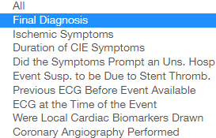

Y axis

The default title of the Y-axis is **Subjects (count)**. **Y** **Axis Settings** menu provides a user with the following settings:

* Y axis measure;
* Unit of measure.

 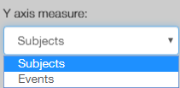 

Coloring

Appropriate menu provides a user with the following options:

* All (selected by default);
* Final Diagnosis;
* Ischemic Symptoms;
* Duration of CIE Symptoms;
* Did the Symptoms Prompt an Uns. Hosp.;
* Event Susp. to be Due to Stent Thromb.;
* Previous ECG Before Event Available;
* ECG at the Time of the Event;
* Were Local Cardiac Biomarkers Drawn;
* Coronary Angiography Performed.

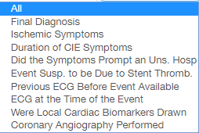

Tooltips

When a user hovers the cursor over a bar, the tooltip with the following fields is displayed:

* X-axis value
* Y-axis value;
* Coloring option value.

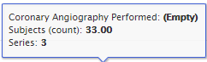

CI Event Filters

A user can apply CI Events filters to modify the plot.

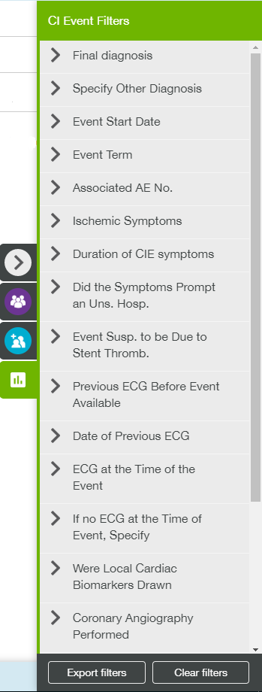

Details on Demand table

Details on Demand table contains two tabs: CI Events tab and Subjects tab.

CI Events tab:

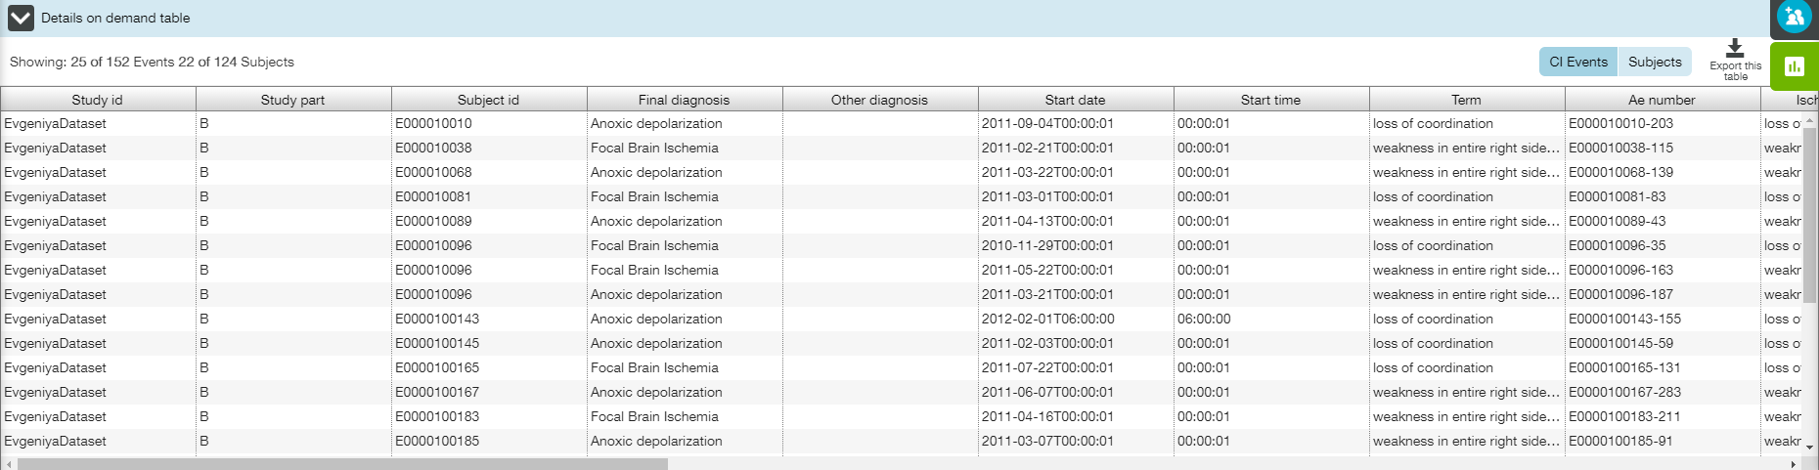

Subjects tab:

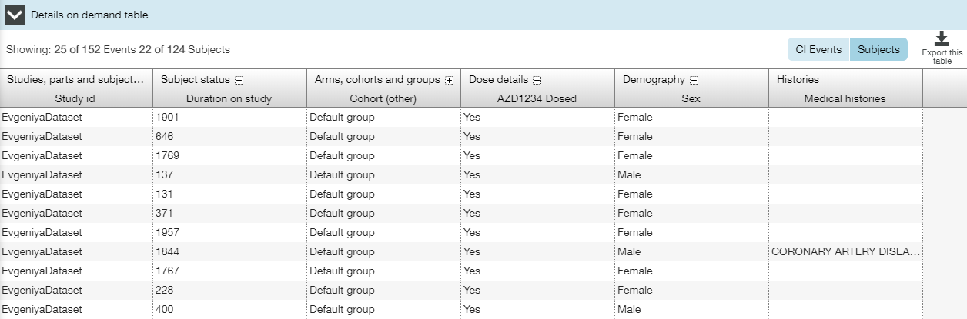

#### View Linked AEs

When a user selects an area, the selected area is highlighted and popup menu appears with the following data:

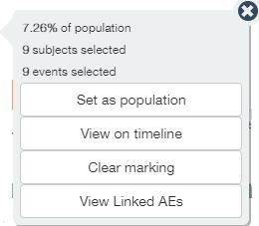

Additional option (as compared to typical pop-up menu) **View Linked AEs** is provided to a user.

AE may be associated with multiple CI events. **View linked AEs** is the link between CI Events and AEs, so that a user can filter and jump to AEs on the basis of selected CI events.

When a user clicks **View linked AEs** button, **AEs Subject Counts** tab of the **Adverse Events** view is opened. Only those AEs that are linked to the given CI Events through the presence of AE number fields within both the AE data and the CI Event data are displayed. Not all AEs will be associated to a CI Event and it's not necessarily the case that every CI event have an associated AE record.

AE filter widget on the top of the **AEs Subject Counts** page describes that the set of AEs have been limited based on an AE number.

**Note**: Click the tag to view the list of appropriate subject id’s followed by AE numbers (‘E0000100130-1’ means that subject id is E0000100130, and AE number is 1).

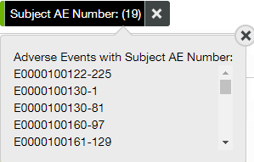

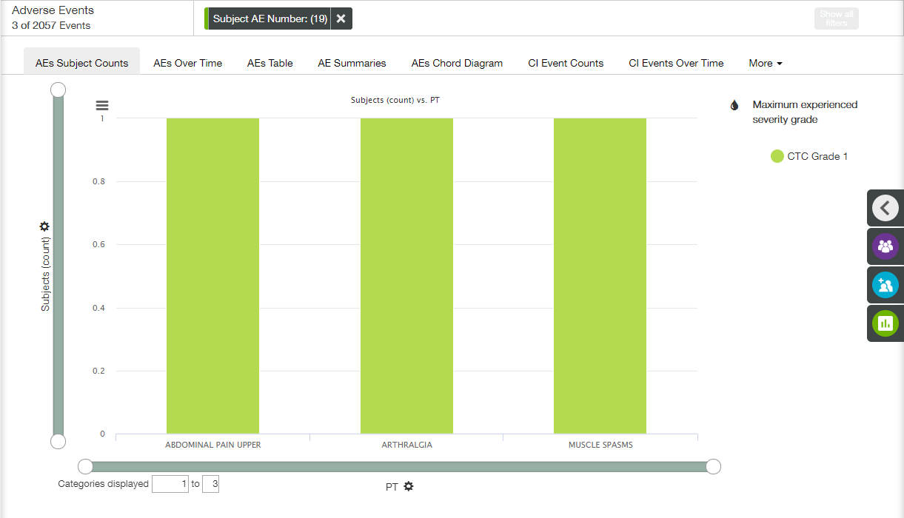

### CI Events Over Time Tab

**CI Event Over Time** tab displays the Cardiac Ischemic (CI) events count over time.

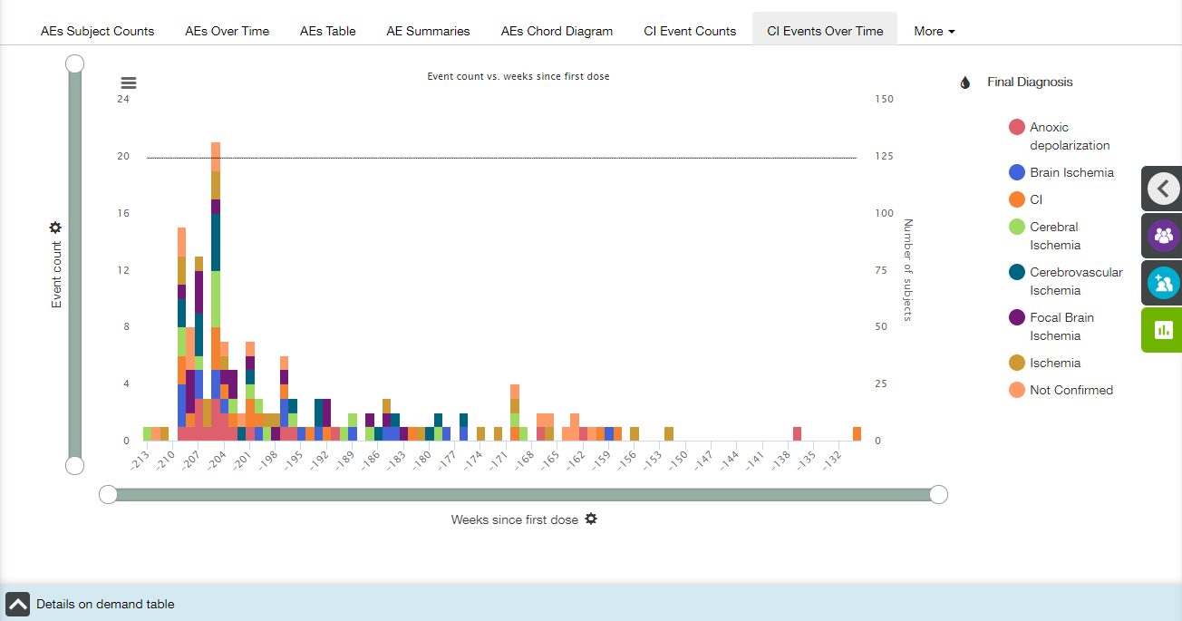

Main elements available on the CI Events Over Time tab are the following:

* Bar plot;
* X- and Y-axis zoom bars (see X and Y Axes Settings section);
* X- and Y-axis controls and titles (see X and Y Axes Settings section);
* Z-axis title;
* Coloring control (see Coloring section);
* Chart context menu icon (see Chart Context Menu section);
* Details on Demand table at the bottom of the screen, collapsed by default (see Details on Demand Table section).

X axis

The title of the X-axis is **Weeks since first dose** by default.  X axis has time binning (see Time Binning section for details).

Value of X-axis could be changed by choosing one of the options from dropdown list under the plot:

* Days since first dose;
* Weeks since first dose;
* Days since randomisation;
* Weeks since randomisation;
* Days since first dose of drug;
* Weeks since first dose of drug.

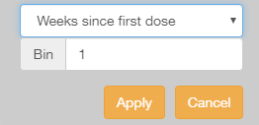 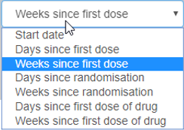

Y axis

The title of the Y-axis is **Event count**, and no other option is available.

Z-axis

The plot includes a Z axis that is a single grey line that displays the total number of subjects on the study at the given point in time.

The line isn't angled between data points but 'steps' downward each time a subject leaves, as in the example. For points in time up to and including day zero (including negative values) the number of subjects is assumed to be equal to the number of subjects at day zero.

Y zoom bar also affects the Z axis.

Coloring

Appropriate menu provides a user with the following options:

* All (selected by default);
* Final Diagnosis;
* Ischemic Symptoms;
* Duration of CIE Symptoms;
* Did the Symptoms Prompt an Uns. Hosp.;
* Event Susp. to be Due to Stent Thromb.;
* Previous ECG Before Event Available;
* ECG at the Time of the Event;
* Were Local Cardiac Biomarkers Drawn;
* Coronary Angiography Performed.



Tooltips

When a user hovers the cursor over a bar, the tooltip with the following fields is displayed:

* X-axis value;
* Z-axis value;
* Y-axis value for each coloring category.

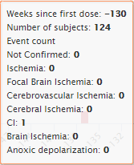

CI Event Filters

A user can apply CI Events filters to modify the plot.



Details on Demand table

Details on Demand table contains two tabs: CI Events tab and Subjects tab.

CI Events tab:

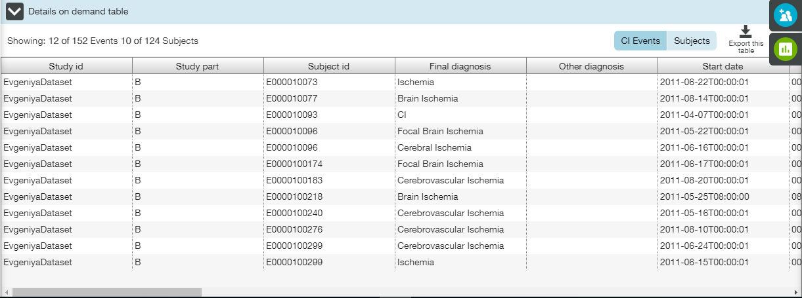

Subjects tab:

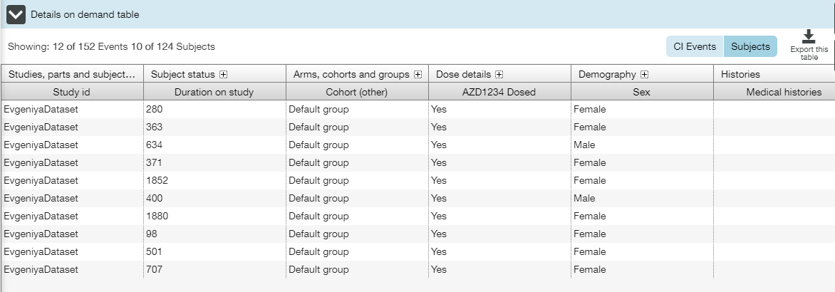

#### View Linked AEs

When a user selects an area, the selected area is highlighted and popup menu appears with the following data:



Additional option (as compared to typical pop-up menu) **View Linked AEs** is provided to a user.

AE may be associated with multiple CI events. **View linked AEs** is the link between CI Events and AEs, so that a user can filter and jump to AEs on the basis of selecting CI events.

When a user clicks **View linked AEs**, **AE Counts** tab of the **Adverse Events** view is opened. Only those AEs that are linked to the given CI Events through the presence of AE number fields within both the AE data and the CI Event data are displayed. Not all AEs will be associated to a CI Event and it's not necessarily the case that every CI event have an associated AE record.

AE filter widget on the top of the page describes that the set of AEs have been limited based on an AE number.

**Note**: Click the tag to view the list of appropriate subject id’s followed by AE numbers (‘E0000100130-1’ means that subject id is E0000100130, and AE number is 1).



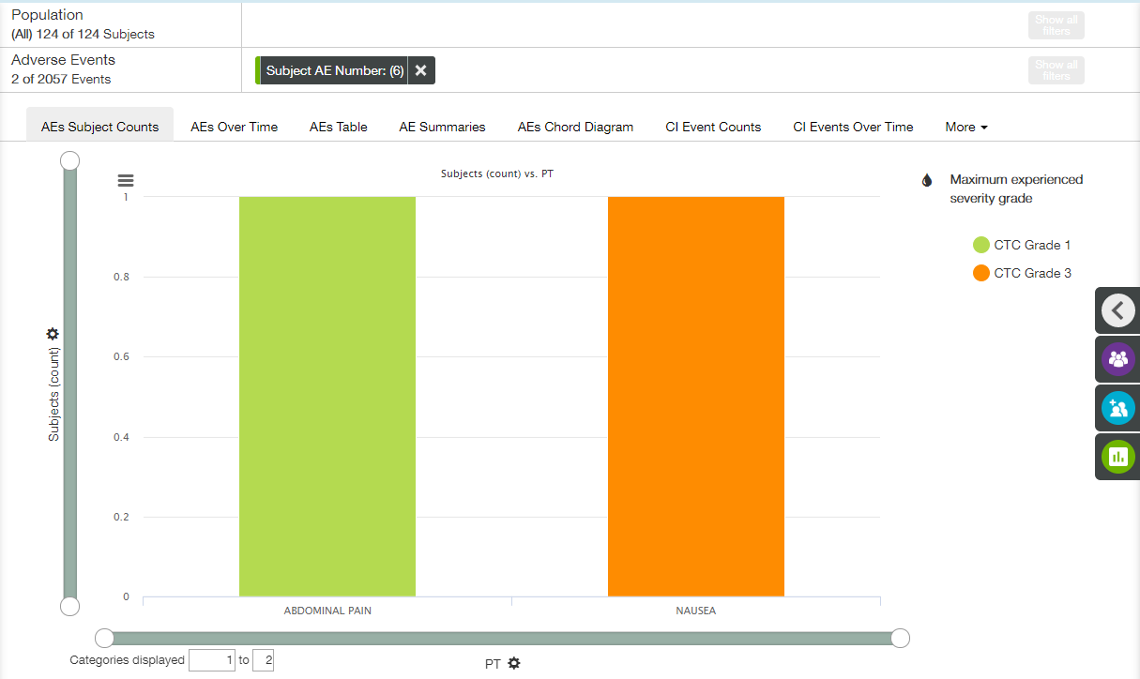

### Cerebrovascular Event Counts Tab

**Cerebrovascular Event Counts** tab displays the count of subject or Cerebrovascular events related to specific Cerebrovascular event category.

Cerebrovascular Events plot is visualized by the incidence rate and occurrence of each event (the entire set of cerebrovascular events for all subjects who received one or more dose of investigational product). It allows quick assimilation of what Cerebrovascular event categories have the highest counts and also highlights relative frequencies of different Cerebrovascular events.

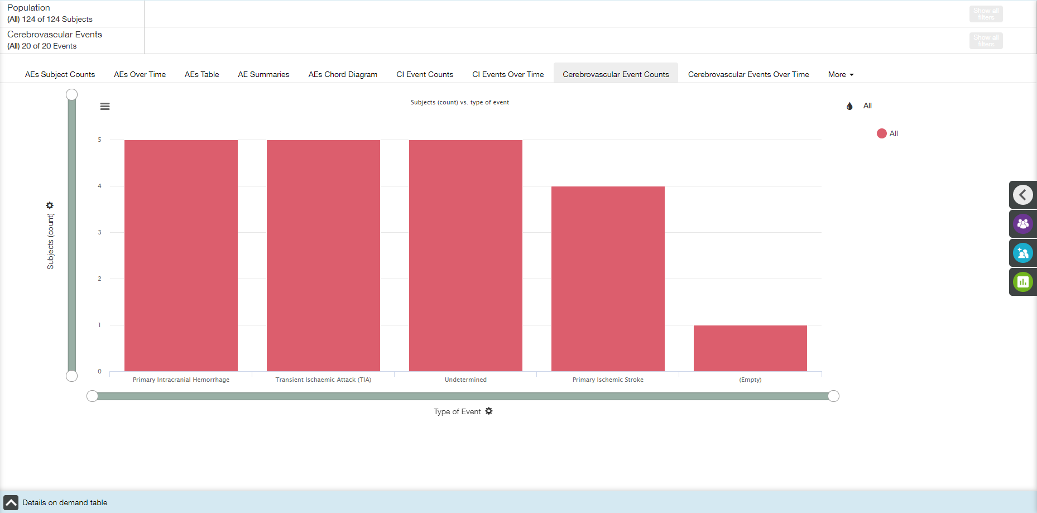

Main elements available on the Cerebrovascular Event Counts tab are the following:

* Bar plot;
* X- and Y-axis zoom bars (see X and Y Axes Settings section);
* X- and Y-axis controls and titles (see X and Y Axes Settings section);
* Coloring control (see Coloring section);
* Chart context menu icon (see Chart Context Menu section);
* Details on Demand table at the bottom of the screen, collapsed by default (see Details on Demand Table section).

X axis

The title of the X-axis is **Type of Event** by default.

Value of X-axis could be changed by choosing one of the options from dropdown list under the plot:

* All;
* Type of Event;
* If Primary Ischemic Stroke;
* If Traumatic.

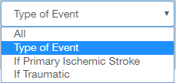

Y axis

The default title of the Y-axis is **Subjects (count)**. **Y** **Axis Settings** menu provides a user with the following settings:

* Y axis measure;
* Unit of measure.

  

Coloring

Appropriate menu provides a user with the following options:

* All (selected by default);
* Type of Event;
* If Primary Ischemic Stroke;
* If Traumatic.

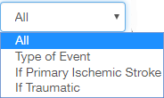

Tooltips

When a user hovers the cursor over a bar, the tooltip with the following fields is displayed:

* X-axis value;
* Y-axis value;
* Coloring option value.

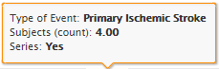

Cerebrovascular Events Filters

A user can apply Cerebrovascular Events filters to modify the plot.

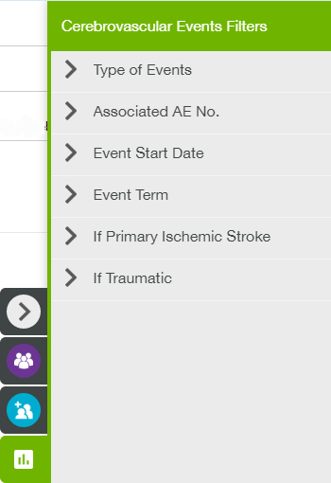

Details on Demand table

Details on Demand table contains two tabs: Cerebrovascular Events tab and Subjects tab.

Cerebrovascular Events tab:

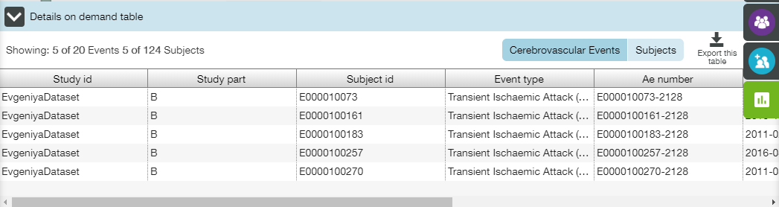

Subjects tab:

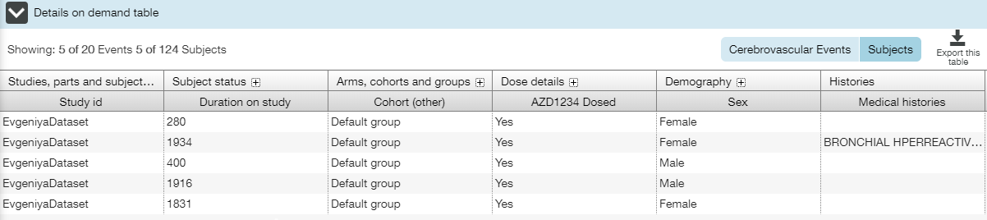

#### View Linked AEs

When a user selects an area, the selected area is highlighted and popup menu appears with the following data:



Additional option (as compared to typical pop-up menu) **View Linked AEs** is provided to a user.

AE may be associated with multiple Cerebrovascular events. **View linked AEs** is the link between Cerebrovascular Events and AEs, so that a user can filter and jump to AEs on the basis of selected Cerebrovascular events.

When a user clicks **View linked AEs** button, **AEs Subject Counts** tab of the **Adverse Events** view is opened. Only those AEs that are linked to the given Cerebrovascular Events through the presence of AE number fields within both the AE data and the Cerebrovascular Event data are displayed. Not all AEs will be associated to a Cerebrovascular Event and it's not necessarily the case that every Cerebrovascular event have an associated AE record.

AE filter widget on the top of the **AEs Subject Counts** page describes that the set of AEs have been limited based on an AE number.

**Note**: Click the tag to view the list of appropriate subject id’s followed by AE numbers (‘E0000100130-1’ means that subject id is E0000100130, and AE number is 1).



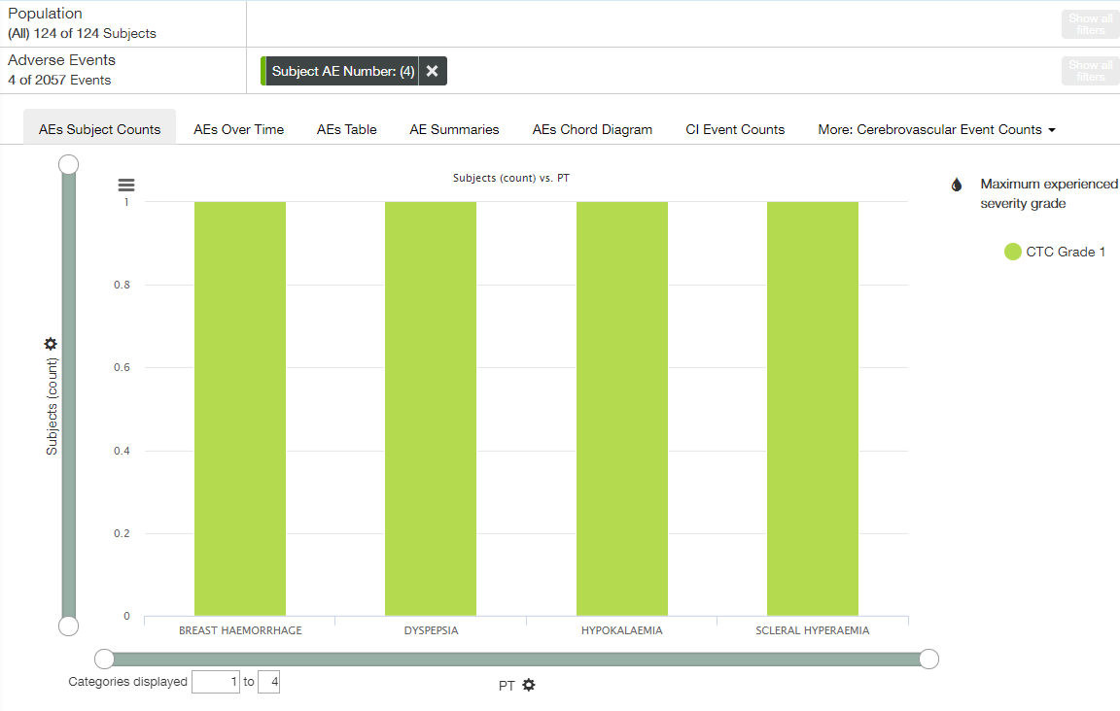

### Cerebrovascular Events Over Time Tab

**Cerebrovascular Events Over Time** tab displays the Cerebrovascular Events count over time.

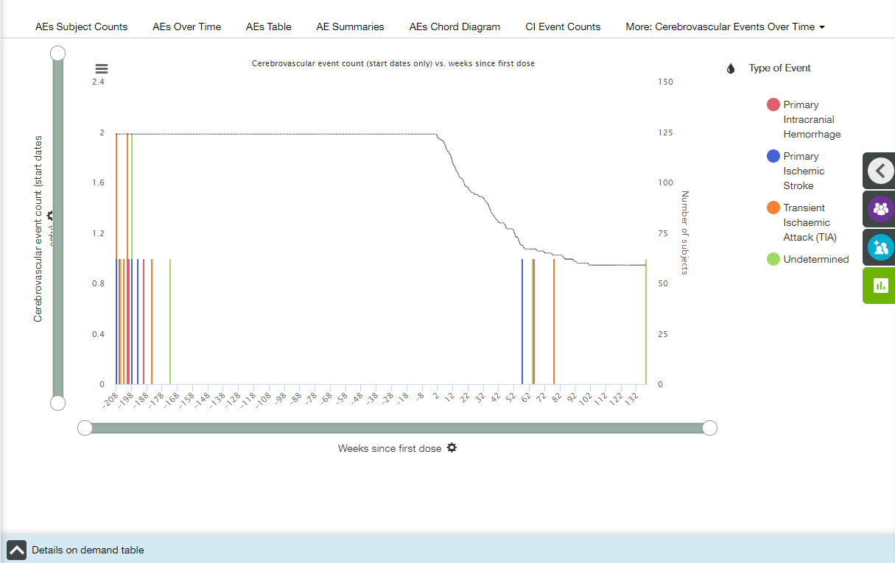

Main elements available on the Cerebrovascular Events Over Time tab are the following:

* Bar plot;
* X- and Y-axis zoom bars (see X and Y Axes Settings section);
* X- and Y-axis controls and titles (see X and Y Axes Settings section);
* Z-axis title;
* Coloring control (see Coloring section);
* Chart context menu icon (see Chart Context Menu section);
* Details on Demand table at the bottom of the screen, collapsed by default (see Details on Demand Table section).

X axis

The title of the X-axis is **Weeks since first dose** by default.  X axis has time binning (see Time Binning section for details).

Value of X-axis could be changed by choosing one of the options from dropdown list under the plot:

* Days since first dose;
* Weeks since first dose;
* Days since randomisation;
* Weeks since randomisation;
* Days since first dose of drug;
* Weeks since first dose of drug.

 

Y axis

The title of the Y-axis is **Cerebrovascular event count (start days only)**, and no other option is available.

Z axis

The plot includes a Z axis that is a single grey line that displays the total number of subjects on the study at the given point in time.

The line isn't angled between data points but 'steps' downward each time a subject leaves, as in the example. For points in time up to and including day zero (including negative values) the number of subjects is assumed to be equal to the number of subjects at day zero.

Y zoom bar also affects the Z axis.

Coloring

Appropriate menu provides a user with the following options:

* All;
* Type of Event (selected by default);
* If Primary Ischemic Stroke;
* If Traumatic.



Tooltips

When the cursor is hovered over a bar, the tooltip appears and shows the following data:

* X-axis value;
* Z-axis value;
* Y-axis value for each coloring category.

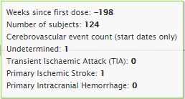

Cerebrovascular Events Filters

A user can apply Cerebrovascular Events filters to modify the plot.



Details on Demand table

Details on Demand table contains two tabs: Cerebrovascular Events tab and Subjects tab.

Cerebrovascular Events tab:

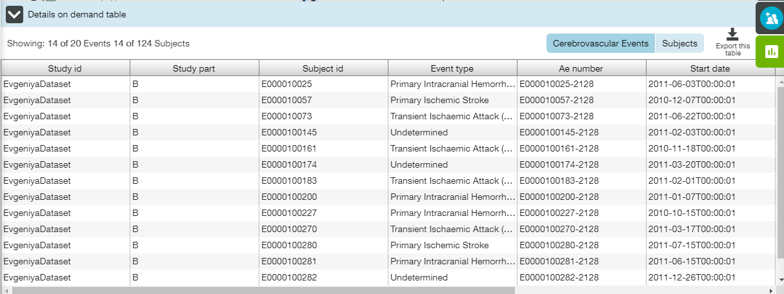

Subjects tab:

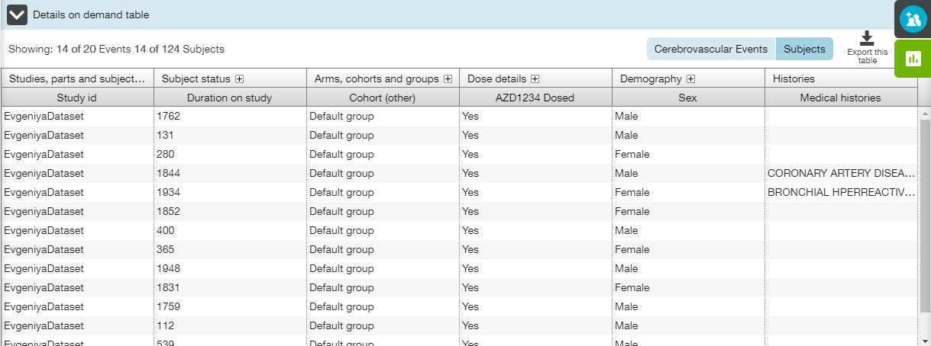

#### View Linked AEs

When a user selects an area, the selected area is highlighted and popup menu appears with the following data:



Additional option (as compared to typical pop-up menu) **View Linked AEs** is provided to a user.

AE may be associated with multiple Cerebrovascular events. **View linked AEs** is the link between Cerebrovascular Events and AEs, so that a user can filter and jump to AEs on the basis of selecting Cerebrovascular events.

When a user clicks **View linked AEs**, **AE Counts** tab of the **Adverse Events** view is opened. Only those AEs that are linked to the given Cerebrovascular Events through the presence of AE number fields within both the AE data and the Cerebrovascular Event data are displayed. Not all AEs will be associated to a Cerebrovascular Event and it's not necessarily the case that every Cerebrovascular event have an associated AE record.

AE filter widget on the top of the page describes that the set of AEs have been limited based on an AE number.

**Note**: Click the tag to view the list of appropriate subject id’s followed by AE numbers (‘E0000100130-1’ means that subject id is E0000100130, and AE number is 1).



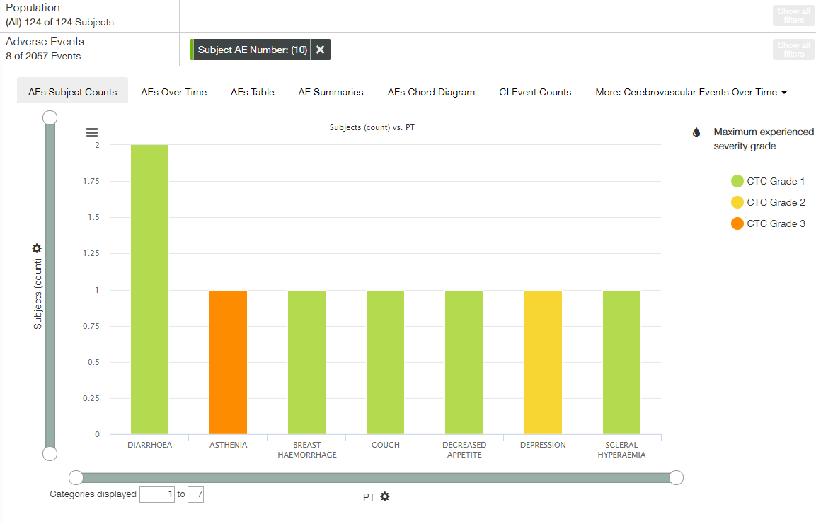

### Additional CVOT Suspected Endpoint Counts Tab

**Additional CVOT Suspected Endpoint Counts** tab displays the count of subject per Additional Cardiovascular Outcome Trials (CVOT) Suspected Endpoint events.

Additional CVOT Suspected Endpoint Events plot is visualized by the incidence rate and occurrence of each event (the entire set of CVOT endpoint events for all subjects who received one or more dose of investigational product). It allows quick assimilation of what Additional CVOT Suspected Endpoint event categories have the highest counts and also highlights relative frequencies of different Additional CVOT Suspected Endpoint events.

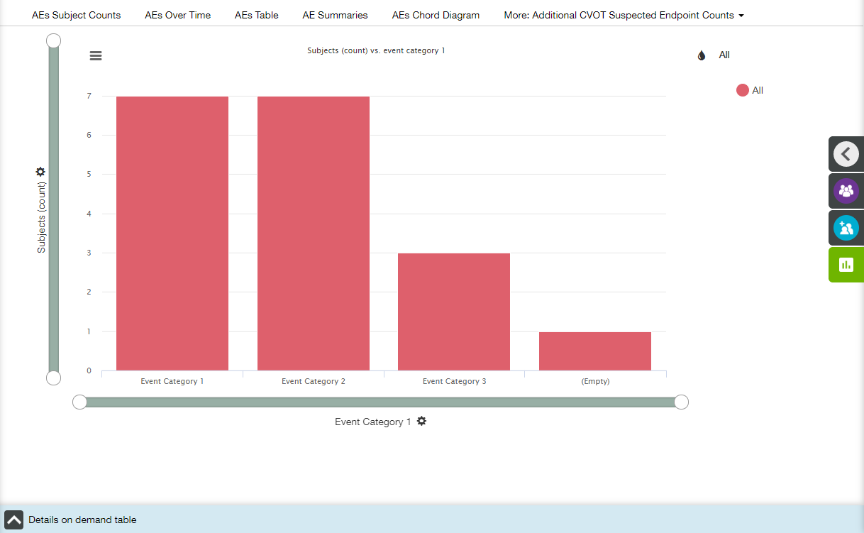

Main elements available on the Additional CVOT Suspected Endpoint Event Counts tab are the following:

* Bar plot;
* X- and Y-axis zoom bars (see X and Y Axes Settings section);
* X- and Y-axis controls and titles (see X and Y Axes Settings section);
* Coloring control (see Coloring section);
* Chart context menu icon (see Chart Context Menu section);
* Details on Demand table at the bottom of the screen, collapsed by default (see Details on Demand Table section).

X axis

The title of the X-axis is **Event Category 1** by default.

Value of X-axis could be changed by choosing one of the options from dropdown list under the plot:

* All;
* Event Category 1;
* Event Category 2;
* Event Category 3;
* Event Description 1;
* Event Description 2;
* Event Description 3.

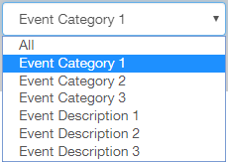

Y axis

The default title of the Y-axis is **Subjects (count)**. **Y** **Axis Settings** menu provides a user with the following settings:

* Y axis measure;
* Unit of measure.

  

Coloring

Appropriate menu provides a user with the following options:

* All (selected by default);
* Event Category 1;
* Event Category 2;
* Event Category 3;
* Event Description 1;
* Event Description 2;
* Event Description 3.

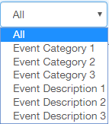

Tooltips

When a user hovers the cursor over a bar, the tooltip with the following fields is displayed:

* X-axis value;
* Y-axis value.
* Coloring option value.

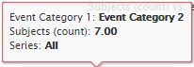

CVOT Endpoint Filters

A user can apply CVOT Endpoint filters to modify the plot.

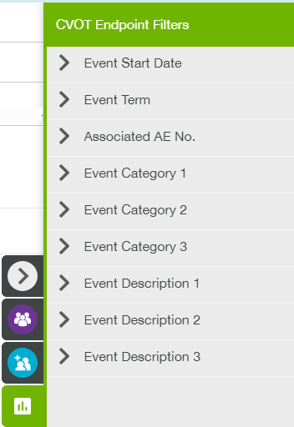

Details on Demand table

Details on Demand table contains two tabs: Additional Suspected CVOT Endpoint tab and Subjects tab.

Additional Suspected CVOT Endpoint tab:

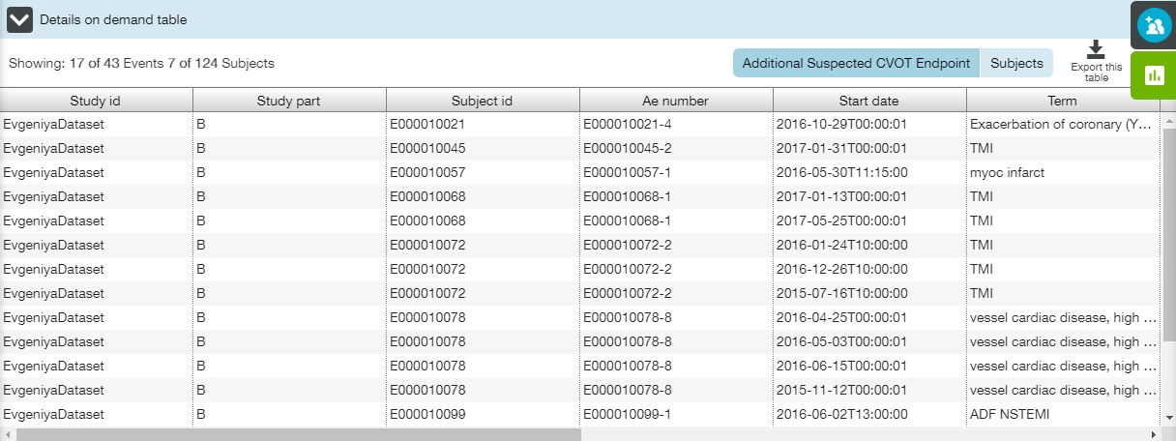

Subjects tab:

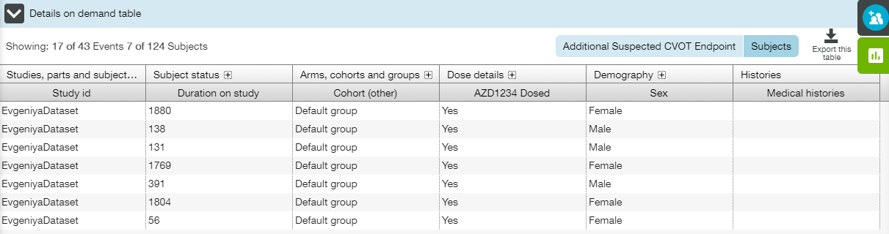

#### View Linked AEs

When a user selects an area, the selected area is highlighted and popup menu appears with the following data:

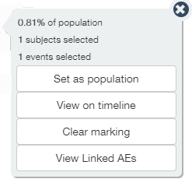

Additional option (as compared to typical pop-up menu) **View Linked AEs** is provided to a user.

AE may be associated with multiple Additional CVOT Suspected Endpoint events. **View linked AEs** is the link between Additional CVOT Suspected Endpoint events and AEs, so that a user can filter and jump to AEs on the basis of selected Additional CVOT Suspected Endpoint events.

When a user clicks **View linked AEs** button, **AEs Subject Counts** tab of the **Adverse Events** view is opened. Only those AEs that are linked to the given Additional CVOT Suspected Endpoint events through the presence of AE number fields within both the AE data and the Additional CVOT Suspected Endpoint event data are displayed. Not all AEs will be associated to an Additional CVOT Suspected Endpoint event and it's not necessarily the case that every Additional CVOT Suspected Endpoint event have an associated AE record.

AE filter widget on the top of the **AEs Subject Counts** page describes that the set of AEs have been limited based on an AE number.

**Note**: Click the tag to view the list of appropriate subject id’s followed by AE numbers (‘E0000100130-1’ means that subject id is E0000100130, and AE number is 1).



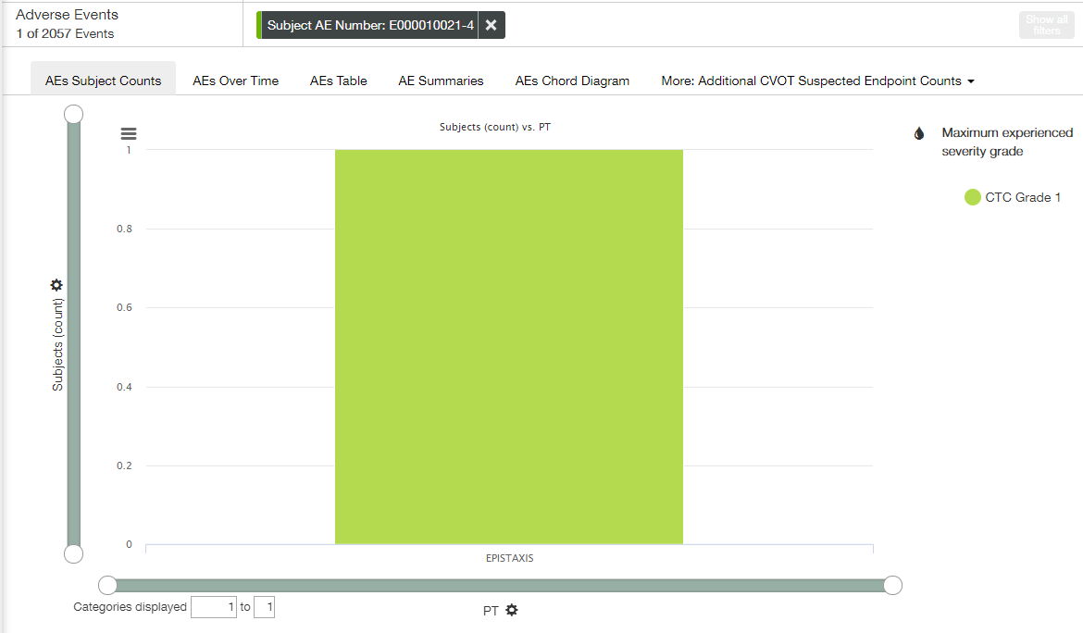

### Additional Suspected CVOT Endpoints Over Time Tab

**Additional CVOT Suspected Endpoints Over Time** tab displays the Additional CVOT Suspected Endpoint counts over time.

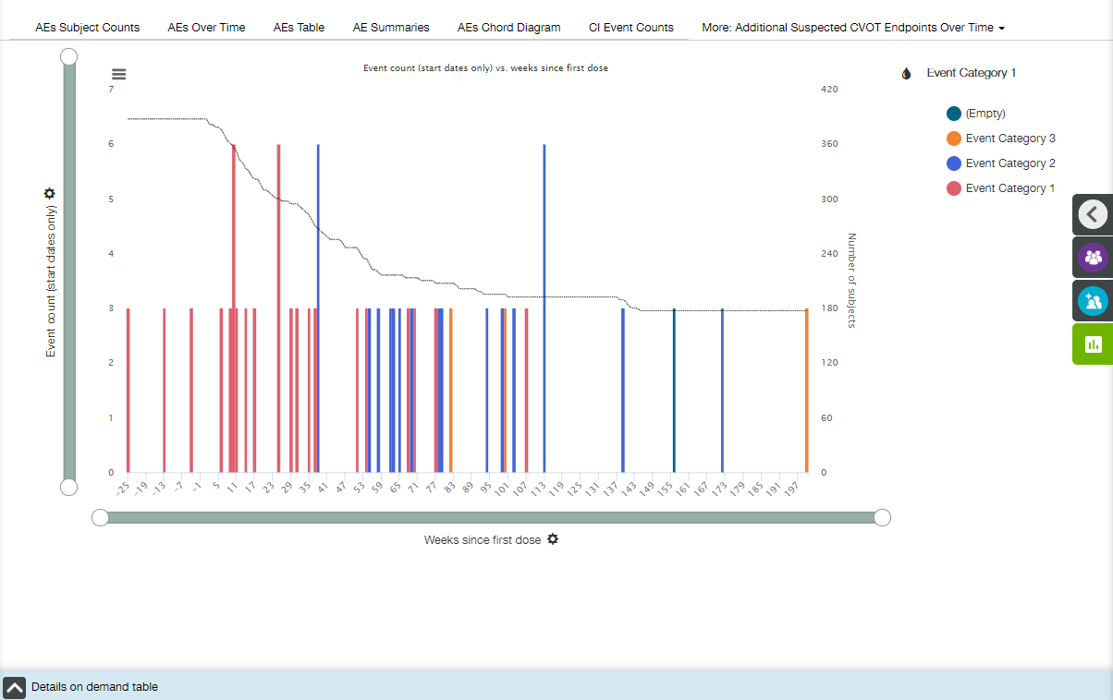

Main elements available on the Additional CVOT Suspected Endpoints Over Time tab are the following:

* Bar plot;
* X- and Y-axis zoom bars (see X and Y Axes Settings section);
* X- and Y-axis controls and titles (see X and Y Axes Settings section);
* Z-axis title;
* Coloring control (see Coloring section);
* Chart context menu icon (see Chart Context Menu section);
* Details on Demand table at the bottom of the screen, collapsed by default (see Details on Demand Table section).

X axis

The title of the X-axis is **Weeks since first dose** by default.  X axis has time binning (see Time Binning section for details).

Value of X-axis could be changed by choosing one of the options from dropdown list under the plot:

* Start date;
* Days since first dose;
* Weeks since first dose;
* Days since randomisation;
* Weeks since randomisation;
* Days since first dose of drug;
* Weeks since first dose of drug.

 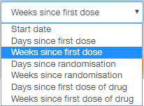

Y axis

The title of the Y-axis is **Event count (start dates only)**, and no other option is available.

Z axis

The plot includes a Z axis that is a single grey line that displays the total number of subjects on the study at the given point in time.

The line isn't angled between data points but 'step' downward each time a subject leaves, as in the example. For points in time up to and including day zero (including negative values) the number of subjects is assumed to be equal to the number of subjects at day zero. Y zoom bar also affects the Z axis.

Coloring

Appropriate menu provides a user with the following options:

* All;
* Event Category 1 (selected by default);
* Event Category 2;
* Event Category 3;
* Event Description 1;
* Event Description 2;
* Event Description 3.



Tooltips

When a user hovers the cursor over a bar, the tooltip with the following fields is displayed:

* X-axis value;
* Z-axis value;
* Y-axis value for each coloring category.

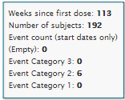

CVOT Endpoint Filters

A user can apply CVOT Endpoint filters to modify the plot.



Details on Demand table

Details on Demand table contains two tabs: Additional Suspected CVOT Endpoint tab and Subjects tab.

Additional Suspected CVOT Endpoint tab:

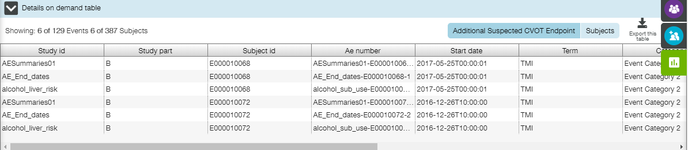

Subjects tab:

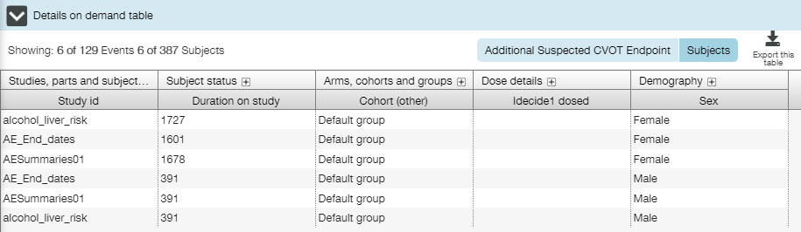

#### View Linked AEs

When a user selects an area, the selected area is highlighted and popup menu appears with the following data:



Additional option (as compared to typical pop-up menu) **View Linked AEs** is provided to a user.

AE may be associated with multiple Additional CVOT Suspected Endpoint events. **View linked AEs** is the link between Additional CVOT Suspected Endpoint events and AEs, so that a user can filter and jump to AEs on the basis of selecting Cerebrovascular events.

When a user clicks **View linked AEs**, **AE Counts** tab of the **Adverse Events** view is opened. Only those AEs that are linked to the given Additional CVOT Suspected Endpoint events through the presence of AE number fields within both the AE data and the Additional CVOT Suspected Endpoint event data are displayed. Not all AEs will be associated to an Additional CVOT Suspected Endpoint event and it's not necessarily the case that every Additional CVOT Suspected Endpoint event have an associated AE record.

AE filter widget on the top of the page describes that the set of AEs have been limited based on an AE number.

**Note**: Click the tag to view the list of appropriate subject id’s followed by AE numbers (‘E0000100130-1’ means that subject id is E0000100130, and AE number is 1).



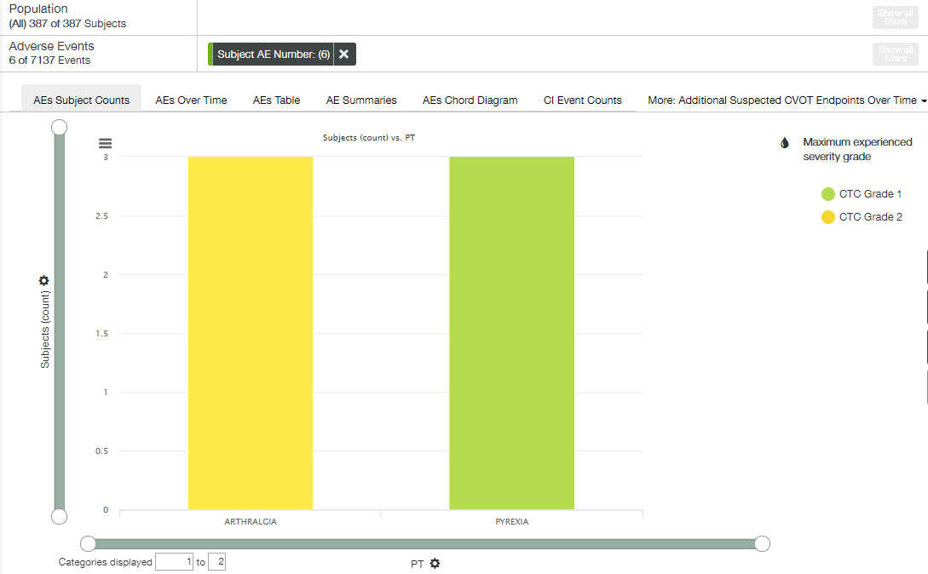

## Conmeds View

**Conmeds** view allows a user to see which concomitant medications are being used frequently through the Subject Population. This view contains the only tab – **Conmeds Counts**.

The following elements are available:

* Population filters (collapsed by default) in the right slide menu (see Population Filters section);
* Cohort filters (collapsed by default) in the right slide menu (see Cohort Filters section);
* Conmeds filters (collapsed by default) in the right slide menu (see Event Filters section);
* Population filter widget (see Population Filters section);
* Conmed Counts filter widget (see Event Filters section).

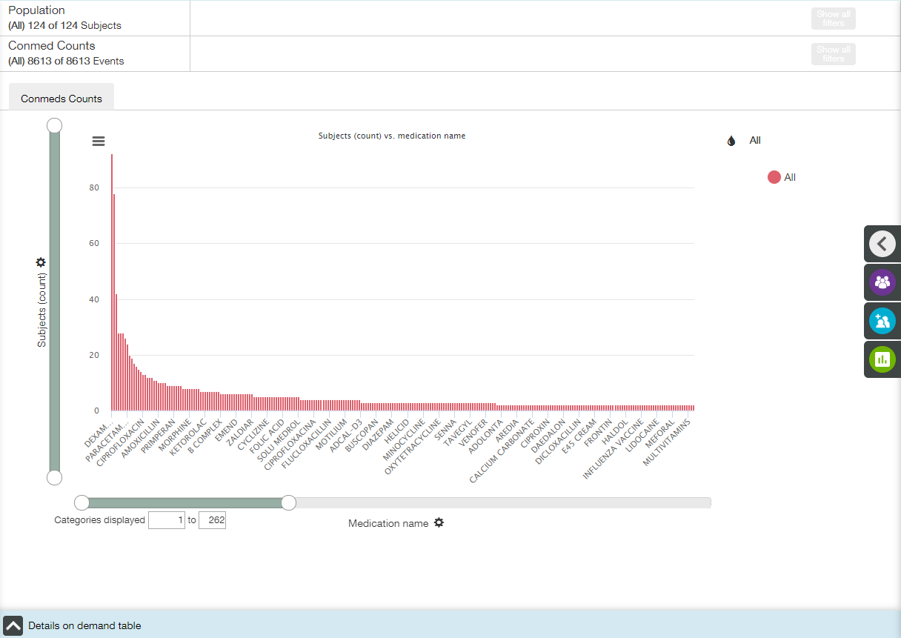

Main elements available on the Conmed Counts tab are the following:

* Bar plot;
* X- and Y-axis zoom bars (see X and Y Axes Settings section);
* X- and Y-axis controls and titles (see X and Y Axes Settings section);
* Coloring control (see Coloring section);
* Chart context menu icon (see Chart Context Menu section);
* Details on Demand table at the bottom of the screen, collapsed by default (see Details on Demand Table section).

X axis

The title of the X-axis is **Medication name** by default.

Value of X-axis could be changed by choosing one of the options from dropdown list under the plot:

* Medication name;
* Atc code.

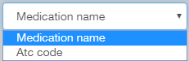

Y axis

The default title of the Y-axis is **Subjects (count)**.

Value of Y-axis could be changed by choosing one of the options from dropdown list:

* Subjects (count);
* Subjects (percentage of total);
* Subjects (percentage within plot).

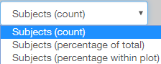

Coloring

Appropriate menu provides a user with the following options:

* All (selected by default);
* Anatomical group;
* Nominal Dose;
* Dose units;
* Ongoing;
* Conmed started prior to study;
* Conmed ended prior to study.

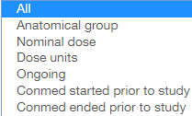

Tooltips

When a user hovers the cursor over a bar, the tooltip with the following fields is displayed:

* X-axis value;
* Y-axis value;
* Coloring option value;
* Count or percentage of subject.

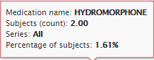

Conmeds Filters

A user can apply Conmeds filters to modify the plot.

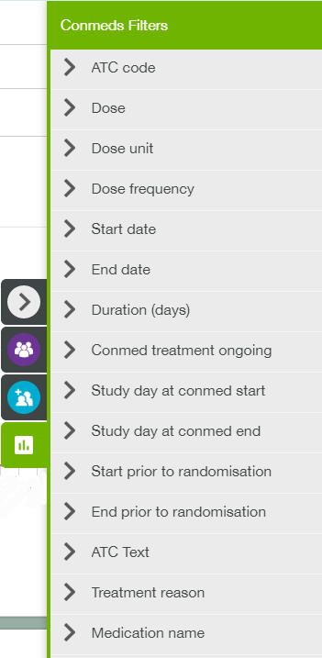

Details on Demand table

Details on Demand table contains two tabs: Conmeds tab and Subjects tab.

Conmeds tab:

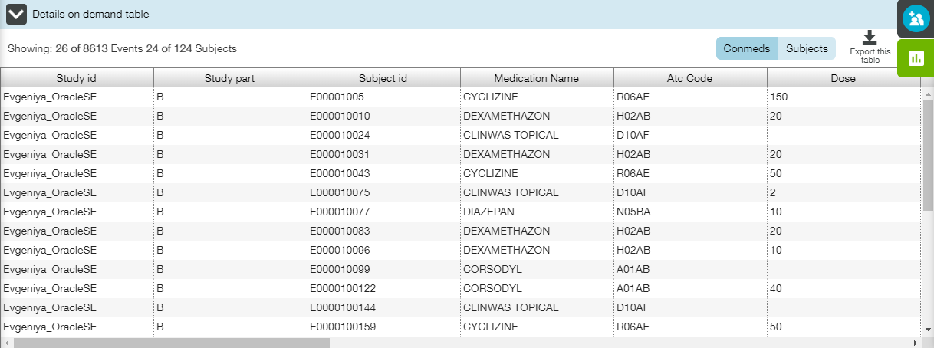

Subjects tab:

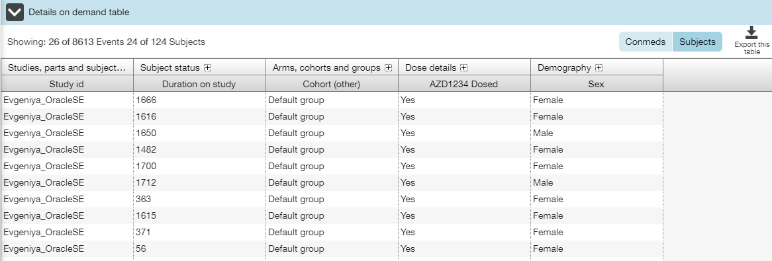

## Labs View

**Labs** view allows a user to investigate indicators of patient health (otherwise known as a laboratory measurement) that have been recorded for all subjects.

Three tabs are available on the Labs view: Box Plot, Shift Plot and Line Plot tab.

The following elements are available for all tabs:

* Population filters (collapsed by default) in the right slide menu (see Population Filters section);
* Cohort filters (collapsed by default) in the right slide menu (see Cohort Filters section);
* Lab filters (collapsed by default) in the right slide menu (see Event Filters section);
* Population filter widget (see Population Filters section);
* Lab measurements filter widget (see Event Filters section).

A user can apply Lab filters to modify a plot.

### Box Plot Tab

Labs Box Plot tab allows a user to browse lab measurements changes over time. The tab contains a set of trellised box plots (see **Trellised Plots** section for trellis description).

Box plot allows the user to quickly assimilate population-level trends in individual laboratory measurements that may be linked to aspects of drug dosing.

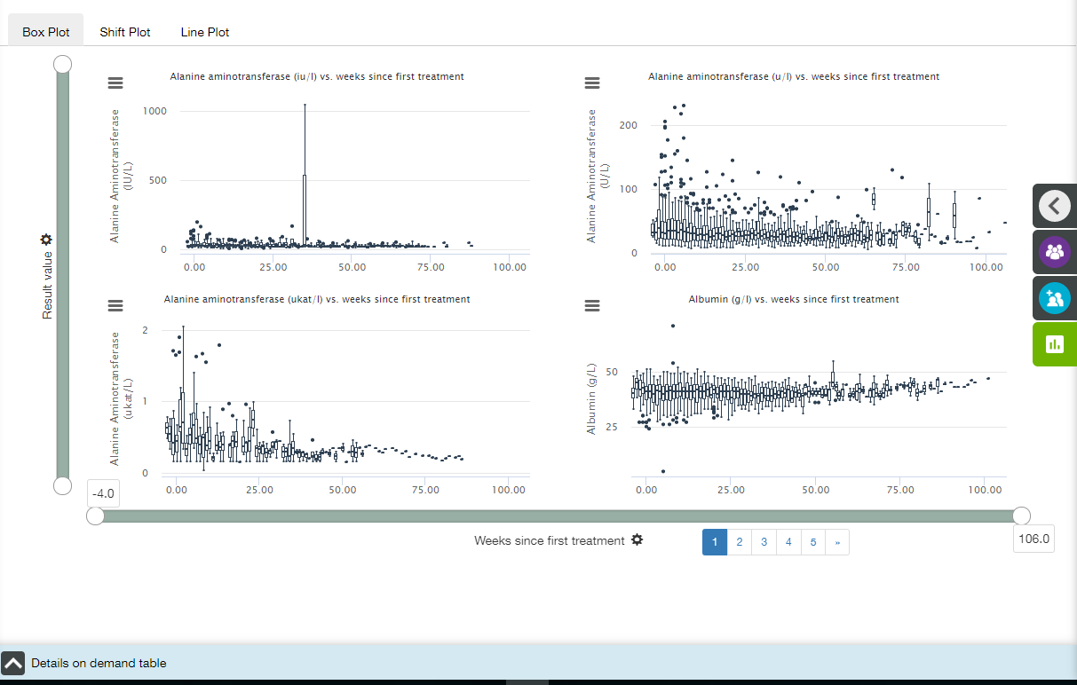

Main elements available on the Labs Box Plot tab are the following:

* Trellised box plots;
* X- and Y-axis zoom bars (see X and Y Axes Settings section);
* X- and Y-axis controls and titles (see X and Y Axes Settings section);
* Chart context menu icons (see Chart Context Menu section);
* Details on Demand table at the bottom of the screen, collapsed by default (see Details on Demand Table section).

X axis

The title of the X-axis is **Weeks since first treatment** by default.  X axis has time binning (see Time Binning section for details).

Value of X-axis could be changed by choosing one of the options from dropdown list under the plot:

* Visit number;
* Days since first treatment;
* Weeks since first treatment;
* Days since randomisation;
* Weeks since randomisation.

 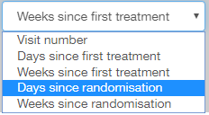

Y axis

The default title of the Y-axis is **Result value**.

Value of Y-axis could be changed by choosing one of the options from dropdown list:

* Ref range norm. value;
* Times upper ref. value;
* Times lower ref. value;
* Absolute change from baseline;
* Percentage change from baseline;
* Result value.

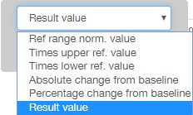

**Note**: If “Ref range norm. value” option is selected, then two red reference lines (Reference low (Y=0) and Reference high (Y=1)) appear on the plot. This allows a user to see whether result values fall between these reference values, or not.

Tooltips

When a user hovers the cursor over a point, the tooltip with the following fields is displayed:

* X-axis value;
* Y-axis value;
* Subject ID: <value>.

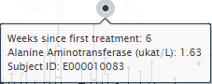

When a user hovers the cursor over a box, the tooltip with the following fields is displayed:

* X-axis value;
* Upper whisker: <value>;
* Upper quartile: <value>;
* Median: <value>;
* Lower quartile: <value>;
* Lower whisker: <value>.

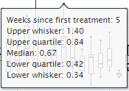

Details on Demand table

Details on Demand table contains two tabs: Labs tab and Subjects tab.

Labs tab:

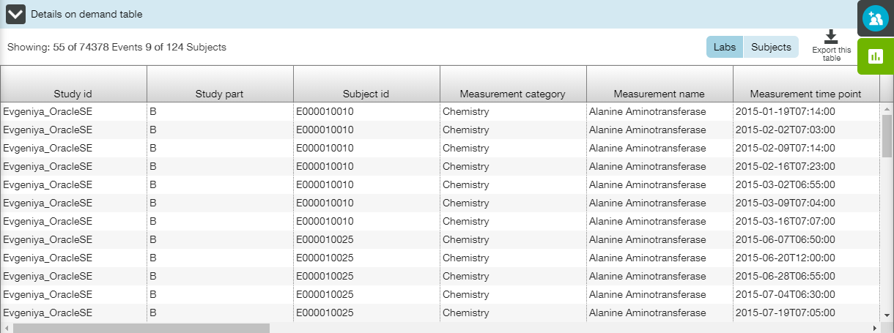

**Note**: Data in the Result value column could be highlighted with red if value is lower than Lower ref range value or upper than higher than Upper ref range value.

Subjects tab:

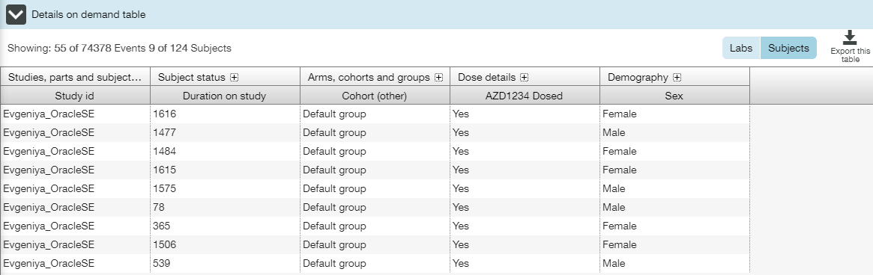

### Shift Plot Tab

Labs Shift Plot tab allows a user to compare, for each of laboratory measurements, the values relative to baseline. The tab contains a set of trellised error bar diagrams (see **Trellised Plots** section for trellis description).

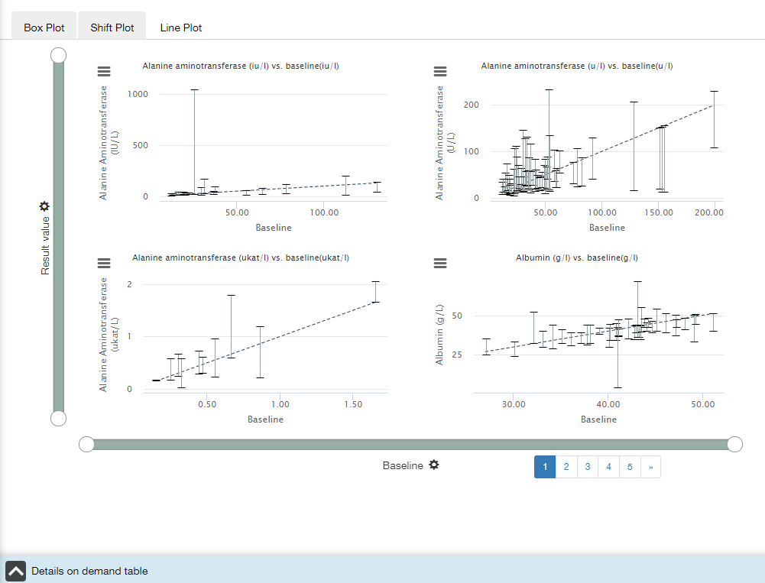

Main elements available on the Labs Shift Plot tab are the following:

* Trellised error bar diagrams;
* X- and Y-axis zoom bars (see X and Y Axes Settings section);
* X- and Y-axis controls and titles (see X and Y Axes Settings section);
* Chart context menu icons (see Chart Context Menu section);
* Details on Demand table at the bottom of the screen, collapsed by default (see Details on Demand Table section).

X axis

The title of the X-axis is **Baseline**, and no other option is available.

Y axis

The title of the Y-axis is **Result Value**, and no other option is available.

Tooltips

When a user hovers the cursor over an error bar, the tooltip with the following fields is displayed:

* [Measurement name]{Measurement unit};
* Y-axis value: [Min], [Max];
* X-axis value.

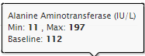

Details on Demand table

Details on Demand table contains two tabs: Labs tab and Subjects tab.

Labs tab:

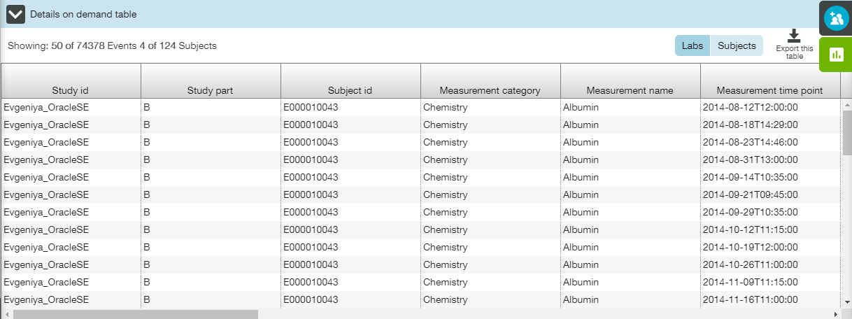

**Note**: Data in the Result value column could be highlighted with red if value is lower than Lower ref range value or upper than higher than Upper ref range value.

Subjects tab:



### Line Plot Tab

Labs Line Plot tab allows a user to quickly assimilate population-level trends in individual laboratory measurements that may be linked to aspects of drug dosing. The tab contains a set of trellised line plots (see **Trellised Plots** section for trellis description).

Labs Line Plot contains combined line and range highcharts that shows the average and standard error of the mean (SEM) lab data values. The chart displays a summary of the laboratory measurements values over time for the study population. Each line Y value represents the mean average value of all unfiltered points at the given X axis timepoint.

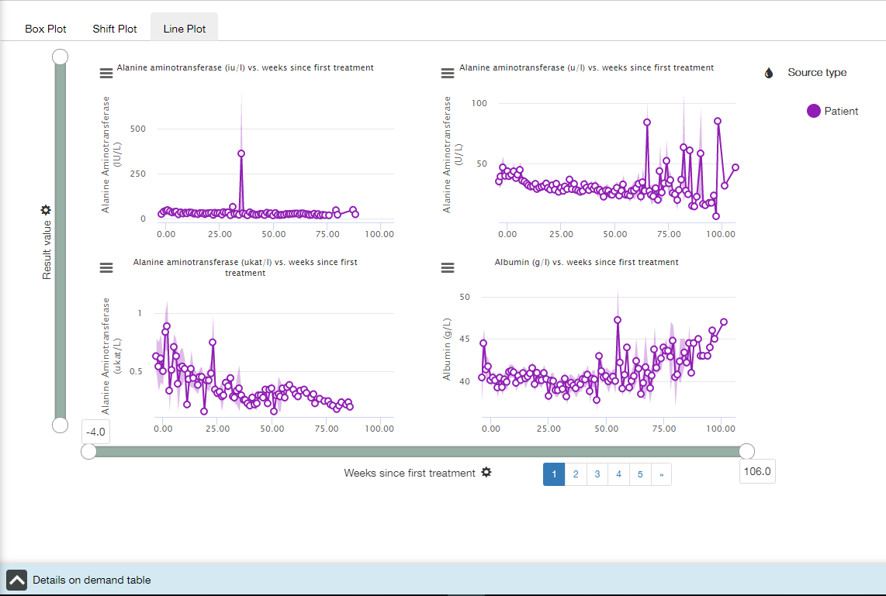

Main elements available on the Labs Line Plot tab are the following:

* Trellised line plots;
* X- and Y-axis zoom bars (see X and Y Axes Settings section);
* X- and Y-axis controls and titles (see X and Y Axes Settings section);
* Coloring control (see Coloring section);
* Chart context menu icons (see Chart Context Menu section);
* Details on Demand table at the bottom of the screen, collapsed by default (see Details on Demand Table section).

X axis

The title of the X-axis is **Weeks since first treatment** by default.  X axis has time binning (see Time Binning section for details).

Value of X-axis could be changed by choosing one of the options from dropdown list under the plot:

* Visit number;
* Days since first treatment;
* Weeks since first treatment;
* Days since randomisation;
* Weeks since randomisation.

 

Y axis

The default title of the Y-axis is **Result value**.

Value of Y-axis could be changed by choosing one of the options from dropdown list:

* Ref range norm. value;
* Times upper ref. value;
* Times lower ref. value;
* Absolute change from baseline;
* Percentage change from baseline;
* Result value.



**Note**: If “Ref range norm. value” option is selected, then two red reference lines (Reference low (Y=0) and Reference high (Y=1)) appear on the plot. This allows a user to see whether result values fall between these reference values, or not.

Coloring

Appropriate menu provides a user with the following options:

* All;
* Source type (selected by default).

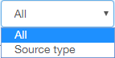

Tooltips

When a user hovers the cursor over a point, the tooltip with the following fields is displayed:

* Coloring option value;
* Average Y-axis value;
* X-axis value;
* The number of data points used to calculate the mean;
* Standard error of the mean.

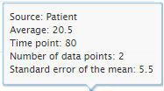

Details on Demand table

Details on Demand table contains two tabs: Labs tab and Subjects tab.

Labs tab:

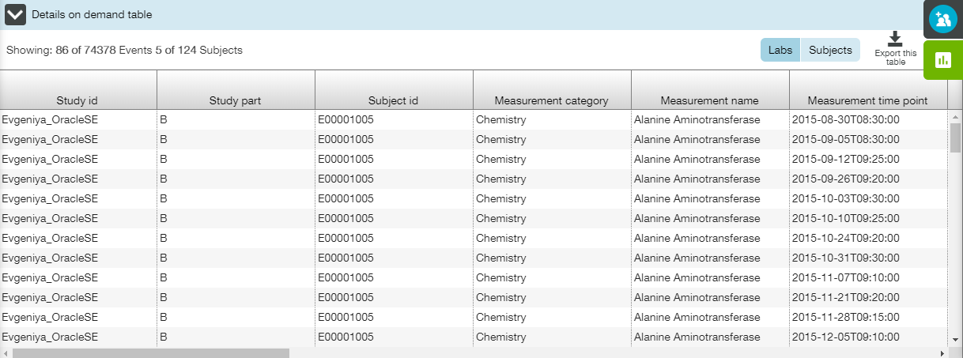

**Note**: Data in the Result value column could be highlighted with red if value is lower than Lower ref range value or upper than higher than Upper ref range value.

Subjects tab:

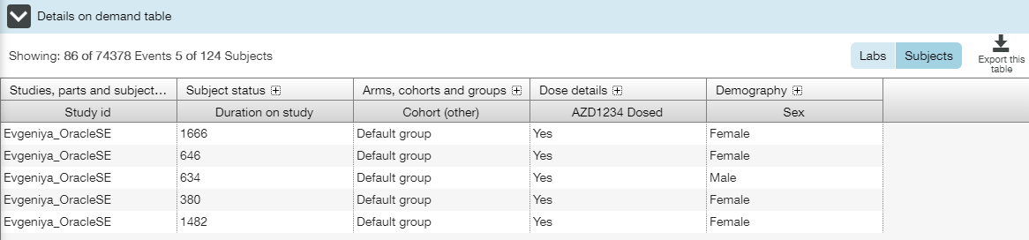

## Vital Signs View

**Vital Signs** view allows a user to quickly assimilate changes in vital-signs over time that may be linked to drug dosing. This view contains only one tab - **Vitals Measurements over Time**. The tab contains a set of trellised box plots (see **Trellised Plots** section for trellis description).

The following elements are available:

* Population filters (collapsed by default) in the right slide menu (see Population Filters section);
* Cohort filters (collapsed by default) in the right slide menu (see Cohort Filters section);
* Vitals filters (collapsed by default) in the right slide menu (see Event Filters section);
* Population filter widget (see Population Filters section);
* Vitals Measurements filter widget (see Event Filters section).

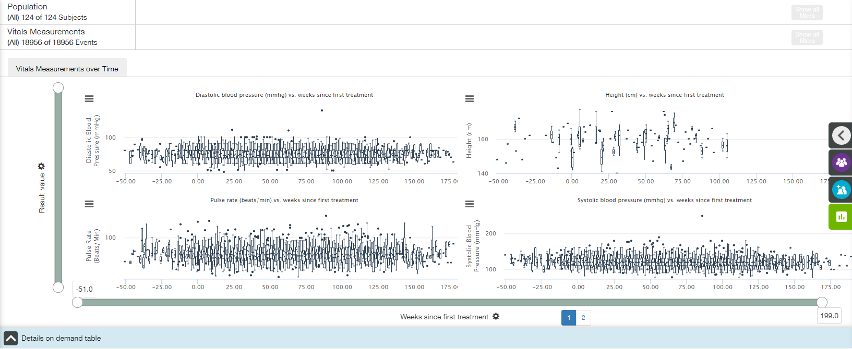

Main elements available on the Vitals Measurements over Time tab are the following:

* Trellised box plots;
* X- and Y-axis zoom bars (see X and Y Axes Settings section);
* X- and Y-axis controls and titles (see X and Y Axes Settings section);
* Chart context menu icons (see Chart Context Menu section);
* Details on Demand table at the bottom of the screen, collapsed by default (see Details on Demand Table section).

X axis

The title of the X-axis is **Weeks since first treatment** by default.  X axis has time binning (see Time Binning section for details).

Value of X-axis could be changed by choosing one of the options from dropdown list under the plot:

* Visit number;
* Days since first treatment;
* Weeks since first treatment;
* Days since randomisation;
* Weeks since randomisation.

 

Y axis

The default title of the Y-axis is **Result value**.

Value of Y-axis could be changed by choosing one of the options from dropdown list:

* Absolute change from baseline;
* Percentage change from baseline;
* Result value.

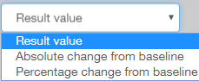

Tooltips

When a user hovers the cursor over a point, the tooltip with the following fields is displayed:

* X-axis value;
* Y-axis value;
* Subject ID: <value>.

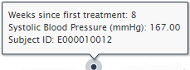

When a user hovers the cursor over a box, the tooltip with the following fields is displayed:

* X-axis value;
* Upper whisker: <value>;
* Upper quartile: <value>;
* Median: <value>;
* Lower quartile: <value>;
* Lower whisker: <value>.

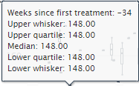

Vitals Filters

A user can apply Vitals filters to modify the plot.

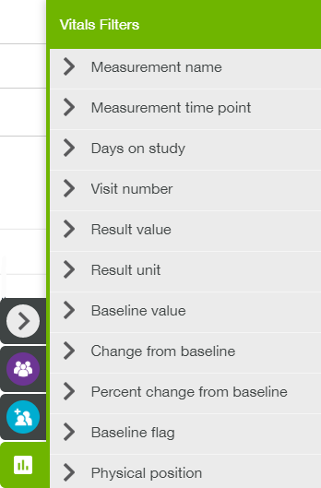

Details on Demand table

Details on Demand table contains two tabs: Vital Signs tab and Subjects tab.

Vital Signs tab:

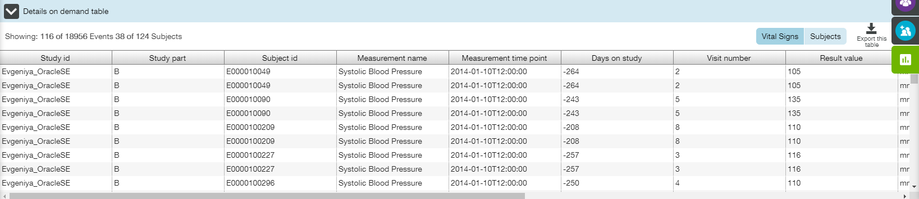

Subjects tab:

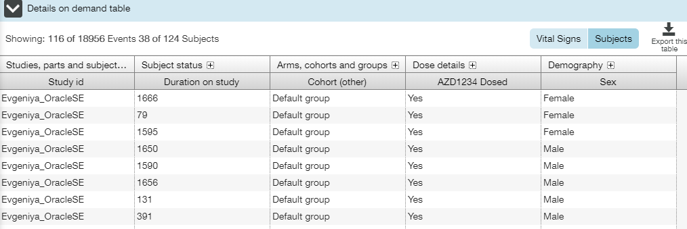

## Cardiac Functions View

**Cardiac Function** view allows a user to browse cardiovascular data measurements, such as ECG (electrical signals and timings of these in the heart) and ejection fraction measurements (left ventricular ejection fraction). This view contains only one tab - **Cardiac Measurements over Time**. The tab contains a set of trellised box plots (see **Trellised Plots** section for trellis description).

The following elements are available:

* Population filters (collapsed by default) in the right slide menu (see Population Filters section);
* Cohort filters (collapsed by default) in the right slide menu (see Cohort Filters section);
* Cardiac filters (collapsed by default) in the right slide menu (see Event Filters section);
* Population filter widget (see Population Filters section);
* Cardiac Function Measurements filter widget (see Event Filters section).

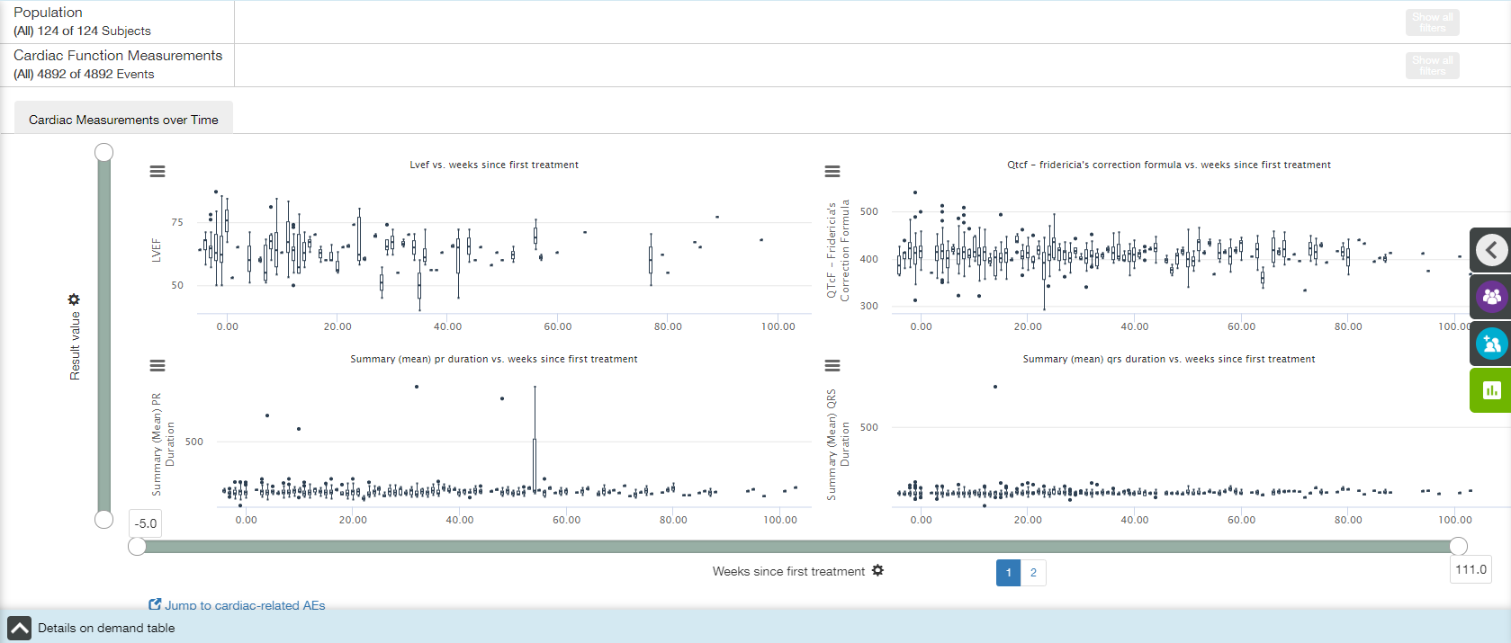

Main elements available on the Cardiac Measurements over Time tab are the following:

* Trellised box plots;
* X- and Y-axis zoom bars (see X and Y Axes Settings section);
* X- and Y-axis controls and titles (see X and Y Axes Settings section);
* Chart context menu icons (see Chart Context Menu section);
* Details on Demand table at the bottom of the screen, collapsed by default (see Details on Demand Table section);
* Jump to cardiac-related AEs link.

X axis

The title of the X-axis is **Weeks since first treatment** by default.  X axis has time binning (see Time Binning section for details).

Value of X-axis could be changed by choosing one of the options from dropdown list under the plot:

* Visit number;
* Days since first treatment;
* Weeks since first treatment;
* Days since randomisation;
* Weeks since randomisation.

 

Y axis

The default title of the Y-axis is **Result value**.

Value of Y-axis could be changed by choosing one of the options from dropdown list:

* Absolute change from baseline;
* Percentage change from baseline;
* Result value.



Tooltips

When a user hovers the cursor over a point, the tooltip with the following fields is displayed:

* X-axis value;
* Y-axis value;
* Subject ID: <value>.

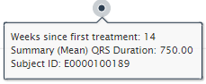

When a user hovers the cursor over a box, the tooltip with the following fields is displayed:

* X-axis value;
* Upper whisker: <value>;
* Upper quartile: <value>;
* Median: <value>;
* Lower quartile: <value>;
* Lower whisker: <value>;

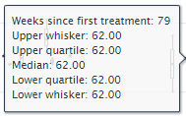

Cardiac Filters

A user can apply Cardiac filters to modify the plot.

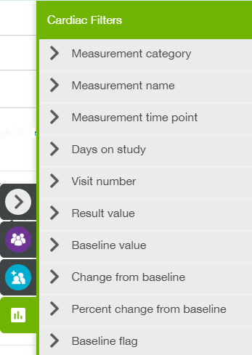

Details on Demand table

Details on Demand table contains two tabs: Cardiac Function tab and Subjects tab.

Cardiac Function tab:

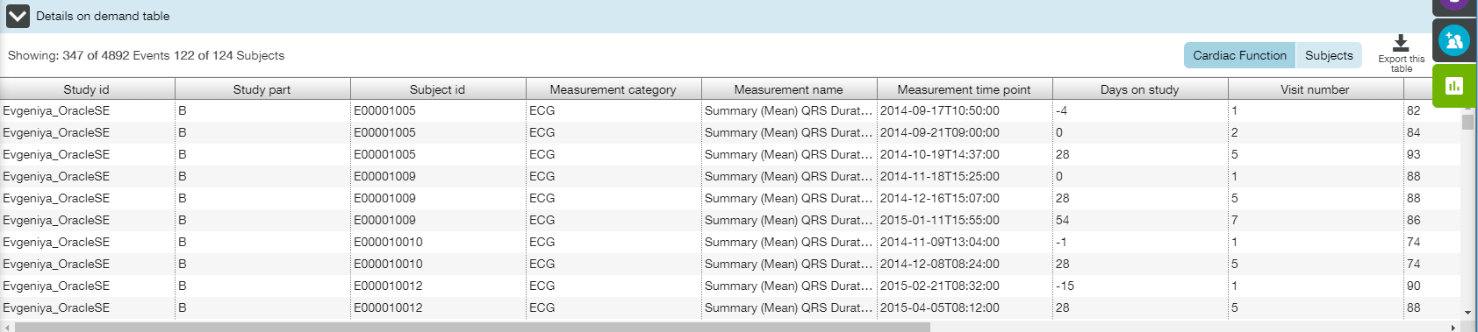

Subjects tab:

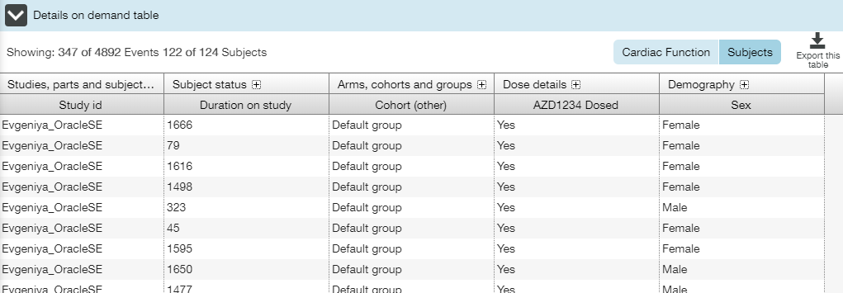

### Jump to Cardiac-related AEs

Jump to cardiac-related AEs link allows a user quickly get to contextually relevant AEs view.

When a user jumps, **AEs Subject Counts** tab of the **Adverse Events** view is opened. An event filter is set so that only AEs that belong to the system organ class "Cardiac disorders" are displayed.

**Note**: In the case that other AEs filters are already in place these are maintained.

AE filter widget on the top of the page describes that the set of AEs have been limited based on an AE system organ class.

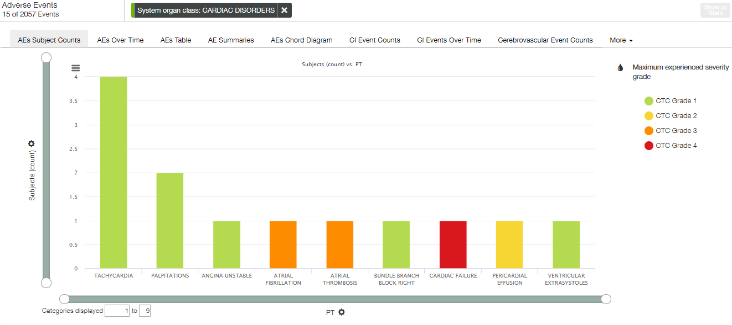

## Liver Function View

**Liver Function** view allows a user to investigate indicators of a fatal drug-induced liver injury risk that have been recorded for all subjects. This view contains only one tab – **Hy’s Law**.

The tab displays the maximum measured concentrations per subject for liver function indicators Bilirubin and AST/ALT, relative to a normal reference range.

The following elements are available:

* Population filters (collapsed by default) in the right slide menu (see Population Filters section);
* Cohort filters (collapsed by default) in the right slide menu (see Cohort Filters section);
* Liver filters (collapsed by default) in the right slide menu (see Event Filters section);
* Population filter widget (see Population Filters section);
* Liver Function Measurements filter widget (see Event Filters section).

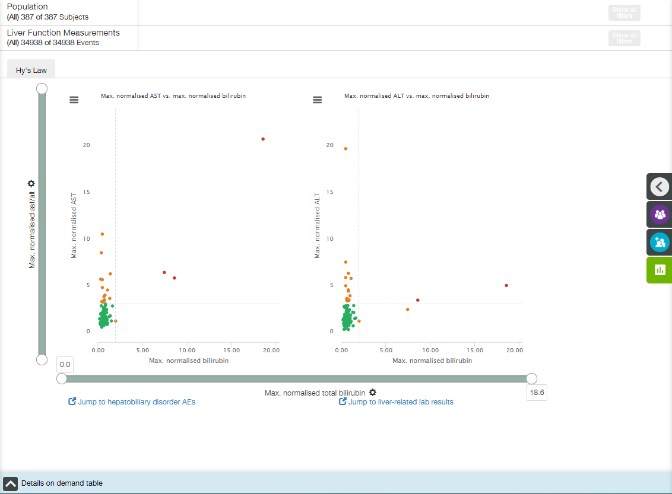

Main elements available on the Hy’s Law tab are the following:

* Two scatter plots;
* X- and Y-axis zoom bars (see X and Y Axes Settings section);
* X- and Y-axis controls and titles (see X and Y Axes Settings section);
* Chart context menu icons (see Chart Context Menu section);
* Details on Demand table at the bottom of the screen, collapsed by default (see Details on Demand Table section);
* Jump to hepatobiliary disorder AEs link;
* Jump to liver-related lab results link.

Two dotted lines are displayed on the plots as references: x = 2; y = 3.

Points on the plots are colored according to ALT/AST/Total Bilirubin ULN normalization value.

| Grades | Color | Comment |
| --- | --- | --- |
| Bilirubin < 2, AST or ALT <3 | Green | Normal |
| Bilirubin > 2, AST or ALT < 3 Bilirubin < 2, AST or ALT > 3 | Orange | Elevated AST or ALT or Elevated Bilirubin |
| Bilirubin > 2, AST or ALT > 3 | Red | Elevated AST or ALT and Bilirubin (potential Hy's case) |

X axis

The title of the X-axis is **Max. normalised total bilirubin**, and no other option is available.

Y axis

The title of the Y-axis is **Max. normalised ast/alt**, and no other option is available.

Tooltips

When a user hovers the cursor over a point, the tooltip with the following fields is displayed:

* Y axis value;
* X axis value.

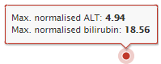

Liver Filters

A user can apply Liver filters to modify the plot.

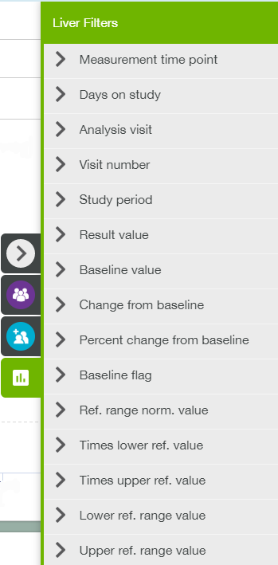

Details on Demand table

Details on Demand table contains two tabs: Liver Function tab and Subjects tab.

Liver Function tab:

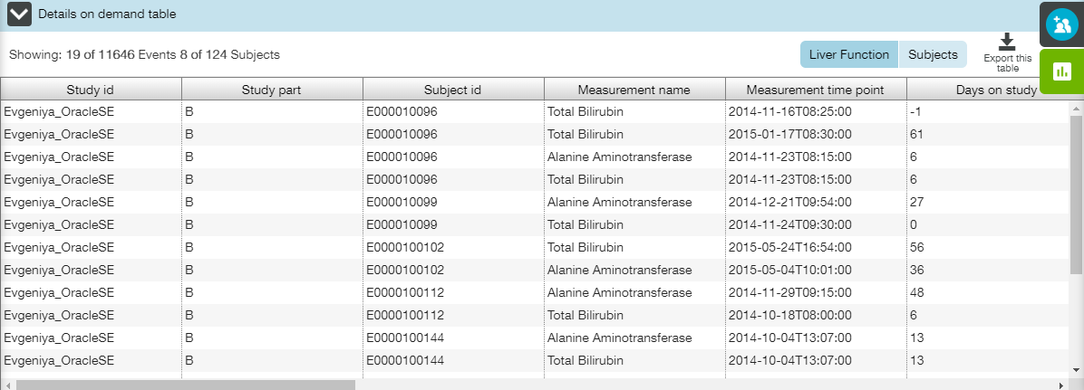

Subjects tab:

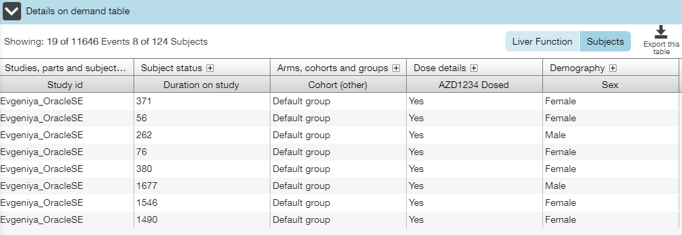

### Jump to Hepatobiliary Disorder AEs

**Jump to hepatobiliary disorder AEs** link allows a user quickly get to contextually relevant AEs view.

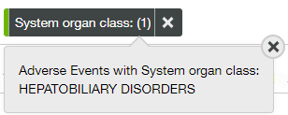When a user jumps, **AEs Subject Counts** tab of the **Adverse Events** view is opened. An event filter is set so that only AEs that belong to the system organ class "Hepatobiliary disorders" are displayed.

**Note**: In the case that other AEs filters are already in place these are maintained.

AE filter widget on the top of the page describes that the set of AEs have been limited based on an AE system organ class.

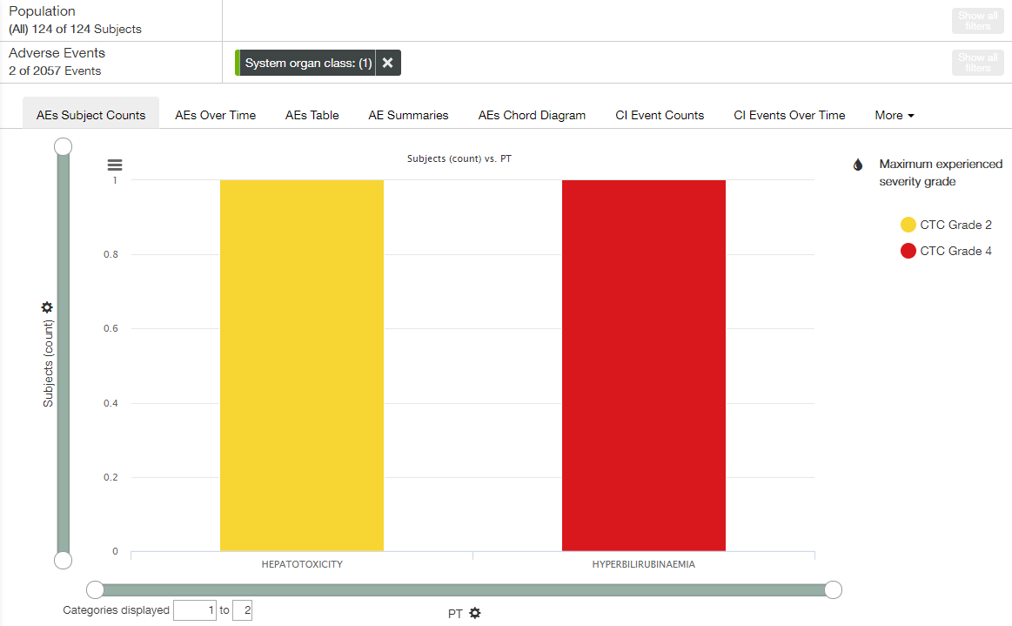

### Jump to Liver-Related Lab Results

**Jump to liver-related lab results** link allows a user quickly get to contextually relevant Labs view.

When a user jumps, **Box Plot** tab of the **Labs** view is opened. An event filter is set so that only the following measurements are displayed:

* Alanine Aminotransferase;
* Alkaline Phosphatase;
* Aspartate Aminotransferase;
* Total Bilirubin.

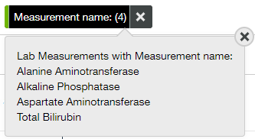

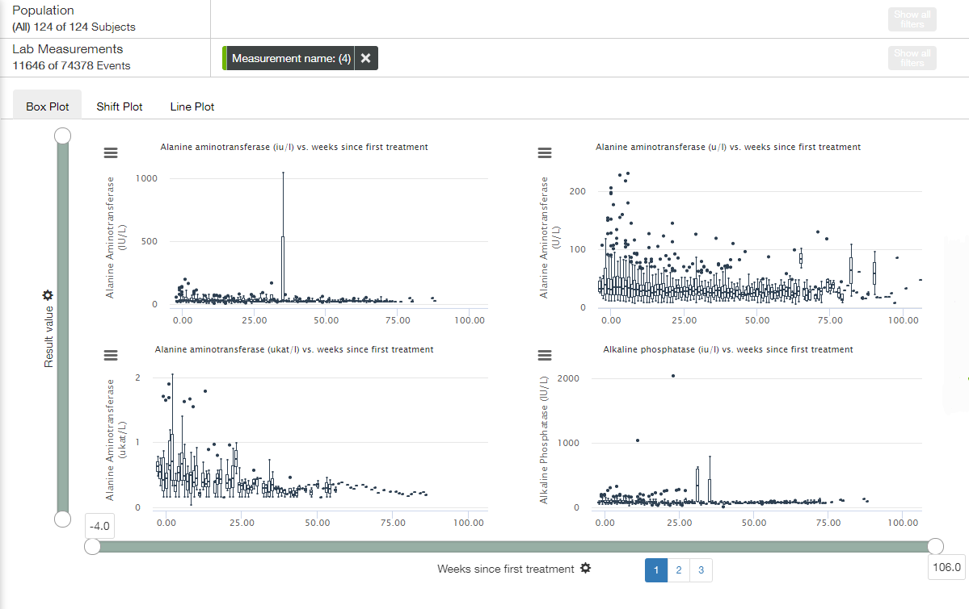

## Renal Function View

**Renal Function** view allows a user to investigate renal health. This view contains two tabs: **Creatinine Clearance** tab and **CKD Distribution** tab, providing a group of plots representing patient data related to the kidney.

The following elements are available for both tabs:

* Population filters (collapsed by default) in the right slide menu (see Population Filters section);
* Cohort filters (collapsed by default) in the right slide menu (see Cohort Filters section);
* Renal filters (collapsed by default) in the right slide menu (see Event Filters section);
* Population filter widget (see Population Filters section);
* Renal Function Measurements filter widget (see Event Filters section).

A user can apply Renal filters to modify a plot.

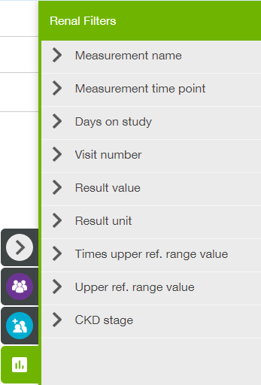

### Creatinine Clearance Tab

**Creatinine Clearance** tab shows creatinine clearance over time for all of the subjects. The tab contains a set of trellised box plots (see **Trellised Plots** section for trellis description).

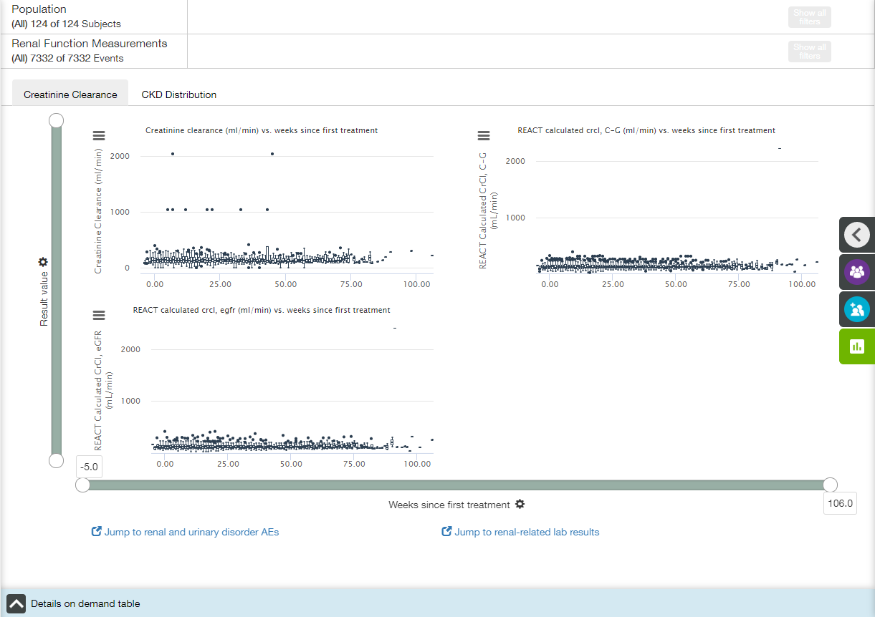

**Note**: 'REACT Calculated CrCl, C-G (mL/min)' and 'REACT Calculated CrCl, eGFR (mL/min)' values are calculated using, respectively, the Cockroft-Gault and eGFR methods.

Main elements available on Creatinine Clearance tab:

* Trellised box plots;
* X- and Y-axis zoom bars (see X and Y Axes Settings section);
* X- and Y-axis controls and titles (see X and Y Axes Settings section);
* Chart context menu icons (see Chart Context Menu section);
* Details on Demand table at the bottom of the screen, collapsed by default (see Details on Demand Table section);
* Jump to renal and urinary disorder AEs link;
* Jump to renal-related lab results link.

X axis

The title of the X-axis is **Weeks since first treatment** by default.  X axis has time binning (see Time Binning section for details).

Value of X-axis could be changed by choosing one of the options from dropdown list under the plot:

* Visit number;
* Days since first treatment;
* Weeks since first treatment;
* Days since randomisation;
* Weeks since randomisation.

 

Y axis

The default title of the Y-axis is **Result value**.

Value of Y-axis could be changed by choosing one of the options from dropdown list:

* Ref range norm. value;
* Times upper ref. value;
* Times lower ref. value;
* Absolute change from baseline;
* Percentage change from baseline;
* Result value.



Tooltips

When a user hovers the cursor over a point, the tooltip with the following fields is displayed:

* X-axis value;
* Y-axis value;
* Subject ID: <value>.

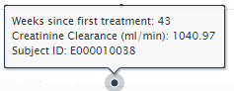

When a user hovers the cursor over a box, the tooltip with the following fields is displayed:

* X-axis value;
* Upper whisker: <value>;
* Upper quartile: <value>;
* Median: <value>;
* Lower quartile: <value>;
* Lower whisker: <value>.

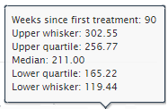

Details on Demand table

Details on Demand table contains two tabs: Renal Function tab and Subjects tab.

Renal Function tab:

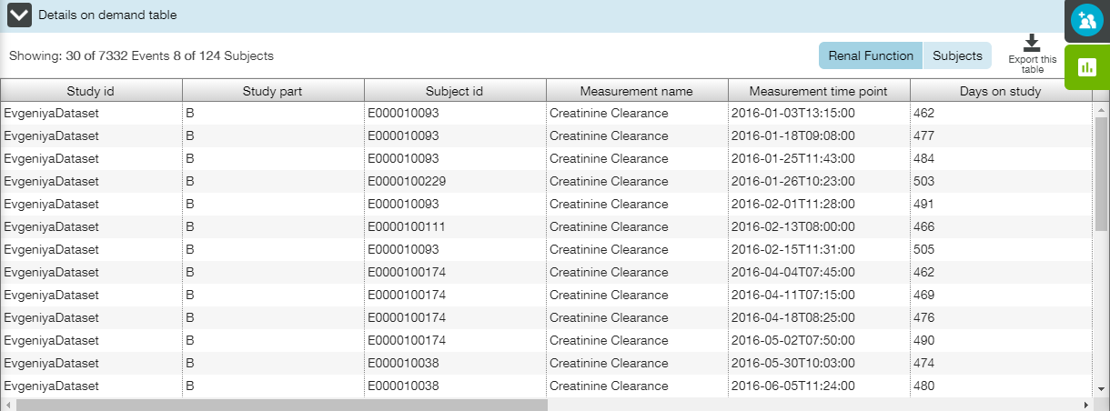

Subjects tab:

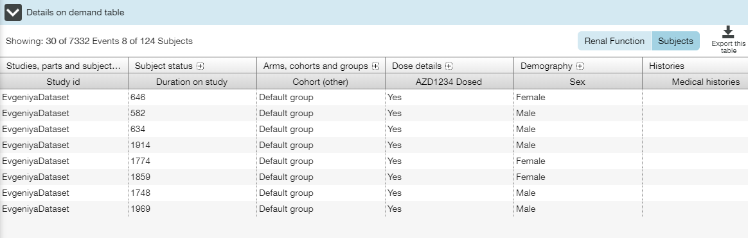

#### Jump to Renal and Urinary Disorder AEs Link

Jump to renal and urinary disorder AEs link allows a user quickly get to contextually relevant AEs view.

When a user jumps, **AEs Subject Counts** tab of the **Adverse Events** view is opened. An event filter is set so that only AEs that belong to the system organ class "Renal and Urinary disorders" are displayed.

**Note**: In the case that other AEs filters are already in place these are maintained.

AE filter widget on the top of the page describes that the set of AEs have been limited based on an AE system organ class(-es): RENAL and/or RENAL AND URINARY DISORDERS.

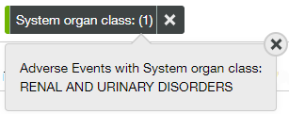

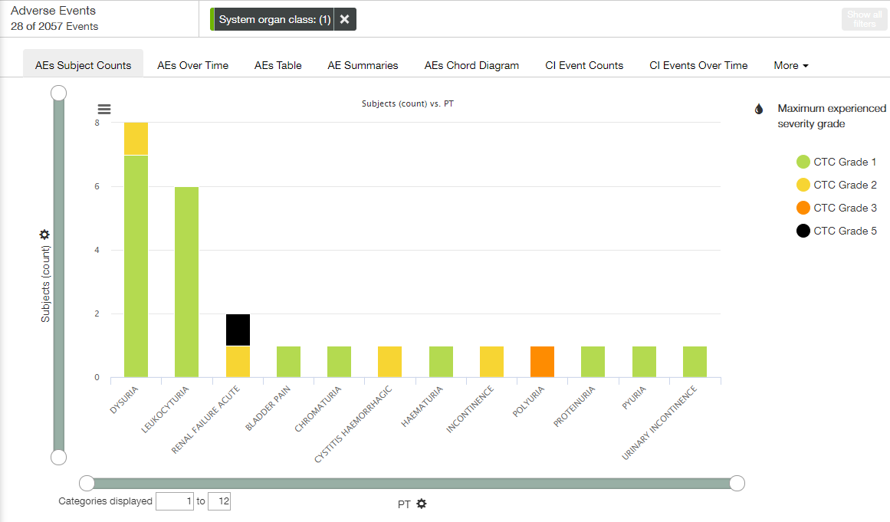

#### Jump to Renal-related Lab Results Link

**Jump to renal-related lab results** link allows a user quickly get to contextually relevant Labs view.

When a user jumps, **Box Plot** tab of the **Labs** view is opened. An event filter is set so that only the following measurements are displayed:

* Creatinine;
* Creatinine Clearance;
* Urea Nitrogen.

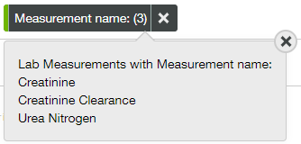

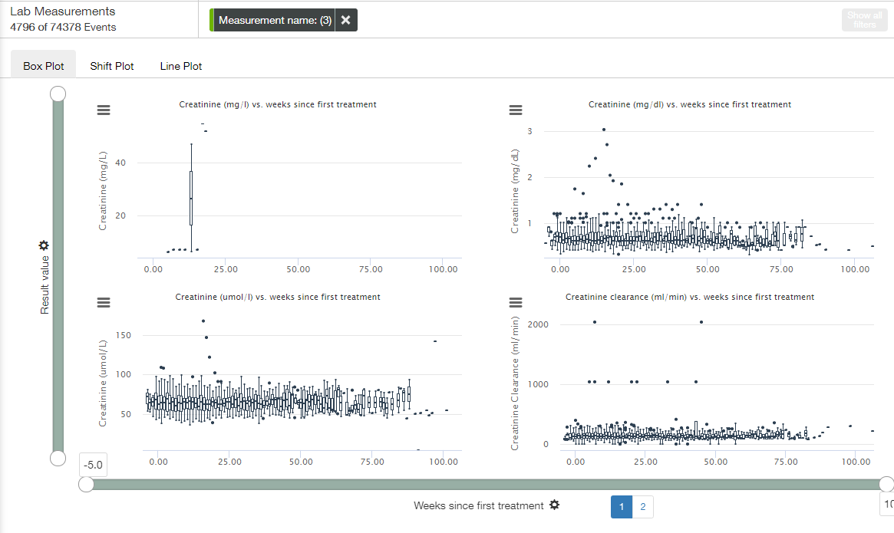

### CKD Distribution Tab

**CKD Distribution** tab shows distribution of subjects into chronic kidney disease (CKD) stages. The tab contains a set of trellised stacked bar plots (see **Trellised Plots** section for trellis description).

Creatinine clearance levels are directly associated with levels of CKD stage and these are easily derived from creatinine clearance values by a simple binning of values.

The CKD stages used are as follows, where stage 5 is more severe (a lower rate of creatinine clearance) than stage 1:

* CKD Stage 1: 90 <= x;
* CKD Stage 2: 60 <= x < 90;
* CKD Stage 3: 30 <= x < 60;
* CKD Stage 4: 15 <= x < 30;
* CKD Stage 5: <15.

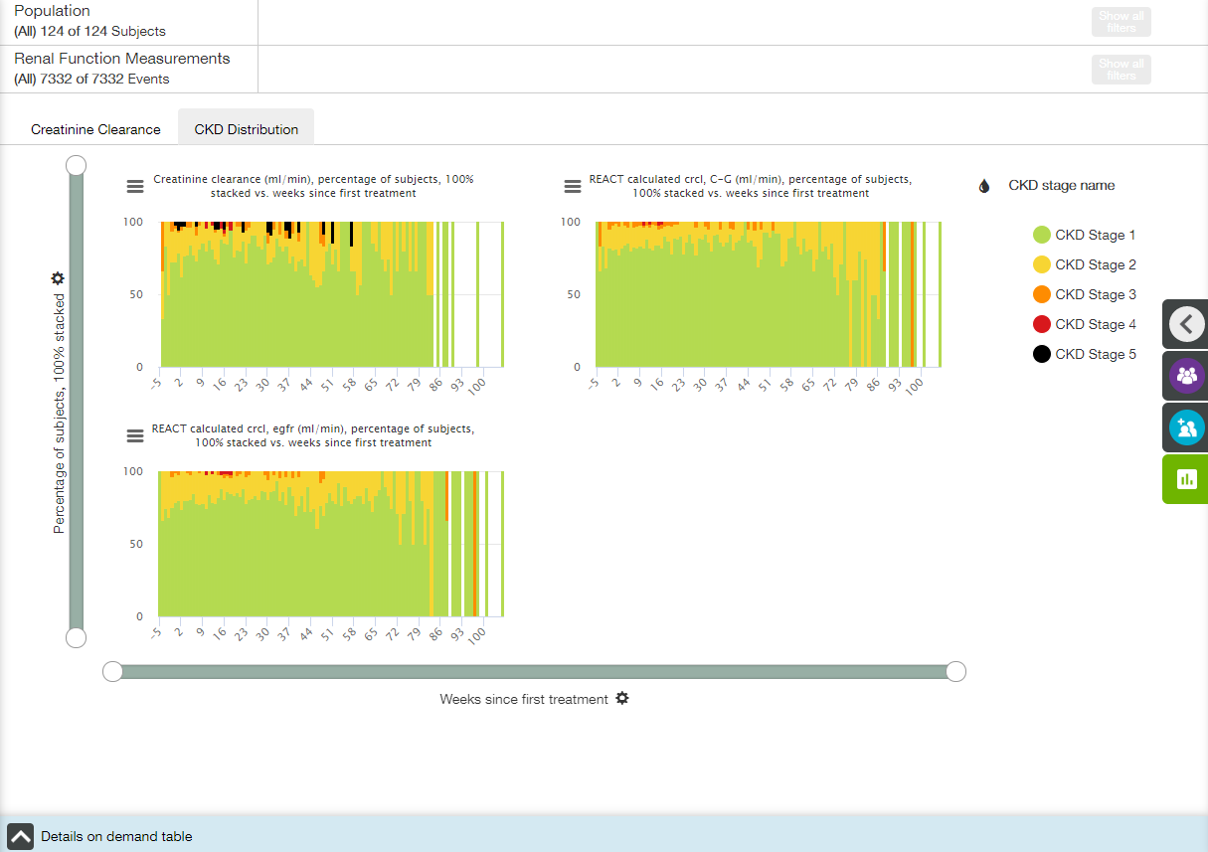

Main elements available on CKD Distribution tab:

* Trellised bar plots;
* X- and Y-axis zoom bars (see X and Y Axes Settings section);
* X- and Y-axis controls and titles (see X and Y Axes Settings section);
* Coloring control (see Coloring section);
* Chart context menu icons (see Chart Context Menu section);
* Details on Demand table at the bottom of the screen, collapsed by default (see Details on Demand Table section).

X axis

The title of the X-axis is **Weeks since first treatment** by default.  X axis has time binning (see Time Binning section for details).

Value of X-axis could be changed by choosing one of the options from dropdown list under the plot:

* Visit number;
* Days since first treatment;
* Weeks since first treatment;
* Days since randomisation;
* Weeks since randomisation.

 

Y axis

The title of the Y-axis is **Percentage of subjects, 100% stacked**, and no other option is available.

Coloring

Appropriate menu provides a user with the following options:

* All;
* CDK stage name (selected by default).

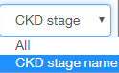

Tooltips

When a user hovers the cursor over a bar, the tooltip with the following fields is displayed:

* X-axis value;
* Y-axis value;
* Coloring option value.

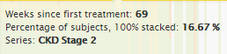

Details on Demand table

Details on Demand table contains two tabs: Renal Function tab and Subjects tab.

Renal Function tab:

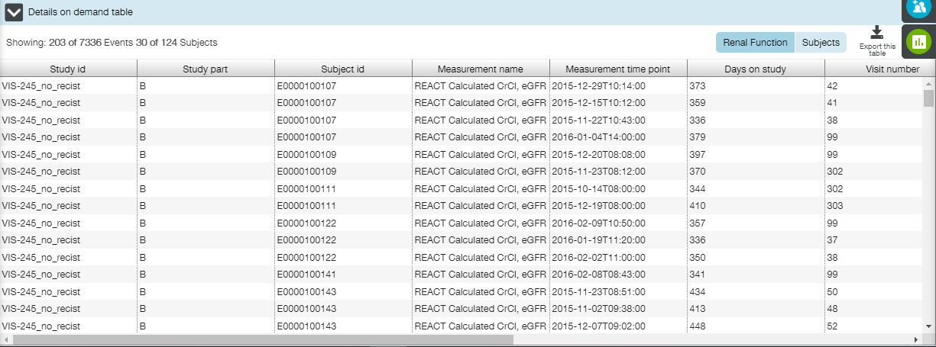

Subjects tab:

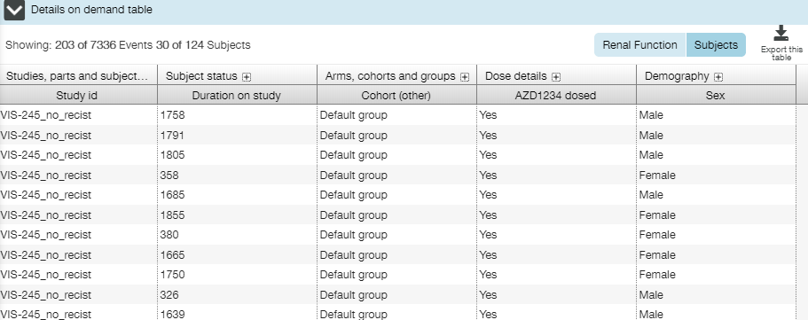

## Respiratory View

**Respiratory** view allows a user to browse respiratory measurements. This view contains four tabs:

* Exacerbations Counts tab;
* Lung Function Measurements Over Time tab;
* Exacerbations Over Time tab;
* Exacerbations Onset tab.

The following elements are available for all tabs:

* Population filters (collapsed by default) in the right slide menu (see Population Filters section);
* Cohort filters (collapsed by default) in the right slide menu (see Cohort Filters section);
* Population filter widget (see Population Filters section);
* Respiratory Measurements filter widget (see Event Filters section).

Exacerbations filters panel is available for all tabs but **Lung Function Measurements Over Time** tab.

### Exacerbations Counts Tab

**Exacerbations Counts** tab shows the counts and maximum recorded severity of each recorded exacerbation. The bar plot counts exacerbations and sets of subjects that have experienced an exacerbation. Only subjects with exacerbations are displayed on this plot.

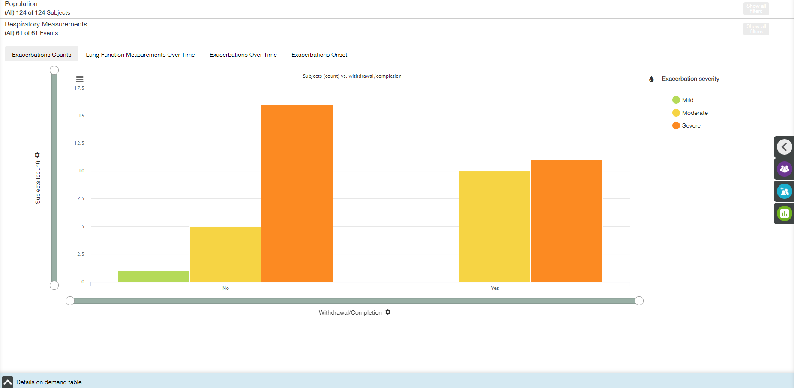

Main elements available on Exacerbations Counts tab:

* Bar plot;
* X- and Y-axis zoom bars (see X and Y Axes Settings section);
* X- and Y-axis controls and titles (see X and Y Axes Settings section);
* Coloring control (see Coloring section);
* Chart context menu icon (see Chart Context Menu section);
* Details on Demand table at the bottom of the screen, collapsed by default (see Details on Demand Table section).

X axis

The title of the X-axis is **Withdrawal/Completion** by default.  X axis has time binning (see Time Binning section for details).

Value of X-axis could be changed by choosing one of the options from dropdown list under the plot:

* All;
* Study ID;
* Study name;
* Study part ID;
* Duration on study;
* Randomisation Date;
* Withdrawal/Completion;
* Reason for withdrawal;
* Center;
* Sex;
* Race;
* Age;
* Weight;
* Height;
* First Treatment date;
* Death;
* Date of death.

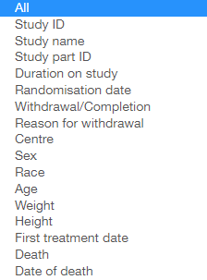

Y axis

The default title of the Y-axis is **Subjects (count)**. **Y** **Axis Settings** menu provides a user with the following settings:

* Y axis measure;
* Unit of measure.

  

Coloring

Appropriate menu provides a user with the following options:

* All;
* Exacerbation severity(selected by default);
* Hospitalisation;
* Emergency room visit;
* Depot corticosteroid treatment;
* Increased inhaled corticosteroid treatment;
* Systemic corticosteroid treatment;
* Antibiotics treatment.

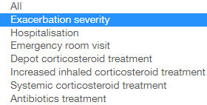

Tooltips

When a user hovers the cursor over a bar, the tooltip with the following fields is displayed:

* X-axis value;
* Y-axis value;
* Coloring option value.

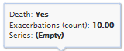

Details on Demand table

Details on Demand table contains two tabs: Exacerbations tab and Subjects tab.

Exacerbations tab:

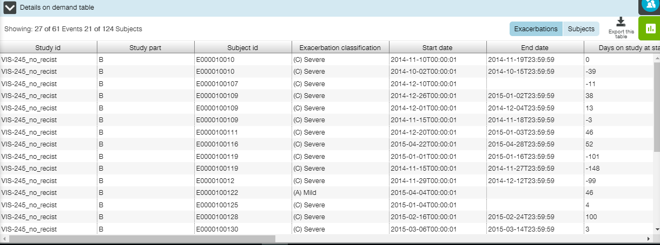

Subjects tab:

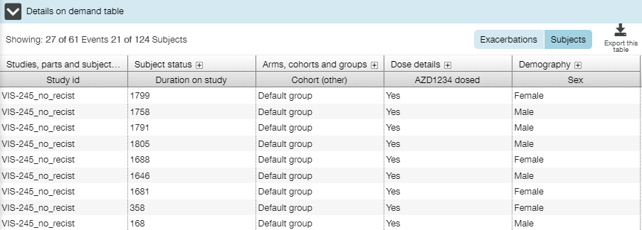

### Lung Function Measurements Over Time Tab

**Lung Function Measurements Over Time** tab displays lung function measurements for all subjects. The tab contains a set of trellised box plots (see **Trellised Plots** section for trellis description).

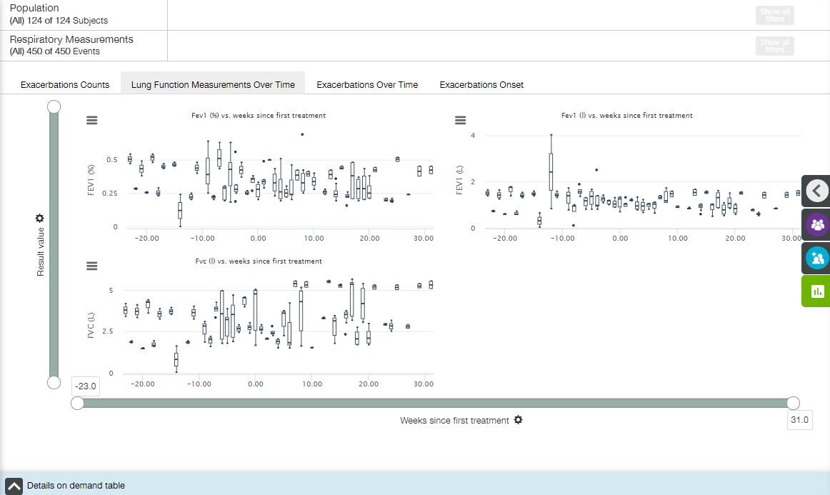

Main elements available on the Lung Function Measurements Over Time tab are the following:

* Trellised box plots;
* X- and Y-axis zoom bars (see X and Y Axes Settings section);
* X- and Y-axis controls and titles (see X and Y Axes Settings section);
* Chart context menu icon (see Chart Context Menu section);
* Details on Demand table at the bottom of the screen, collapsed by default (see Details on Demand Table section).

X axis

The title of the X-axis is **Weeks since first treatment** by default.  X axis has time binning (see Time Binning section for details).

Value of X-axis could be changed by choosing one of the options from dropdown list under the plot:

* Visit number;
* Days since first treatment;
* Weeks since first treatment;
* Days since randomisation;
* Weeks since randomisation.

 

Y axis

The default title of the Y-axis is **Result value**.

Value of Y-axis could be changed by choosing one of the options from dropdown list:

* Result value;
* Absolute change from baseline;
* Percentage change from baseline.

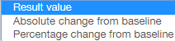

Tooltips

When a user hovers the cursor over a point, the tooltip with the following fields is displayed:

* X-axis value;
* Y-axis value;
* Subject ID: <value>.

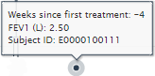

When a user hovers the cursor over a box, the tooltip with the following fields is displayed:

* X-axis value;
* Upper whisker: <value>;
* Upper quartile: <value>;
* Median: <value>;
* Lower quartile: <value>;
* Lower whisker: <value>.

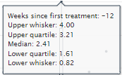

Lung Function Filters

A user can apply Lung Function filters to modify the plot.

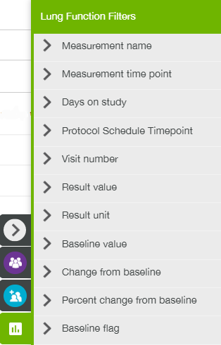

Details on Demand table

Details on Demand table contains two tabs: Lung Function tab and Subjects tab.

Lung Function tab:

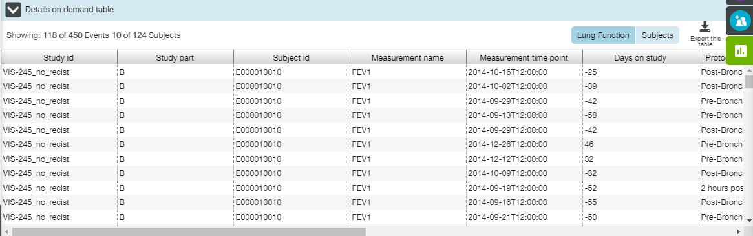

Subjects tab:

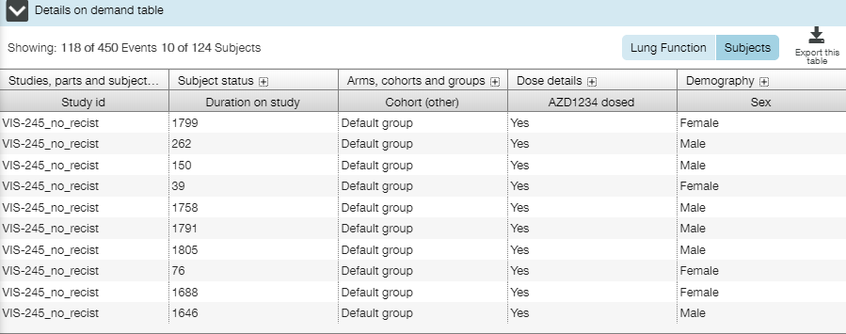

### Exacerbations Over Time Tab

**Exacerbations Over Time** tab is visualized by the incidence rate and occurrence of each exacerbation event over time. The bar plot displays exacerbations counts against time.

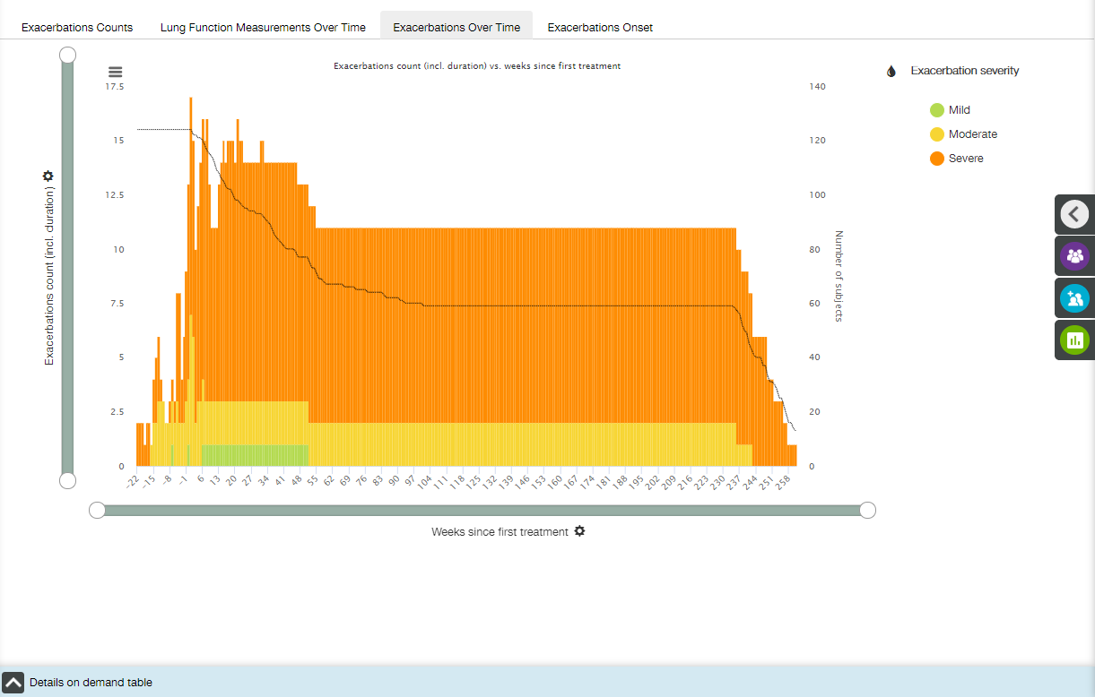

Main elements available on the Exacerbations Over Time tab are the following:

* Bar plot;
* X- and Y-axis zoom bars (see X and Y Axes Settings section);
* X- and Y-axis controls and titles (see X and Y Axes Settings section);
* Z-axis title;
* Coloring control (see Coloring section);
* Chart context menu icon (see Chart Context Menu section);
* Details on Demand table at the bottom of the screen, collapsed by default (see Details on Demand Table section).

X axis

The title of the X-axis is **Weeks since first treatment** by default.  X axis has time binning (see Time Binning section for details).

Value of X-axis could be changed by choosing one of the options from dropdown list under the plot:

* Days since first treatment;
* Weeks since first treatment;
* Days since randomisation;
* Weeks since randomisation.

 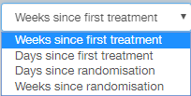

Y axis

The default title of the Y-axis is **Exacerbations count (incl. duration).**

Value of Y-axis could be changed by choosing one of the options from dropdown list:

* Exacerbations count (incl. duration);
* Exacerbations count (start dates only).

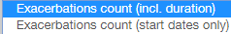

**Note**: “Exacerbations count (incl. duration)” option counts any given exacerbation event across all X axis categories in which the event was present. “Exacerbations count (start days only)’ option counts exacerbation events in the X category in which they started (according to the exacerbation event start date).

Z-axis

The plot includes a Z axis that is a single grey line that displays the total number of subjects on the study at the given point in time.

The line isn't angled between data points but 'steps' downward each time a subject leaves, as in the example. For points in time up to and including day zero (including negative values) the number of subjects is assumed to be equal to the number of subjects at day zero.

Y zoom bar also affects the Z axis.

Coloring

Appropriate menu provides a user with the following options:

* All;
* Exacerbation severity(selected by default);
* Hospitalisation;
* Emergency room visit;
* Depot corticosteroid treatment;
* Increased inhaled corticosteroid treatment;
* Systemic corticosteroid treatment;
* Antibiotics treatment.



Tooltips

When a user hovers the cursor over a bar, the tooltip with the following fields is displayed:

* X-axis value;
* Z-axis value;
* Y-axis value for each coloring value;
* Coloring option value.

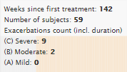

Details on Demand table

Details on Demand table contains two tabs: Exacerbations tab and Subjects tab.

Exacerbations tab:

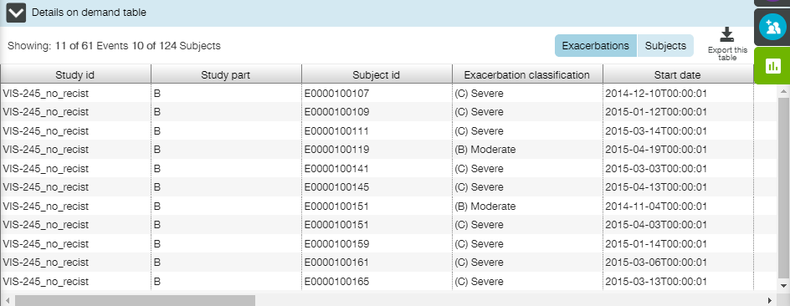

Subjects tab:

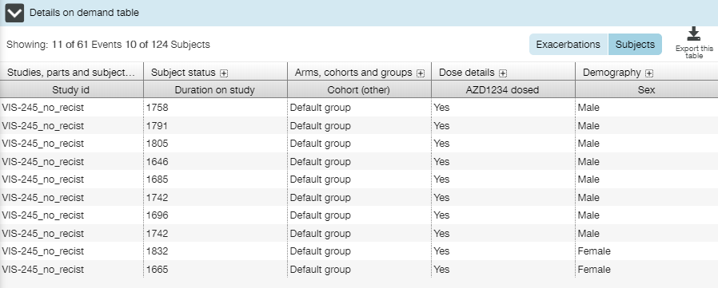

### Exacerbations Onset Tab

Exacerbations Onset tab contains a line plot that shows the change of event or subject count over time.

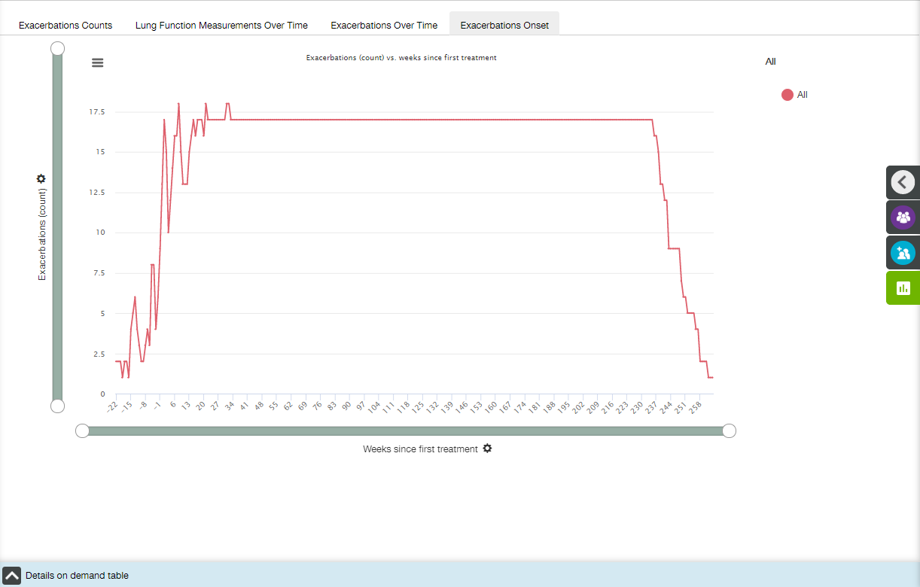

Main elements available on the Exacerbations Onset tab are the following:

* Line plot;
* X- and Y-axis zoom bars (see X and Y Axes Settings section);
* X- and Y-axis controls and titles (see X and Y Axes Settings section);
* Coloring control (see Coloring section);
* Chart context menu icon (see Chart Context Menu section);
* Details on Demand table at the bottom of the screen, collapsed by default (see Details on Demand Table section).

X axis

The title of the X-axis is **Weeks since first treatment** by default.  X axis has time binning (see Time Binning section for details).

Value of X-axis could be changed by choosing one of the options from dropdown list under the plot:

* Days since first treatment;
* Weeks since first treatment;
* Days since randomisation;
* Weeks since randomisation.

 

Y axis

The default title of the Y-axis is **Exacerbations (count).**

Value of Y-axis could be changed by choosing one of the options from dropdown list:

* Exacerbations (count);
* Cumulative exacerbation count;
* Subjects (count);
* Cumulative subject count.

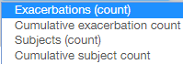

Coloring

Coloring option has **All** value only.

Tooltips

When a user hovers the cursor over a bar, the tooltip with the following fields is displayed:

* Coloring option value;
* Y-axis value;
* X-axis value.

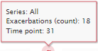

Details on Demand table

Details on Demand table contains two tabs: Exacerbations tab and Subjects tab.

Exacerbations tab:

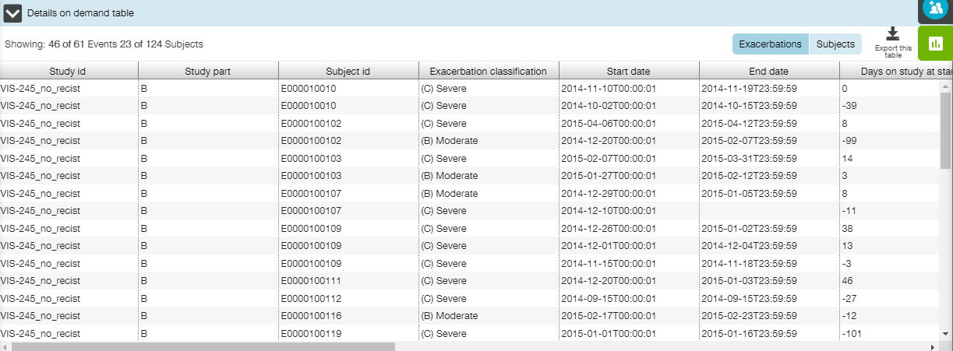

Subjects tab:

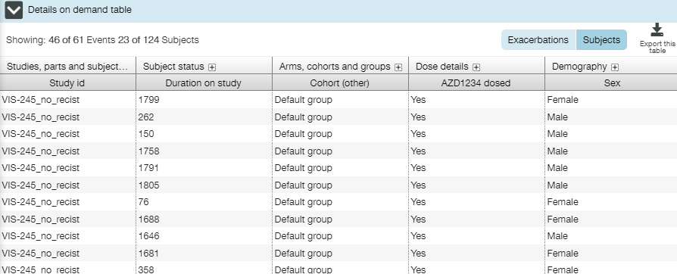

## Tumour Response View

**Tumor Response** view allows a user to investigate cancer patients’ data that have been recorded for subjects in order to evaluate tumor response to the particular treatment.

Three tabs are available on the **Tumor Response** view:

* Waterfall Plot tab;
* TL Diameters over Time tab;
* Prior Therapy vs. Time on Compound tab.

The following elements are available for all tabs:

* Population filters (collapsed by default) in the right slide menu (see Population Filters section);
* Cohort filters (collapsed by default) in the right slide menu (see Cohort Filters section);
* Population filter widget (see Population Filters section).

Additionally, specific Events Filters followed by Event filter widget, and Settings panels are available for some tabs.

### Waterfall Plot Tab

**Waterfall Plot** tab displays the waterfall plot that presents each individual patient’s response to a particular drug based on a parameter, such as tumor burden.

X axis across the plot serves as a baseline measure; vertical bars are drawn for each patient, either above or below the baseline. Y axis may be used to measure maximum percent change from baseline, e.g., percent growth or reduction of the tumor by some measurement.

**Note**: Results of the first assessment nearest (in time) to the date of the first dose are taken as a baseline for each patient.

Waterfall plot goes from the worst value, such as greatest progression of disease, on the left side of the plot, to the best value, i.e., most reduction of tumor, on the right side of the plot Thus, the data are organized in order to provide a clear picture of the study population’s results: from worst to best, based on the parameters included.

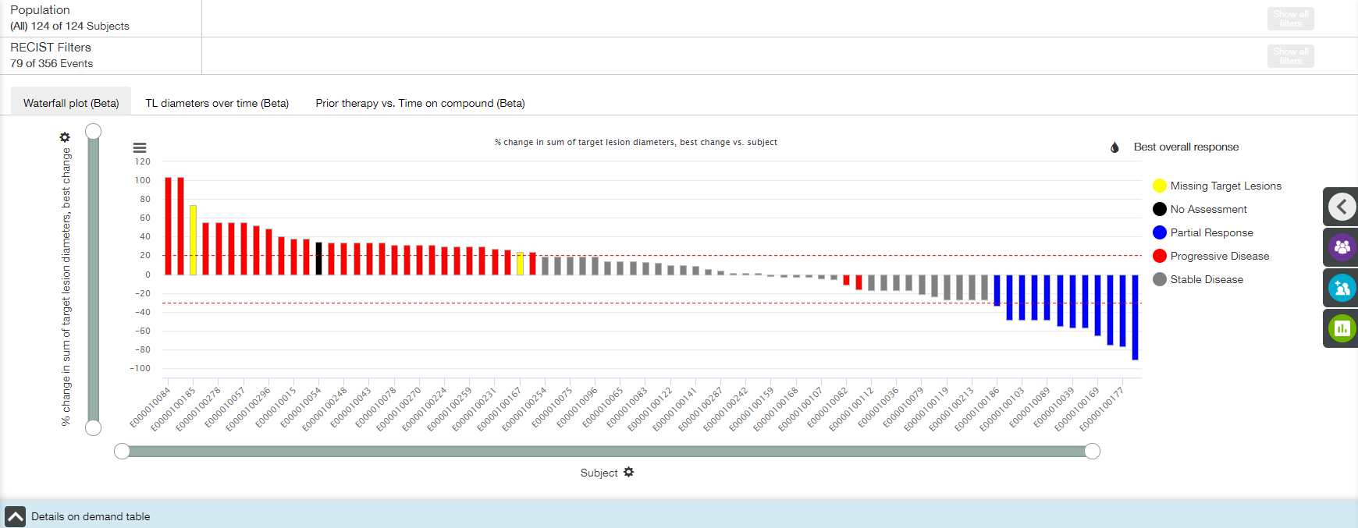

Main elements available on Waterfall Plot tab:

* Bar plot;
* X- and Y-axis zoom bars (see X and Y Axes Settings section);
* X- and Y-axis controls and titles (see X and Y Axes Settings section);
* Coloring control (see Coloring section);
* Chart context menu icons (see Chart Context Menu section);
* Details on Demand table at the bottom of the screen, collapsed by default (see Details on Demand Table section).

X axis

The title of the X-axis is **Subject**, and no other option is available.

Y axis

The default title of the Y-axis is **% change in sum of target lesion diameters, best change.**

Value of Y-axis could be changed by choosing one of the options from dropdown list:

* Best change;
* Week 6;
* Week 12;
* Week 18;
* …

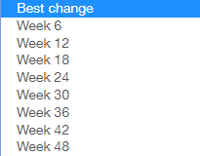

Coloring

Appropriate menu does not allow a user to change the coloring. The diagram is colored in accordance with the best overall response levels:

* Missing Target Lesions – data for some target lesions are missed;
* No Assessment – particular assessment is missed;
* Partial Response – overall response to the treatment can be treated as valuable (Y-axis value is less than -30%);
* Progressive Disease – overall response to the treatment can be treated as low (Y-axis value is more than +20%);
* Stable Disease – overall response to the treatment can be treated as medium.

**Note**: Two dashed lines (+20% and -30%) indicates borders of Stable Disease condition.

Tooltips

When a user hovers the cursor over a point, the tooltip with the following fields is displayed:

* X-axis value;
* Y-axis value;
* Coloring option value.

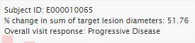

RECIST filters

A user can apply RECIST filters to modify a plot.

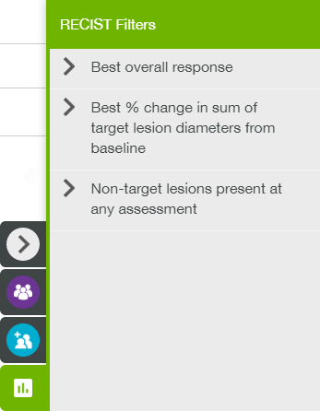

Details on Demand table

Details on Demand table contains only Subjects tab.

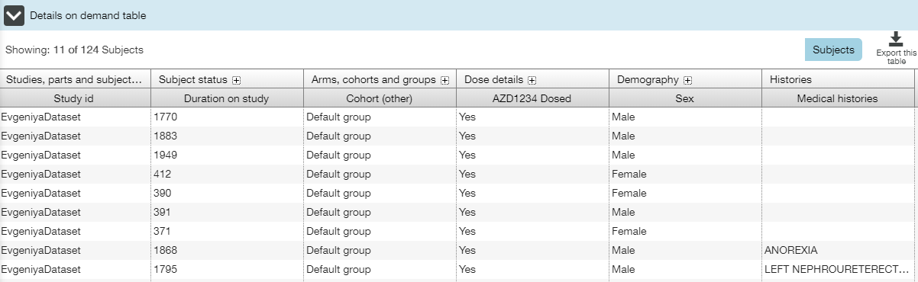

### TL Diameters over Time Tab

**TL Diameters over Time** tab shows a user target lesions’ size time dependence for each subject.

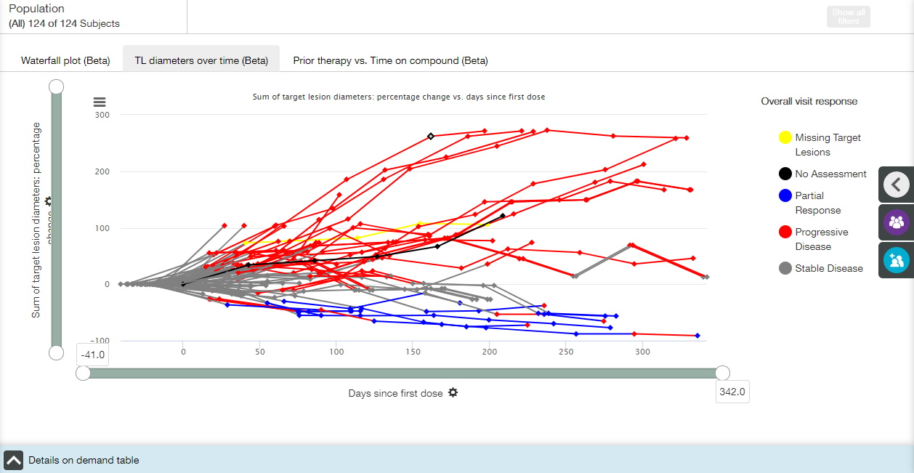

Main elements available on TL Diameters over Time tab:

* Line plot;
* X- and Y-axis zoom bars (see X and Y Axes Settings section);
* X- and Y-axis controls and titles (see X and Y Axes Settings section);
* Coloring control (see Coloring section);
* Chart context menu icons (see Chart Context Menu section);
* Details on Demand table at the bottom of the screen, collapsed by default (see Details on Demand Table section).

X axis

The default title of the X-axis is **Days since first dose.**

Value of X-axis could be changed by choosing one of the options from dropdown list under the plot:

* Days since first dose;
* RECIST assessment week.

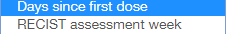

Y axis

The default title of the Y-axis is **Sum of target lesions diameters: percentage change.**

Value of Y-axis could be changed by choosing one of the options from dropdown list:

* Sum of target lesions diameters: percentage change;
* Sum of target lesions diameters: absolute value (mm);
* Sum of target lesions diameters: absolute change (mm).

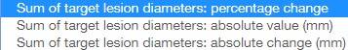

Coloring

Appropriate menu does not allow a user to change the coloring. The diagram is colored in accordance with the overall visit response levels:

* Missing Target Lesions – data for some target lesions are missed;
* No Assessment – particular assessment is missed;
* Partial Response – overall response to the treatment can be treated as valuable (Y-axis value is less than -30%);
* Progressive Disease – overall response to the treatment can be treated as low (Y-axis value is more than +20%);
* Stable Disease – overall response to the treatment can be treated as medium.

Tooltips

When a user hovers the cursor over a point, the tooltip with the following fields is displayed:

* Subject Number: <value>;
* X-axis value;
* Y-axis value;
* Coloring option value.

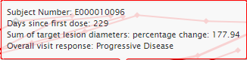

Details on Demand table

Details on Demand table contains two tabs: RECIST tab and Subjects tab.

RECIST tab:

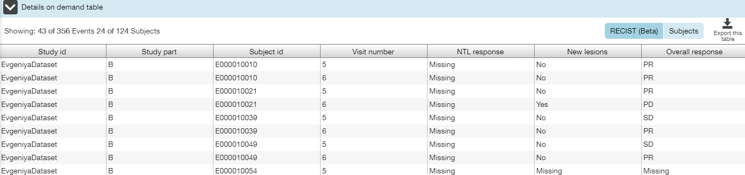

Subjects tab:

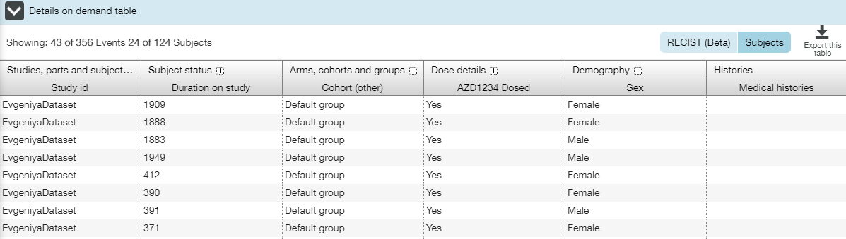

### Prior Therapy vs. Time on Compound Tab

**Prior Therapy vs. Time on Compound** tab shows chemo- and radiotherapies occurred before study treatment was started (negative direction) and during study treatment (positive direction).

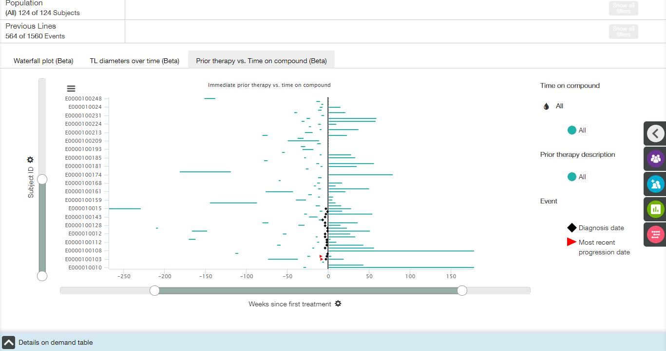

Main elements available on Prior Therapy vs. Time on Compound tab:

* Horizontal bar plot;
* X- and Y-axis zoom bars (see X and Y Axes Settings section);
* X- and Y-axis controls and titles (see X and Y Axes Settings section);
* Coloring control (see Coloring section);
* Chart context menu icons (see Chart Context Menu section);
* Details on Demand table at the bottom of the screen, collapsed by default (see Details on Demand Table section).

X axis

The title of the X-axis is **Weeks since first treatment**, and no other option is available.

Y axis

The title of the Y-axis is **Subject ID**, and no other option is available.

Coloring

Coloring control is combined with legend. **Event** and **Prior therapy description** colors cannot be changed, whereas **Time on compound** coloring is adjustable.

Appropriate menu provides a user with the following options:

* All;
* Cohort (Dose);
* Max. dose per admin <medication name>.

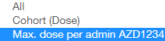

Tooltips

When a user hovers the cursor over a bar, the tooltip with the following fields is displayed:

* Subject ID: <value>;
* Therapy: <value>;
* Duration of therapy: <value>.

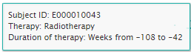

When a user hovers the cursor over an event icon, the tooltip with the following fields is displayed:

* Subject ID: <value>;
* <Event value>: <date value>;
* Weeks since first treatment: <value>.

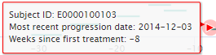

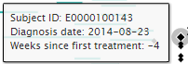

Previous Lines filters

A user can apply Previous Lines filters to modify a plot.

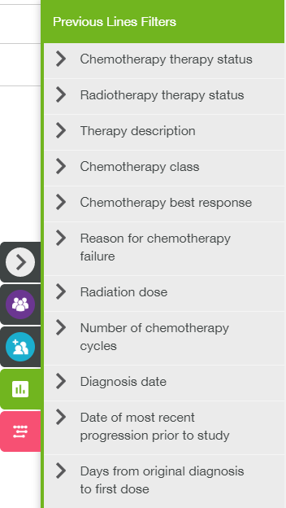

Prior Therapy Settings

Prior Therapy Settings panel allows a user to select therapies only.

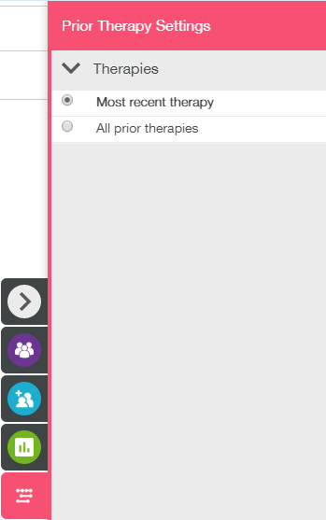

Details on Demand table

Details on Demand table contains Subjects tab only.

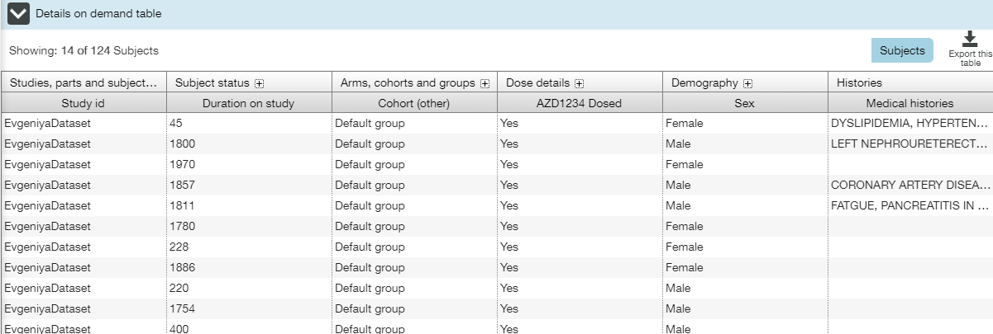

## Oncogenic Biomarkers View

Oncogenic Biomarkers view allows a user to investigate some cancer-related genomic information. This view contains two tabs:

* Genomic Profile tab;
* ctDNA tab.

The following elements are available for both tabs:

* Population filters (collapsed by default) in the right slide menu (see Population Filters section);
* Cohort filters (collapsed by default) in the right slide menu (see Cohort Filters section);
* Event filters (collapsed by default) in the right slide menu (see Event Filters section);
* Settings (collapsed by default) in the right slide menu (see Settings section);
* Population filter widget (see Population Filters section);
* Event filter widget (see Event Filters section).

**Note**: Additional settings in the VA-Security application should be specified for Oncogenic Biomarkers view to be available for a particular user.

### Genomic Profile Tab

Genomic Profile plot displays genomic profile for each subject, with altered genes being colored. Genes are organized by gene percentage prevalence increasing.

**Note**: Percentage prevalence is calculated as follows:(number of patients with an alteration in a particular gene in the oncoprint / total number of subjects displayed in the oncoprint)*100.

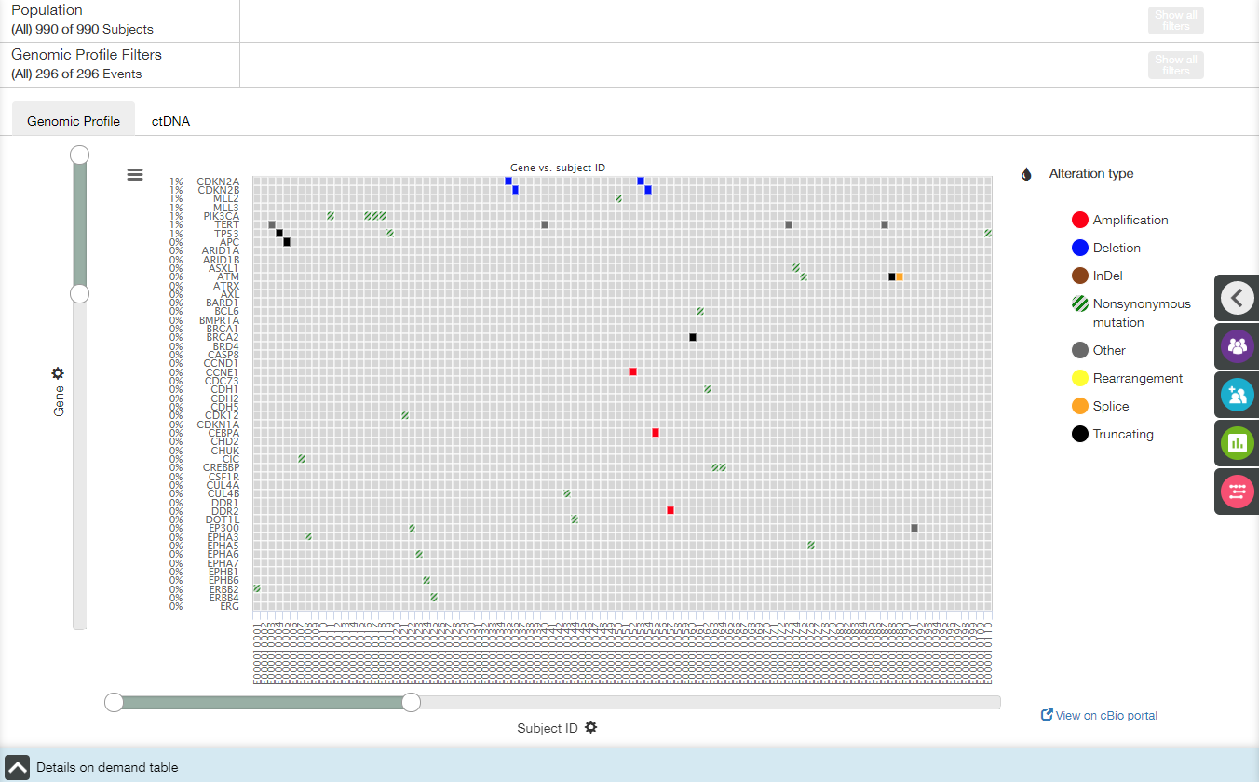

If number of subjects exceeds 100 and/or number of genes exceeds 50, the following warning appears:

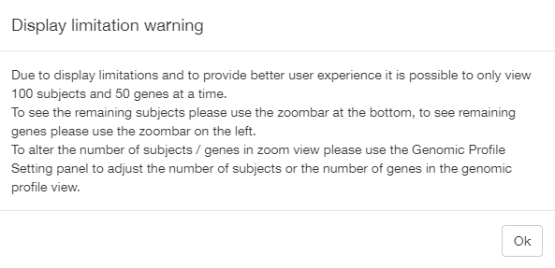

Main elements available on Waterfall Plot tab:

* Plot;
* X- and Y-axis zoom bars (see X and Y Axes Settings section);
* X- and Y-axis controls and titles (see X and Y Axes Settings section);
* Coloring control (see Coloring section);
* Chart context menu icons (see Chart Context Menu section);
* Details on Demand table at the bottom of the screen, collapsed by default (see Details on Demand Table section);
* **View on cBio portal** link.

X axis

The title of the X-axis is **Subject ID**, and no other option is available.

Y axis

The title of the Y-axis is **Gene**, and no other option is available.

Coloring

Appropriate menu does not allow a user to change the coloring. The diagram is colored in accordance with available gene alteration types.

Tooltips

When a user hovers the cursor over a colored box, the tooltip with the following fields is displayed:

* X-axis value;
* Y-axis value;
* Total number of alterations: <value>;
* Table with alteration description.

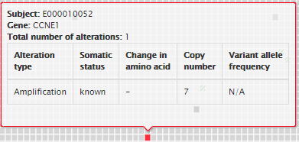

Genomic Profile filters

A user can apply Genomic Profile filters to modify a plot.

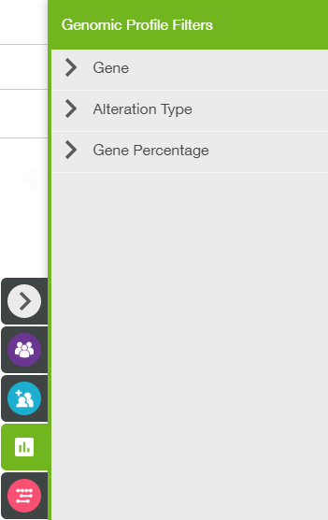

Genomic Profile settings

Genomic Profile Settings panel allows a user to define a number of subjects/genes to be displayed on the plot (not more than 100 subjects*50 genes).

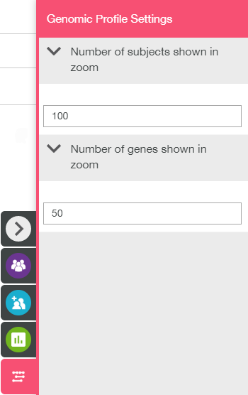

Details on Demand table

Details on Demand table contains two tabs: Genomic Profile tab and Subjects tab.

Genomic Profile tab:

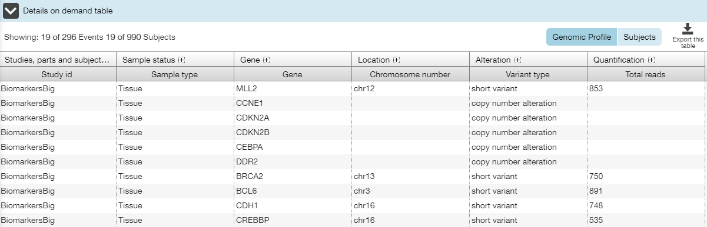

Subjects tab:

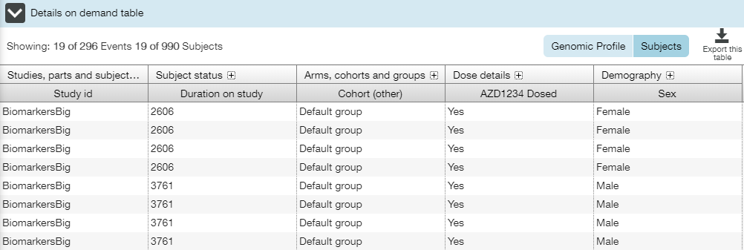

#### View on cBio Portal Link

**Genomic Profile** tab provides a user with possibility to open cBioPortal application, work there with appropriate genomic data, and return to VA-Hub.

**Note:** Appropriate settings are specified in the AdminUI application during the clinical study setup. If the link is absent, it means that these settings were not specified for the particular dataset.

**View on cBio portal** link allows a user quickly get to cBio portal. The linked cBioportal instance opens in a new browser tab, allowing a user to enter appropriate credentials and log in.

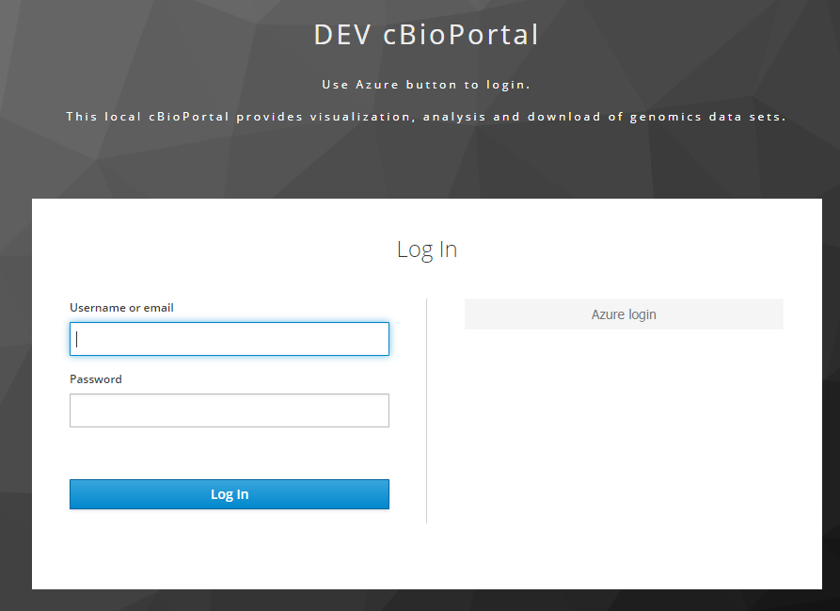

### ctDNA Tab

**ctDNA** tab allows a user to browse variant allele frequency of circulating tumor DNAs (ctDNAs) time dependence for each subject.

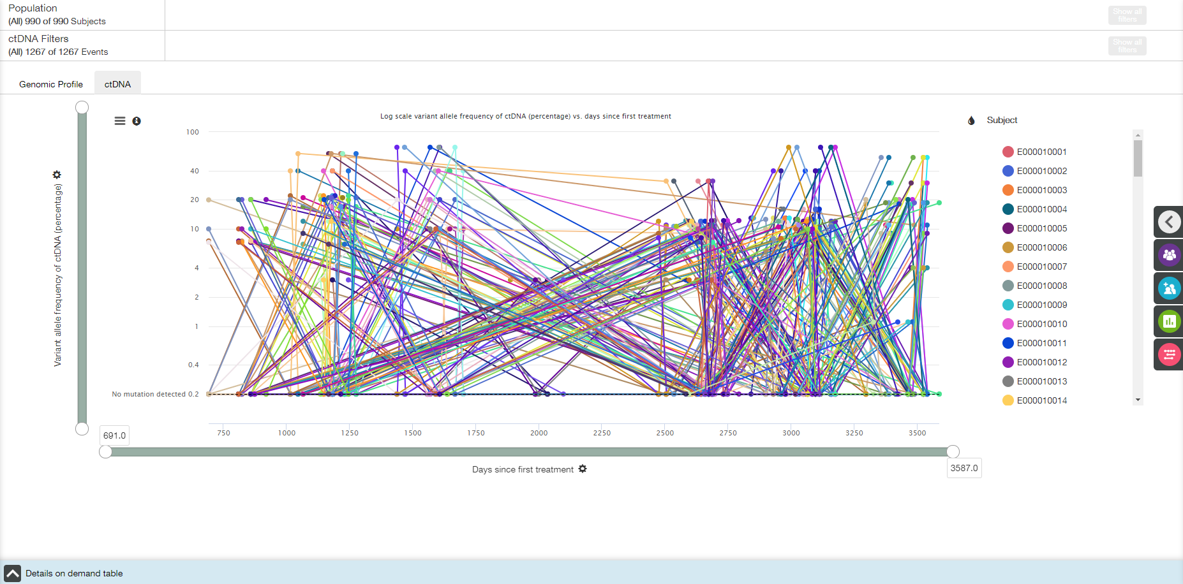

Line segments connect dots that correspond to the same subject, gene and mutation.

**Note**: Dashed line at 0.2%/0.002 fraction indicates lower limit of detection.

Main elements available on the ctDNA tab are the following:

* Line plot;
* X- and Y-axis zoom bars (see X and Y Axes Settings section);
* X- and Y-axis controls and titles (see X and Y Axes Settings section);
* Coloring control (see Coloring section);
* Chart context menu icon (see Chart Context Menu section);
* Information icon besides the Chart context menu icon;
* Details on Demand table at the bottom of the screen, collapsed by default (see Details on Demand Table section).

X axis

The title of the X-axis is **Days since first treatment** by default.

Value of X-axis could be changed by choosing one of the options from dropdown list under the plot:

* Days since first treatment;
* Visit number;
* Visit day.

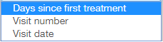

Y axis

The title of the Y-axis is **Variant allele frequency of ctDNA (percentage)** by default.

Value of Y-axis could be changed by choosing one of the options from dropdown list:

* Variant allele frequency of ctDNA (percentage);
* Variant allele frequency of ctDNA (fraction).

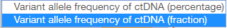

Coloring

Appropriate menu provides a user with the following options:

* Subject;
* Gene;
* Mutation.

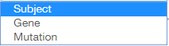

Information icon

When a user clicks the information icon , the following pop-up with plot description appears:

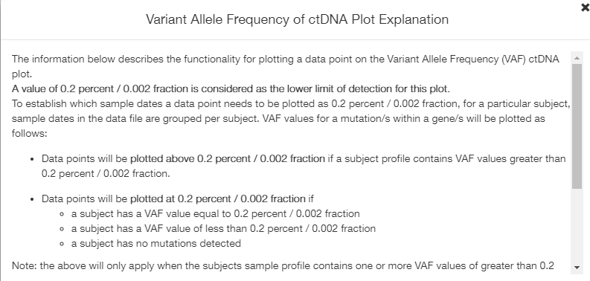

Tooltips

When a user hovers the cursor over a colored box, the tooltip with the following fields is displayed:

* Subject ID: <value>;
* Gene: <value>;
* Mutation: <value>;
* Y-axis value;
* X-axis value.

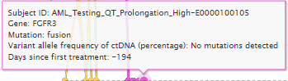

Details on Demand table

Details on Demand table contains three tabs: VAF of ctDNA tab, Genomic Profile tab and Subjects tab.

VAF of ctDNA tab:

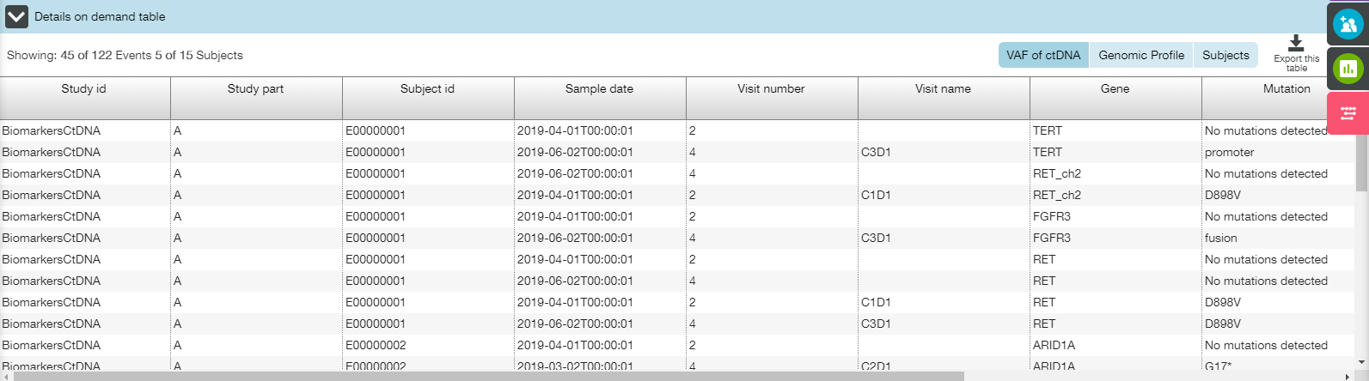

Genomic Profile tab:

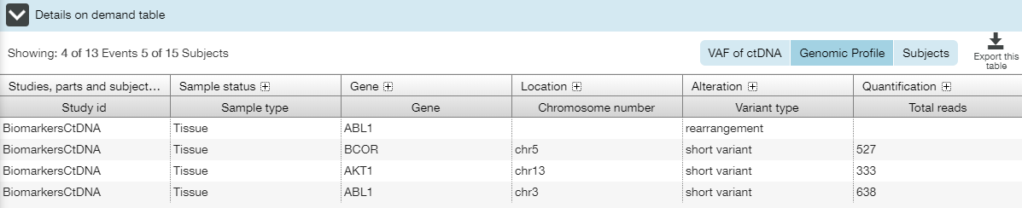

Subjects tab:

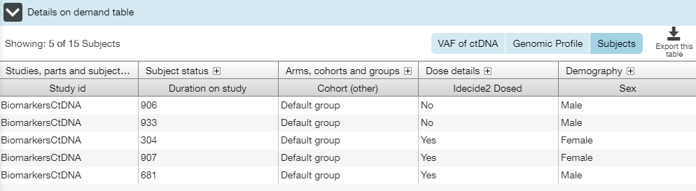

## Timeline View

**Timeline** view contains a single plot that displays all available timeline tracks for the subjects. By default **Status summary** track is turned on.

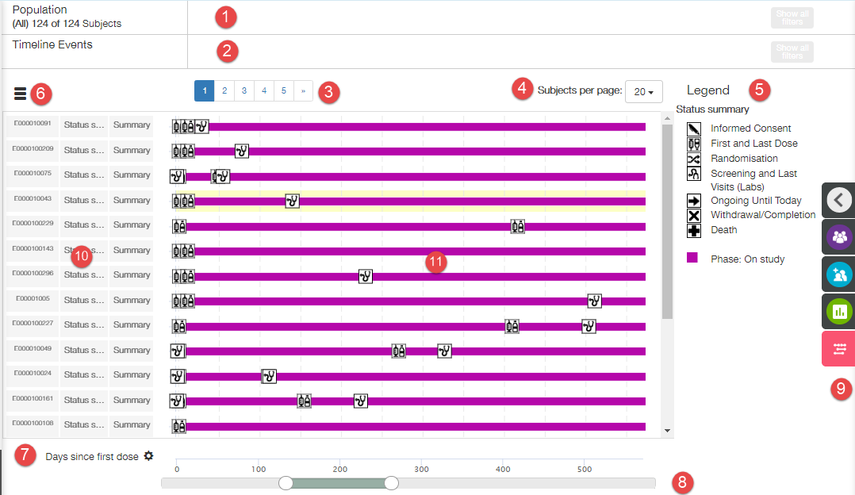

Timeline view window contains the following elements:

1. Population widget;
2. Timeline Events widget;
3. Pagination control (number of pages depends on number of subjects and number of subjects per page);
4. Subjects per page control;
5. Plot legend;
6. Chart context menu;

**Note**: Appropriate functions are not available for the moment.

1. X axis settings menu;

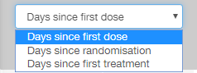

1. Zoom control;
2. Right slide panel (contains Population Filters, Cohort Filters, Timeline Filters and Timeline Settings);
3. Table with three columns:
   1. Subject ids;
   2. Track names;
   3. Summary;

**Note**: Summary column has ‘Summary’ value when tracks are collapsed, and other values, when tracks are expanded.

1. Plot.

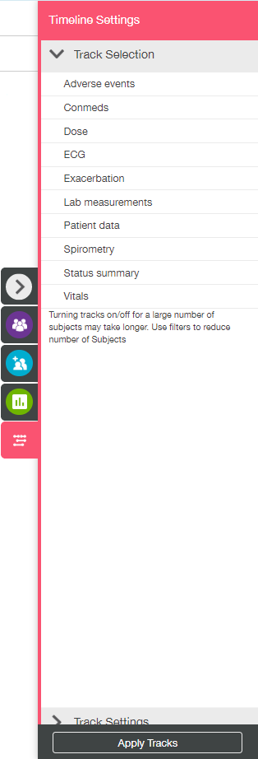**Timeline Filters** and **Timeline Settings** are available on the right slide panel.

Timeline Settings panel comprises of two sections: Track Selection and Track Settings.

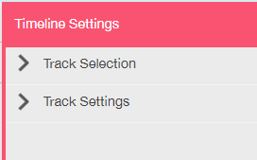

**Track Selection** section allows a user to select which track(s) to display.

The following tracks can be displayed, if available:

* Adverse events track;
* Conmeds track;
* Dose track;
* ECG track;
* Exacerbation track;
* Lab measurements track;
* Patient Data track;
* Spirometry track;
* Status Summary track;
* Vitals track.

A user should select/deselect tracks to be displayed, and click **Apply Tracks** button on the bottom of the panel.

**Track Settings** section allows a user to change settings for selected tracks.

**Note**: For the moment only ECG, Lab Measurements, Vitals and Spirometry tracks have settings. Some settings become available on lowest expansion level of tracks only.

**Timeline Filters** provide sets of filters per each type of track. **Timeline Filters** panel follows **Timeline Settings** panel (e.g., if only Adverse Events track was selected on Timeline settings panel, then only AE Filter set is displayed on the **Timeline Filters** panel).

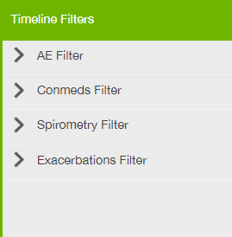

**Note**: Usage of **Timeline Filters** keep number of displayed subjects the same. It reduces number of displayed tracks.

**Population** and **Cohort Filters** can be used to reduce number of subjects.

**Note**: If several tracks are selected on the T**imeline Settings** panel, then all available timeline tracks are displayed (grouped by subject). Legend combines separate legends for the selected tracks.

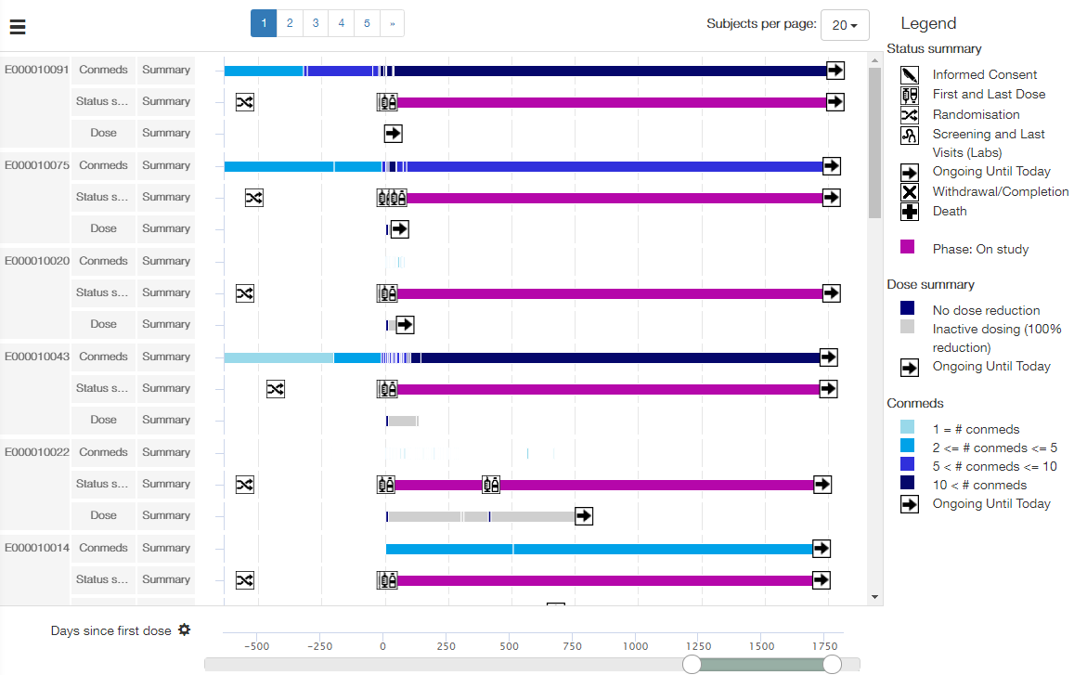

**Note**: Double-click on the particular place of the bar results in the vertical blue dashed line appearance. This line goes through the whole plot and marks the X axis position that corresponds to the place of clicking.

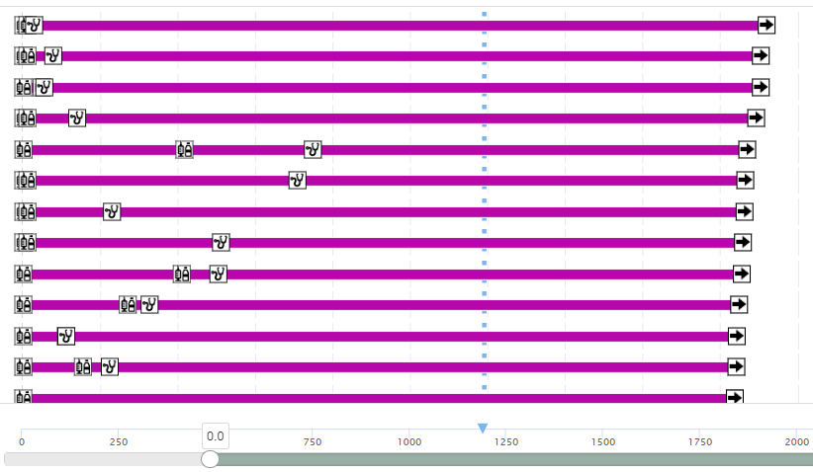

### Status Summary Track

Status summary track shows the duration on study for all subjects. Event icons are displayed on the bars.

**Note:** Displayed subjects are sorted by the duration on study. This sorting stays for all other tracks.

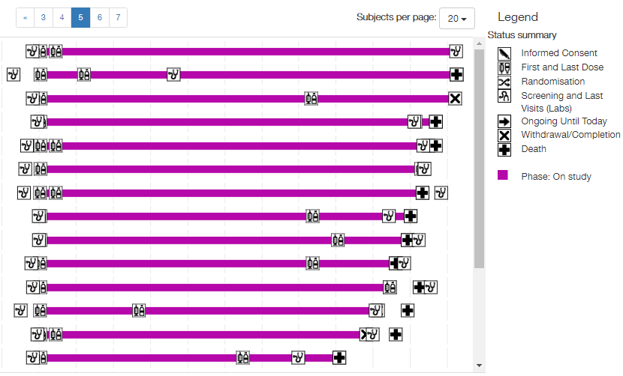

The legend describes the event icons and coloring of the status summary bar.

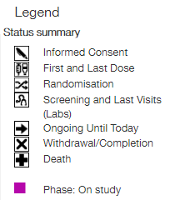

When a user hovers a mouse over the event icon, the tooltip with the following fields is displayed:

* Subject: <value>;
* Event: <value>;
* Event at day: <value>;
* Study day: <value>.

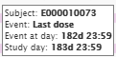

**Note**: for **Ongoing Until Today** icon ‘Event at day’ and ‘Study day’ values are calculated from date of last study data upload into the system.

When a user hovers a mouse over bar, the tooltip with the following fields is displayed:

* Subject: <value>;
* Event: On study;
* Start: <value> End: <value>;
* Study Day Start: <value> Study Day End: <value>.

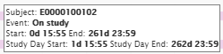

**Note**: There are no Timeline filters for **Status summary** track.

### Adverse Events Track

**Adverse Events** track shows adverse events for all subjects who received one or more dose of investigation drug grouped by the MedDRA dictionary terms and categorized by their grade of severity.

Event icons are displayed on the bars.

There are two detailing levels: 1st level (collapsed tracks) and 2nd (expanded tracks).

#### First Level

By default, the 1st level of Adverse Events tracks is displayed. Each track provides a user with summary information on all adverse events that were reported for the subject.

**Note**: Each cell of the third column of the table is filled with ‘Summary’ value.

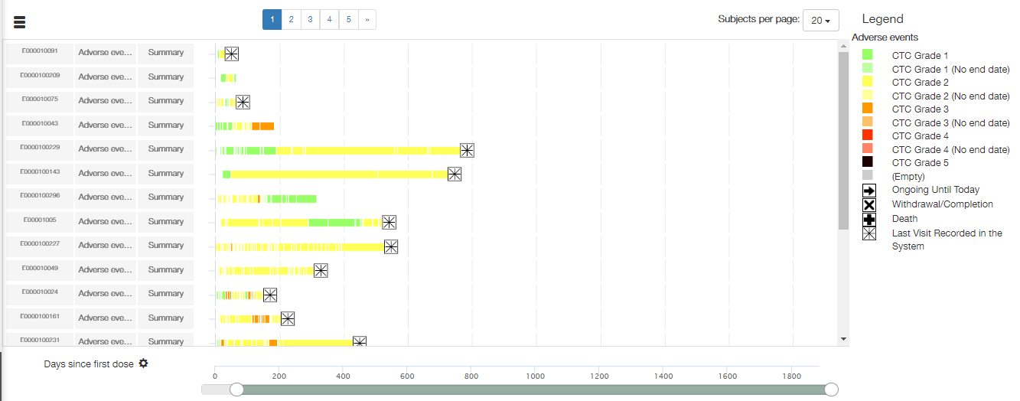

The length of the track represents the total duration of the adverse events for the subject.

The legend contains event icons description and description of the coloring by severity (two tones for each severity grade color depending on the presence of the end severity grade's date of the adverse event).

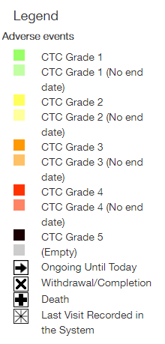

**Note**: The legend remains the same for all detailing levels.

When a user hovers a mouse over the event icon, the tooltip with the following fields is displayed:

* Subject: <value>;
* Event: <value>;
* Event at day: <value>;
* Study day: <value>.

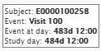

**Note**: for **Ongoing Until Today** icon ‘Event at day’ and ‘Study day’ values are calculated from date of last study data upload into the system.

**Note**: These tooltips remain the same for all detailing levels.

A subject may have multiple adverse events that occur and escape at different moments of the time during the study. It means that a set of adverse events being reported varies in time. Collapsed Adverse Events track is displayed as a dashed bar. Each dash corresponds to a particular set of adverse events, and its color describes maximum value of severity grade for this set.



When a user hovers a mouse over the particular dash of the bar, the tooltip with the following fields is displayed:

* Subject: <value>;
* Event: Adverse Event Summary;
* Included AEs: list of <value>;
* Max severity grade: <value>;
* Start: <value> End: <value>;
* Study Day Start: <value> Study Day End: <value>.

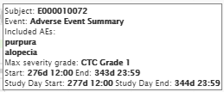

#### Second Level

To expand a Summary Adverse events track, a user should point with mouse cursor to the required track, click a right mouse button, and select one of the following menu items:

* **Expand** – to expand Adverse events track for a particular subject;
* **Expand all Adverse events tracks** – to expand all the tracks.

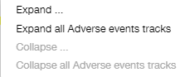

Summary Adverse event track expands to the set of separate tracks – one per each adverse event.

**Note**: ‘Summary’ value in cells of the third column of the table changes to the names of particular adverse events.

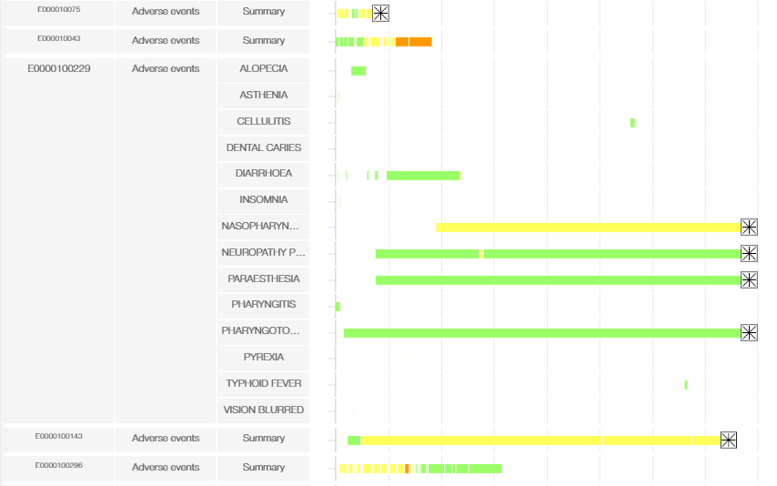

In order to collapse adverse events track, a user should point with mouse cursor to the required track, click a right mouse button, and select one of the following menu items:

* **Collapse** – to collapse Adverse events track for a particular subject;
* **Collapse all Adverse events tracks** – to collapse all the tracks.

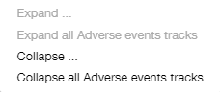

When a user hovers a mouse over the particular dash of the bar, the tooltip with the following fields is displayed:

* Subject: <value>;
* PT: <value>;
* Serious: Y/N;
* Causality: <value>;
* Action taken: <value>;
* Severity grade: <grade>;
* Start: <value> End: <value>;
* Study Day Start: <value> Study Day End: <value>.

**Note**: PT is a preferred term of the specified adverse event.

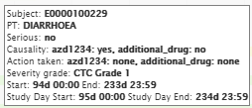

#### Adverse Events Filters

If **Adverse Events track** is selected on the T**imeline Settings** panel, then **AE** **Filter** section with appropriate filters is available on the **Timeline Filters** panel.

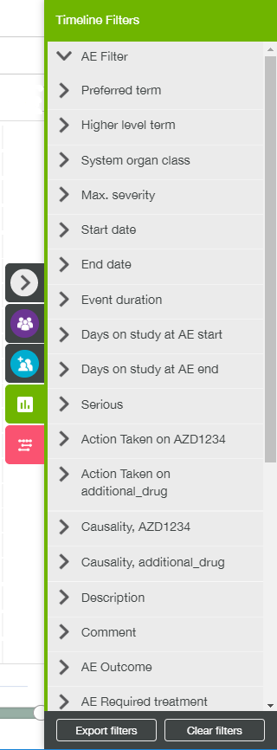

### Conmeds Track

**Conmeds** track shows medications for all subjects who received one or more dose of investigational product grouped by medication name.

**Ongoing until today** icon is displayed in the end of the bar, if particular conmed event has no end date.

There are three detailing levels: 1st level (collapsed tracks), 2nd (expanded tracks, grouped by medication class of taken medications) and 3rd (expanded tracks, grouped by medication name of taken medications).

#### First Level

By default, the 1st level of **Conmeds** tracks is displayed. Each track provides a user with summary information on all medications that were reported for the subject.

**Note**: Each cell of the third column of the table is filled with ‘Summary’ value.

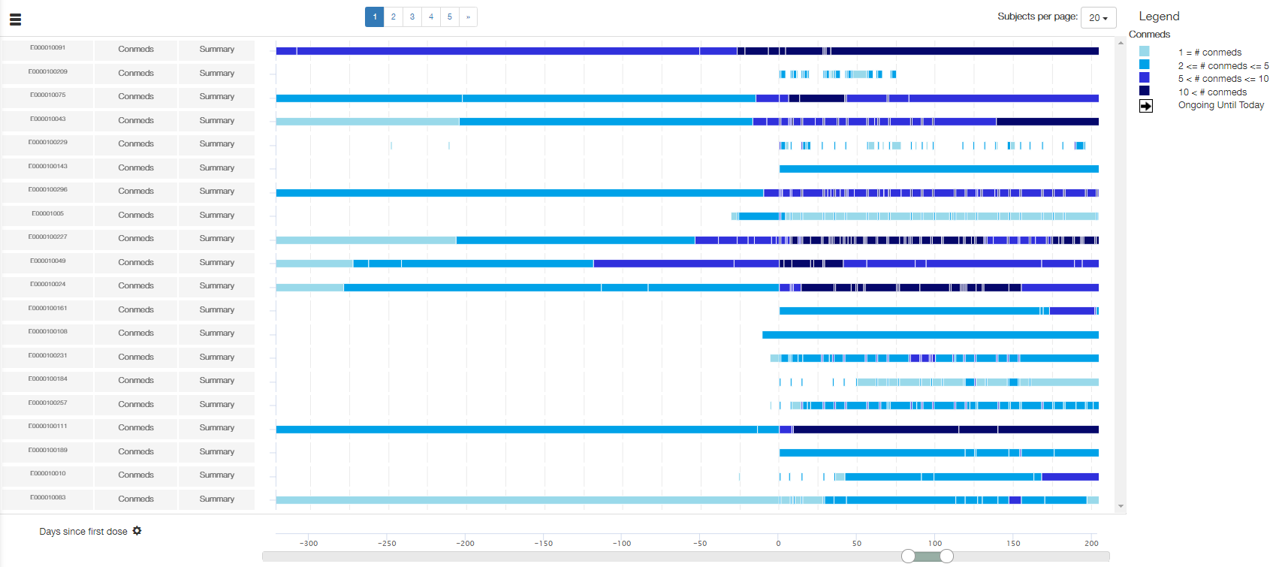

The length of tracks represents the duration of taking the medication for the particular subject.

The legend contains color scheme by the count of simultaneously taken medications and **Ongoing until today** icon description.

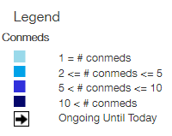

**Note**: The legend remains the same for all detailing levels.

When a user hovers a mouse over the **Ongoing until today** icon, the tooltip with the following fields is displayed:

* Subject: <value>;
* Event: Ongoing;
* Event at day: <value>;
* Study day: <value>.

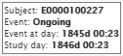

**Note**: for **Ongoing Until Today** icon ‘Event at day’ and ‘Study day’ values are calculated from date of last study data upload into the system.

**Note**: This tooltip remains the same for all detailing levels.

A subject may have multiple conmeds that are taken at different moments of the time during the study. It means that a set of conmeds being reported varies with time. Collapsed Conmeds track is displayed as a dashed bar. Each dash corresponds to a particular set of conmeds, and its color describes number of conmeds for this set.



When a user hovers a mouse over the particular dash of the bar, the tooltip with the following fields is displayed:

* Subject: <value>;
* Event: Number of conmeds;
* Included Conmeds: <value>;
* Number of conmeds: <value>;
* Table with conmeds;
* Start: <value> End: <value>;
* Study Day Start: <value> Study Day End: <value>.

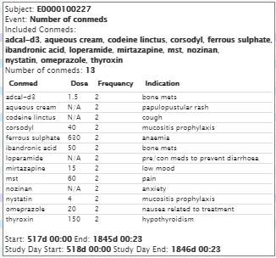

#### Second Level

To expand a Conmeds track, a user should point with mouse cursor to the required track, click a right mouse button, and select one of the following menu items:

* **Expand** – to expand Conmeds track for a particular subject;
* **Expand all Conmeds tracks** – to expand all the tracks.

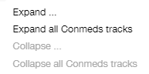

Conmeds track expands to the set of separate tracks – one per each medication class of taken medications.

**Note**: ‘Summary’ value in cells of the third column of the table changes to the names of particular medication class.

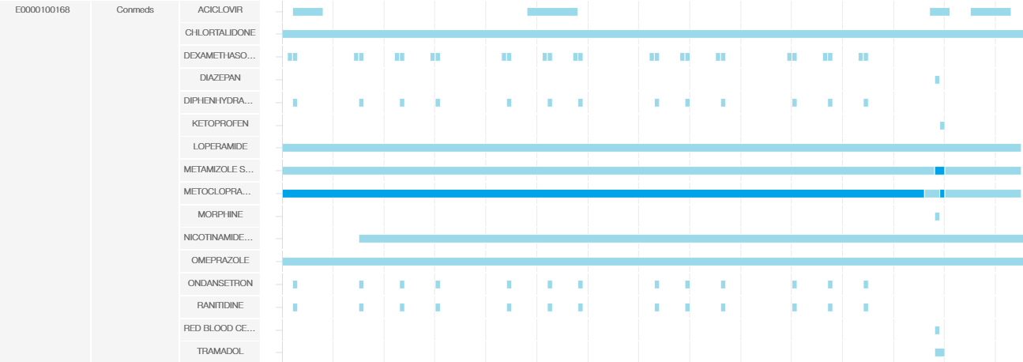

When a user hovers a mouse over the particular dash of the bar, the tooltip with the following fields is displayed:

* Subject: <value>;
* Event: Conmed class;
* Conmed class: <value>;
* Included Conmeds: list of <value>;
* Number of conmeds: <value>;
* Table with conmeds;
* Start: <value> End: <value>;
* Study Day Start: <value> Study Day End: <value>.

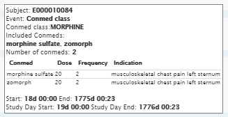

#### Third Level

In order to see the 3rd level of Conmeds track detailing, a user should expand selected track once more.

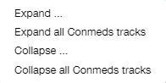

Conmeds track expands to the set of separate tracks – one per each medication name of taken medications.

**Note**: If a user selects **Expand** menu item, then all 2nd-level tracks for the particular subject will be expanded.

**Note**: If a user selects **Expand all Conmeds tracks** menu item, then all 2nd-level tracks for all subjects will be expanded.

**Note**: If a 2nd-level track includes only one conmed, then there will be only one 3rd-level track.

**Note**: Tracks for one subject are sorted alphabetically by the medication class name (or medication name). Medication name may differ from appropriate medication class name, so the order of tracks will change after expanding a track to the 3rd level, even if there was only one medication per each class.

**Note**: ‘Summary’ value in cells of the third column of the table changes to the names of particular medication.

2nd level:

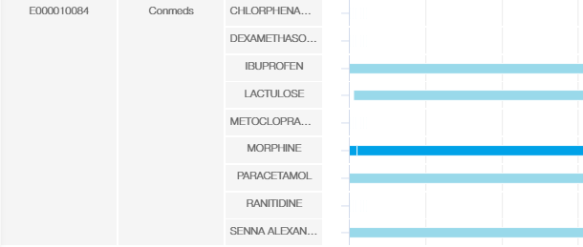

3rd level:

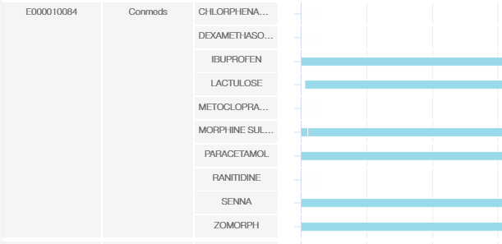

**Note**: If a user selects **Collapse** menu item, then all 3rd-level tracks for the particular subject will be collapsed.

**Note**: If a user selects **Collapse** **all Conmeds tracks** menu item, then all 3rd-level tracks for all subjects will be collapsed.

**Note**: A user should collapse tracks twice to change detailing level from 3rd to 1st.

When a user hovers a mouse over the bar, the tooltip with the following fields is displayed:

* Subject: <value>;
* Event: Conmed medication;
* Conmed: <value>;
* Dose: <value>;
* Frequency: <value>;
* Indication: <value>;
* Start: <value> End: <value>;
* Study Day Start: <value> Study Day End: <value>.

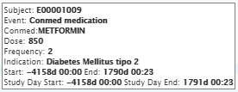

#### Conmeds Filters

If **Conmeds track** is selected on the T**imeline Settings** panel, then **Conmeds** **Filter** section with appropriate filters is available on the **Timeline Filters** panel.

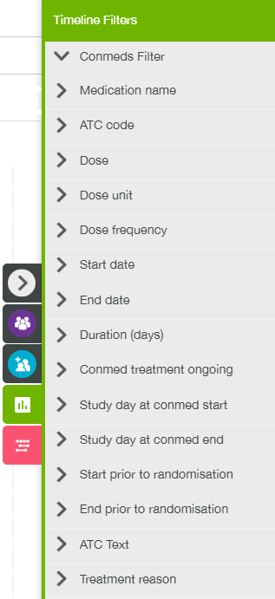

### Dose Track

**Dose** **track** for each subject shows discrete dosing events, superimposed upon a bar that shows how long the subject has been on the study.

**Ongoing until today** icon is displayed in the end of the bar, if a subject has started a period of active dosing, for any drug, for which there is no associated discontinuation, or the drug has discontinued, but there has been the start of another active dose period after the date of discontinuation.

There are three detailing levels: 1st level (collapsed tracks), 2nd (expanded tracks, providing individual drug dosing events) and 3rd (expanded tracks, showing the dose of individual drug that the subject was on at any given time).

#### First Level

By default the 1st level Dose track is displayed on the timeline page. Dose track contains bars that are split up into individual dosing events with inactive dosing fragments in between.

**Note**: Each cell of the third column of the table is filled with ‘Summary’ value.

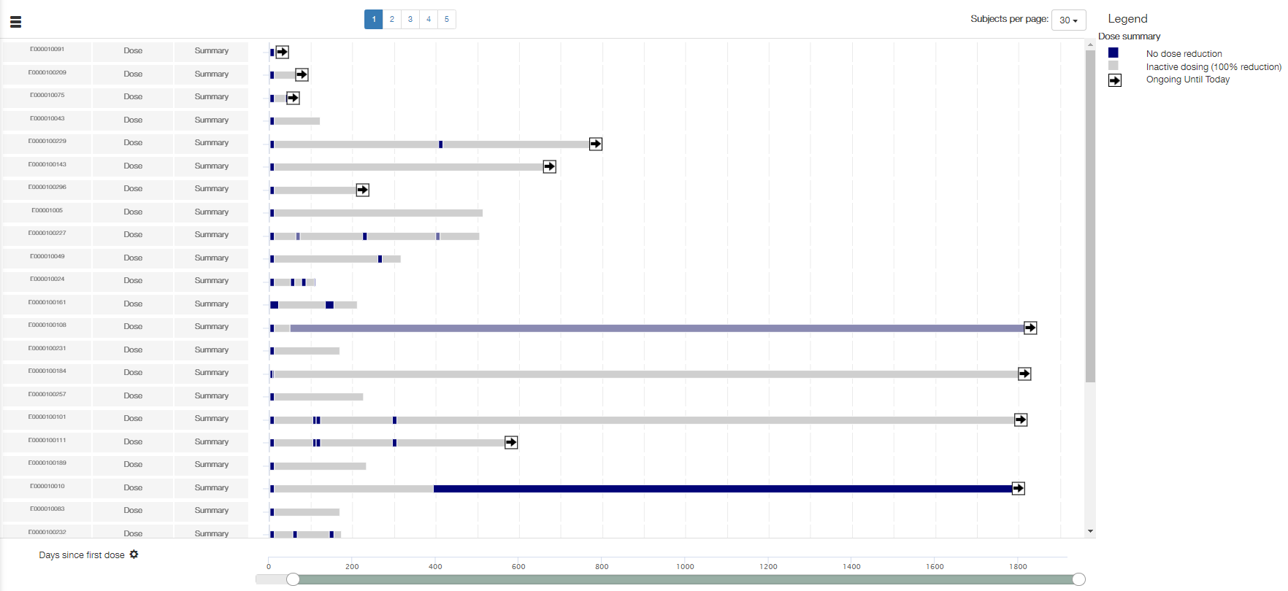

The legend contains Dose summary: color scheme by active/inactive dosing and **Ongoing until today** icon description.

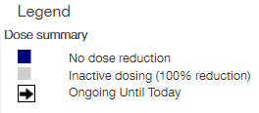

**Note**: The legend remains the same for 1st and 2nd detailing levels.

**Note**: Half-tone colors describe % of dose reduction value between 0 and 100%.

When a user hovers a mouse over the **Ongoing until today** icon, the tooltip with the following fields is displayed:

* Subject: <value>;
* Event: Ongoing;
* Event at day: <value>;
* Study day: <value>.

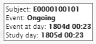

**Note**: for **Ongoing Until Today** icon ‘Event at day’ and ‘Study day’ values are calculated from date of last study data upload into the system.

**Note**: This tooltip remains the same for 1st and 2nd detailing levels.

When a user hovers a mouse over the particular fragment of the bar with active dosing, the tooltip with the following fields is displayed:

* Subject: <value>;
* Event: Active dosing;
* List of <Drug name>: <Dose> <Frequency>;
* Start: <value> End: <value>;
* Study Day Start: <value> Study Day End: <value>.

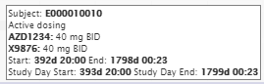

**Note**: Number of active dosed drugs may vary with time for the same subject.

When a user hovers a mouse over the particular fragment of the bar with inactive dosing, the tooltip with the following fields is displayed:

* Subject: <value>;
* Event: Inactive dosing;
* Start: <value> End: <value>;
* Study Day Start: <value> Study Day End: <value>;

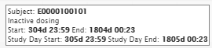

**Note**: This tooltip remains the same for 1st and 2nd detailing levels.

#### Second Level

To expand a Dose track, a user should point with mouse cursor to the required track, click a right mouse button, and select one of the following menu items:

* **Expand** – to expand Dose track for a particular subject;
* **Expand all Dose tracks** – to expand all the tracks.

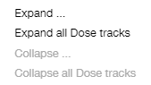

Dose track expands to the set of separate tracks – one per each individual drug dosing event.

**Note**: ‘Summary’ value in cells of the third column of the table changes to the names of particular drugs.

1st level:



2nd level:



When a user hovers a mouse over the particular fragment of the bar with active dosing, the tooltip with the following fields is displayed:

* Subject: <value>;
* Event: Active dosing;
* <Drug name>: <Dose> <Frequency>;
* Start: <value> End: <value>;
* Study Day Start: <value> Study Day End: <value>.

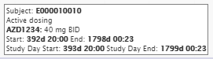

#### Third Level

In order to see the 3rd level of Dose track detailing, a user should expand selected track once more.

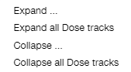

**Note**: If a user selects **Expand** menu item, then all 2nd-level tracks for the particular subject will be expanded.

**Note**: If a user selects **Expand all Dose tracks** menu item, then all 2nd-level tracks for all subjects will be expanded.

Dose track expands to the set of line graphs for each drug showing the dose that the subject was on at any given time. The line goes from start of dosing to dose discontinuation.

2nd level:



3rd level:

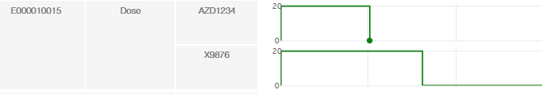

**Note**: If a user selects **Collapse** menu item, then all 3rd-level tracks for the particular subject will be collapsed.

**Note**: If a user selects **Collapse** **all Dose tracks** menu item, then all 3rd-level tracks for all subjects will be collapsed.

**Note**: A user should collapse tracks twice to change detailing level from 3rd to 1st.

The legend contains the Drug dose summary: straight line for dosing event, and event icons description.

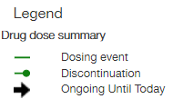

**Note**: Dose tracks for different subjects can be expanded separately. If some tracks has the 1st/2nd detailing level, and some – the 3rd one, then legend will contain both Dose summary and Drug dose summary.

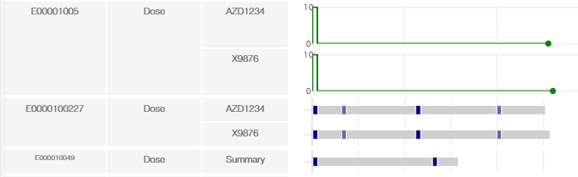

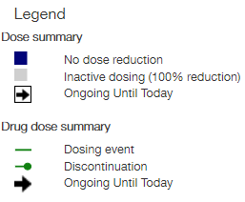

When a user hovers a mouse over a point in the graph, where the line changes direction, the tooltip with the following fields is displayed:

* Subject: <value>;
* Event: Dose Event;
* Dose: <Dose value> <Dose unit> <Frequency>;
* Start: <value>;
* Study Day Start: <value>;
* End: <value>;
* Study Day End: <value>;
* Ongoing: true/false.

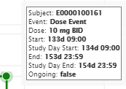

When a user hovers a mouse over the **Discontinuation** icon, the tooltip with the following fields is displayed:

* Subject: <value>;
* Discontinued at <value>;
* Discontinued at study day: <value>.

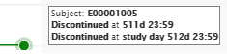

When a user hovers a mouse over the **Ongoing until today** icon, the tooltip with the following fields is displayed:

* Subject: <value>;
* Ongoing event at day: <value>;
* Study day: <value>.

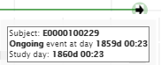

#### Dose Filters

If **Dose track** is selected on the **Timeline Settings** panel, then **Dose** **Filter** section with appropriate filters is available on the **Timeline Filters** panel.

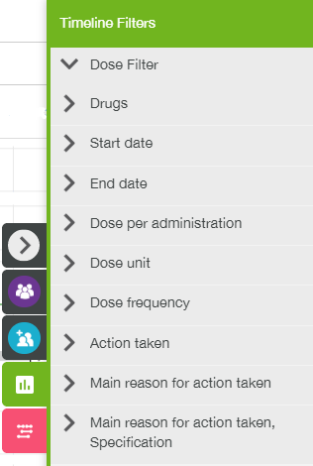

### ECG Track

**ECG** **track** for each subject shows ECG measurements over time.

There are three detailing levels: 1st level (collapsed tracks), 2nd (expanded tracks, providing evaluated values per each ECG measurement) and 3rd (line graphs for each actual measurement value).

#### First Level

By default the 1st level ECG track is displayed. Each track provides a user with a single marker per ECG evaluation.

**Note**: Each cell of the third column of the table is filled with ‘Summary’ value.

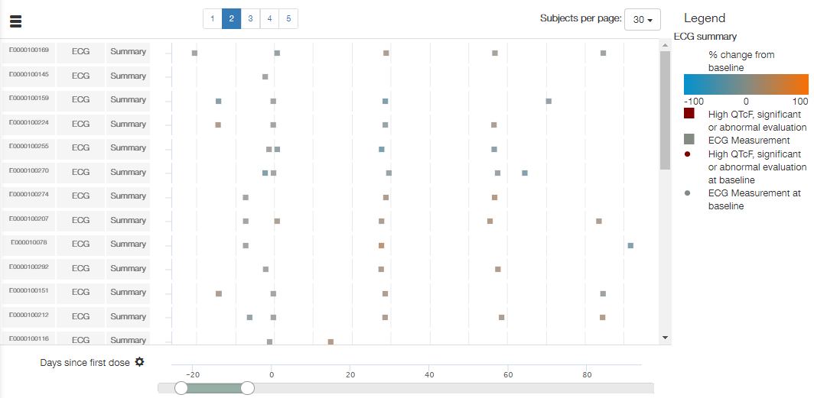

ECG measurement markers are colored according to the largest % change from baseline among any of the measurements.

**Note**: Each subject has its own baseline.

The legend contains ECG summary: color scheme for % change from baseline, and current/baseline measurements markers description as well as significant or abnormal evaluation in QTcF if it was detected on ECG tracks.

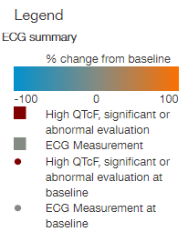

**Note**: The legend remains the same for 1st and 2nd detailing levels.

When a user hovers a mouse over the square/circle marker, the tooltip with the following fields is displayed:

* Subject: <value>;
* Visit: <value>;
* Sex: <value>;
* Date of baseline: <value>;
* Significant: <value>;
* Abnormal: <value>;
* Max value percent change: <value>;
* QTcF change: <value>;
* QTcF value: <value>;
* Event at day: <value>;
* Study day: <value>.

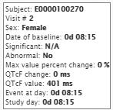

ECG TRACK SETTINGS

If **ECG track** is selected on in the **Track Selection** section of the **Timeline Settings** panel, then the following ECG warnings can be toggled on/off in the **Track Settings** section of the panel:

* QTcF male;
* QTcF female;
* QTcF change from baseline;
* Abnormal.

**Note**: These track settings are the same for 1st and 2nd levels.

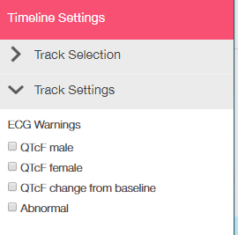

All ECG warnings are checked by default.

If these warnings are toggled on, then ECG evaluation markers will have a particular warning color (dark red) if they meet at least one of the following criteria:

* QTcF absolute value >=450ms for males (indicates QTcF male warning);
* QTcF absolute value >=480ms for females (indicates QTcF female warning);
* QTcF absolute change from baseline >=60ms (indicates QTcF change from baseline warning);
* Abnormal = Yes (indicates Abnormal warning).These measurements are labelled as clinically significant and abnormal in the overall ECG evaluation.

ECG tracks without warnings:

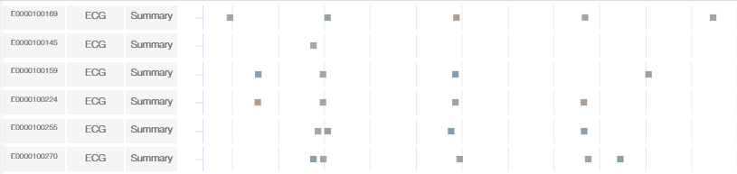

ECG tracks with warnings:

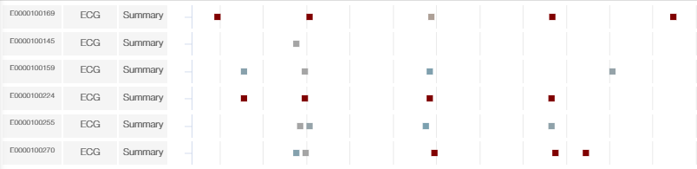

#### Second Level

To expand an ECG track, a user should point with mouse cursor to the required track, click a right mouse button, and select one of the following menu items:

* **Expand** – to expand ECG track for a particular subject;
* **Expand all ECG tracks** – to expand all the tracks.

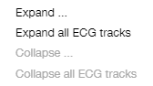

ECG track expands to the set of separate tracks – one per each ECG measurement (PR, RR, QTcF, etc.).

**Note**: ‘Summary’ value in cells of the third column of the table changes to the names of particular measurement.

1st level:



2nd level:

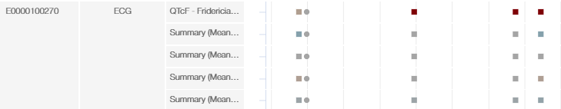

Markers are colored using the same method as for the 1st level but applying only to the data within the given measurement. Warnings are applied only to QTcF measurement (on the 2nd level).

When a user hovers a mouse over the square/circle marker, the tooltip with the following fields is displayed:

* Subject: <value>;
* Visit: <value>;
* Sex: <value>;
* Date of baseline: <value>;
* Significant: <value>;
* Abnormal: <value>;
* Test name: <value>;
* Baseline value: <value>;
* Change from baseline: <value>;
* % change from baseline: <value>;
* Raw value: <value>;
* Event at day: <value>;
* Study day: <value>.

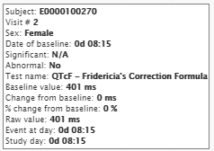

**Note**: This tooltip remains the same for 2nd and 3rd detailing levels.

#### Third Level

In order to see the 3rd level of ECG track detailing, a user should expand selected track once more.

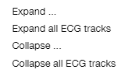

**Note**: If a user selects **Expand** menu item, then all 2nd-level tracks for the particular subject will be expanded.

**Note**: If a user selects **Expand all ECG tracks** menu item, then all 2nd-level tracks for all subjects will be expanded.

ECG track expands to the set of line graphs for each actual measurement value.

**Note**: ‘Summary’ value in cells of the third column of the table changes to the names of particular measurement, the same as for the 2nd level.

2nd level:



3rd level:

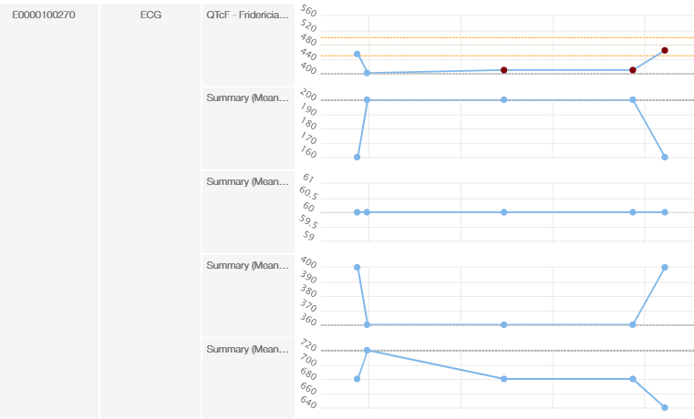

**Note**: If a user selects **Collapse** menu item, then all 3rd-level tracks for the particular subject will be collapsed.

**Note**: If a user selects **Collapse** **all ECG tracks** menu item, then all 3rd-level tracks for all subjects will be collapsed.

**Note**: A user should collapse tracks twice to change detailing level from 3rd to 1st.

There is a reference line for the baseline value on all plots in a dashed grey line. The reference line is labelled as the baseline. Markers and lines are displayed in neutral color (light-blue). The QTcF plots have a horizontal reference lines in orange drawn at 450ms, 480ms and 500ms. Markers of the warning states for QTcF related tracks are colored in red.

The legend contains ECG details: description of baseline/reference lines and measurement icons.

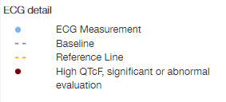

**Note**: Some reference lines can be invisible if they overlap with baseline or gridline. Baseline can be also invisible if it coincides with gridline.

**Note**: ECG tracks for different subjects can be expanded separately. If some tracks has the 1st/2nd detailing level, and some – the 3rd one, then legend will contain both ECG summary and ECG details.

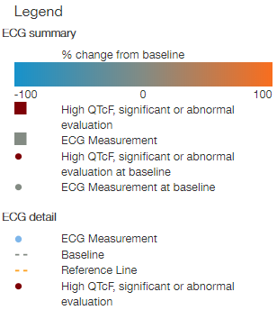

ECG TRACK SETTINGS

Additional track setting appears in the **Track Settings** section of the **Timeline Settings** panel on the 3rd level of detailing. A user can select one of the following Y-axis values for the line graphs:

* Raw values;
* Change from baseline;
* % change from baseline.

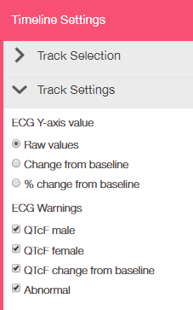

#### ECG Filters

If **ECG track** is selected on the T**imeline Settings** panel, then **ECG** **Filter** section with appropriate filters is available on the **Timeline Filters** panel.

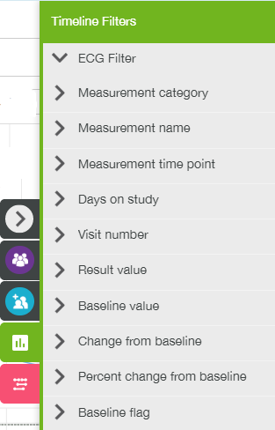

### Exacerbation Track

**Exacerbation track** shows exacerbations for all subjects who received one or more dose of investigational product categorized by their grade of severity.

**Ongoing until today** icon is displayed in the end of the bar, if particular exacerbations event has no end date.

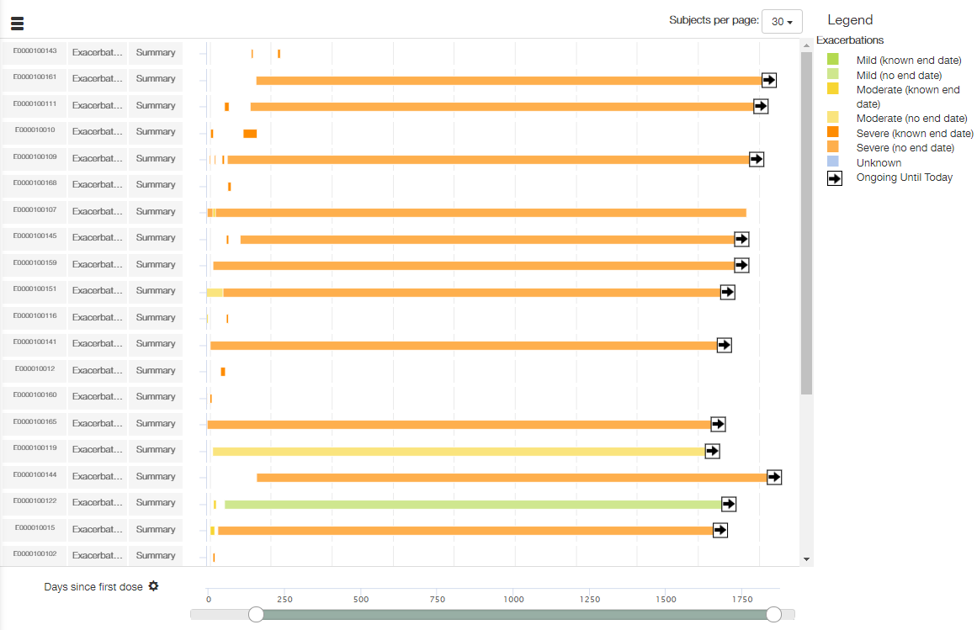

The legend contains the description of the coloring by severity (two tones for each severity grade color depending on the presence of the end severity grade's date of the exacerbations event) and **Ongoing until today** icon description.

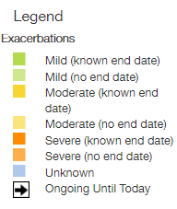

When a user hovers a mouse over **Ongoing until today** icon, the tooltip with the following fields is displayed:

* Subject: <value>;
* Event: Ongoing;
* Event: Exacerbation severity grade;
* Severity of exacerbation: <value>;
* Event at day: <value>;
* Study day: <value>.

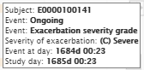

**Note**: for **Ongoing Until Today** icon ‘Event at day’ and ‘Study day’ values are calculated from date of last study data upload into the system.

When a user hovers a mouse over the bar, the tooltip with the following fields is displayed:

* Subject: <value>;
* Event: Exacerbation severity grade;
* Severity of exacerbation: <value>;
* Start: <value> End: <value>;
* Study Day Start: <value> Study Day End: <value>.

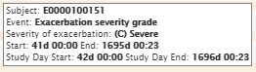

If **Exacerbation track** is selected on the T**imeline Settings** panel, then **Exacerbation** **Filter** section with appropriate events filters is available on the **Timeline Filters** panel.

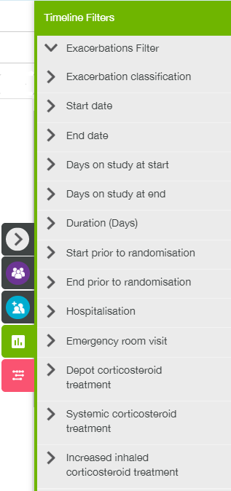

### Lab Measurements Track

**Lab measurements track** shows lab events for all subjects who received one or more dose of investigational product.

There are four detailing levels: 1st level (collapsed tracks), 2nd (expanded tracks, providing Y value for each lab category per subject), 3rd (expanded tracks, providing Y value for each lab name per subject) and 4th (line graphs for each lab name per subject).

#### First Level

By default, the 1st level of Lab Measurements tracks is displayed. Each track provides a user with single y value per subject.

**Note**: Each cell of the third column of the table is filled with ‘Summary’ value.

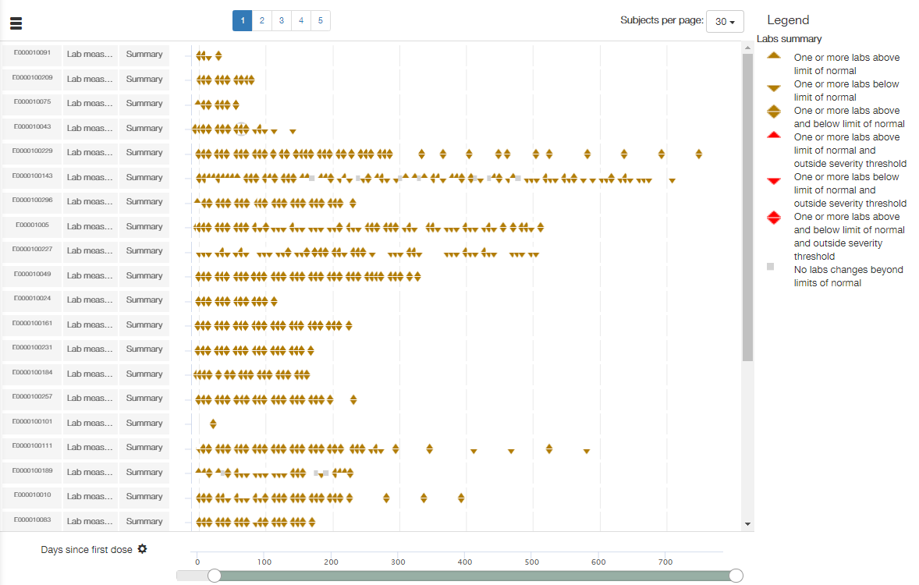

The legend contains Labs summary: description of lab event icons.

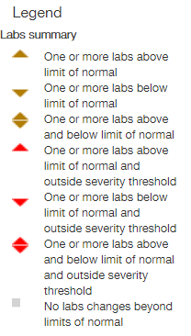

**Note**: The legend remains the same for 1st, 2nd and 3rd detailing levels.

When a user hovers a mouse over the lab event icon, the tooltip with the following fields is displayed:

* Subject: <value>;
* Visit: <value>;
* Labs above normal limit: <value>;
* Labs below normal limit: <value>;
* Labs above severity threshold: <value>;
* Labs below severity threshold: <value>;
* Event at day: <value>;
* Study day: <value>.

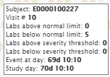

**Note**:

* “Labs above normal limit” indicates count of events which values are above upper reference value;
* “Labs below normal limit” indicates count of events which values are below lower reference value;
* “Labs above severity threshold” and “Labs below severity threshold” values are =0 for now.

#### Second Level

To expand a Lab measurements track, a user should point with mouse cursor to the required track, click a right mouse button, and select one of the following menu items:

* **Expand** – to expand Lab measurements track for a particular subject;
* **Expand all Lab measurements** tracks – to expand all the tracks.

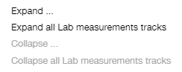

Lab measurements track expands to the set of separate tracks – one per each lab category.

**Note**: ‘Summary’ value in cells of the third column of the table changes to the names of lab category.

1st level:



2nd level:

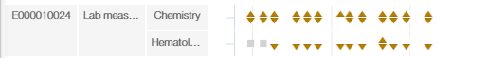

Icons are colored using the same method as for the 1st level but applying only to the data within the given lab category.

When a user hovers a mouse over the lab event icon, the tooltip with the following fields is displayed:

* Subject: <value>;
* Lab category: <value>;
* Visit: <value>;
* Labs above normal limit: <value>;
* Labs below normal limit: <value>;
* Labs above severity threshold: <value>;
* Labs below severity threshold: <value>;
* Event at day: <value>;
* Study day: <value>.

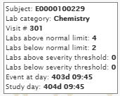

#### Third Level

In order to see the 3rd level of Lab measurements track detailing, a user should expand selected track once more.

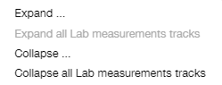

**Note**: If a user selects **Expand** menu item, then all 2nd-level tracks for the particular subject will be expanded.

**Note**: **Expand all Lab measurements tracks** is disabled for 2nd-level tracks.

Lab measurements track expands to the set of separate tracks – one per each lab name.

**Note**: ‘Summary’ value in cells of the third column of the table changes to the lab names.

2nd level:

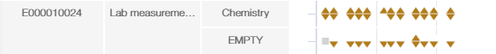

3rd level:

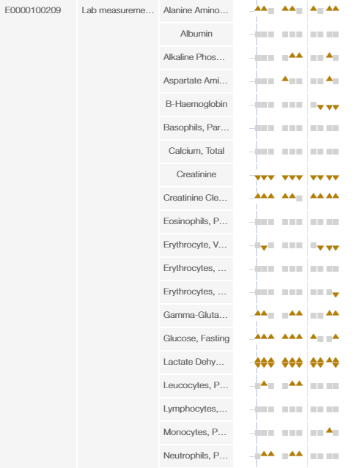

Icons are colored using the same method as for the 1st level but applying only to the data within the given lab measurement name.

When a user hovers a mouse over the lab event icon, the tooltip with the following fields is displayed:

* Subject: <value>;
* Labcode: <value>;
* Visit: <value>;
* Labs above normal limit: <value>;
* Labs below normal limit: <value>;
* Labs above severity threshold: <value>;
* Labs below severity threshold: <value>;
* Event at day: <value>;
* Study day: <value>.

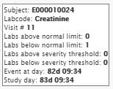

#### Fourth Level

In order to see the 4th level of Lab measurements track detailing, a user should expand selected track once more.



**Note**: If a user selects **Expand** menu item, then all 3rd-level tracks for the particular subject will be expanded.

**Note**: **Expand all Lab measurements tracks** is disabled for 3rd-level tracks.

Lab measurements track expands to the set of line graphs one per each lab name.

**Note**: ‘Summary’ value in cells of the third column of the table changes to the lab names.

3rd level:

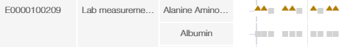

4th level:

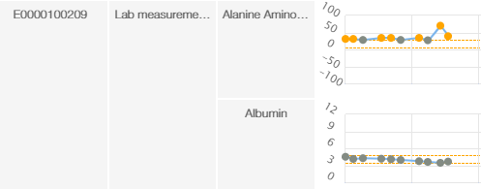

**Note**: If a user selects **Collapse** menu item, then all 4th-level tracks for the particular subject will be collapsed.

**Note**: If a user selects **Collapse** **all Lab Measurement tracks** menu item, then all 4th-level tracks for all subjects will be collapsed.

**Note**: A user should collapse tracks three times to change detailing level from 4th to 1st.

Limits of normal are marked on each plot with two horizontal lines colored with orange. Markers of above/below normal states are colored in orange as well.

**Note**: Reference lines and orange markers are available only for Y-axis value = Raw value.

The legend contains Labs summary and Labs details - description of lab event icons.

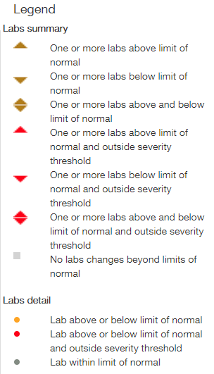

When a user hovers a mouse over the lab event icon, the tooltip with the following fields is displayed:

* Subject: <value>;
* Labcode: <value>;
* Event: Visit;
* Visit: <value>;
* Raw value: <value>;
* Baseline flag: <value>;
* Baseline value: <value>;
* Change from baseline: <value>;
* % change of baseline: <value>;
* Event at day: <value>;
* Study day: <value>.

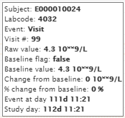

LAB MEASUREMENTS TRACK SETTINGS

Track setting appears in the **Track Settings** section of the **Timeline Settings** panel on the 4th level of detailing. A user can select one of the following Y-axis values for the line graphs:

* Raw values;
* Change from baseline;
* % change from baseline;
* Ref. Range Norm. Value;
* Times Upper Ref. Value;
* Times Lower Ref. Value.

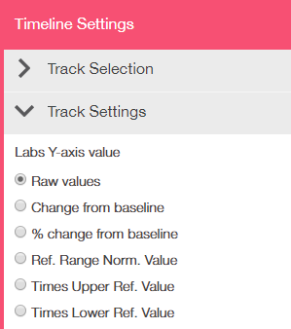

#### Lab Measurements Filters

If **Lab Measurements track** is selected on the T**imeline Settings** panel, then **Labs Filter** section with appropriate filters is available on the **Timeline Filters** panel.

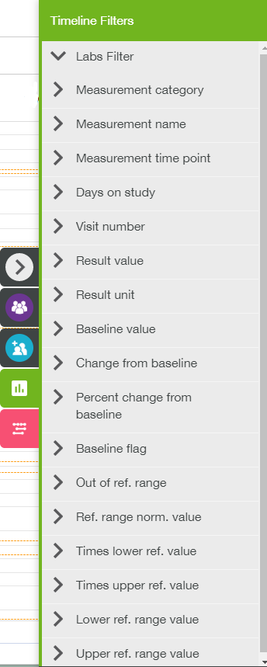

### Patient Data Track

**Patient Data** **track** for each subject shows fatigue-related data, reported by patients.

There are two detailing levels: 1st level (collapsed tracks) and 2nd (expanded tracks, one for each individual measurement).

#### First Level

By default the 1st level of Patient Data track is displayed. Each track provides a user with summary information on fatigue-related events that were reported by the patient.

**Note**: Each cell of the third column of the table is filled with ‘Summary’ value.

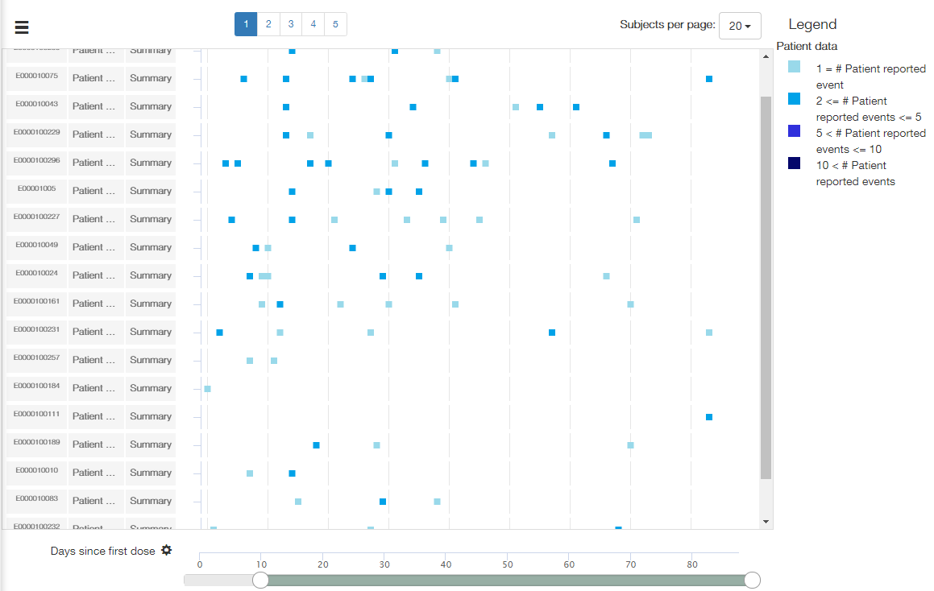

The legend contains Patient data - color scheme for event markers by the count of patients reported events on a given day.

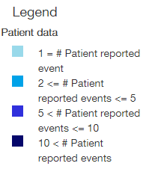

When a user hovers a mouse over the event marker, the tooltip with the following fields is displayed:

* Subject: <value>;
* Number of events: <value>;
* Included events: list of <values>;
* Event at day: <value>;
* Study day: <value>.

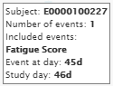

#### Second Level

To expand a Patient data track, a user should point with mouse cursor to the required track, click a right mouse button, and select one of the following menu items:

* **Expand** – to expand Patient data track for a particular subject;
* **Expand all Patient data track**s – to expand all the tracks.

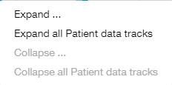

Patient data track expands to the set of line graphs – one per each measurement.

**Note**: ‘Summary’ value in cells of the third column of the table changes to the names of particular measurements.

1st level:



2nd level:

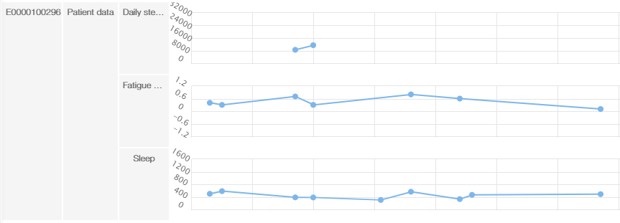

In order to collapse Patient data track, a user should point with mouse cursor to the required track, click a right mouse button, and select one of the following menu items:

* **Collapse** – to collapse Patient data track for a particular subject;
* **Collapse all Patient data tracks** – to collapse all the tracks.

The legend contains Patient data and Patient data details – description of data measurement markers.

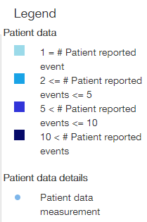

When a user hovers a mouse over a measurement marker, the tooltip with the following fields is displayed:

* Subject: <value>;
* Test name: <value>;
* Raw value: <value>;
* Unit: <value>;
* Event at day: <value>;
* Study day: <value>.

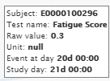

#### Patient Data Filters

If **Patient data track** is selected on the T**imeline Settings** panel, then **Patient Data Filter** section with appropriate filters is available on the **Timeline Filters** panel.

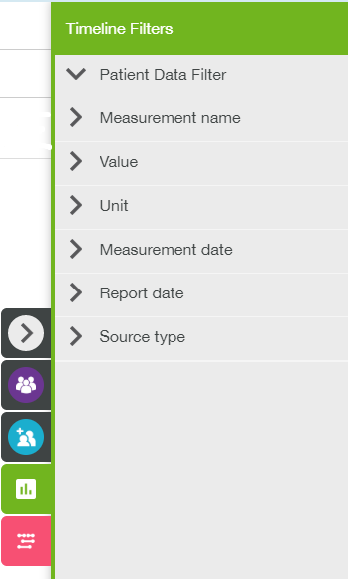

### Spirometry Track

**Spirometry** **track** for each subject shows lung function measurements over time.

There are three detailing levels: 1st level (collapsed tracks), 2nd (expanded tracks, one for each measurement), and 3rd (line graphs for each measurement).

#### First Level

By default the 1st level of Spirometry track is displayed. Each track provides a user with lung function evaluation for the particular subject.

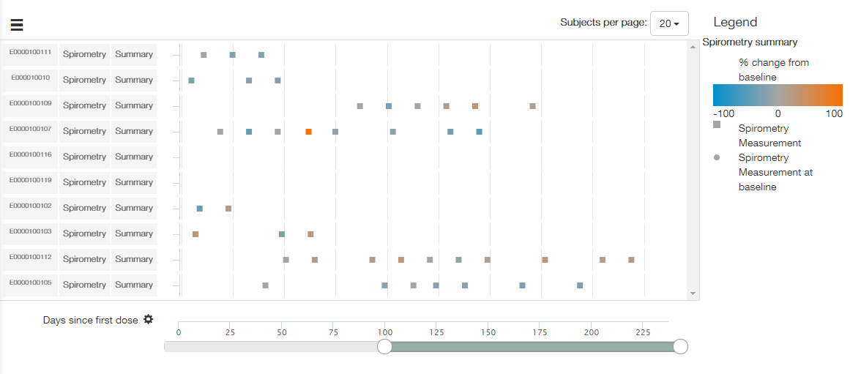

The legend contains Spirometry Summary – description of the color scheme according to % change from baseline, and measurement markers description.

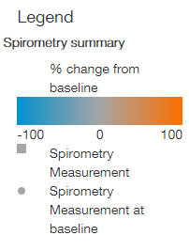

**Note**: The legend remains the same for 1st and 2nd detailing levels.

When a user hovers a mouse over the measurement marker, the tooltip with the following fields is displayed:

* Subject: <value>;
* Visit: <value>;
* Sex: <value>;
* Date of baseline: <value>;
* Max value percent change: <value>;
* Event at day: <value>;
* Study day: <value>.

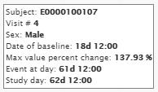

#### Second Level

To expand a Spirometry track, a user should point with mouse cursor to the required track, click a right mouse button, and select one of the following menu items:

* **Expand** – to expand Spirometry track for a particular subject;
* **Expand all Spirometry** **tracks** – to expand all the tracks.

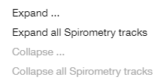

Spirometry track expands to the set of separate tracks – one per each spirometry name, per measurement (FVC, PEF, FEV25_75).

**Note**: ‘Summary’ value in cells of the third column of the table changes to the names of particular measurements.

1st level:



2nd level:

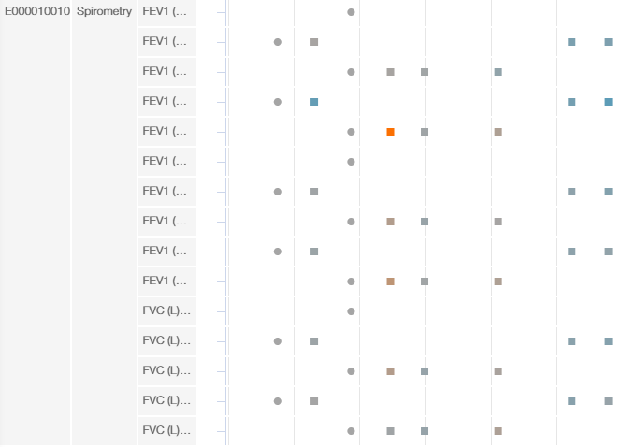

In order to collapse Spirometry track, a user should point with mouse cursor to the required track, click a right mouse button, and select one of the following menu items:

* **Collapse** – to collapse Spirometry track for a particular subject;
* **Collapse all Spirometry tracks** – to collapse all the tracks.

When a user hovers a mouse over the measurement icon, the tooltip with the following fields is displayed:

* Subject: <value>;
* Visit: <value>;
* Sex: <value>;
* Date of baseline: <value>;
* Lung function code: <value>;
* Baseline value: <value>;
* Change from baseline: <value>;
* % change from baseline: <value>;
* Raw value: <value>;
* Event at day: <value>;
* Study day: <value>.

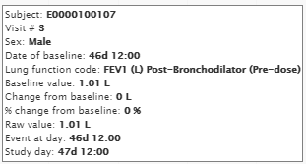

**Note**: This tooltip remains the same for 2nd and 3rd detailing levels.

#### Third Level

In order to see the 3rd level of Spirometry track detailing, a user should expand selected track once more.

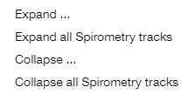

**Note**: If a user selects **Expand** menu item, then all 2nd-level tracks for the particular subject will be expanded.

**Note**: If a user selects **Expand all Spirometry tracks** menu item, then all 2nd-level tracks for all subjects will be expanded.

Spirometry track expands to the set of line graphs for each actual measurement value.

**Note**: ‘Summary’ value in cells of the third column of the table changes to the names of particular measurement, the same as for the 2nd level.

2nd level:



3rd level:

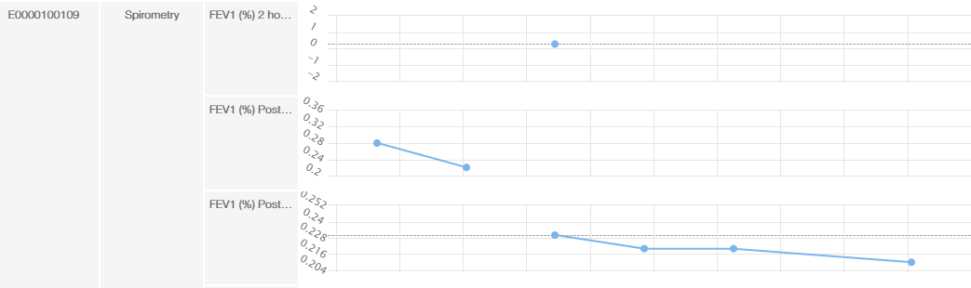

**Note**: If a user selects **Collapse** menu item, then all 3rd-level tracks for the particular subject will be collapsed.

**Note**: If a user selects **Collapse** **all Spirometry tracks** menu item, then all 3rd-level tracks for all subjects will be collapsed.

**Note**: A user should collapse tracks twice to change detailing level from 3rd to 1st.

There is a reference line for the baseline value on all plots in a dashed grey line. The reference line is labelled as the baseline. Markers and lines are displayed in neutral color (light-blue).

The legend contains Spirometry details: description of baseline/reference lines and measurement icons.

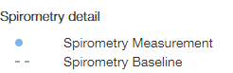

**Note**: Spirometry tracks for different subjects can be expanded separately. If some tracks has the 1st/2nd detailing level, and some – the 3rd one, then legend will contain both Spirometry summary and Spirometry details.

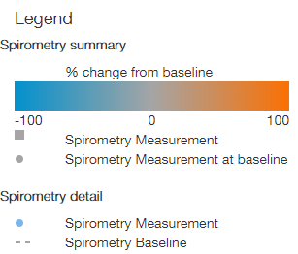

SPIROMETRY TRACK SETTINGS

Additional track setting appears in the **Track Settings** section of the **Timeline Settings** panel on the 3rd level of detailing. A user can select one of the following Y-axis values for the line graphs:

* Raw values;
* Change from baseline;
* % change from baseline.

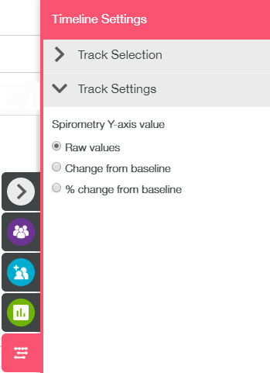

#### Spirometry Filters

If **Spirometry track** is selected on the T**imeline Settings** panel, then **Spirometry Filter** section with appropriate filters is available on the **Timeline Filters** panel.

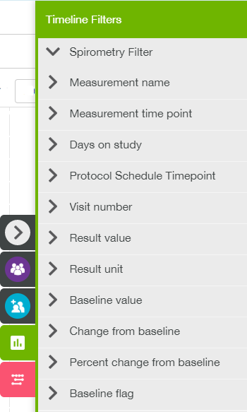

### Vitals Track

**Vitals** **track** shows vital measurements over time for each subject.

There are three detailing levels: 1st level (collapsed tracks), 2nd (expanded tracks, providing vital evaluations per measurement) and 3rd (set of line graphs per vital measurement).

#### First Level

By default the 1st level Vitals track is displayed on the timeline page. Each track provides a user with a single marker per vital evaluation.

**Note**: Each cell of the third column of the table is filled with ‘Summary’ value.

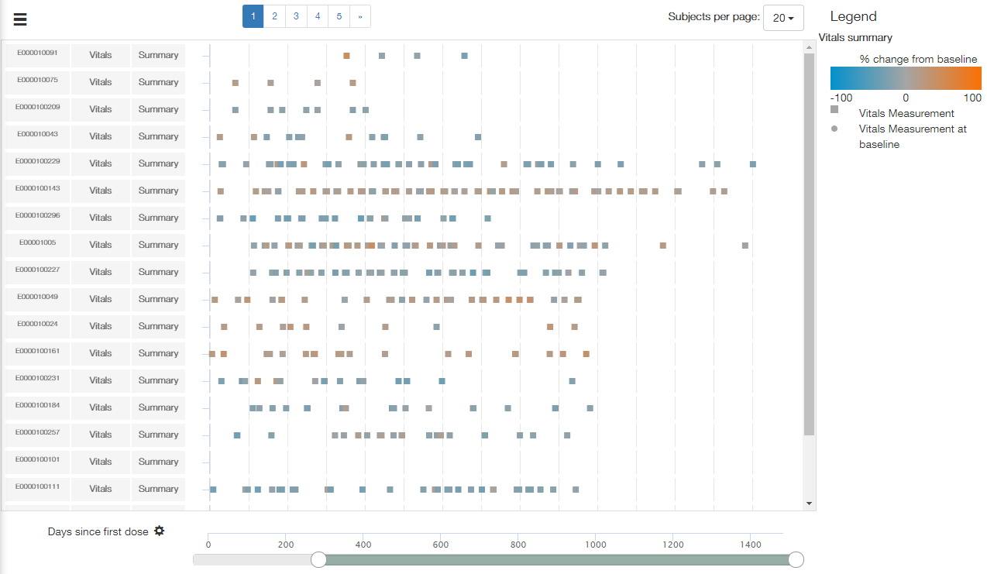

The legend contains Vitals summary: color scheme for % change from baseline, and current/baseline measurements markers description.

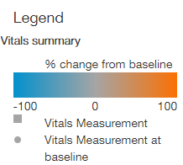

**Note**: The legend remains the same for 1st and 2nd detailing levels.

When a user hovers a mouse over the measurement icon, the tooltip with the following fields is displayed:

* Subject: <value>;
* Visit: <value>;
* Sex: <value>;
* Date of baseline: <value>;
* Max value percent change: <value>;
* Event at day: <value>;
* Study day: <value>.

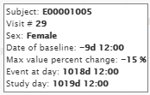

#### Second Level

To expand a Vitals track, a user should point with mouse cursor to the required track, click a left mouse button, and select one of the following menu items:

* **Expand** – to expand Vitals track for a particular subject;
* **Expand all Vitals** **tracks** – to expand all the tracks.

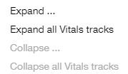

Vitals track expands to the set of separate tracks – one per each vital name, per measurement (pulse rate, temperature, diastolic blood pressure etc.).

**Note**: ‘Summary’ value in cells of the third column of the table changes to the names of particular measurements.

1st level:



2nd level:

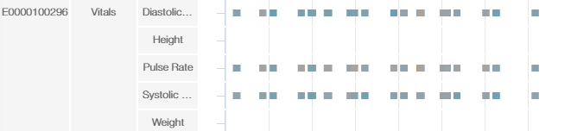

Markers are colored using the same method as the 1st level but applying only to the data within the given measurement.

When user hovers a mouse over the icon, the tooltip with the following fields is displayed:

* Subject: <value>;
* Visit: <value>;
* Sex: <value>;
* Date of baseline: <value>;
* Test name: <value>;
* Baseline value: <value>;
* Change from baseline: <value>;
* % change from baseline: <value>;
* Raw value: <value>;
* Event at day: <value>;
* Study day: <value>.

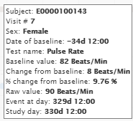

**Note**: This tooltip is the same for 2nd and 3rd detailing levels.

#### Third Level

In order to see the 3rd level of Vitals track detailing, a user should expand selected track once more.

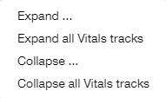

**Note**: If a user selects **Expand** menu item, then all 2nd-level tracks for the particular subject will be expanded.

**Note**: If a user selects **Expand all Vitals tracks** menu item, then all 2nd-level tracks for all subjects will be expanded.

Vitals track expands to the set of line graphs for each actual measurement value.

2nd level:



3rd level:

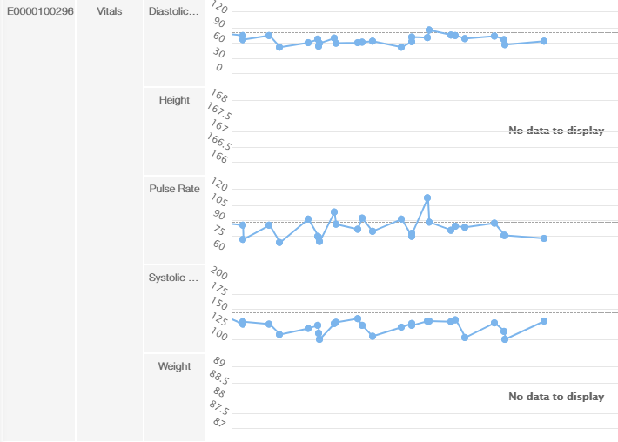

**Note**: If a user selects **Collapse** menu item, then all 3rd-level tracks for the particular subject will be collapsed.

**Note**: If a user selects **Collapse** **all Vitals tracks** menu item, then all 3rd-level tracks for all subjects will be collapsed.

**Note**: A user should collapse tracks twice to change detailing level from 3rd to 1st.

There is a reference line for the baseline value on all plots in a dashed grey line. Markers and lines are displayed in neutral color (light-blue).

The legend contains Vitals details: description of baseline and measurement Markers.

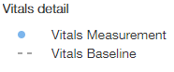

**Note**: Vitals tracks for different subjects can be expanded separately. If some tracks has the 1st/2nd detailing level, and some – the 3rd one, then legend will contain both Vitals summary and Vitals details.

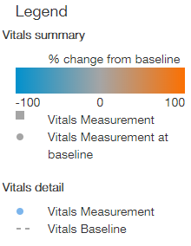

VITALS SETTINGS

Track setting appears in the **Track Settings** section of the **Timeline Settings** panel on the 3rd level of detailing. A user can select one of the following Y-axis values for the line graphs:

* Raw values;
* Change from baseline;
* % change from baseline.

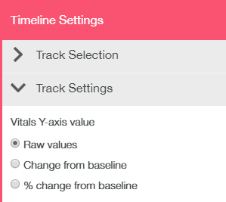

#### Vitals Filters

If **Vitals track** is selected on the T**imeline Settings** panel, then **Vitals Filter** section with appropriate filters is available on the **Timeline Filters** panel.

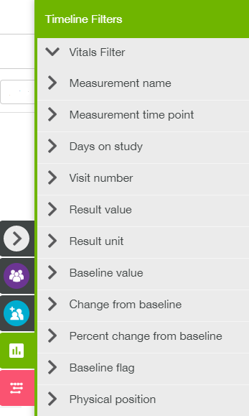

## Single Subject View

**Single Subject** view (SSV) provides a user with detailed information about a single subject in the analysis. Subject search field (is empty by default) allows to select a subject id, and set of tabs provide existing data analysis for the selected subject.

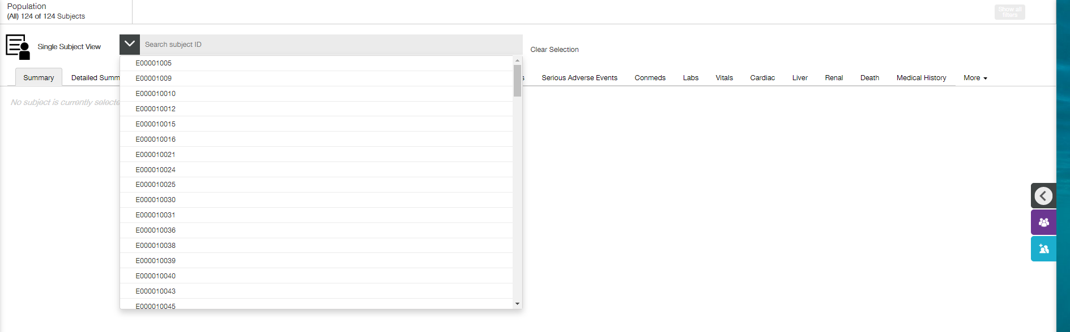

Click the right arrow besides the **Search** field to expand the drop-down list with subject ids. Select a subject. Click **Clear Selection**, if required. This action will also remove the analysis data, corresponding to previously selected subject, from the tab.

**Note**: It is also possible to type subject id or part of subject id into the **Search** field. This action will result in filtering the list of subjects in drop-down list to fit the value being typed.

Right slide filters panel contains **Population** **Filters** and **Cohort** **Filters**. Both of them filters the drop-down subject ids list. Additionally, on some tabs **Events** **Filters** and **Events** **Settings** are provided.

Some tabs provide a user with information in table form, some – in plots, and some combine both ways.

**Note**: All the tabs are empty when no subject is selected.

**Note**: If some data (e.g. lung function) is not provided for all subjects in the uploaded dataset, there will be no **Lung Function** tab in the **Single Subject** view. If some data is not provided only for some subjects in the uploaded dataset, then appropriate tab will demonstrate ‘No data to display’ message on the plot and/or empty table when such subject is selected.

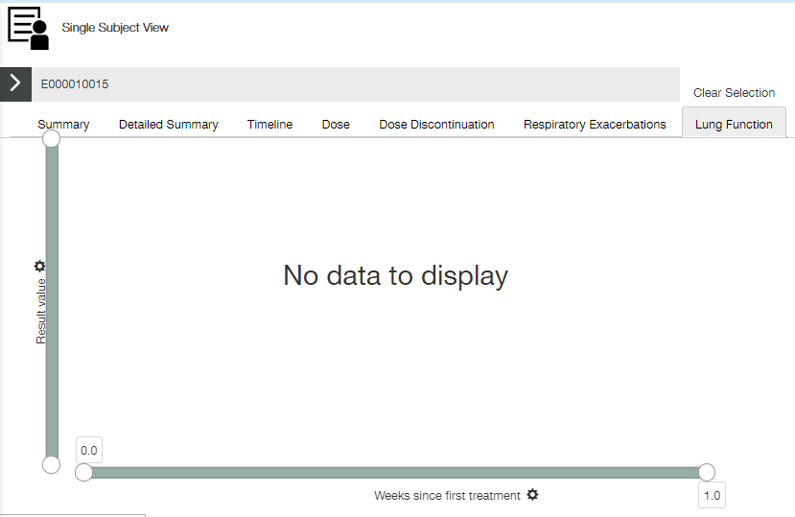

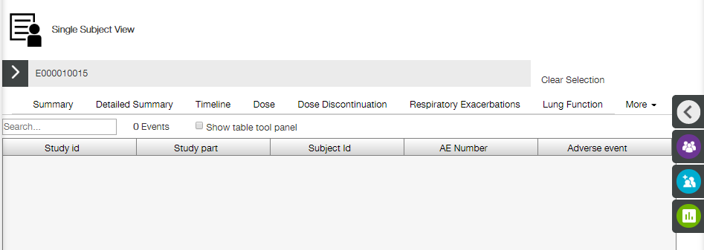

### Common Table Controls

Most part of the tables (except for **Summary** and **Detailed Summary** tabs) has the same controls:

* **Search** field (displayed above the table);

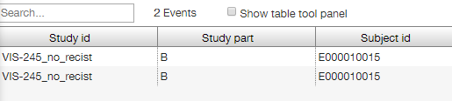

* **Show table tool** **panel** checkbox (displayed above the table) – allows a user to use table tools;
* Table tool panel (appears to the right of the table);

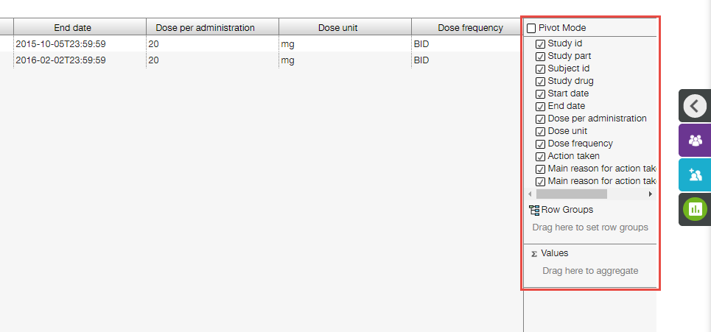

* Context menu ( icon appears when a user hovers a mouse over any column header).

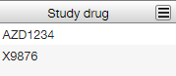

Additionally, a user can click the column header to start sorting the table by this column values. Up arrow besides the column name indicates ascending sorting order . The second click on the same column header reverts sorting order. Down arrow besides the column name indicates descending sorting order . The third click on the same column header removes sorting.

A user also can drag and drop column header in order to move the column to the left/right position in the table.

#### Table Tool Panel

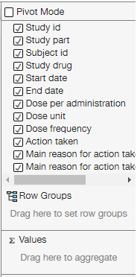

The following tools are provided on the panel:

* Set of checkboxes, allowing a user to select which table columns to display;

**Note**: All the columns are checked by default.

* **Row groups** – allows a user to group table rows by values of selected columns hierarchically;
* **Values** – allows a user to apply some aggregation functions to any applicable column to populate the group row with values;
* **Pivot mode** checkbox – allows a user to use the pivot mode, when only groups and values columns are displayed.

**Note**: A column is applicable for aggregating if its values are numerical.

EXAMPLE

Single Subject view, Adverse Events tab

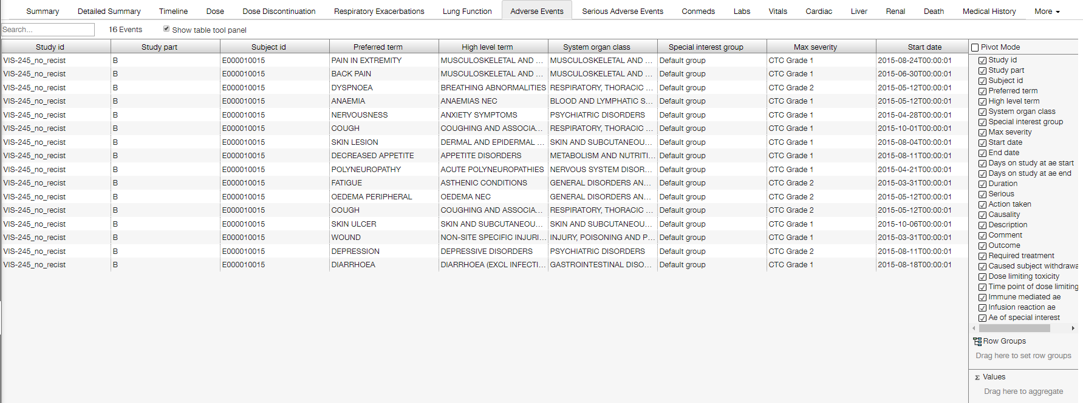

Let’s group rows by max severity, then by system organ class. To do this, a user should drag-n-drop column names from the upper part of the **Table Tool** panel to the **Row groups** section.

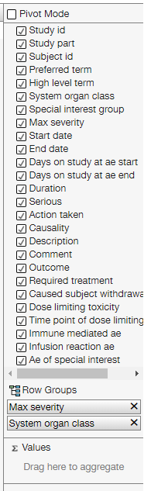

**Note**: The order of adding column names to the **Row groups** section establishes the grouping hierarchy.

**Note**: It is also possible to add a column name to the **Row group** section by means of column context menu (see the next section for details).

Grouping result looks like the following:

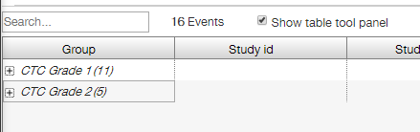

It can be expanded:

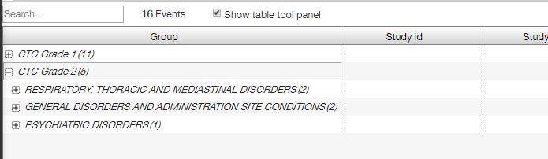

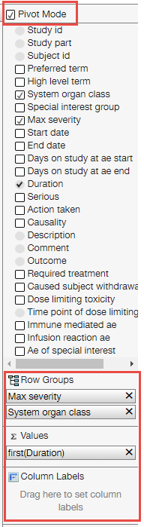Number in parentheses provides number of collapsed rows. Grouping result can be expanded up to the lowest level of grouping hierarchy:

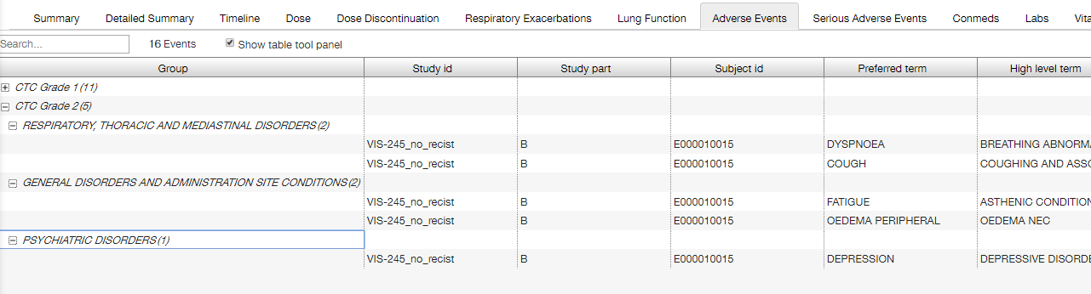

Let’s collapse it back and use some aggregation. To do this, a user should drag-n-drop column name(s) to the **Values** section of the **Table Tool** panel. This action results in changing values in this column:

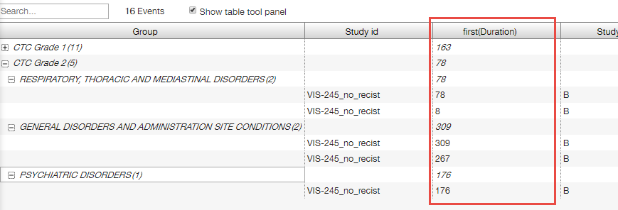

Marking **Pivot Mode** checkbox results in removing all columns other than **Group** and aggregation column(s).

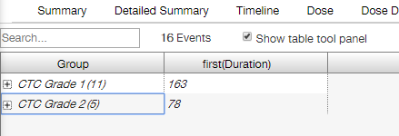

**Note**: Column Labels section appears when **Pivot Mode** checkbox is marked. This feature currently is not supported by the application.

In the Pivot mode all hierarchy levels can be expanded but the lowest one retains hidden.

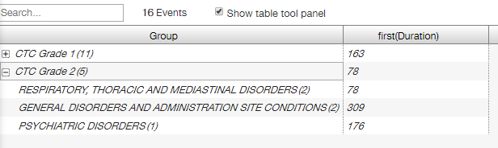

#### Context Menu

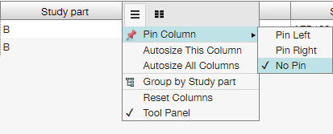

Column context menu provides a user with the following settings:

* **Pin column** – allows a user to pin current column to the left/right edge of a table, or unpin it;
* **Autosize this column** – allows a user to adjust width of the current column automatically;
* **Autosize all columns** - allows a user to adjust width of all columns of the table automatically;
* **Group by [column name]** - allows a user to group rows of the table by values of selected column;

**Note**: This menu item appears only if column values are suitable for grouping;

* **Reset columns** - allows a user to reset settings for all columns of the table;
* **Tool panel** – displays the table tools panel.

The following settings appear in the column context menu, if current column was selected for row grouping:

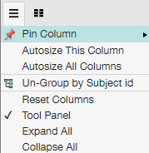

* **Un-Group by [column name]** - allows a user to ungroup rows of the table by values of selected column;
* **Expand All** – allows a user to expand grouped rows;
* **Collapse All** – allows a user to collapse grouped rows.

**Note**: The last two items appear in the context menu of all columns of the table when row grouping is selected.

The following settings appear in the column context menu, if current column was selected for aggregation:

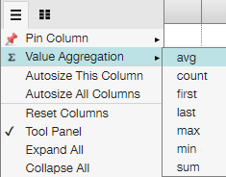

* **Value Aggregation** – allows a user to change the aggregation function;
* **Expand All** – allows a user to expand grouped rows;
* **Collapse All** – allows a user to collapse grouped rows.

**Note**: Possible aggregation values are as follows:

* avg – average from values in group;
* count – number of values in group;
* first – upper value in group;
* last – lower value in group;
* max – maximum value in group;
* min – minimum value in group;
* sum – sum of values in group.

Additionally, clicking  icon allows a user to select which table columns to display.

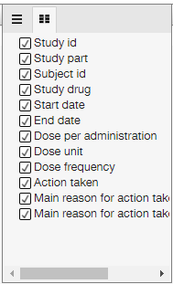

**Note**: All table settings are reset when a user opens another tab.

### Summary Tab

**Summary** tab provides a user with two tables with demography data on the selected subject and study details.

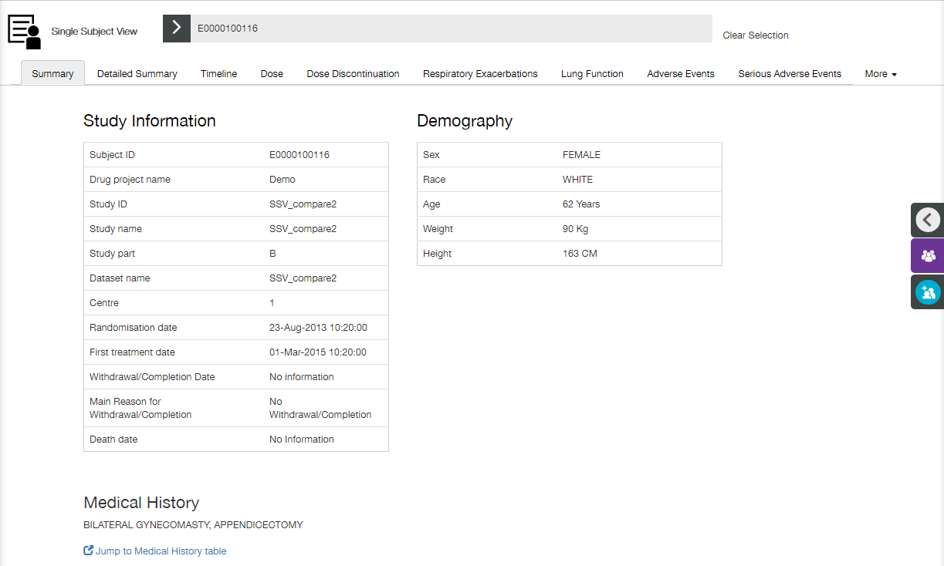

Additionally, **Medical History** section is available, providing a user with medical history details. Click **Jump to Medical History table** link to open appropriate tab.

### Detailed Summary Tab

**Detailed Summary** tab provides a user with a set of tables, representing almost all data uploaded for the selected subject.

Click **Export all tables** link to export the data to the .csv file.

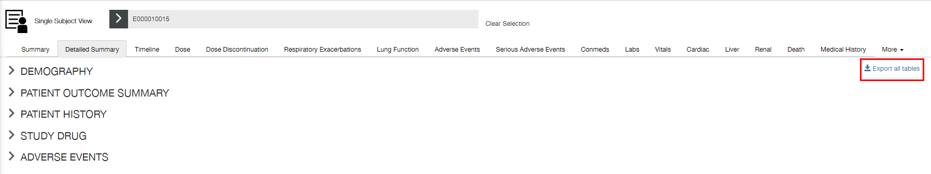

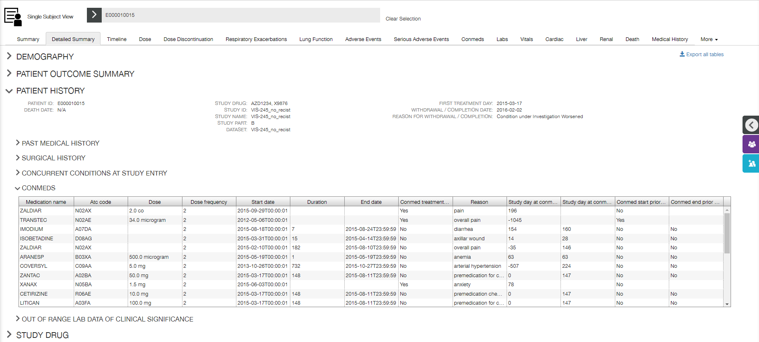

### Timeline Tab

**Timeline** tab contains a single plot that displays all available timeline tracks for the selected subject. By default all available track types are turned on.

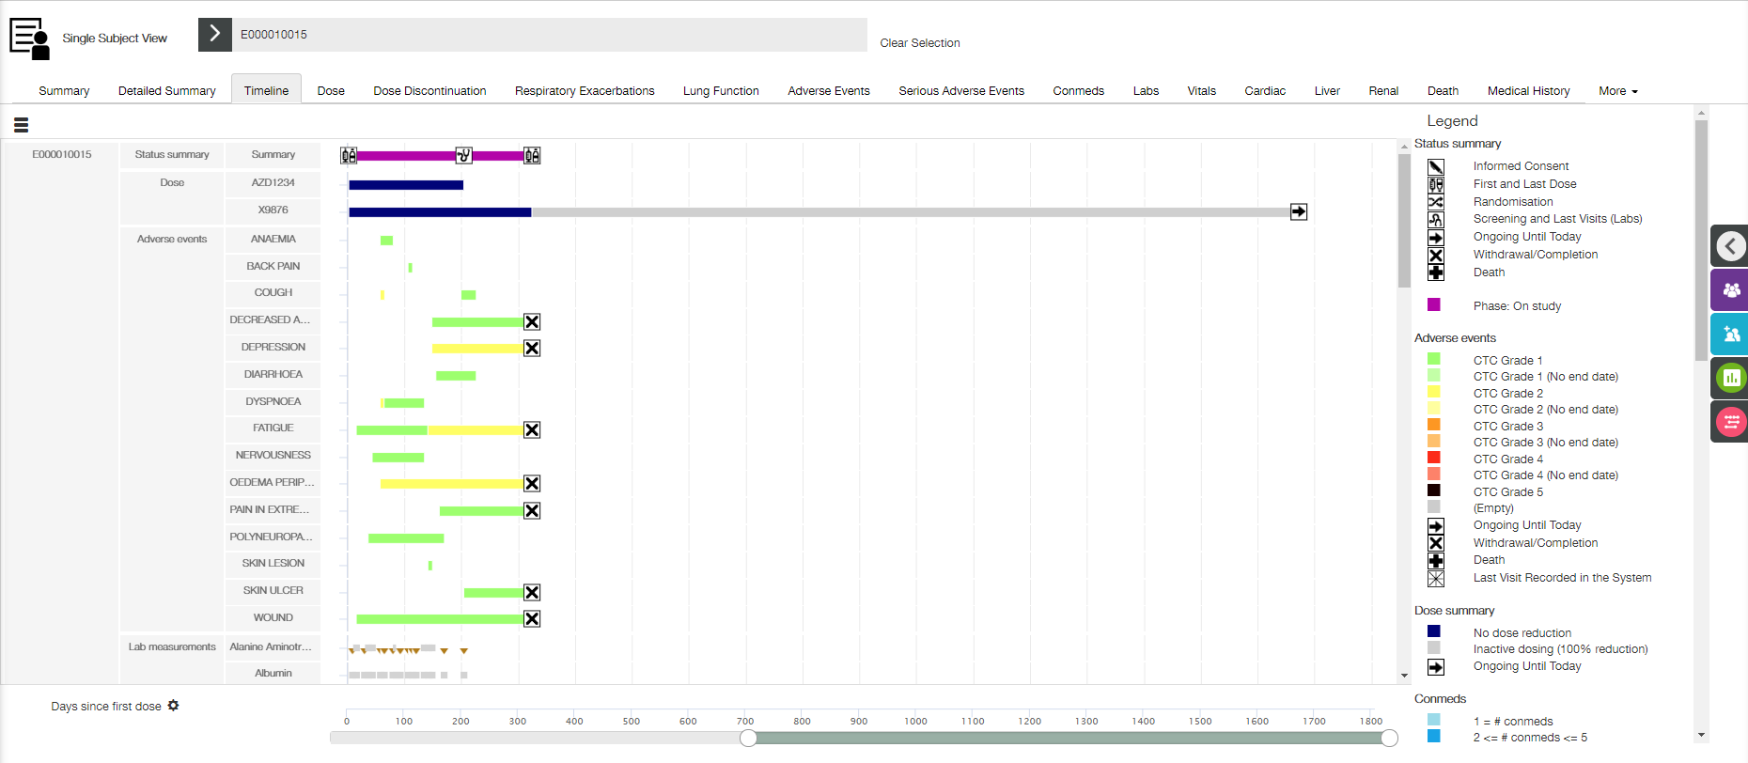

The **Timeline** tab functionality on the **Single Subject** view is identical to that on the **Timeline** view (see Timeline section for details), aside for some minor aspects.

The legend on this tab is represented by combination of legends of all available tracks for selected subject.

The following tracks can be displayed, if available:

* Adverse events track;
* Conmeds track;
* Dose track;
* ECG track;
* Exacerbation track;
* Lab measurements track;
* Patient Data track;
* Spirometry track;
* Status Summary track;
* Vitals track.

**Timeline Filters** and **Timeline Settings** are available on the right slide panel.

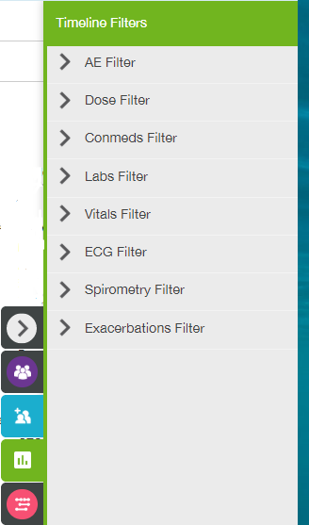 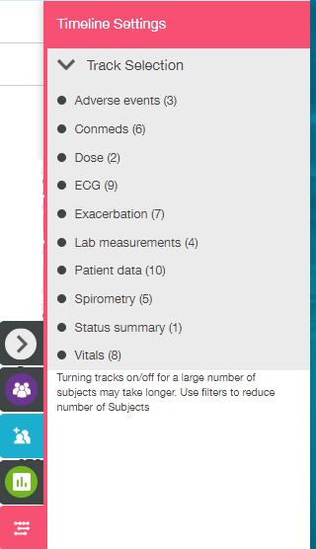

Timeline settings allow a user to select which track(s) to display. Timeline filters provide sets of filters per each type of track. Timeline filters panel follows Timeline settings panel (e.g., if only Adverse events track was selected on Timeline settings panel, then only AE Filter set is displayed on Timeline filters panel).

### Dose Tab

**Dose** tab contains a single table that displays dose events for the selected subject. By default records are sorted chronologically by **Start** date-time.

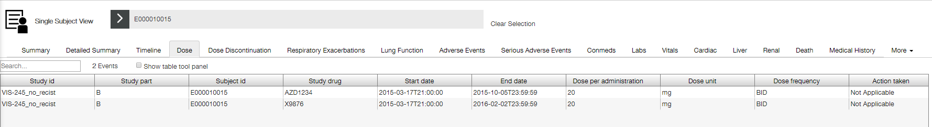

See Common Table Controls section for description of available controls.

**Dose** **Filters** are available on the right slide panel. Dose filters correspond to the table columns (except for **Study id**, **Study part** and **Subject id** columns).

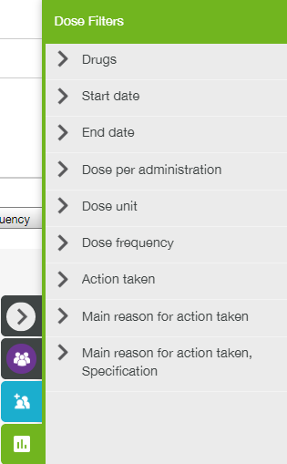

### Dose Discontinuation Tab

**Dose Discontinuation** tab contains a single table that displays dose discontinuation events for the selected subject. By default records are sorted chronologically by date-time of IP discontinuation.

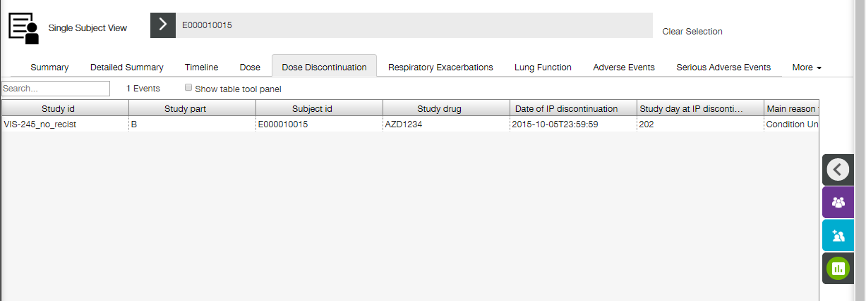

See Common Table Controls section for description of available controls.

**Dose** **Discontinuation** **Filters** are available on the right slide panel. Filters correspond to the table columns (except for **Study id**, **Study part** and **Subject id** columns).

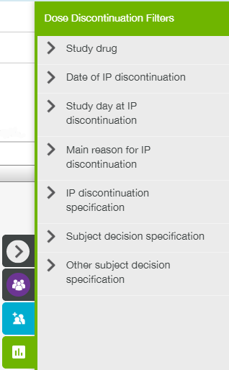

### Respiratory Exacerbations Tab

**Respiratory Exacerbations** tab contains a single table that displays respiratory exacerbations events for the selected subject. By default records are sorted chronologically by start date-time.

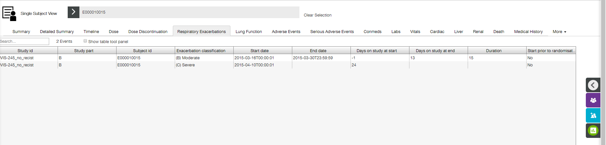

See Common Table Controls section for description of available controls.

**Respiratory Exacerbations** **Filters** are available on the right slide panel. Filters correspond to the table columns (except for **Study id**, **Study part** and **Subject id** columns).

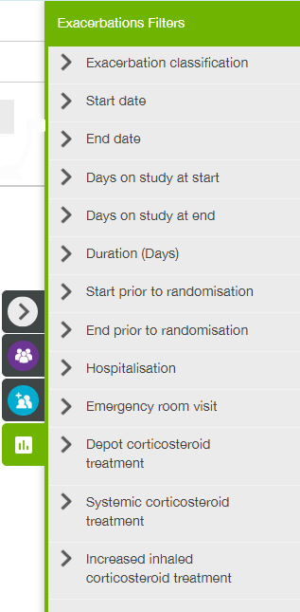

### Lung Function Tab

**Lung Function** tab is comprised of a set of Lung Function plots and Lung Function table placed below.

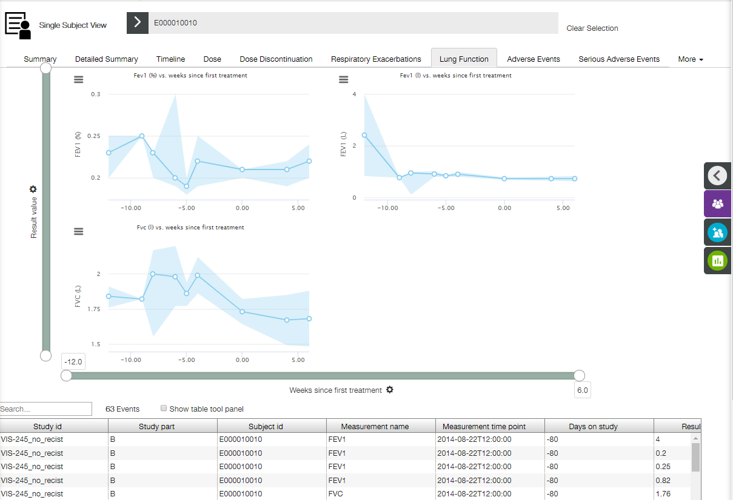

Lung Function line and range plots represent the summary of the Lung Function values over time. Each line Y value represents the median value of all unfiltered points at the given X axis timepoint. The range displays the range at the given points. Plots are trellised by measurement name (see Trellised Plots section for trellis description).

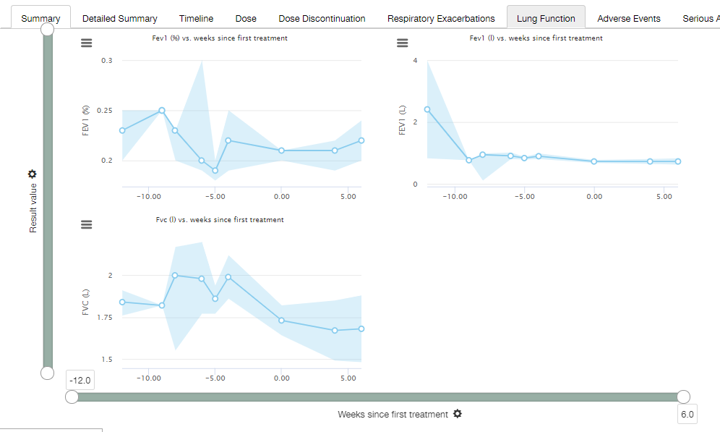

X axis

X axis has time binning (see Time Binning section for details). The following axis labels are available:

* Visit number;
* Days since first treatment;
* Weeks since first treatment;
* Days since randomisation;
* Weeks since randomisation.

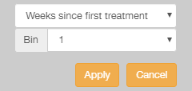 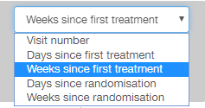

Y axis

The following Y axis labels are available:

* Absolute change from baseline;
* Percentage change from baseline;
* Result value.

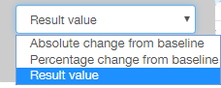

Tooltips

The following tooltip appears when a user hovers a mouse cursor over a particular point on the plot.

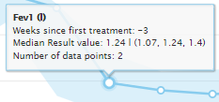

The tooltip contains the following information:

* Y axis label (lung function measurement);
* X axis position;
* Y axis position (measured value with calculation details);
* Number of data points;

Table

Lung Function table displays respiratory exacerbations events for the selected subject. By default records are sorted chronologically by measurement date-time.

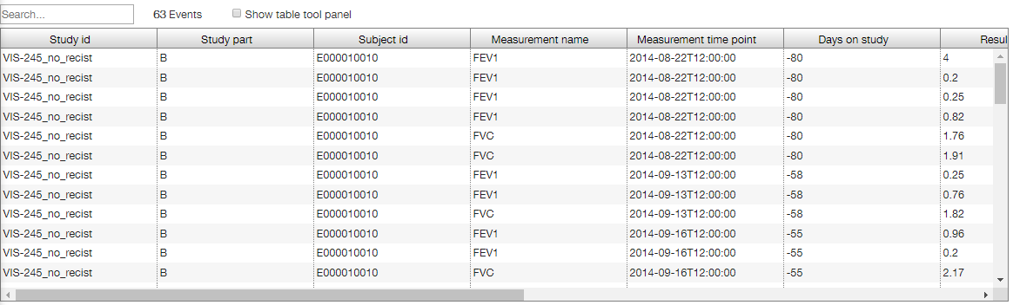

**Note**: If a user selects some points on the plot, appropriate table rows become highlighted.

See Common Table Controls section for description of available controls.

Lung Function Filters

**Lung Function Filters** are available on the right slide panel.

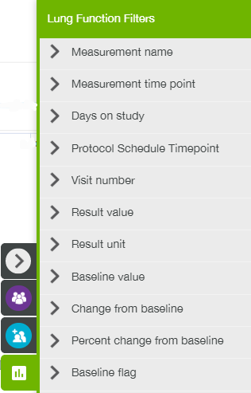

### Adverse Events Tab

**Adverse Events** tab contains a single table that displays all of the adverse events for the selected subject. By default records are sorted chronologically by start date-time.

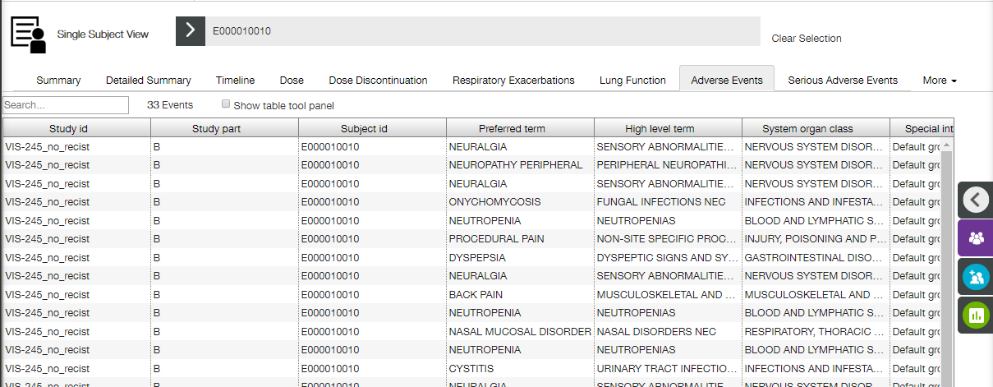

See Common Table Controls section for description of available controls.

**Adverse Events** **Filters** are available on the right slide panel.

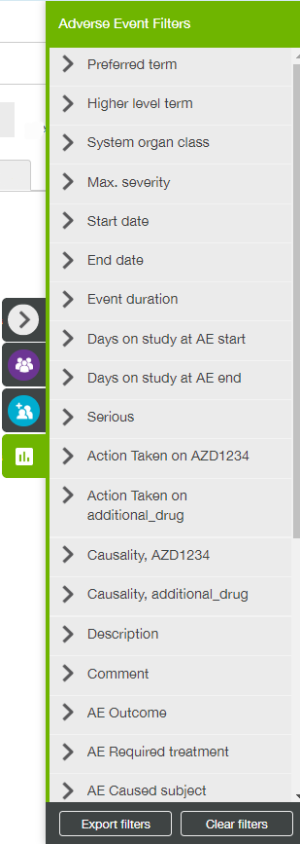

### Serious Adverse Events Tab

**Serious Adverse Events** tab contains a single table that displays all of the serious adverse events for the selected subject. By default records are sorted chronologically by start date-time.

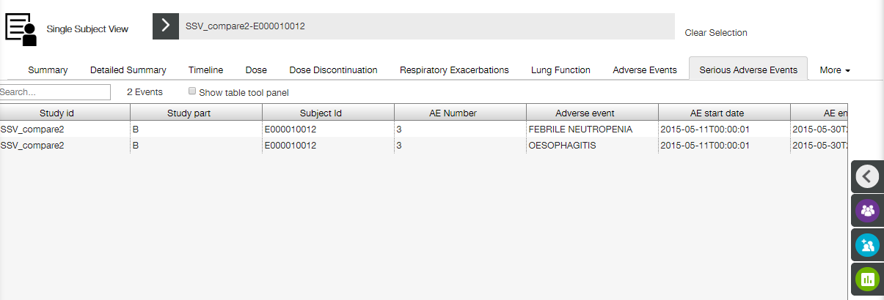

See Common Table Controls section for description of available controls.

**Serious Adverse Events** **Filters** are available on the right slide panel.

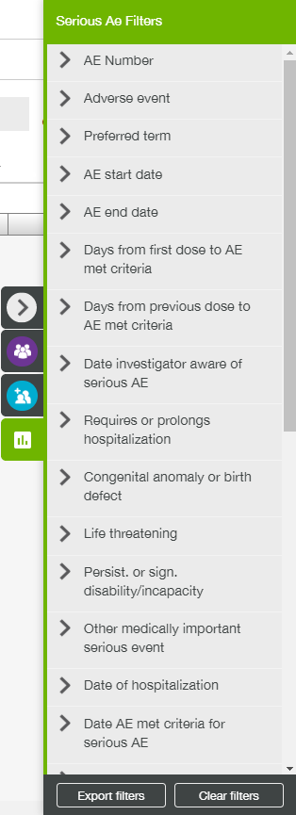

### Conmeds Tab

**Conmeds** tab contains a single table that displays all of the concomitant medications being used by the selected subject. By default records are sorted chronologically by start date-time.

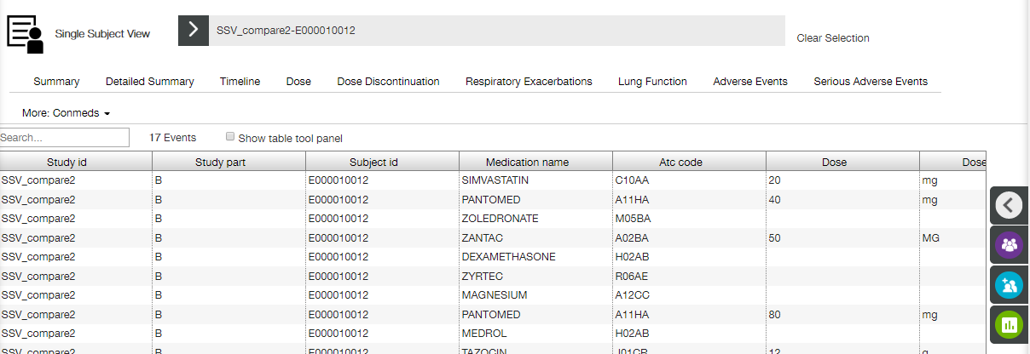

See Common Table Controls section for description of available controls.

**Conmeds** **Filters** are available on the right slide panel.

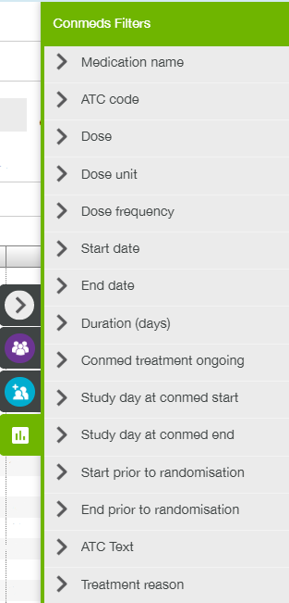

### Labs Tab

**Labs** tab is comprised of a set of Labs plots and Labs table placed below.

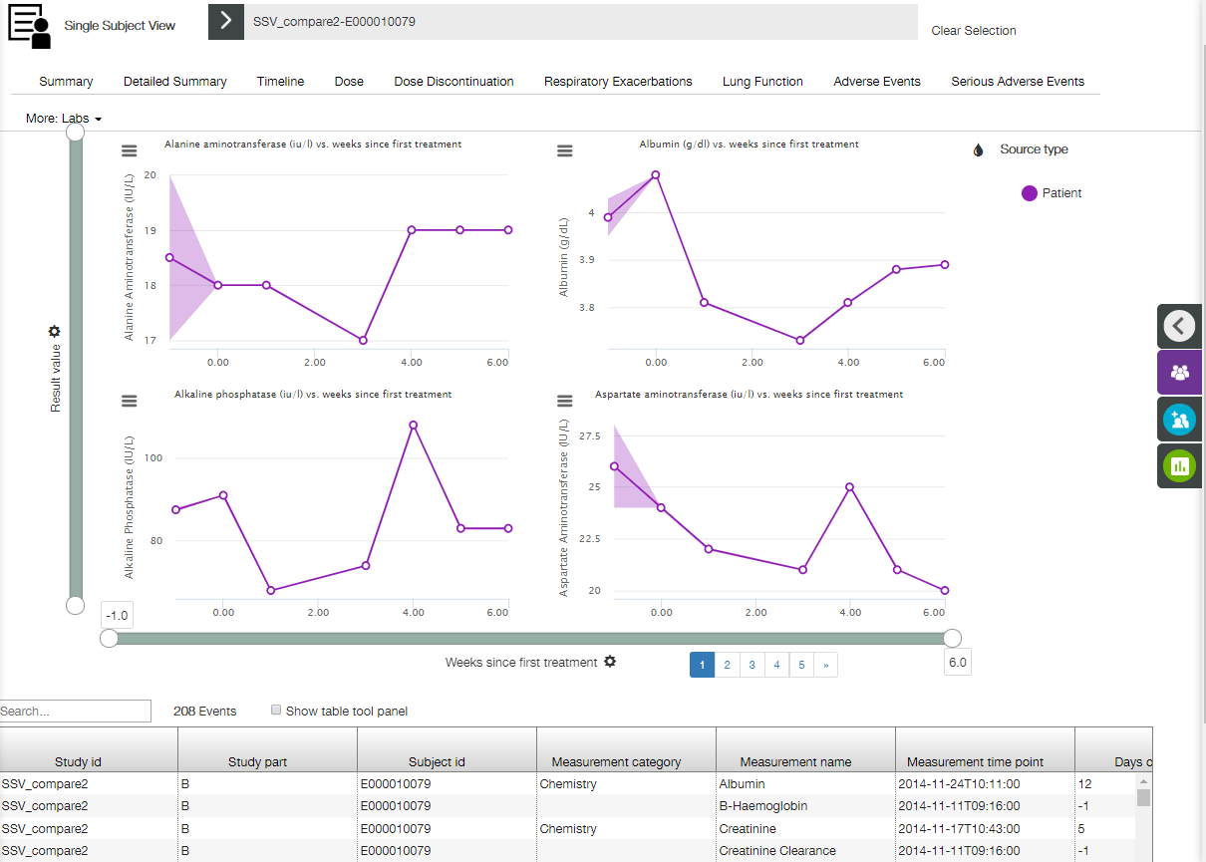

Labs line and range plots represent summary of the laboratory measurements (labs) values over time. Each line Y value represents the median value of all unfiltered points at the given X axis timepoint. The range displays the range at the given points.

Plots are trellised by measurement name and unit (see Trellised Plots section for trellis description).

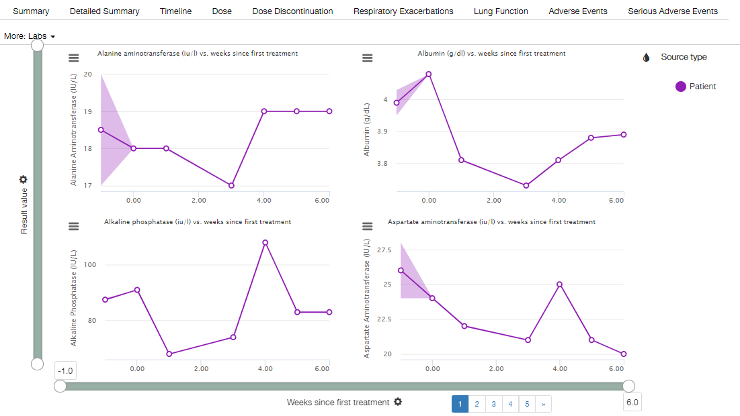

X axis

X axis has time binning (see Time Binning section for details). The following axis labels are available:

* Visit number;
* Days since first treatment;
* Weeks since first treatment;
* Days since randomisation;
* Weeks since randomisation.

 

Y axis

The following Y axis labels are available:

* Ref range norm. value;
* Times upper ref. value;
* Times lower ref. value;
* Absolute change from baseline;
* Percentage change from baseline;
* Result value.



Tooltips

The following tooltip appears when a user hovers a mouse cursor over a particular point on the plot.

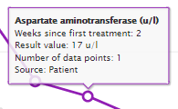

The tooltip contains the following information:

* Y axis label (lab data measurement);
* X axis position;
* Y axis position;
* Number of data points;
* Source.

Table

**Labs** table displays labs values for the selected subject. By default records are sorted chronologically by measurement date-time.

**Note**: If a user selects some points on the plot, appropriate table rows become highlighted.

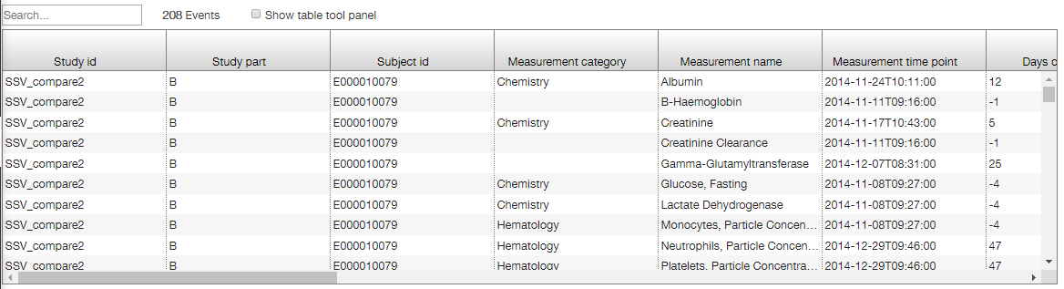

See Common Table Controls section for description of available controls.

Lab Filters

**Lab Filters** are available on the right slide panel.

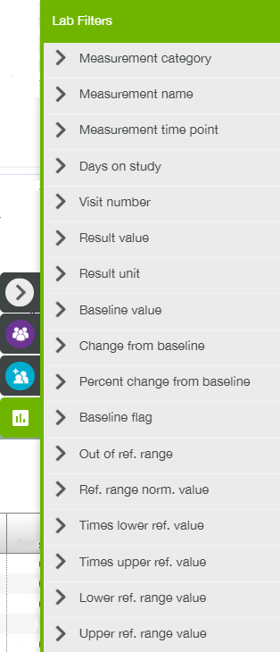

### Vitals Tab

**Vitals** tab is comprised of a set of Vitals plots and Vitals table placed below.

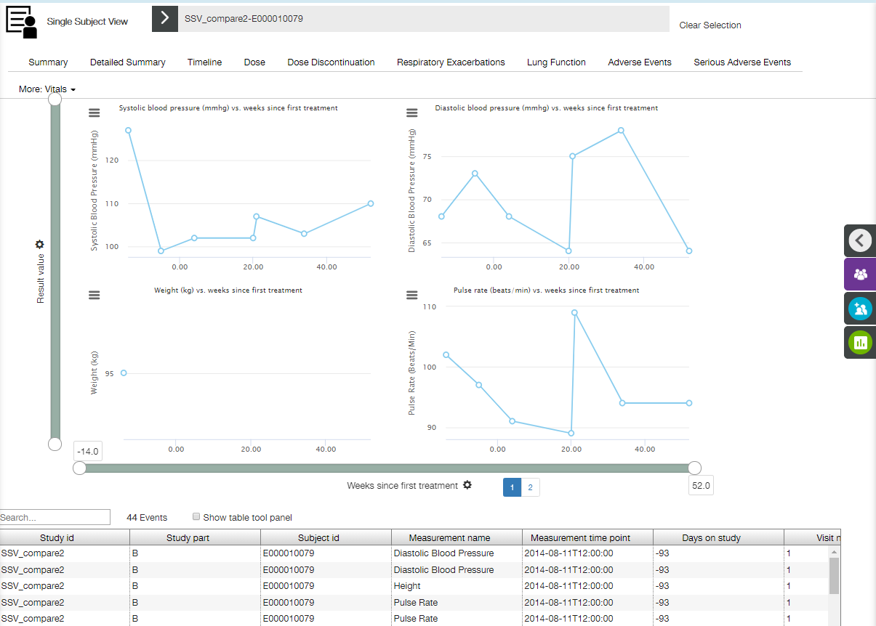

Vitals line plots represent the measured/available vital signs over time. Plots are trellised by measurement names (see Trellised Plots section for trellis description).

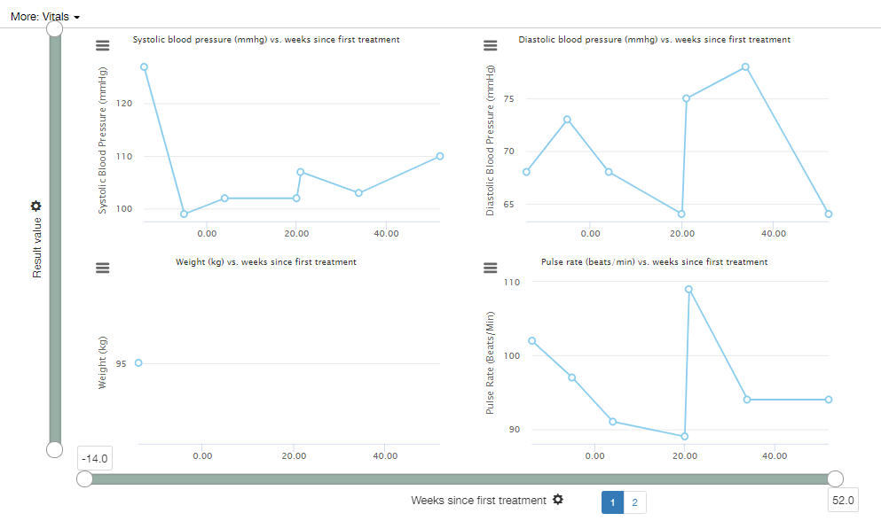

X axis

X axis has time binning (see Time Binning section for details). The following axis labels are available:

* Visit number;
* Days since first treatment;
* Weeks since first treatment;
* Days since randomisation;
* Weeks since randomisation.

 

Y axis

The following Y axis labels are available:

* Absolute change from baseline;
* Percentage change from baseline;
* Result value.



Tooltips

The following tooltip appears when a user hovers a mouse cursor over a particular point on the plot.

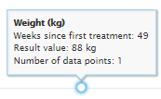

The tooltip contains the following information:

* Y axis label (vital data measurement);
* X axis position;
* Y axis position;
* Number of data points.

Table

**Vitals** table displays vital signs events for the selected subject. By default records are sorted chronologically by measurement date-time.

**Note**: If a user selects some points on the plot, appropriate table rows become highlighted.

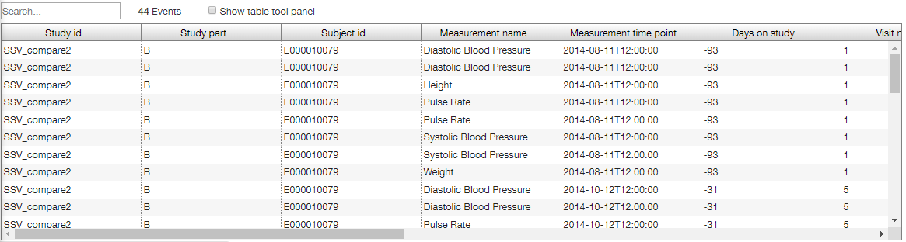

See Common Table Controls section for description of available controls.

Vitals Filters

**Vitals Filters** are available on the right slide panel.

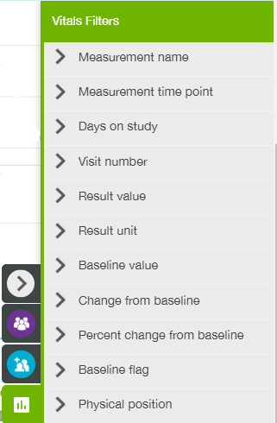

### Cardiac Tab

**Cardiac** tab is comprised of a set of Cardiac plots and Cardiac table placed below.

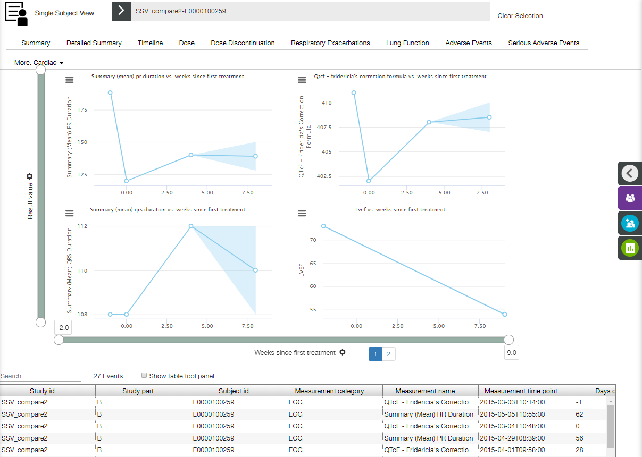

Cardiac line and range plots represent the measured/available cardiac data over time. The line displays the median value at a given time point. The range around the line displays the range at the given points.

Plots are trellised by measurement names (see Trellised Plots section for trellis description).

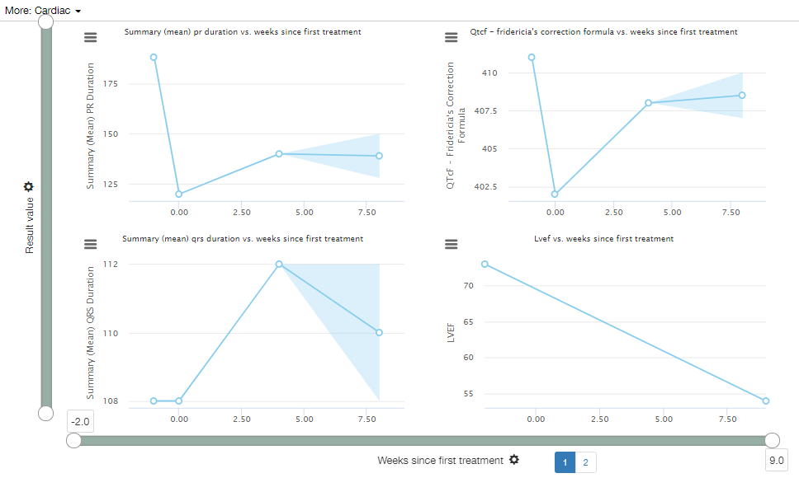

X axis

X axis has time binning (see Time Binning section for details). The following axis labels are available:

* Visit number;
* Days since first treatment;
* Weeks since first treatment;
* Days since randomisation;
* Weeks since randomisation.

 

Y axis

The following Y axis labels are available:

* Absolute change from baseline;
* Percentage change from baseline;
* Result value.



Tooltips

The following tooltip appears when a user hovers a mouse cursor over a particular point on the plot.

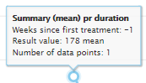

The tooltip contains the following information:

* Y axis label (cardiac data measurement);
* X axis position;
* Y axis position;
* Number of data points.

Table

Cardiac table displays cardiac events for the selected subject. By default records are sorted chronologically by measurement date-time.

**Note**: If a user selects some points on the plot, appropriate table rows become highlighted.

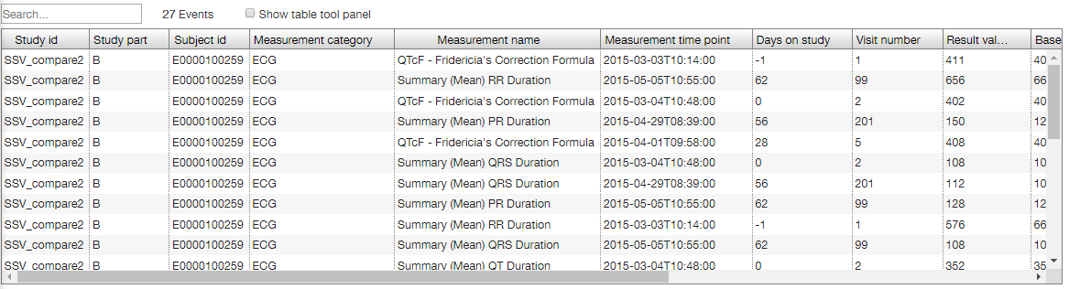

See Common Table Controls section for description of available controls.

Cardiac Filters

**Cardiac Filters** are available on the right slide panel.

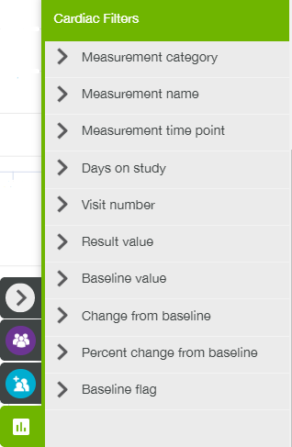

### Liver Tab

**Liver** tab contains two scatter plots that display the maximum measured concentrations for liver function indicators Bilirubin and AST/ALT, relative to a normal reference range. Two dotted lines are displayed on the plots: x = 2; y = 3. See Liver Function View section for more details.

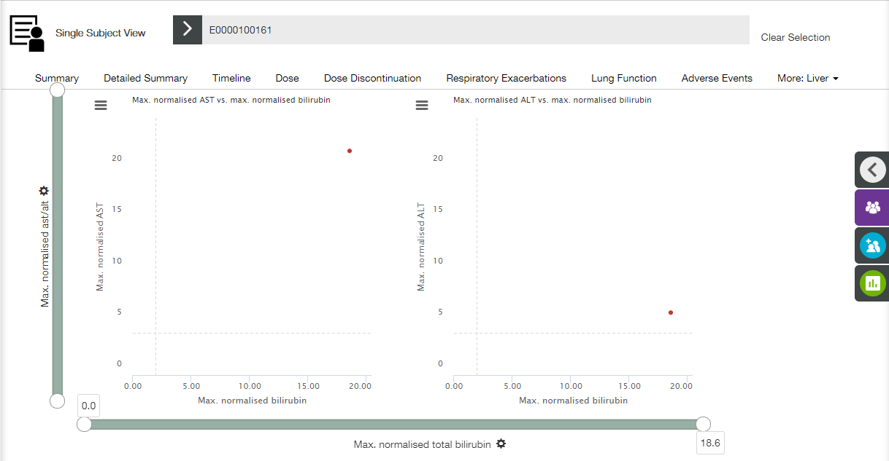

Tooltips

The following tooltip appears when a user hovers a mouse cursor over a particular point on the plot.

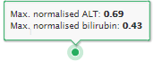

The tooltip contains the following information:

* Y axis position;
* X axis position.

Liver Filters

**Liver** filters are available on the right slide panel.

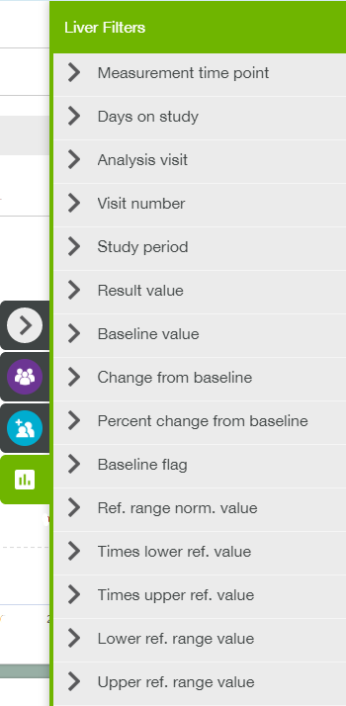

### Liver Risk Factors Tab

**Liver Risk Factors** tab contains a single table that displays liver risk factor for the selected subject. By default records are sorted chronologically by start date-time.

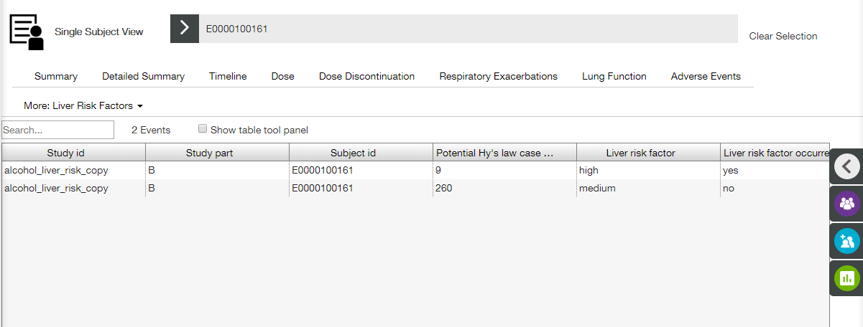

See Common Table Controls section for description of available controls.

**Liver Risk Factors Filters** are available on the right slide panel.

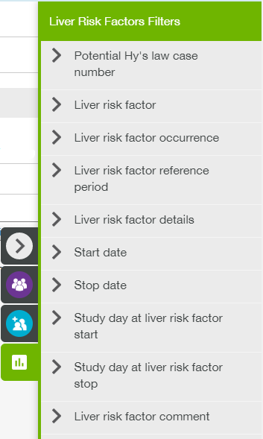

### Liver Diagnostic Investigation Tab

**Liver Diagnostic Investigation** tab contains a single table that displays liver diagnostic investigation for the selected subject. By default records are sorted chronologically by liver diagnostic investigation day-time.

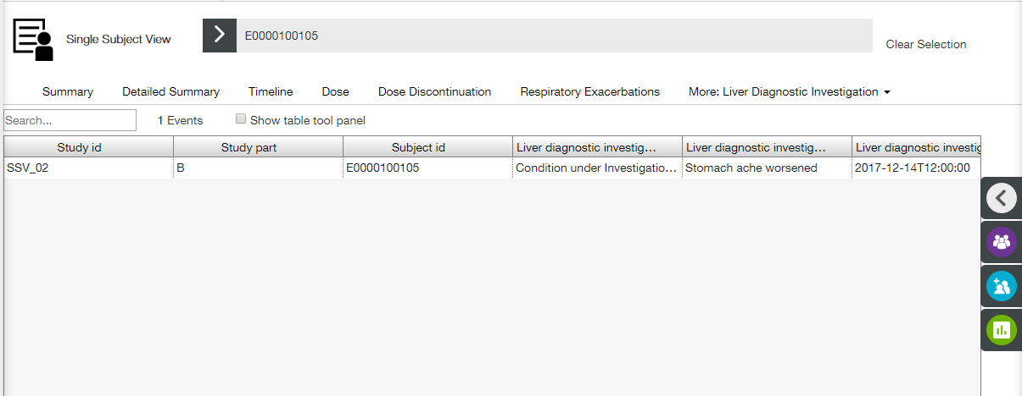

See Common Table Controls section for description of available controls.

**Liver Diagnostic Investigation Filters** are available on the right slide panel.

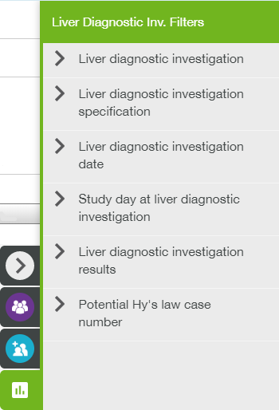

### Renal Tab

**Renal** tab is comprised of a set of Renal plots and Renal table placed below.

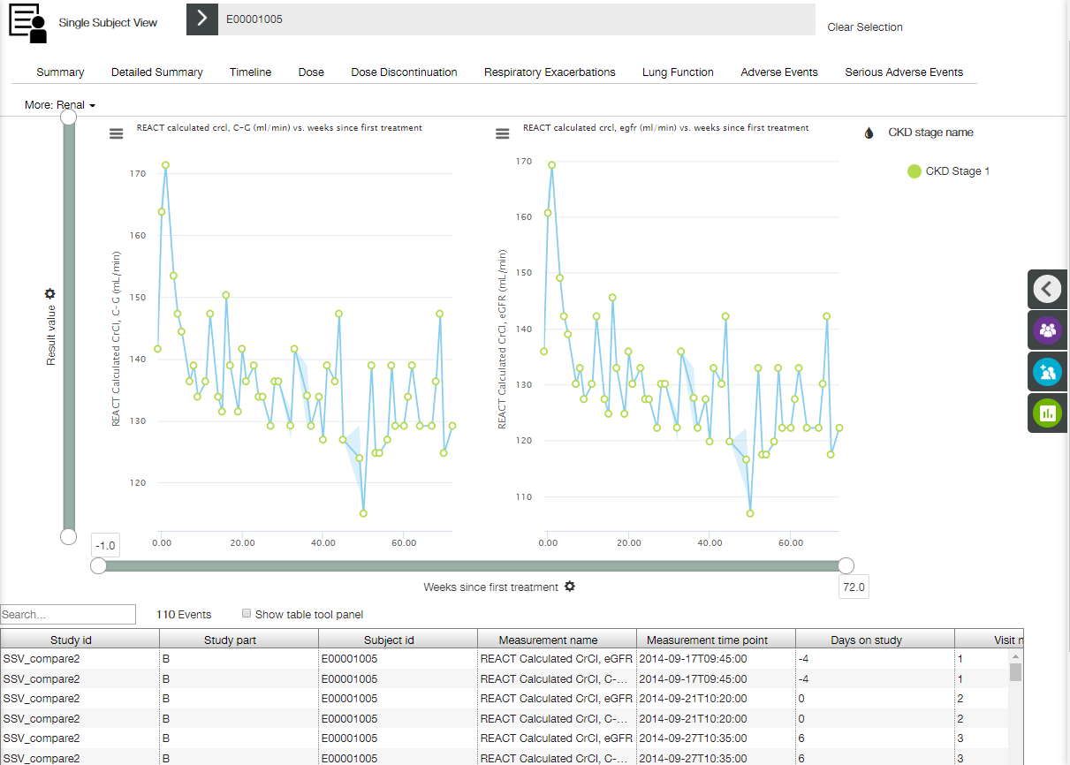

Renal set of line and range plots represent the summary of the renal values over time for the selected subject. Each datapoint Y value represents the median value of all unfiltered points at the given X axis timepoint. The range displays the max, min and median value of the given points.

Plots are trellised by measurement name (see Trellised Plots section for trellis description). Plot markers are colored according to their CKD stages by default.

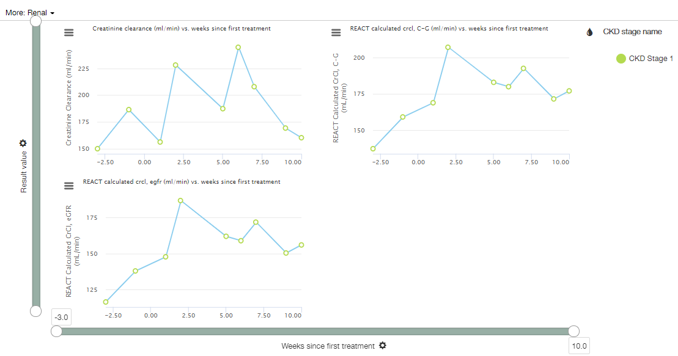

X axis

X axis has time binning (see Time Binning section for details). The following axis labels are available:

* Visit number;
* Days since first treatment;
* Weeks since first treatment;
* Days since randomisation;
* Weeks since randomisation.

 

Y axis

The following Y axis labels are available:

* Absolute change from baseline;
* Percentage change from baseline;
* Result value;
* Times upper ref. value;
* Times lower ref. value;
* Ref range norm. value.

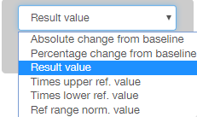

Tooltips

The following tooltip appears when a user hovers a mouse cursor over a particular point on the plot.

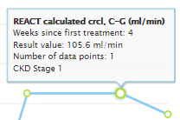

The tooltip contains the following information:

* Y axis label (renal data measurement);
* X axis position;
* Y axis position;
* Number of data points;
* CKD stage.

Table

**Renal** table displays all of the Renal Creatinine clearance (CrCl) measurement events for the selected subject. By default records are sorted chronologically by measurement date-time.

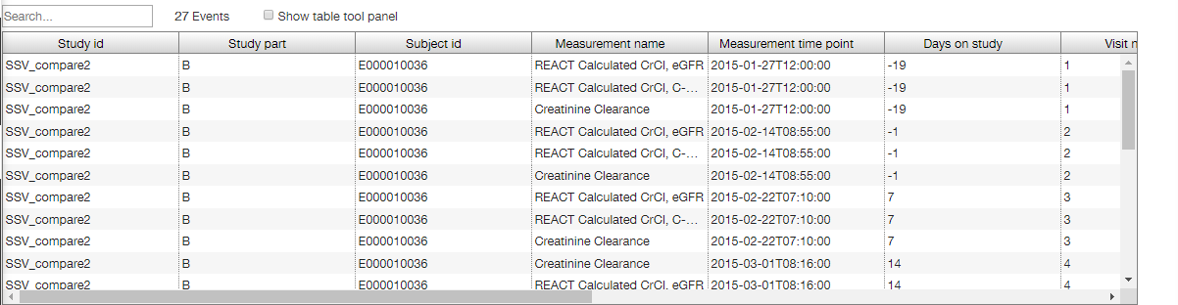

**Note**: If a user selects some points on the plot, appropriate table rows become highlighted.

See Common Table Controls section for description of available controls.

Renal Filters

**Renal** **Filters** are available on the right slide panel.

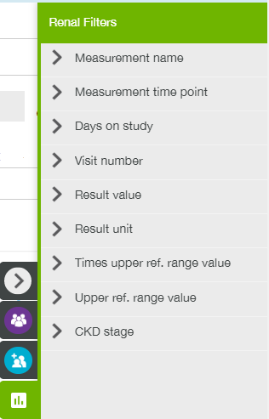

### Death Tab

**Death** tab contains a single table that displays data related to death for the selected subject.

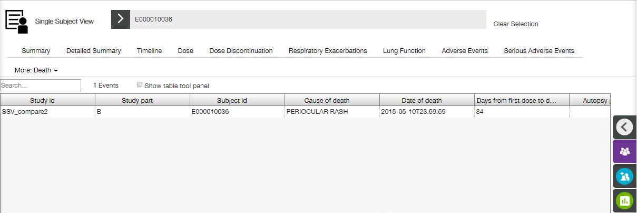

See Common Table Controls section for description of available controls.

**Death** **Filters** are available on the right slide panel.

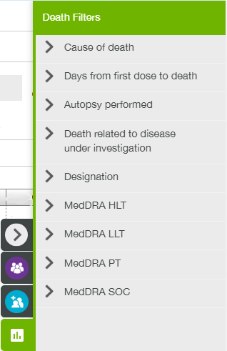

### Medical History Tab

**Medical History** tab contains a single table that displays medical conditions for the selected subject. By default records are sorted chronologically by start date-time.

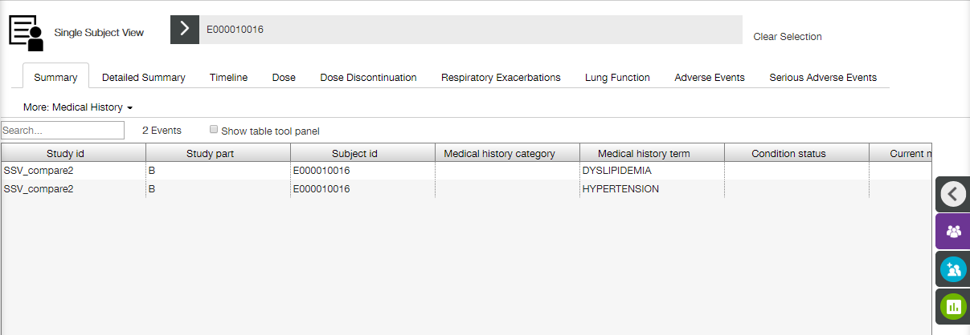

See Common Table Controls section for description of available controls.

**Medical History Filters** are available on the right slide panel.

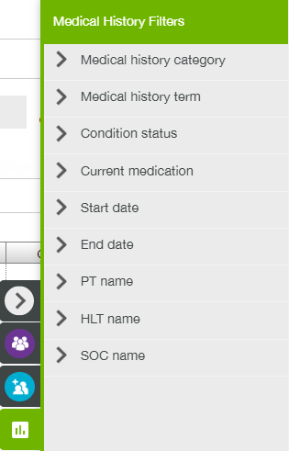

### Surgical History Tab

**Surgical History** tab contains a single table that displays relevant surgical procedures for the selected subject. By default records are sorted chronologically by start date-time.

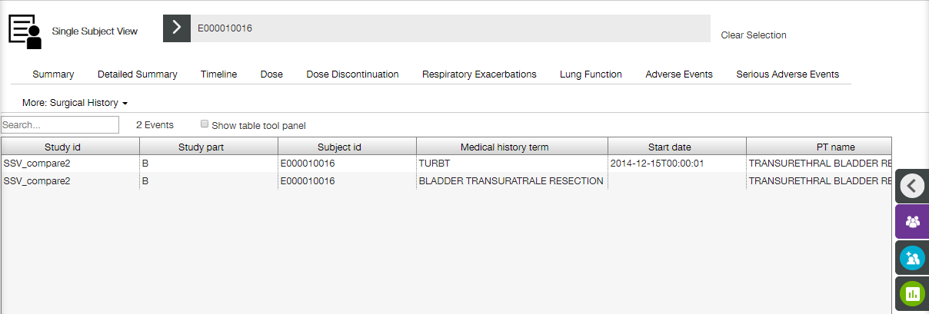

See Common Table Controls section for description of available controls.

**Surgical History Filters** are available on the right slide panel.

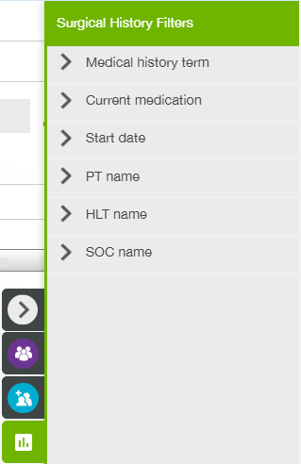

### Death Narrative Tab

**Death Narrative** tab provides a user with a description of circumstances of a death that were recorded for the selected subject.

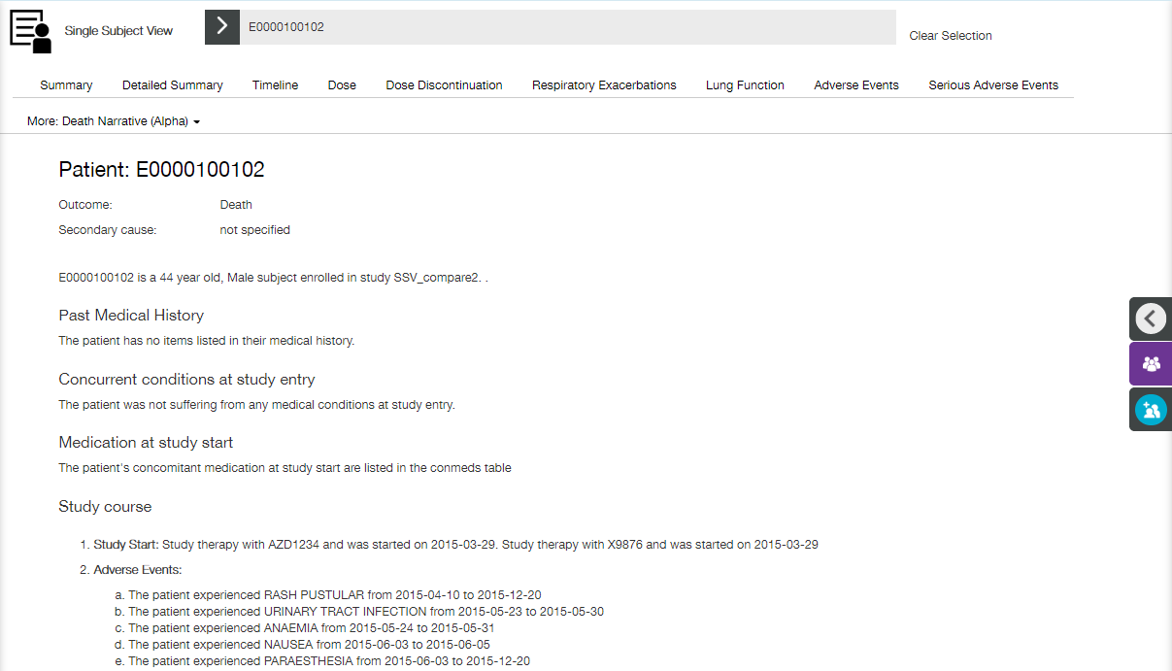

The following information is provided:

* Short death narrative summary;
* Past medical history;
* Concurrent conditions at study entry;
* Medication at study start;
* Study course;
* Patient results with some tables, such as Adverse events table, Conmeds table, etc.

Click **Download as doc** link on the bottom of the page to download all **Death Narrative** tab content as a .doc file.

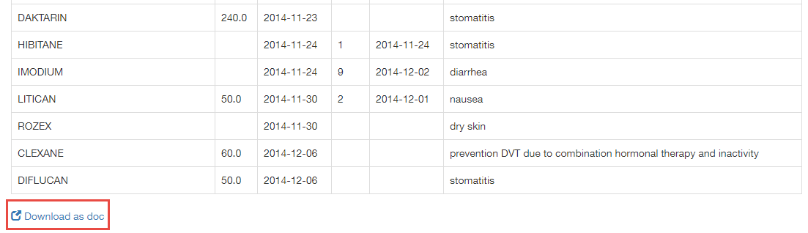

### Substance Use - Alcohol Tab

**Substance Use -** **Alcohol** tab contains a single table that displays records about past and current use of alcohol for the selected subject. By default records are sorted chronologically by start date-time.

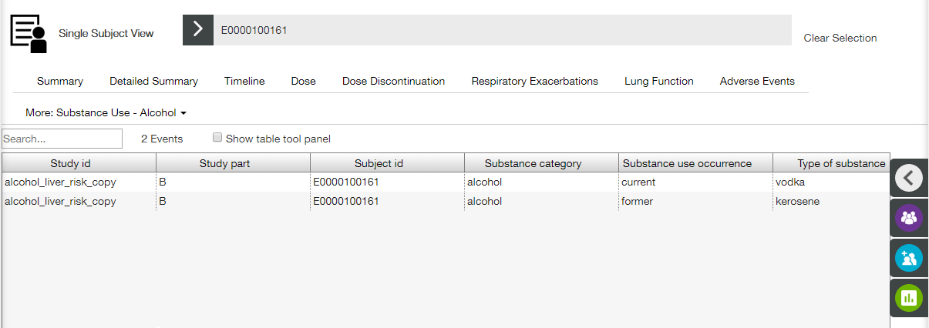

See Common Table Controls section for description of available controls.

**Substance Use - Alcohol** **Filters** are available on the right slide panel.

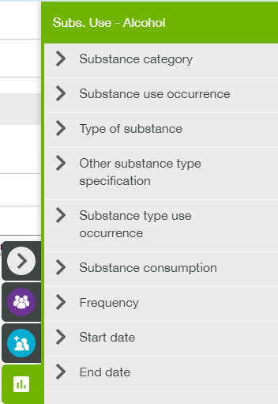

### Substance Use - Nicotine Tab

**Substance Use - Nicotine** tab contains a single table that displays records about past and current use of nicotine for the selected subject. By default records are sorted chronologically by start date-time.

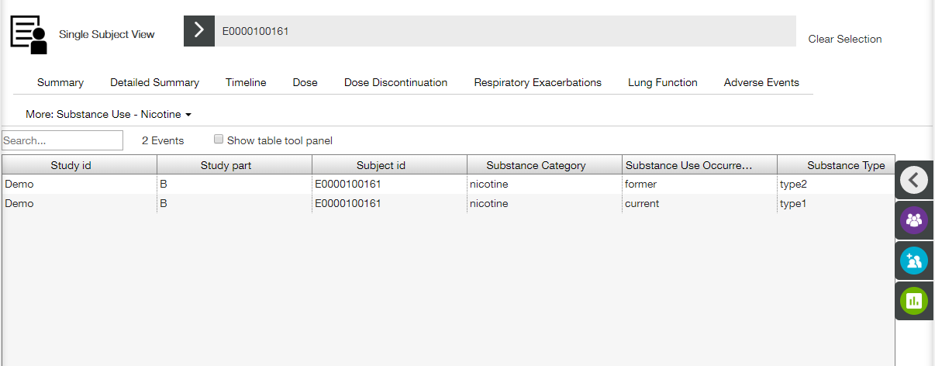

See Common Table Controls section for description of available controls.

**Substance Use - Nicotine Filters** are available on the right slide panel.

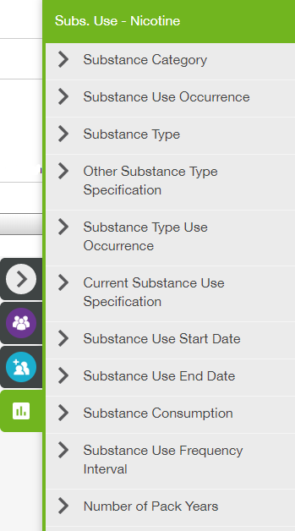

## Cohort Editor View

Cohort Editor allows a user to create a cohort - a number of subjects selected by the following attributes:

* Population characteristics (using Population filters);
* Existence of events that meet certain criteria (using Adverse Event filters).

**Cohort Editor** view window contains three panes:

* **Cohort Editor** (a user can add, delete, rename, save, apply or search for a cohort, and select filter group (population or adverse event) here);
* **Filters** (a user can set particular filters here);
* **Sharing** (a user can share the cohort with other users here).

**Note**: **Sharing** pane becomes available only when a particular cohort is selected.

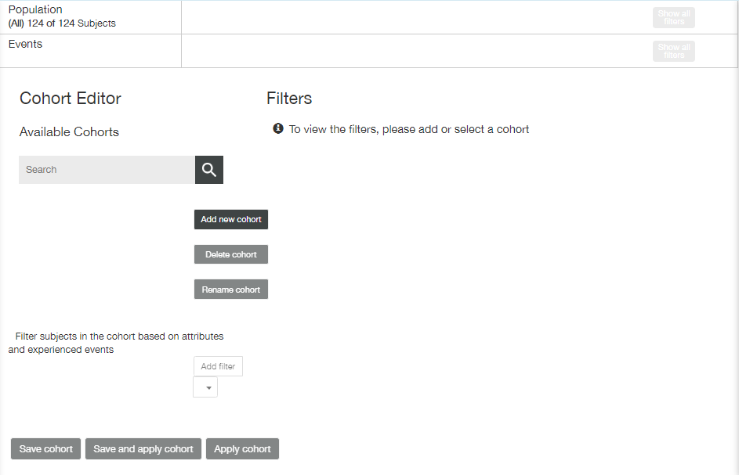

**Note**: When a particular cohort is selected, **Filters** pane displays list of filters (population filters or adverse events filters) followed by **Export filters** and **Clear filters** buttons.

**Note**: A cohort can be used only within a corresponding dataset.

### Adding a New Cohort

Click **Add new cohort** button. Dialog window appears. Enter a cohort name and click **Submit**.

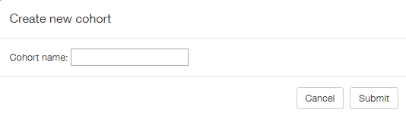

New cohort appears in the **Available Cohorts** list.

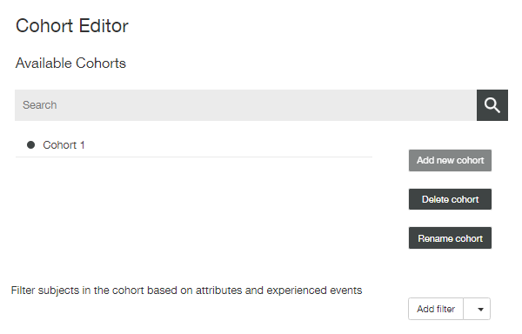

**Delete cohort** and **Rename cohort** buttons become available after creating new cohort group. **Sharing** pane also appears at the right side of the page.

Click the down arrow to open **Add filter** drop-down list and select one of two filter groups.

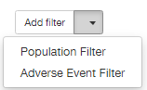

Selected filter group name appears in the **Filter subjects in the cohort based on attributes and experienced events** list. **Filters** pane displays selected group of filters.

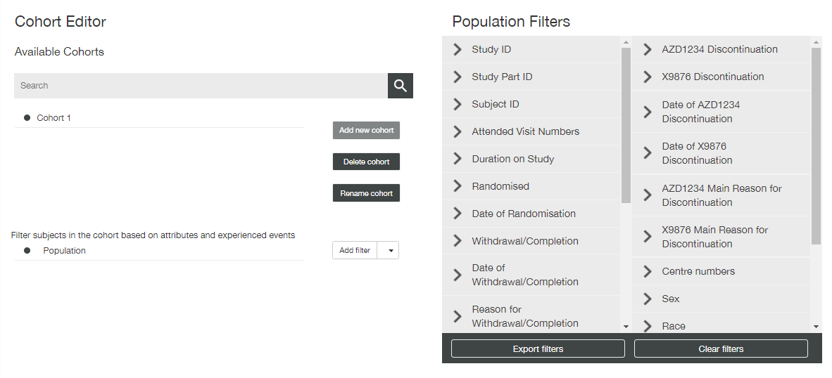

Use **Filters** pane to choose the required filter(s):

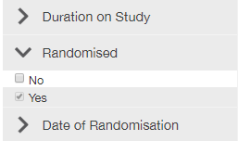

1. Click down arrow besides the filter name to expand the filter;
2. Select required values;
3. Click **Apply** to apply the filter, or **Reset** to cancel.

**Note**: If a user selected some values for filtering, but did not click **Apply** or **Reset** buttons, and collapsed the filter, selection is saved and displayed to a user next time when he/she expands the filter.

Applied filters are marked in the filter list – number of selected values is displayed.

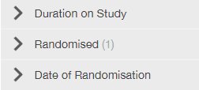

It is also possible to add another filter group. In this case population filters and adverse events filters will be combined, but only using AND rule.

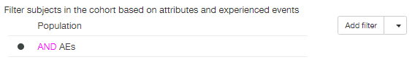

All selected filters are displayed on the top of the page, at Population and Events widgets.

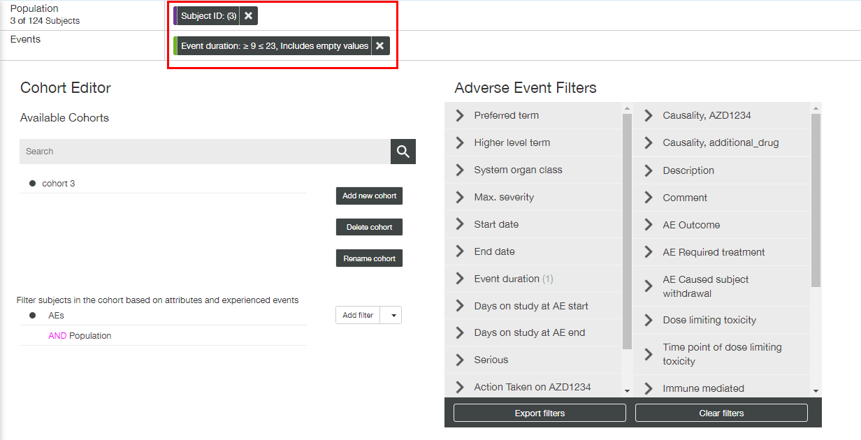

### Saving and Applying a Cohort

After applying some filters, **Save cohort** and **Save and apply cohort** buttons become available.

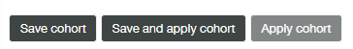

After saving cohort group becomes available in the **Cohort Filters** on the right slide menu.

If a newly created cohort was not saved, and a user tries to select another cohort or another view, confirmation window appears.

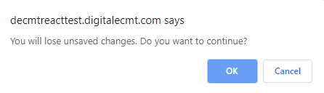

Applying cohort works in the same way as applying appropriate filters on any view – it effects in redrawing current plot in accordance with selected values.

So, if a newly created cohort was applied, then a user will see it being applied for any plot on any view.

**Note**: Only saved cohort can be applied.

EXAMPLE

A new cohort (named ‘Cohort for 3 subjects’) includes three subjects selected by means of **Subject ID** population filter. Appropriate tag is displayed at the **Population** widget on the top of the page. Cohort is saved and applied.

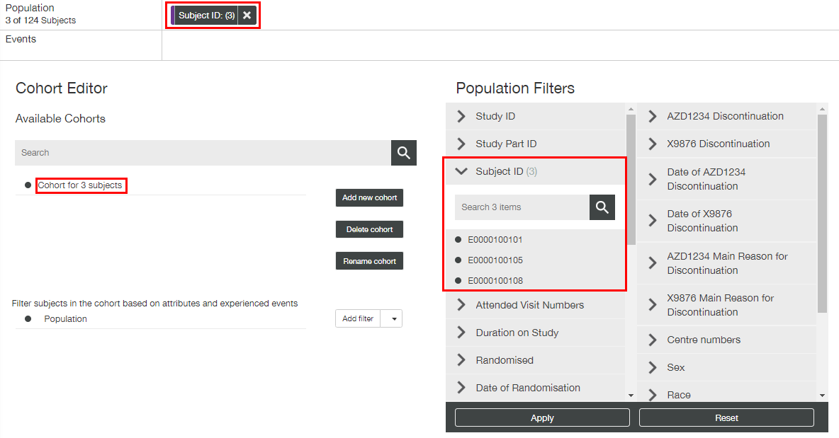

When a user moves to some view, e.g. to **Dose & Exposure** view, he/she finds ‘Cohort for 3 subjects’ being applied.

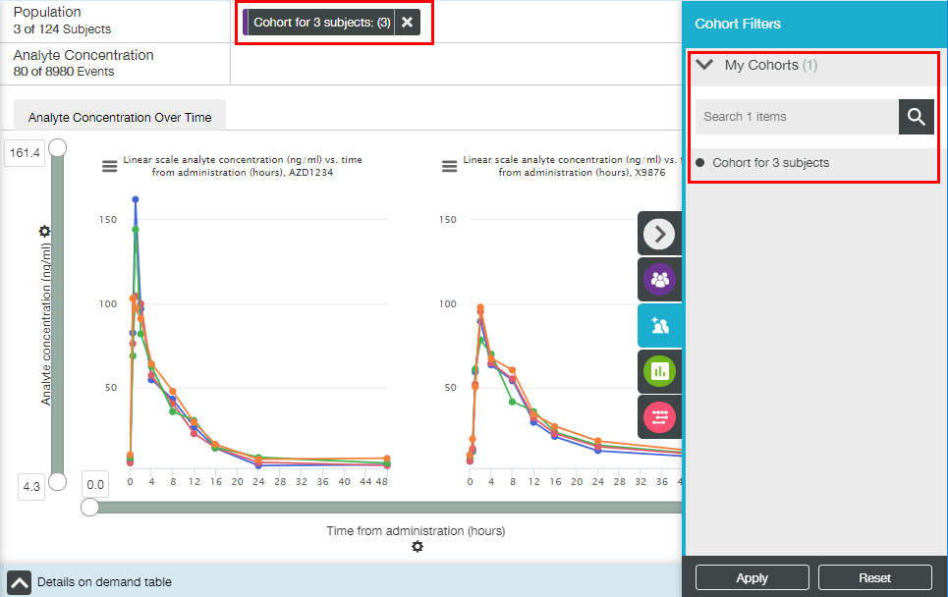

#### Applying Several Cohorts. Applying Cohorts on Merged Datasets

If a user created two or more cohorts and applies them, then only the common part of filtered subjects would be displayed. E.g. ‘Cohort 1’ has X+Y subjects and ‘Cohort 2’ has Y+Z subjects. When user apply both these cohorts, only Y subjects would be displayed on the plot.

It is also possible to create a cohort for merged datasets. E.g. a user creates a cohort when viewing merged datasets A, B and C called ‘My Cohort’.

‘My Cohort’ is accessible to use (and edit) when a user displays an analysis with any of the following combinations:

* A+B+C;
* A+B;
* A+C;
* B+C;
* A;
* B;
* C.

‘My Cohort’ is not accessible to use (nor edit) when a user displays an analysis that involves an entirely different merged study, e.g., dataset D, such as:

* A+B+C+D;
* A+B+D;
* A+D;
* D.

### Renaming and Deleting a Cohort

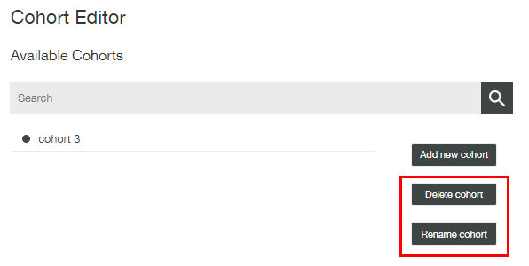

It is possible to rename saved and unsaved cohorts.

Select required cohort and click **Rename cohort.** **Rename cohort** dialog window appears. Enter a cohort name and click **Submit**.

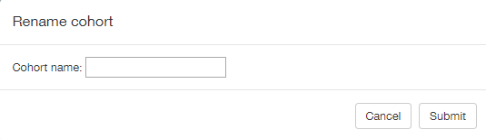

Click **Save** or **Save and apply cohort** to save changes.

**Note**: If a cohort was previously applied, then after clicking **Save** a cohort still remains applied with a new name. There is no need to apply it again.

It is also possible to remove saved and unsaved cohorts.

Select required cohort and click **Delete** **cohort**. No warning appears, and a cohort is removed **immediately**.

**Note**: Both **Rename cohort** and **Delete cohort** buttons are unavailable until any cohort is selected.

### Sharing Cohorts

A user who creates a cohort (‘cohort owner’) can share the saved cohort among other users by means of **Sharing** pane.

The list of users is displayed whereby the cohort owner can check users with whom to share the cohort. Two buttons are available under the list: **Select All** and **Deselect All**. **Search** field allows a user to filter the users list.

**Note**: The list contains all users who is able to access the study the cohort owner is working with.

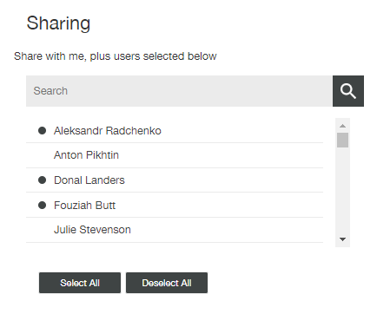

Another user will be able to view, edit and apply the shared cohort as if he/she created it itself. He/she will also be able to see the sharing settings and change them.

**Note**: Any edits to or deletion of the cohort affect the cohort for all users with whom the cohort is shared.

### Important Details of Cohorts Usage

There is a difference between using Adverse Events filters directly and by means of Cohort filters. Let’s try to select serious adverse events only.

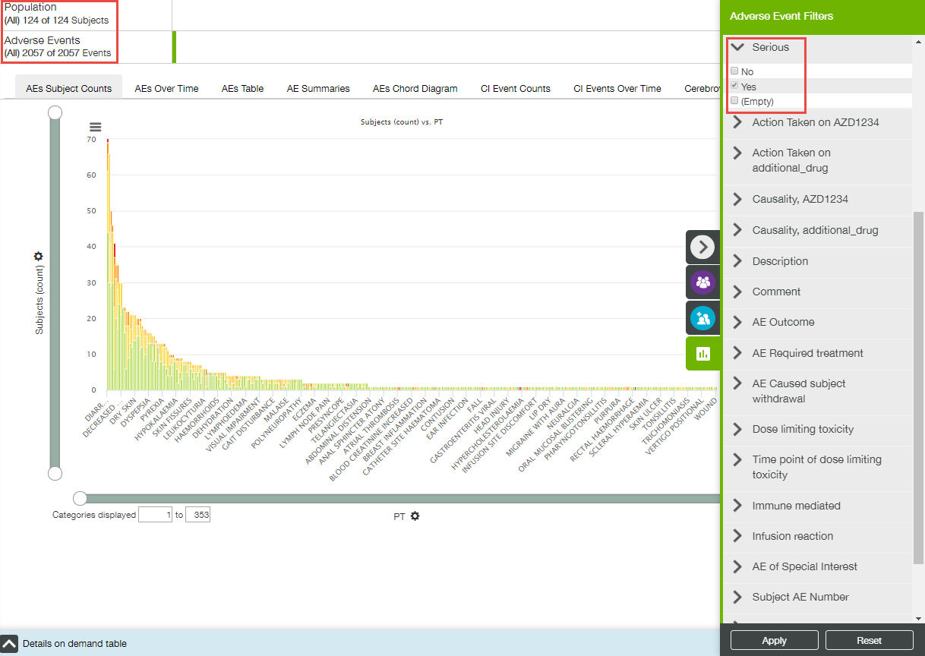

Appropriate filter applying resulted in reducing adverse events number, but not the population (number of subjects).

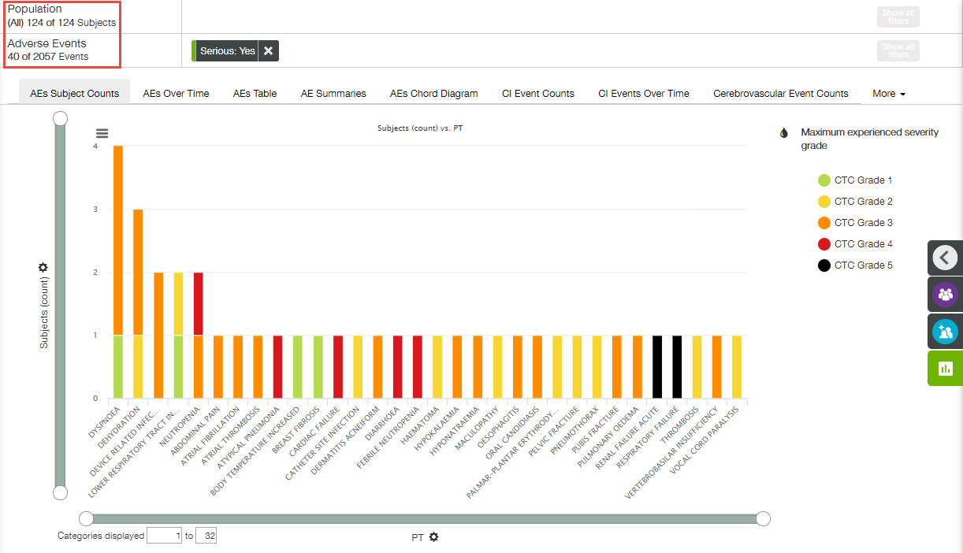

**Note**: High values of severity grade value and seriousness of adverse event are divorced from each other.

Now let’s remove Adverse Event filtering, and create a similar cohort.

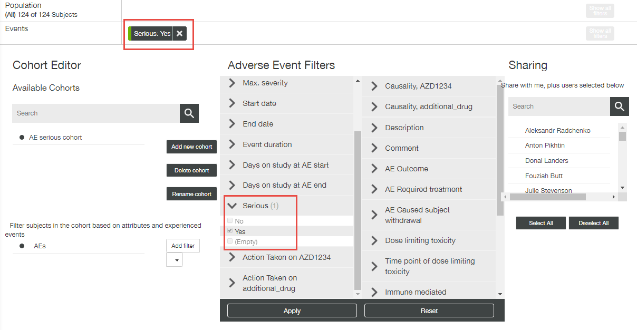

Filtering by this cohort reduces the population, so the result of applying cohort filter at the **Adverse Events** view gives us another picture. Additionally, now all adverse events are displayed for reduced population, not only marked as serious.

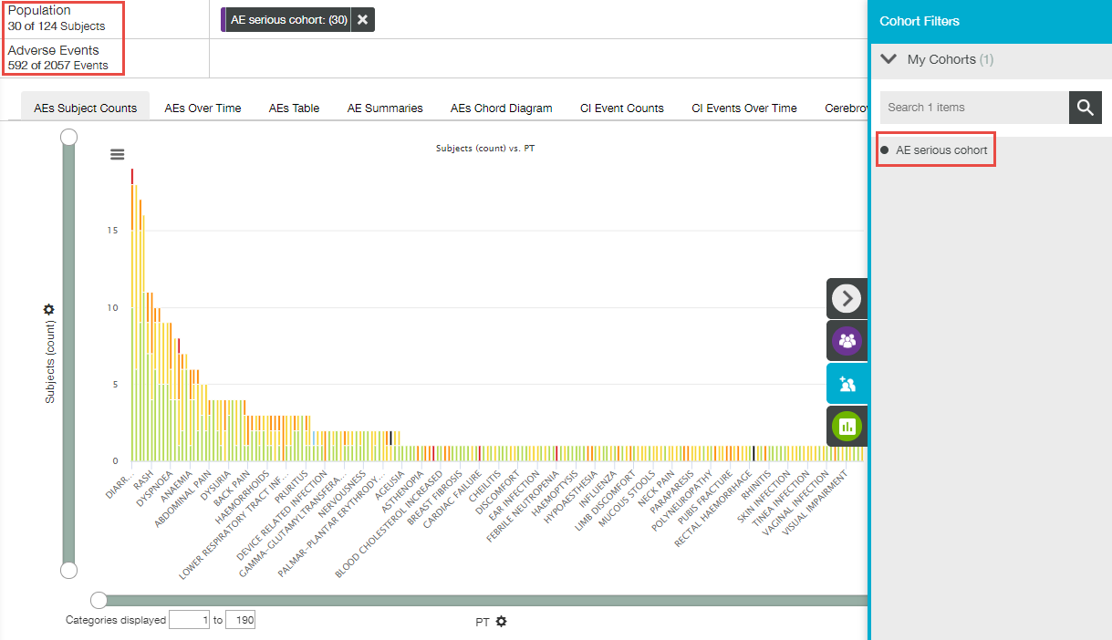

## Machine Insights View

**Machine Insights** view allows a user to visualize increased risk level of developing abnormal heart rhythms and sudden cardiac death. This view contains only **QT Prolongation** tab.

**Note**: Additional settings in the VA-Security application should be specified for **Machine Insights** view to be available for a particular user.

QT Prolongation plot shows a risk level based on information about QT interval value of subject’s ECG measurements, together with the following information:

* Concomitant medication;
* Some adverse events, such as diarrhea;
* Laboratory results (K and Mg levels).

**Note**: Integration with Azure Machine Learning Studio is used to perform calculations required for QT Prolongation plot.

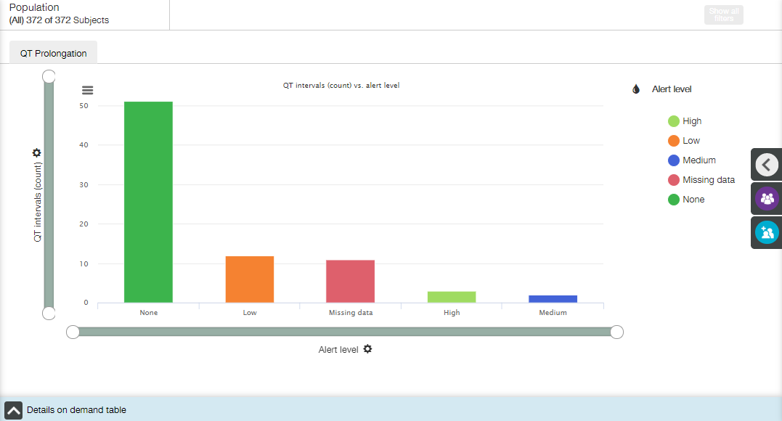

The plot is constructed as a bar chart, going from the highest bar to the lowest. Each bar corresponds to some risk level.

Main elements available on Waterfall Plot tab:

* Bar plot;
* X- and Y-axis zoom bars (see X and Y Axes Settings section);
* X- and Y-axis controls and titles (see X and Y Axes Settings section);
* Coloring control (see Coloring section);
* Chart context menu icons (see Chart Context Menu section);
* Details on Demand table at the bottom of the screen, collapsed by default (see Details on Demand Table section).

X axis

The title of the X-axis is **Alert level**, and no other option is available.

Y axis

The title of the Y-axis is **QT intervals (count)**, and no other option is available.

Coloring

Appropriate menu does not allow a user to change the coloring. The diagram is colored according to available alert levels.

Tooltips

When a user hovers the cursor over a bar, the tooltip with the following fields is displayed:

* X-axis value;
* Y-axis value.

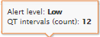

Details on Demand table

Details on Demand table contains two tabs: QT Prolongation tab and Subjects tab.

QT Prolongation tab:

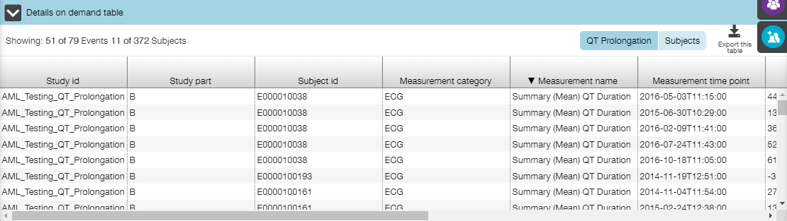

Subjects tab:

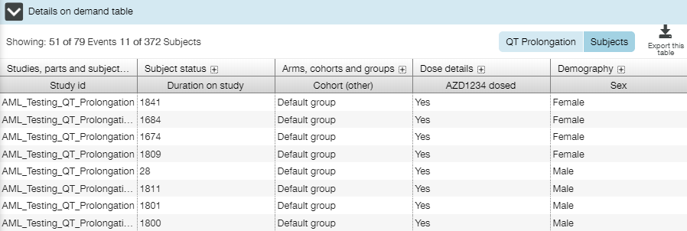

1. Roles and Permissions

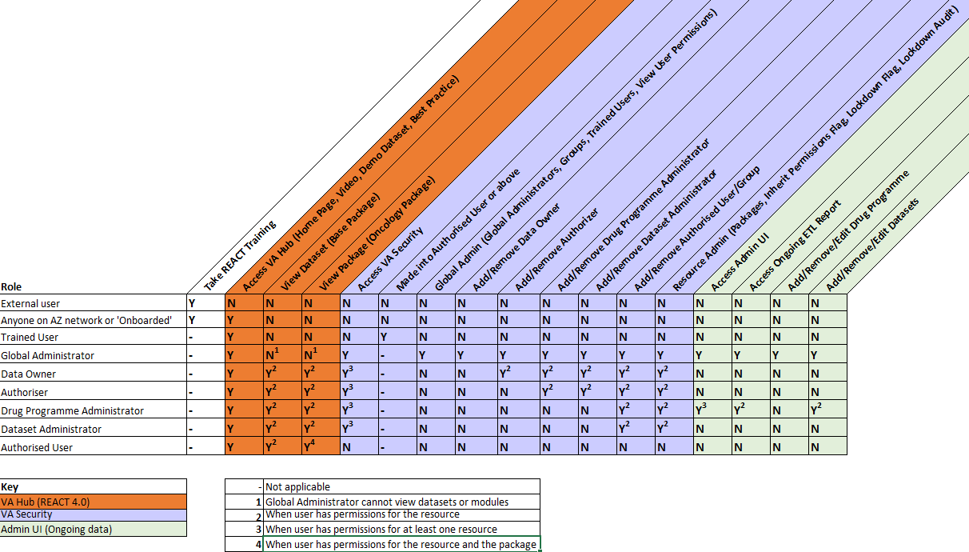

1. VA-Hub Database Tables and Views

| **View** | **Plots** | **AdminUI Mappings** | **Tables** |
| --- | --- | --- | --- |
| **Population Summary** | Summary Plot | Demography information | RESULT_PATIENTS |
| **Dosing and Exposure** | Analyte Concentration | Specimen Collection PK Concentration | RESULT_SPECIMEN_COLLECTION RESULT_PK_CONCENTRATION |
| Dose Proportionality | Stacked PK Results | RESULT_STACKED_PK_RESULTS |
| PK-Response | Stacked PK Results Recist assessment summarised (recist2) Recist target lesion assessments (recist1) | RESULT_STACKED_PK_RESULTS RESULT_RECIST_ASSESSMENT RESULT_RECIST_TARGET_LESION |
| **Adverse Events** | AEs Subject Counts AEs Over Time AEs Table AE Summaries | Adverse events | RESULT_AE  RESULT_AE_CAUSALITY  RESULT_AE_SEVERITY |
| AEs Chord Diagram | Adverse events | RESULT_AE RESULT_AE_SEVERITY RESULT_EVENT_TYPE RESULT_AE_ACTION_TAKEN (not used for this plot at the moment) RESULT_AE_CAUSALITY (not used for this plot at the moment) |
| CI Event Counts CI Events Over Time Cerebrovascular Event Counts Cerebrovascular Event Over Time Additional CVOT Suspected Endpoint Counts Additional Suspected CVOT Endpoints Over Time | Adverse events Cerebrovascular event data Additional Suspected CVOT Endpoint data | RESULT_AE RESULT_CI_EVENT RESULT_CEREBROVASCULAR RESULT_CVOT |
| **Conmeds** | Conmeds Counts | Concomitant medication | RESULT_CONMED_SCHEDULE |
| **Labs** | Box Plot Shift Plot Line Plot | Laboratory results | RESULT_LABORATORY |
| **Vital Signs** | Vitals Measurements over Time | Vital signs | RESULT_VITALS |
| **Cardiac Functions** | Cardiac Measurements over Time | Cardiac data- ECG Cardiac data - LVEF | RESULT_ECG  RESULT_LVEF |
| **Liver Function** | Hy's Law | Laboratory results | RESULT_LABORATORY |
| **Reneal Function** | Creatinine Clearance CKD Distribution | Laboratory results | RESULT_LABORATORY |
| **Respiratory** | Exacerbations Counts Lung Function Measurements Over Time Exacerbations Over Time Exacerbations Onset | Exacerbations Lung function Exacerbation classification rules | RESULT_EXACERBATION RESULT_LUNGFUNC |
| **Tumor Response** | Waterfall plot | Recist assessment summarised (recist2) Recist target lesion assessments (recist1) | RESULT_RECIST_ASSESSMENT RESULT_RECIST_TARGET_LESION |
| TL diameters over time | Recist assessment summarised (recist2) Recist target lesion assessments (recist1) | RESULT_RECIST_ASSESSMENT RESULT_RECIST_TARGET_LESION |
| Prior therapy vs. Time on compound | Chemotherapy information (caprx) Radiotherapy information (caprxr) Disease Extent Pathology Patient group information (long and thin) + Alternative Subject Groupings | RESULT_CHEMOTHERAPY RESULT_RADIOTHERAPY RESULT_DISEASE_EXTENT RESULT_PATHOLOGY MAP_SUBJECT_GROUP* (PRECALC_DEMO also contains subject groupings information) |
| **Oncogenic Biomarkers** | Genomic Profile | Genomic Profile Biomarker Results | RESULT_BIOMARKERS |
| ctDNA | Circulating tumor DNA | RESULT_CTDNA |
| **Timeline** | Timeline | Patient reported data | RESULT_PATIENT_REPORTED_DATA |
| **Single Subject** | ~ | ~ | ~ |
| **Cohort Editor** | ~ | ~ | ~ |
| **Machine Insights** | QT intervals | ECG - Legacy AZ Raw format Concomitant medication Adverse events Laboratory results | RESULT_ALGORITHM_OUTCOMES |